ASSIGNMENT: 03

Question: 01
#include<iostream>
#include<cstring>
#include<string>
#include<fstream>
using namespace std;
enum TYPE{CURRENT,SAVING};
class BANK
{
private:
char name[50]; //user name
char account[25]; //account number maximum 24 digits
TYPE type; // current or saving
double balance; // balance in account
char bank[50]; // bank name
char code[50]; // branch code
char city[50]; // city name
static unsigned int currentcount;
static unsigned int savingcount;
public:
BANK() //by default assigns default values
{
strcpy_s(name, "unknown");
strcpy_s(account, "0000");
strcpy_s(bank, "unknwn");
strcpy_s(code, "unknown");
strcpy_s(city, "unknown");
type = CURRENT;
balance = 0.0;
}
BANK(char name[50], char account[25], TYPE type, double balance, char bank[50], char code[50],
char city[50]) // assigns user entered values
{
strcpy_s(this->name, name);
strcpy_s(this->account, account);
this->type = type;
this->balance = balance;
strcpy_s(this->bank, bank);
strcpy_s(this->code, code);
strcpy_s(this->city, city);
if (type == CURRENT)
currentcount++;
if (type == SAVING)
savingcount++;
}
void setname(char name[50]) //getter setters
{
strcpy_s(this->name, name);
}
char* getname()
{
return name;
}
void setacc(char account[25])
{
strcpy_s(this->account, account);
}
char* getacc()
{
return account;
}
void setbal(double balance)
{
this->balance = balance;
}
double getbal()
{
return balance;
}
void settype(TYPE type)
{
this->type = type;
}
TYPE gettype()
{
return type;
}
void setbank(char bank[50])
{
strcpy_s(this->bank, bank);
}
char* getbank()
{
return bank;
}
void setcode(char code[50])
{
strcpy_s(this->code, code);
}
char* getcode()
{
return code;
}
void setcity(char city[50])
{
strcpy_s(this->city, city);
}
char* getcity()
{
return city;
}
void deposit(int amount)
{
balance += amount;
cout << "\nAmount Deposited! ";
}
void withdraw(int drawn)
{
if (drawn > balance)
{
balance -= drawn;
cout << "\nAmout Withdrawn! ";
}
else
cout << "\nInsufficient Balance! ";
}
void display()
{
cout << "\nAcoount Holder Name: " << name;
cout << "\nBank Name: " << bank;
cout << "\nCity Name: " << city;
cout << "\nBalance: " << balance;
}
static int setcount(TYPE type)
{
if (type == CURRENT)
currentcount++;
if (type == SAVING)
savingcount++;
}
static void getcount()
{
cout << "\nCurrent Accounts: " << currentcount;
cout << "\nSaving Accounts: " << savingcount;
}
};
unsigned int BANK::currentcount = 0;
unsigned int BANK::savingcount = 0;
void savefile(BANK* ptr[], int total);
void loadfile(BANK* ptr[], int& total);
int main()
{
int enter;
char name[50];
char account[25];
TYPE type;
double balance;
char bank[50];
char code[50];
char city[50];
int choice;
int total = 0;
BANK* ptr[100];
loadfile(ptr, total);
do
{
cout << "\n1.Create Account \n2.Display All Accounts ";
cout << "\n3.Delete Account \n4.Deposit ";
cout << "\n5.Withdraw \n6.Save to file ";
cout << "\n7.exit ";
cout << "\nYour Choice: ";
cin >> choice;
while (choice < 1 || choice>7)
{
cout << "\nInvalid Choice. Enter Again. ";
cin >> choice;
}
switch (choice)
{
case 1:
cin.ignore();
cout << "Enter Name: ";
cin.getline(name, 50);
cout << "Account Number: ";
cin.getline(account, 25);
cout << "\n1.Current Account ";
cout << "\n2.Saving Account ";
cout << "Enter: ";
cin >> enter;
cin.ignore();
while (enter < 1 || enter>2)
{
cout << "\nInvalid Choice! Enter Again.";
cin >> enter;
cin.ignore();
}
if (enter == 1)
type = CURRENT;
else
type = SAVING;
cout << "\nEnter Balance: ";
cin >> balance;
cin.ignore();
cout << "Enter Bank Name: ";
cin.getline(bank, 50);
cout << "Enter Branch Code: ";
cin.getline(code, 50);
cout << "\Enter City Name: ";
cin.getline(city, 50);
ptr[total] = new BANK(name, account, type, balance, bank, code, city);
total++;
break;
case 2:
for (int i = 0;i <total;i++)
{
ptr[i]->display();
}
break;
case 3:
int index;
cout << "\nEnter Index: ";
cin >> index;
if (index < 0 || index >= total)
{
cout << "Invalid index!";
break;
}
delete ptr[index];
for (int i = index; i < total - 1; i++)
{
ptr[i] = ptr[i + 1];
}
total--;
ptr[total - 1] = nullptr;
cout << "Account has deleted! ";
break;
case 4:
int num;
int amount;
cout << "\nEnter Account Number to deposit: ";
cin >> num;
cout << "\nEnter Amount You want deposit: ";
cin >> amount;
ptr[num]->deposit(amount);
break;
case 5:
int innum;
int inamount;
cout << "\nEnter Account Number: ";
cin >> innum;
cout << "\nEnter Amount you want to withdrawn: ";
cin >> inamount;
ptr[innum]->withdraw(inamount);
break;
case 6:
savefile(ptr, total);
break;
case 7:
savefile(ptr, total);
cout << "\nProgram Exiting! ";
exit(0);
break;
}
} while (choice != 7);
}
void savefile(BANK* ptr[], int total)
{
ofstream open("account.txt");
if (!open)
{
cout << "\nError in opening file!(file saving) ";
return;
}
cout << "\nFile has opened(file saving) ";
for (int i = 0;i < total;i++)
{
if (ptr[i]->gettype() == TYPE::CURRENT)
{
open << "Current ";
}
else
{
open << "Saving ";
}
open << ptr[i]->getname() << " " << ptr[i]->getacc() << " "
<< ptr[i]->getbal() << " " << ptr[i]->getbank() << " "
<< ptr[i]->getcode() << " " << ptr[i]->getcity() << endl;
}
open.close();
}
void loadfile(BANK* ptr[], int& total)
{
ifstream handler("account.txt");
if (!handler)
{
cout << "\nError in opening file!(file loading) ";
return;
}
cout << "\nFile has opened(file loading) ";
char name[50], account[25], bank[50], code[50], city[50];
char typest[10];
double balance;
while (handler >> name >> account >> typest >> balance >> bank >> code >> city)
{
TYPE type;
if (strcmp(typest, "CURRENT") == 0)
type = TYPE::CURRENT;
else
type = TYPE::SAVING;
ptr[total] = new BANK(name, account, type, balance, bank, code, city);
total++;
}
handler.close();
}
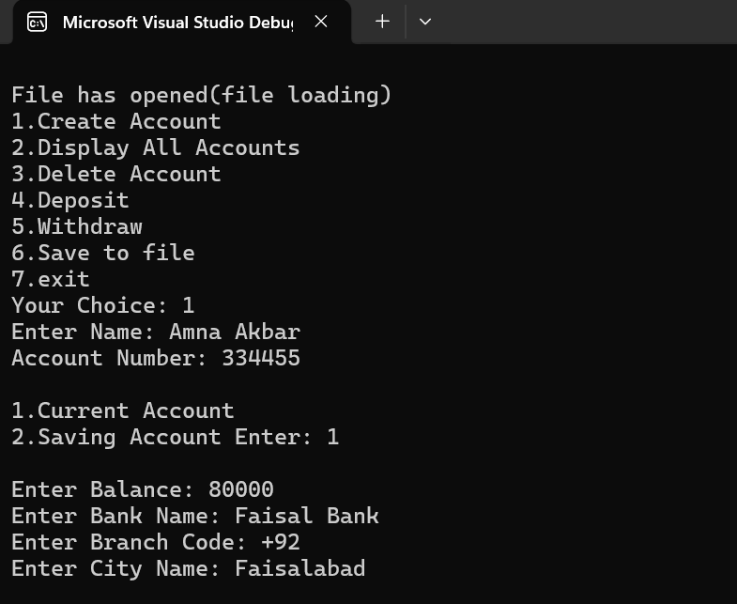
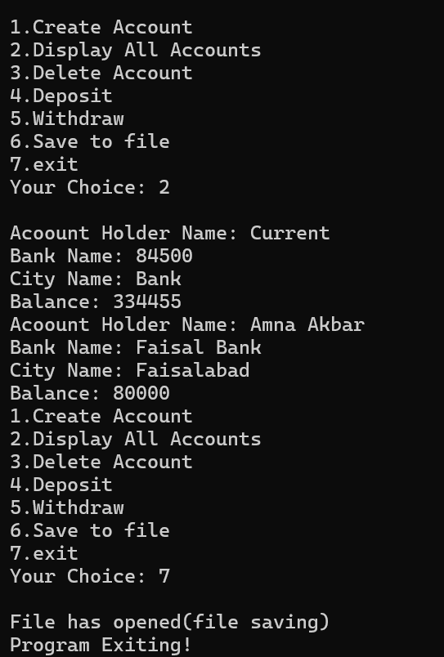

Question: 02
#include<iostream>
using namespace std;
class STAND
{
private:
int id;
int sales;
static int sold;
public:
STAND()
{
id = 0;
sales = 0;
}
STAND(int id,int sales)
{
this->id = id;
this->sales = sales;
this->sold++;
}
void justsold()
{
sold++;
sales++;
}
static int totalsold()
{
return sold;
}
void display()
{
cout << "\nStand ID: " << id
<< "\nSold Today: " << sales << endl;
}
};
int STAND::sold = 0;
int main()
{
STAND stand1(101, 5);
STAND stand2(102, 8);
STAND stand3(103, 3);
stand1.justsold();
stand1.justsold();
stand2.justsold();
stand3.justsold();
stand3.justsold();
stand3.justsold();
stand1.display();
stand2.display();
stand3.display();

cout << "\nTotal Hot Dogs Sold: "
<< STAND::totalsold() << endl;

}
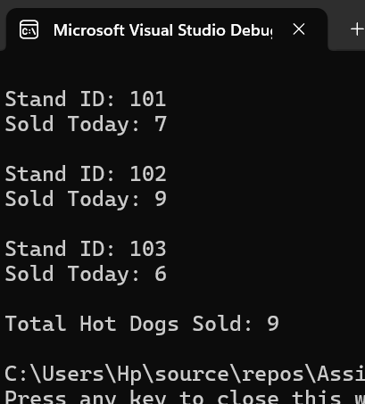

Question: 04
#include<iostream>
using namespace std;
class tollboth
{
private:
unsigned int cars;
double money;
public:
tollboth()
{
cars = 0;
money = 0.0;
}
tollboth(unsigned int cars,double money)
{
this->cars = cars;
this->money = money;
}
void payingcars()
{
cars++;
money += 50;
cout << "\nInformation Added ";
}
void nopay()
{
cars++;
cout << "\nInformation Added ";
}
void display() const
{
cout << "\nTotal Cars: " << cars;
cout << "\nTotal Money: " << money;
}
};
int main()
{
int choice;
tollboth t;
do
{
cout << "\n1.Paying Cars \n2.Non-Paying Cars: \n3.Display Information \n4.Exit"
<< "\nEnter: ";
cin >> choice;
switch (choice)
{
case 1:
t.payingcars();
break;
case 2:
t.nopay();
break;
case 3:
t.display();
break;
case 4:
exit(0);
}
} while (1);
}
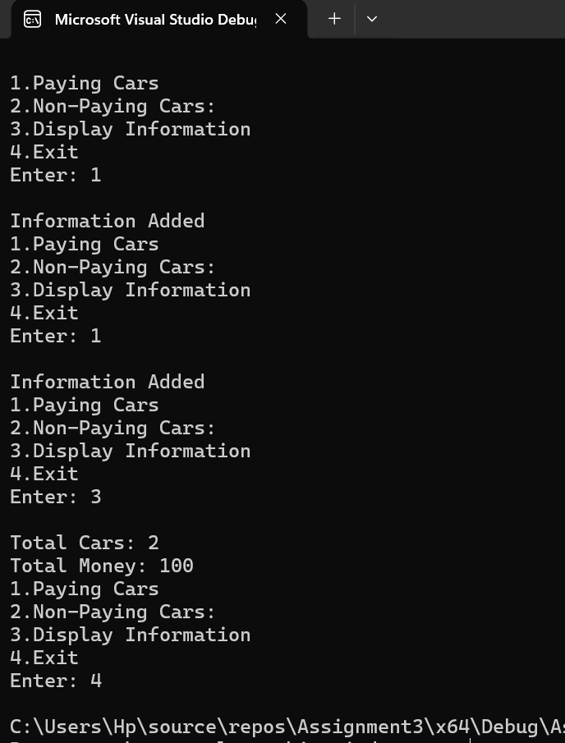

Question: 05
#include<iostream>
using namespace std;

class timme
{
private:
int seconds;
int minutes;
int hours;

public:
timme()
{
seconds = 0;
minutes = 0;
hours = 0;
}
timme(int h, int m, int s)
{
hours = h;
minutes = m;
seconds = s;
}

void display() const
{
cout << hours << ":" << minutes << ":" << seconds << endl;
}
void add(const timme& t1, const timme& t2)
{
seconds = t1.seconds + t2.seconds;
minutes = t1.minutes + t2.minutes;
hours = t1.hours + t2.hours;

if (seconds >= 60)
{
minutes += seconds / 60;
seconds %= 60;
}

if (minutes >= 60)
{
hours += minutes / 60;
minutes %= 60;
}
}
};

int main()
{
timme t1(10, 59, 50);
timme t2(2, 15, 15);
timme t3;

t3.add(t1, t2);
t3.display();

return 0;
}


