FAST NUCES-CFD 25F-0105

Spring 2026
SECTION BS AI – 2B
CS-1004 Object-Oriented Programming
Assignment # 03

SUBMITTED BY
NAME: Muhammad Ali Sajjad
ROLL #: 25F-0105

SUBMITTED TO
Sir Tahir Farooq

SUBMISSION DATE
March 27, 2026

DEPARTMENT OF AI AND DATA SCIENCE,
FAST-NU, CFD

Q#01:

/* ===== MULTI-FORMAT DATA SERIALIZATION SYSTEM ===== */
#include<iostream>
#include<string>
#include<fstream>//For FILE-HANDLING (OFSTREAM-Writing to File);(IFSTREAM-Reading from File)
using namespace std;

enum AccType { NONE = 0, Current = 1, Savings = 2 };

class Account
{
private:
char name[25];
char accNum[12];
AccType accType;
double accBalance;
char bankName[15];
char branchCode[10];
char city[15];

public:
static int currentCount;
static int savingCount;

Account() :accType(NONE), accBalance(0)
{
//Since Default constructor initially gets no Account Type, so there is no need to increment either counter Current or Saving counter.

strcpy_s(name, "NONE");
strcpy_s(accNum, "DEFAULT");
strcpy_s(bankName, "NONE");
strcpy_s(branchCode, "NONE");
strcpy_s(city, "NONE");
}

Account(char name[], char accNum[], AccType accType, double accBalance, char bankName[], char branchCode[], char city[])
{
strcpy_s(this->name, name);
strcpy_s(this->accNum, accNum);
strcpy_s(this->bankName, bankName);
strcpy_s(this->branchCode, branchCode);
strcpy_s(this->city, city);

this->accType = accType;
this->accBalance = accBalance;
}

static void getAccCounts()//In assignment Question there might be a typo because we can't use static member function as a getter or setter
{
cout << "\n===== ACTIVE ACCOUNT COUNTER =====\n";
cout << "Total Current Accounts: " << currentCount;
cout << "\nTotal Savings Accounts: " << savingCount << endl;
}
void deposit(double amount)
{
accBalance += amount;
cout << "\n===== AMOUNT DEPOSITED SUCCESSFULLY =====\n";
}
void createAccount()
{
cout << "Enter Following Details for Account\n";
cout << "Depositor's Name: ";
cin.getline(name, 25);

cout << "Account Number: ";
cin.getline(accNum, 12);

cout << "Account Type(1 for Current or 2 for Saving): ";
int choice;
cin >> choice;
cin.ignore();
accType = static_cast<AccType>(choice);
if (accType == 1)
currentCount++;
else if (accType == 2)
savingCount++;

cout << "Account Balance: ";
cin >> accBalance;
cin.ignore();

cout << "Bank Name: ";
cin.getline(bankName, 15);

cout << "Branch Code: ";
cin.getline(branchCode, 10);

cout << "City: ";
cin.getline(city, 15);
}

void withdraw(double amount)
{
if (accBalance < amount)
{
cout << "ERROR! Enter Withdrawal amount from (1 TO " << accBalance << ") respectively: ";
cin >> amount;
cin.ignore();
while ((accBalance - amount) < 0)
{
cout << "ERROR! Enter Withdrawal amount from (1 TO " << accBalance << ") respectively: ";
cin >> amount;
cin.ignore();
}
}
accBalance -= amount;
cout << "\n===== WITHDRAWAL SUCCESSFUL =====\n";
}

AccType getAccType() const
{
return accType;
}

void saveToFile(ofstream& outFile) const
{
outFile << name << endl;
outFile << accNum << endl;
outFile << (accType == Current ? 1 : 2) << endl;//For writing ENUM as INT
outFile << accBalance << endl;
outFile << bankName << endl;
outFile << branchCode << endl;
outFile << city << endl;
outFile << "- - -" << endl;//For Accounts Separation.
}

bool loadFromFile(ifstream& inFile)
{
//For Temporary Storage
char tempName[25];
char tempAccNum[12];
int tempAccType;
double tempBalance;
char tempBankName[15];
char tempBranchCode[10];
char tempCity[15];
char separator[10];

inFile.getline(tempName, 25);
if (inFile.eof())
return false;//Stop, If no more Data

inFile.getline(tempAccNum, 12);
inFile >> tempAccType;
inFile.ignore();
inFile >> tempBalance;
inFile.ignore();
inFile.getline(tempBankName, 15);
inFile.getline(tempBranchCode, 10);
inFile.getline(tempCity, 15);
inFile.getline(separator, 10);

//Copying to Actual Data Members.
strcpy_s(name, tempName);
strcpy_s(accNum, tempAccNum);
accType = static_cast<AccType>(tempAccType);
accBalance = tempBalance;
strcpy_s(bankName, tempBankName);
strcpy_s(branchCode, tempBranchCode);
strcpy_s(city, tempCity);

return true;
}

void display() const
{
cout << "\n===== BANK ACCOUNT SUMMARY =====\n";
cout << "Depositor's Name: " << name;
cout << "\nAccount Number: " << accNum;
cout << "\nAccount Type: ";
if (accType == 1)
cout << "Current";
else if (accType == 2)
cout << "Savings";
else
cout << "None\n";
cout << "\nAccount Balance: " << accBalance;
cout << "\nBank Name: " << bankName;
cout << "\nBranch Code: " << branchCode;
cout << "\nCity Name: " << city << endl;
}
};

int Account::currentCount = 0;
int Account::savingCount = 0;

//Global Functions for File Handling purpose
void saveAllAcc(Account* ptr[], int ptrCount, const char* fileName)
{
ofstream outFile(fileName);//Opening file for Writing
if (!outFile)
{
cout << "\nERROR! Can't Open File for Writing\n";
return;
}

outFile << ptrCount << endl;
outFile << "===" << endl;
for (int i = 0; i < ptrCount; i++)
if(ptr[i]!=nullptr)
ptr[i]->saveToFile(outFile);
outFile.close();
cout << "\n===== DATA SAVED TO " << fileName << " SUCCESSFULLY! =====\n";
}

int loadAllAcc(Account* ptr[], int maxAcc, const char* fileName)
{
ifstream inFile(fileName);
int loadedCount = 0;

if (!inFile)
{
cout << "\nERROR! NO EXISTING FILE FOUND.\n";
return 0;//Return 0 Accounts Loaded
}

int savedCount;
char header[10];
inFile >> savedCount;//For Storing Number of Active Accounts.
inFile.ignore();
inFile.getline(header, 10);

if (savedCount > maxAcc)
savedCount = maxAcc;

for (int i = 0; i < savedCount && loadedCount < maxAcc; i++)
{
ptr[loadedCount] = new Account();//Creating New Account

if (ptr[loadedCount]!=nullptr && ptr[loadedCount]->loadFromFile(inFile))//Checking if Account has complete info.
{
if (ptr[loadedCount]->getAccType() == Current)
Account::currentCount++;
else if (ptr[loadedCount]->getAccType() == Savings)
Account::savingCount++;
loadedCount++;
}
else
{
if (ptr[loadedCount] != nullptr)
{
delete ptr[loadedCount];//To Delete Account with incomplete info.
ptr[loadedCount] = nullptr;
}
break;
}
}
inFile.close();
cout << "\n===== LOADED " << loadedCount << " ACCOUNTS FROM " << fileName << " =====\n";

return loadedCount;//Returns number of Accounts Loaded.
}

int main()
{
Account* ptr[100] = { nullptr };//Initializing all to nullptr
const char* fileName = "accounts.txt";
bool exit = false;
int choice;
int ptrCount = 0;//To store record of Active Accounts
ptrCount = loadAllAcc(ptr, 100, fileName);//To load existing Accounts.
do
{
cout << "===== BANK ACCOUNT MENU =====\n";
cout << "\n1 for Creating New Account";
cout << "\n2 for Display Available Account Information";
cout << "\n3 for Deleting an Account";
cout << "\n4 for Storing Information in a TXT.File";
cout << "\n5 for Depositing and Withdrawing from Available Account of your Choice";
cout << "\n6 for Displaying Account Types Counter(STATIC)";
cout << "\n7 for Exiting the Program";
cout << "\nEnter your Choice: ";
cin >> choice;
cin.ignore();

switch (choice)
{
case 1:
{
if (ptrCount < 100)
{
ptr[ptrCount] = new Account();//Creating new Account Object
if (ptr[ptrCount] != nullptr)
{
ptr[ptrCount]->createAccount();
cout << "\n===== NEW ACCOUNT CREATED! =====\n";
ptrCount++;
}
}
else
cout << "\nMaximum Accounts Limit Exceeded\n";

break;
}
case 2:
{
if (ptrCount == 0)
{
cout << "\nNo Active Account Yet!\n";
break;
}

cout << "\n===== ALL ACCOUNTS =====\n";
for (int i = 0; i < ptrCount; i++)
{
if (ptr[i] != nullptr)
{
cout << "\n ACCOUNT - " << i + 1 << " \n";
ptr[i]->display();
}
}

break;
}
case 3:
{
if (ptrCount == 0)
{
cout << "\nNo Active Account Yet!\n";
break;
}

int index;
cout << "\nEnter Account Index to Delete (0 To " << ptrCount - 1 << "): ";
cin >> index;
cin.ignore();

if (index >= 0 && index < ptrCount && ptr[index] != nullptr)
{
//Updating Current & Savings Account Count
if (ptr[index]->getAccType() == Current)
Account::currentCount--;//Static Data Member & Functions can be called without Objects.
else if (ptr[index]->getAccType() == Savings)
Account::savingCount--;

delete ptr[index];
ptr[index] = nullptr;

//Shifting All Active Accounts Leftwards
for (int i = index; i < ptrCount - 1; i++)
ptr[i] = ptr[i + 1];
ptrCount--;//Active Account Update.
ptr[ptrCount] = nullptr;//Adding at Last Position
cout << "\n===== ACCOUNT DELETED =====\n";
}
else
{
cout << "\nERROR! Invalid Index\n";
}
break;
}
case 4:
{
saveAllAcc(ptr, ptrCount, fileName);
break;
}
case 5:
{
if (ptrCount == 0)
{
cout << "\nNo Active Account Yet!\n";
break;
}

int index;
cout << "\nAvailable Active Accounts are from Index (0 To " << ptrCount - 1 << "): ";
cin >> index;
cin.ignore();

if (index >= 0 && index < ptrCount && ptr[index]!= nullptr)
{
double depositAmount;
cout << "Enter Amount of Deposit: ";
cin >> depositAmount;
cin.ignore();
ptr[index]->deposit(depositAmount);

double withdrawalAmount;
cout << "Enter Amount of Withdrawal: ";
cin >> withdrawalAmount;
cin.ignore();
ptr[index]->withdraw(withdrawalAmount);
}
else
{
cout << "\nERROR! Invalid Index\n";
}
break;
}
case 6:
{
Account::getAccCounts();
break;
}
case 7:
{
saveAllAcc(ptr, ptrCount, fileName);
exit = true;
cout << "\n===== SIGNING OFF THANK YOU! :) =====\n";

//Memory Cleanup
for (int i = 0; i < ptrCount; i++)
{
if (ptr[i] != nullptr)
{
delete ptr[i];
ptr[i] = nullptr;
}
}
break;
}
default:
cout << "\nERROR! Invalid Choice!\n";
}

} while (!exit);

system("pause");
return 0;
}

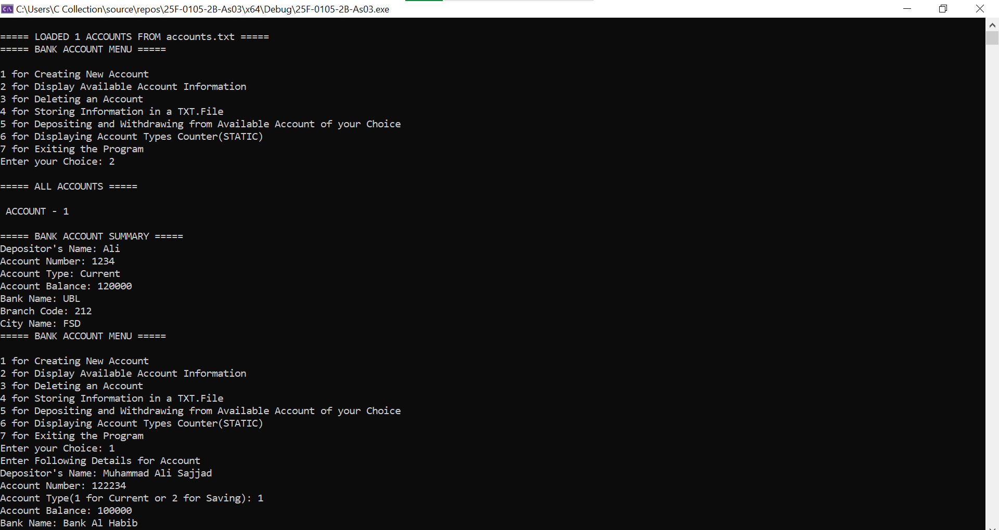
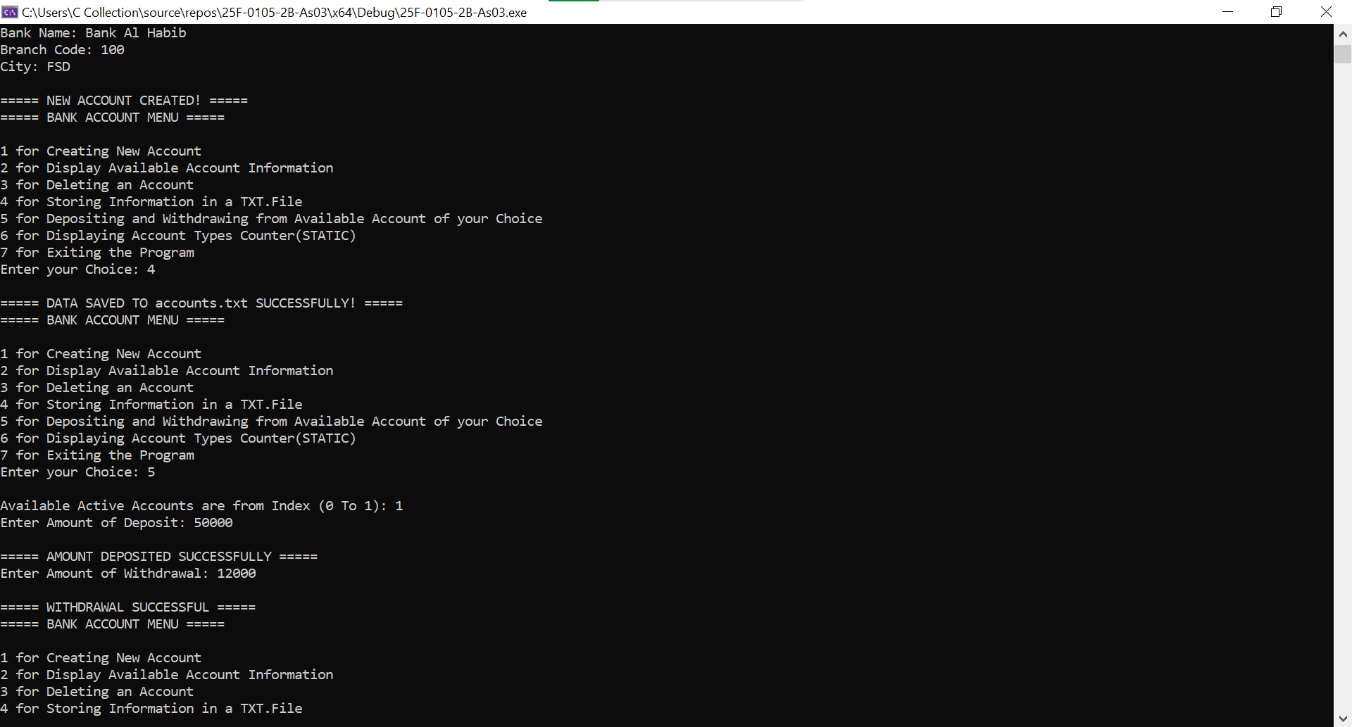
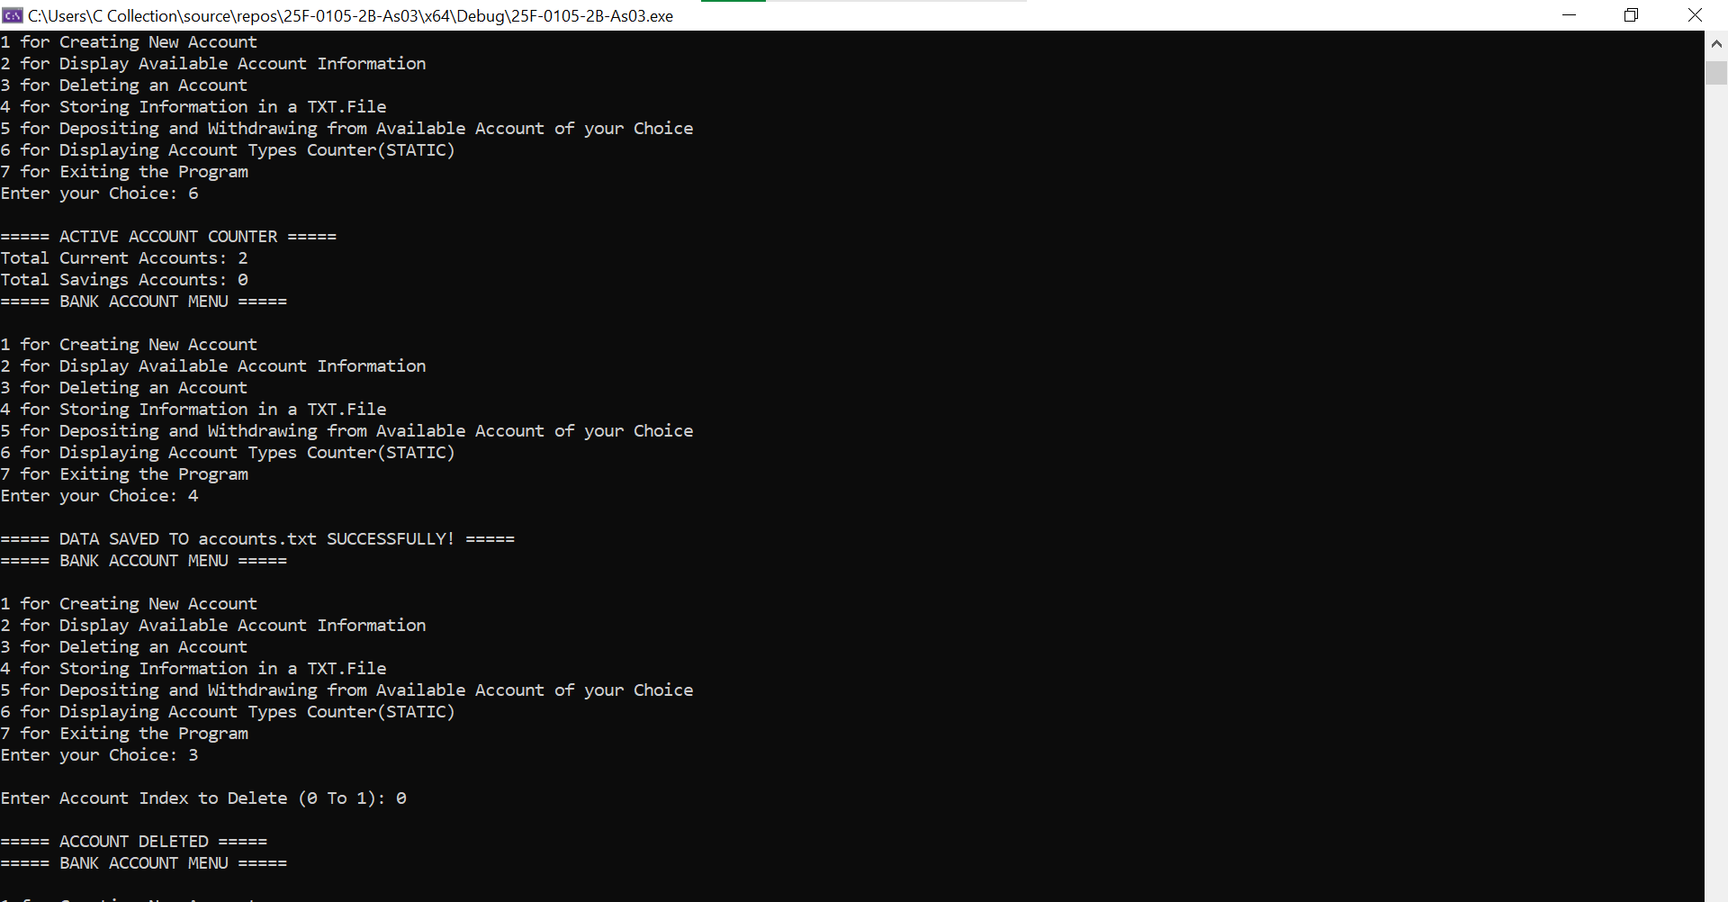
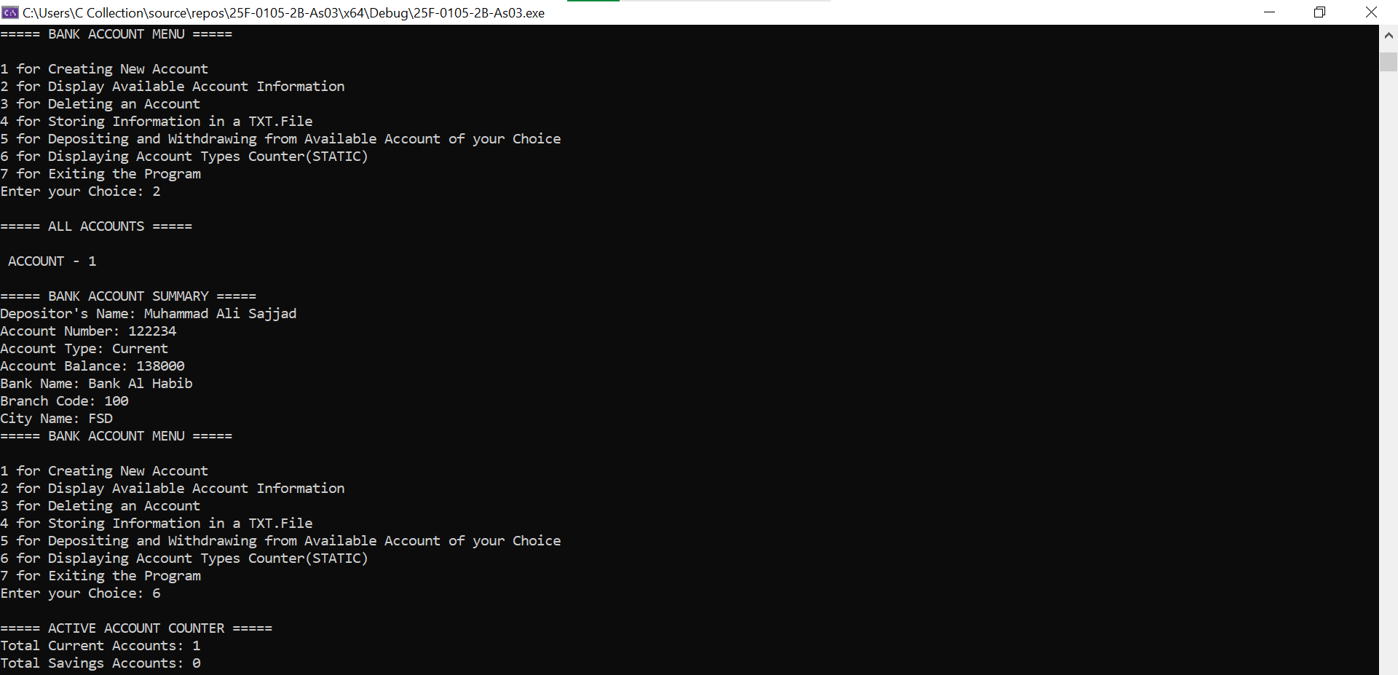
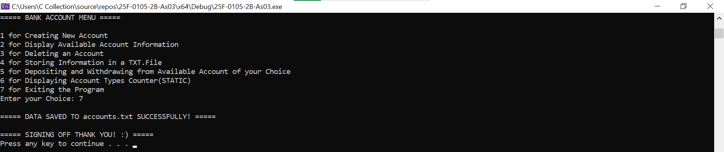
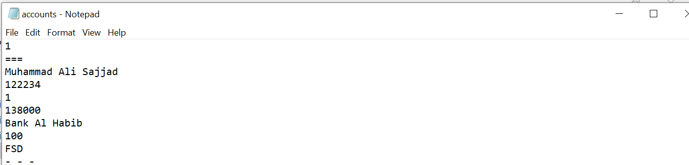

Q#02:

#include<iostream>
using namespace std;

class HotDogStand
{
private:
int ID;
int dayTotalSale;

public:
static int totalSales;
static int currentObj;//Just for making the Objects specific

HotDogStand()
{
cout << "Enter Details for Object-" << currentObj << ":\n";
cout << "Enter Hot Dog Stand's ID: ";
cin >> ID;
cin.ignore();
cout << "Total Hot Dogs Sales of the Day: ";
cin >> dayTotalSale;
cin.ignore();
cout << endl;
totalSales += dayTotalSale;
currentObj++;
}

void justSold()
{
dayTotalSale++;
totalSales++;
cout << "\n===== HOT DOG SOLD ALERT! =====\n";
}

int oneStandSales()
{
return dayTotalSale;
}

static int overallSales()
{
return totalSales;
}
};

int HotDogStand::totalSales = 0;
int HotDogStand::currentObj = 1;

int main()
{
cout << "===== MENU-DRIVEN HOT DOG STAND PROGRAM =====\n";
HotDogStand obj[3];

for (int i = 0; i < 3; i++)
{

int choice;
bool exit = false;
do
{
cout << "\n===== HOT DOG STAND (MENU) for Stand # "<<i+1<<" =====\n";
cout << "1 for Adding a Sale\n";
cout << "2 for Displaying Total Sales of a Single Hot Dog Stand\n";
cout << "3 for Displaying Overall Sales of all Hot Dog Stands\n";
cout << "4 to Exit\n";
cout << "Enter your Choice: ";
cin >> choice;
cin.ignore();

switch (choice)
{
case 1:
{
obj[i].justSold();
break;
}
case 2:
{
cout << "\nTotal Sales of a Single Hot Dog Stand: " << obj[i].oneStandSales() << endl;
break;
}
case 3:
{
cout << "\nOverall Sales of All Hot Dog Stands: " << obj[i].overallSales() << endl;
break;
}
case 4:
{
exit = true;
cout << "\n===== THANK FOR YOUR PURCHASE FROM STAND # " << i + 1 << " :) =====\n";
break;
}
default:
{
cout << "\nInvalid Choice\n";
}
}

} while (!exit);
}

system("pause");
return 0;

}

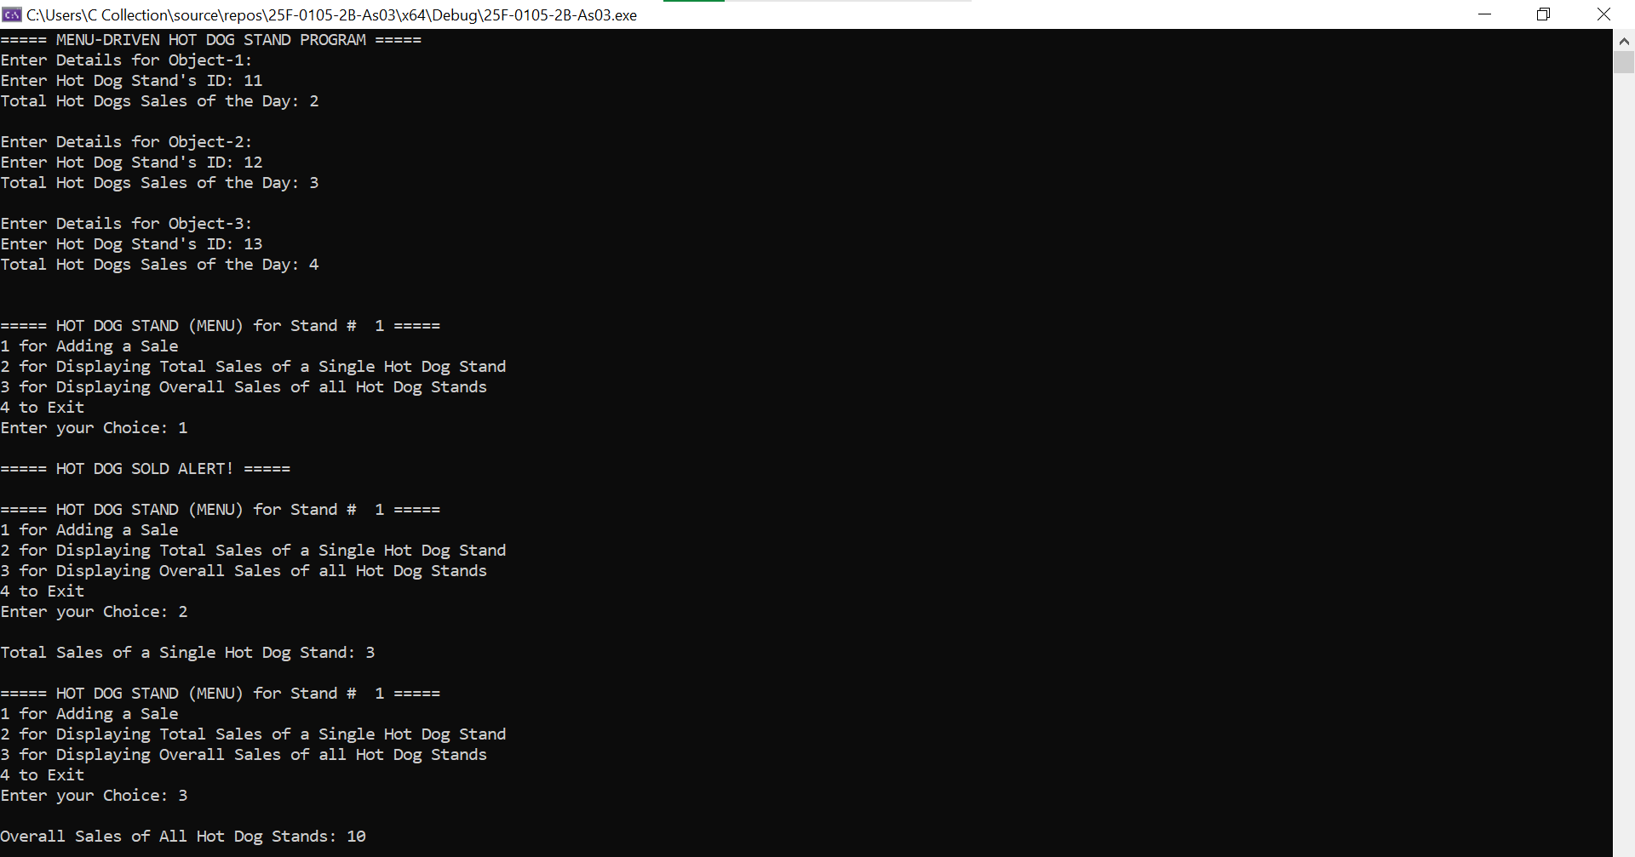
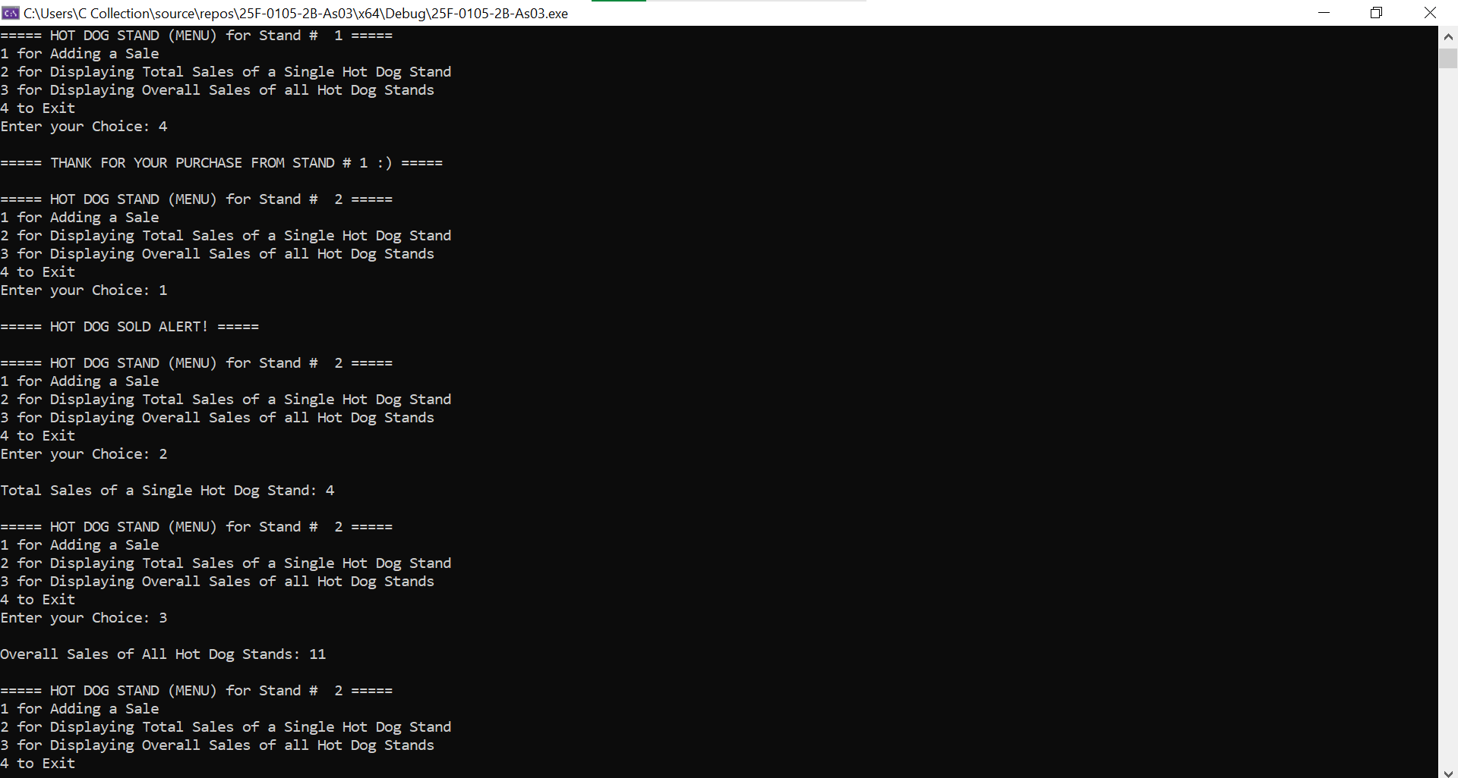
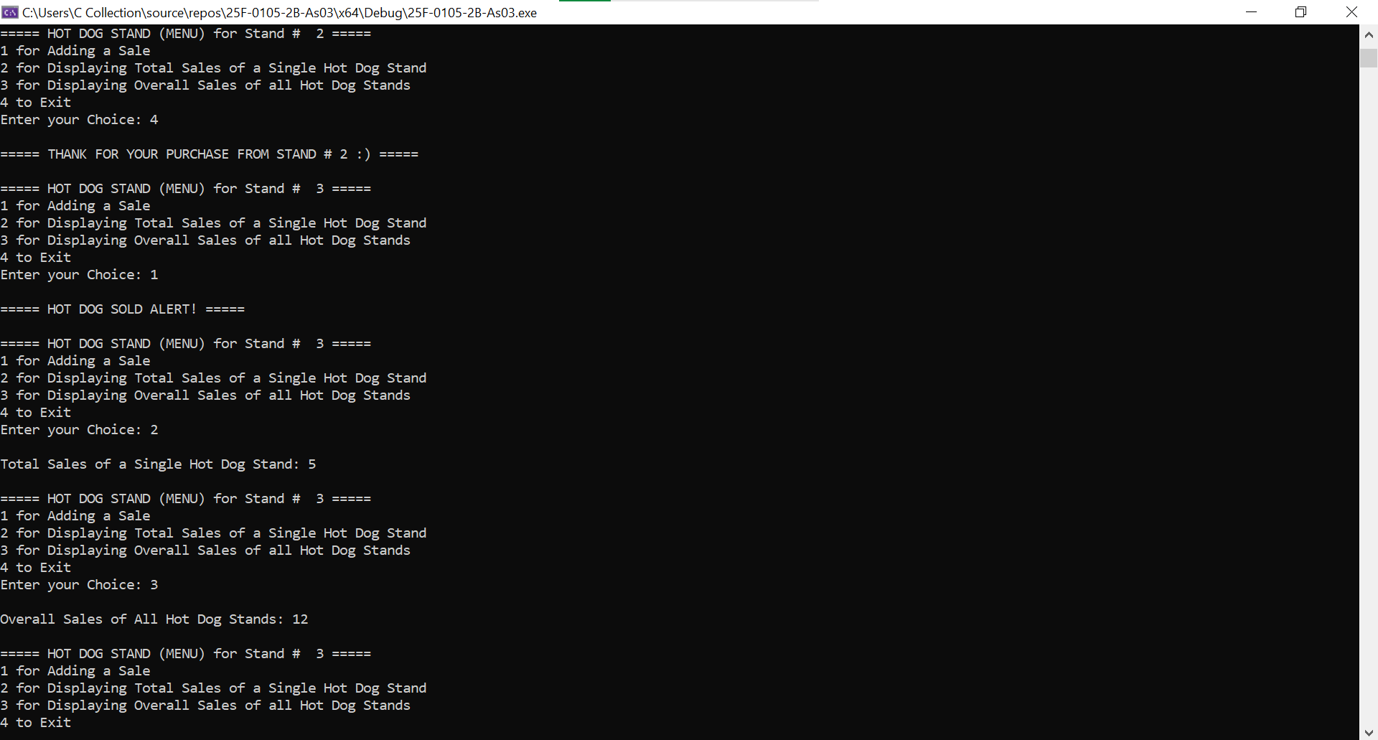
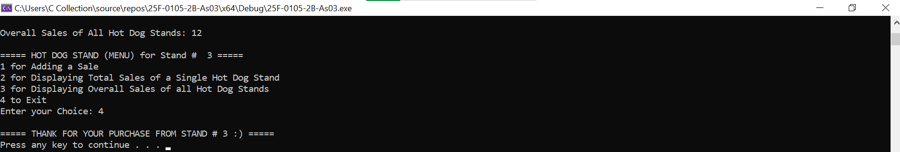

Q#04:

#include<iostream>
#include<string>
using namespace std;

class Tollbooth
{
private:
int carTotal;
double moneyCollected;

public:
Tollbooth()
{
carTotal = 0;
moneyCollected = 0;
}
void payingCar()
{
carTotal++;
moneyCollected += 50;
}
void noPayCar()
{
carTotal++;
}
void display() const//Const- so the values of objects remeins same
{
cout << "\n===== TOLLBOOTH SUMMARY =====\n";
cout << "Total Number of Cars: " << carTotal;
cout << "\nTotal Amount of Money Collected: " << moneyCollected << "\n\n";
}
};

int main()
{
Tollbooth t1;
bool exit = false;//for Menu-Driven Program
int choice;
do
{
cout << "===== TOLLBOOTH PROGRAM =====\n";
cout << "1 for Counting a Paying Car\n";
cout << "2 for Counting a Non-Paying Car\n";
cout << "3 for Displaying Tollbooth Summary\n";
cout << "4 to Exit\n";
cout << "Enter your Choice: ";
cin >> choice;
cin.ignore();

switch (choice)
{
case 1:
{
t1.payingCar();
break;
}
case 2:
{
t1.noPayCar();
break;
}
case 3:
{
t1.display();
break;
}
case 4:
{
exit = true;
cout << "\nExiting Program\n";
break;
}
default:
cout << "ERROR! Invalid Choice\n";
}

} while (!exit);
cout << "\n===== THANK YOU! :) =====\n";

system("pause");
return 0;
}

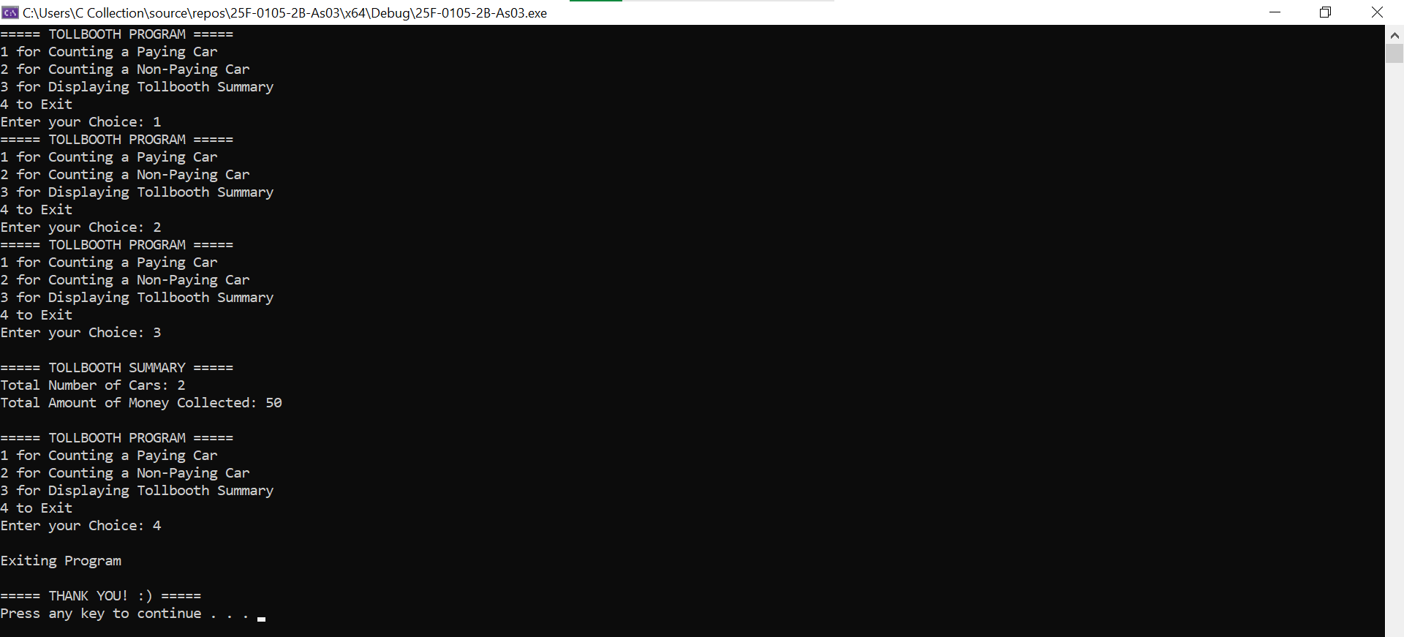

Q#05:

#include<iostream>
#include<string>
using namespace std;

int i = 0;//Global Variable-using it to manage the "for-loop"

class Time
{
private:
int hours;
int minutes;
int seconds;

public:
Time()
{
hours = 0;
minutes = 0;
seconds = 0;
}
Time(int hours, int minutes, int seconds)
{
this->hours = hours;
this->minutes = minutes;
this->seconds = seconds;
}
void addTime(Time t1, Time t2)
{
int sec, min, hr;
sec = t1.seconds + t2.seconds;
min = t1.minutes + t2.minutes;
hr = t1.hours + t2.hours;
while (sec > 60)
{
t1.minutes++;//Just adding '1-minute' to t1 only to cater overflow condition and not to 't2' because t1 and t2 would get added simultaneously to acquire 't3'
sec -= 60;
}
seconds = sec;
while (min > 60)
{
t1.hours++;//Just adding '1-minute' to t1 only to cater overflow condition and not to 't2' because t1 and t2 would get added simultaneously to acquire 't3'
min -= 60;
}
minutes = min;
while (hr > 12)
{
hr-=12;//To show in "12-Hour Format" as mentioned in question.
}
hours = hr;
}
void display() const //Making Display Function constant because it would stop from changing the object's value.
{
cout << "\n===== TIME INFO =====\n";
cout <<hours << ":" << minutes << ":" <<seconds << "\n\n";
}
};

int main()
{
int hours[2];
int minutes[2];
int seconds[2];

for (i = 0; i < 2; i++)
{
cout<<"Enter Time for Object - " << i + 1 << ":\n";
cout << "Hours: ";
cin >> hours[i];
cout << "Minutes: ";
cin >> minutes[i];
cout << "Seconds: ";
cin >> seconds[i];
}
//Yes, these two Time-Objects should be Const because it would make the data stored in these objects unchangeable.
const Time t1(hours[0], minutes[0], seconds[0]);
const Time t2(hours[1], minutes[1], seconds[1]);

Time t3;
t3.addTime(t1, t2);
t3.display();

system("pause");
return 0;
}

