Assignment 3
Question 1)
#include<iostream>
#include<fstream>
#include<cstring>
using namespace std;

enum Type { Current, Saving };

class BankAccount
{
private:
char depositerName[20];
char account[20];
Type type;
double balance;
static char bankName[20];
char branchCode[20];
char city[20];
static unsigned int current;
static unsigned int savings;

public:
BankAccount()
{
strcpy_s(depositerName, "Unknown");
strcpy_s(account, "Unknown");
type = Saving;
balance = 0;
strcpy_s(branchCode, "Unknown");
strcpy_s(city, "Unknown");
}

BankAccount(char name[20], char acc[20], Type t, double bal, char code[20], char c[20])
{
strcpy_s(depositerName, name);
strcpy_s(account, acc);
type = t;
balance = bal;
strcpy_s(branchCode, code);
strcpy_s(city, c);

if (type == Current)
{
current++;
}
else
{
savings++;
}
}

static void setBankName()
{
cout << "Enter Bank Name: ";
cin.getline(bankName, 20);
}

static void getAccCounts()
{
cout << "\nBank Name: " << bankName << endl;
cout << "Current Accounts: " << current << endl;
cout << "Saving Accounts: " << savings << endl;
}

void deposit(double amount)
{
balance += amount;
}

const char* getAccNumber()
{
return account;
}

void withdraw(double amount)
{
if (amount <= balance)
balance -= amount;
else
cout << "Insufficient balance\n";
}

void display()
{
cout << "\nName: " << depositerName << endl;
cout << "Account No: " << account << endl;
cout << "Bank: " << bankName << endl;
cout << "City: " << city << endl;
cout << "Balance: " << balance << endl;
cout << "Type: " << (type == Current ? "Current" : "Saving") << endl;
}

void save(ofstream& write)
{
write << depositerName << endl;
write << account << endl;
write << type << endl;
write << balance << endl;
write << bankName << endl;
write << branchCode << endl;
write << city << endl;
}

void load(ifstream& read)
{
read.getline(depositerName, 20);
read.getline(account, 20);

int t;
read >> t;
type = (t == 0) ? Current : Saving;

read >> balance;
read.ignore();

read.getline(bankName, 20);
read.getline(branchCode, 20);
read.getline(city, 20);

if (type == Current)
current++;
else
savings++;
}
};

char BankAccount::bankName[20] = "Unknown";
unsigned int BankAccount::current = 0;
unsigned int BankAccount::savings = 0;

int main()
{
BankAccount* accounts[100] = { nullptr };
int count = 0;

ifstream read("accounts.txt");
if (read)
{
while (!read.eof() && count < 100)
{
BankAccount* temp = new BankAccount;
temp->load(read);

if (read.fail())
{
delete temp;
break;
}

accounts[count++] = temp;
}
read.close();
}

BankAccount::setBankName();

int choice;

do {
cout << "\n1. Create Account";
cout << "\n2. Display All Accounts";
cout << "\n3. Deposit";
cout << "\n4. Withdraw";
cout << "\n5. Delete Account";
cout << "\n6. Show Counts";
cout << "\n7. Exit\n";
cin >> choice;

switch (choice)
{
case 1:
{
if (count >= 100)
{
cout << "Limit reached!\n";
break;
}

char name[20], acc[20], branch[20], city[20];
double bal;
int t;

cout << "Enter Name: ";
cin.ignore();
cin.getline(name, 20);
cout << "Enter Account Number: ";
cin.getline(acc, 20);
cout << "Enter Type (0=Current, 1=Saving): ";
cin >> t;
cout << "Enter Balance: ";
cin >> bal;
cin.ignore();
cout << "Enter Branch Code: ";
cin.getline(branch, 20);
cout << "Enter City: ";
cin.getline(city, 20);

accounts[count++] = new BankAccount( name, acc, (Type)t, bal, branch, city );
break;
}
case 2:
for (int i = 0; i < count; i++)
{
accounts[i]->display();
}
break;
case 3:
{
char acc[20];
double amt;
cout << "Enter Account Number: ";
cin >> acc;

for (int i = 0; i < count; i++)
{
if (strcmp(accounts[i]->getAccNumber(), acc) == 0)
{
cout << "Enter amount: ";
cin >> amt;
accounts[i]->deposit(amt);
}
}
break;
}
case 4:
{
char acc[20];
double amt;
cout << "Enter Account Number: ";
cin >> acc;

for (int i = 0; i < count; i++)
{
if (strcmp(accounts[i]->getAccNumber(), acc) == 0)
{
cout << "Enter amount: ";
cin >> amt;
accounts[i]->withdraw(amt);
}
}
break;
}
case 5:
{
char acc[20];
cout << "Enter Account Number to delete: ";
cin >> acc;

for (int i = 0; i < count; i++)
{
if (strcmp(accounts[i]->getAccNumber(), acc) == 0)
{
delete accounts[i];

for (int j = i; j < count - 1; j++)
accounts[j] = accounts[j + 1];

accounts[count - 1] = nullptr;
count--;

cout << "Account Deleted!\n";
break;
}
}
break;
}
case 6:
BankAccount::getAccCounts();
break;
case 7:
cout << "Exiting...\n";
break;
default:
cout << "Invalid choice!\n";
}
} while (choice != 7);

ofstream write("accounts.txt");
for (int i = 0; i < count; i++)
{
accounts[i]->save(write);
}

write.close();

for (int i = 0; i < count; i++)
{
delete accounts[i];
}

system("pause");
return 0;
}
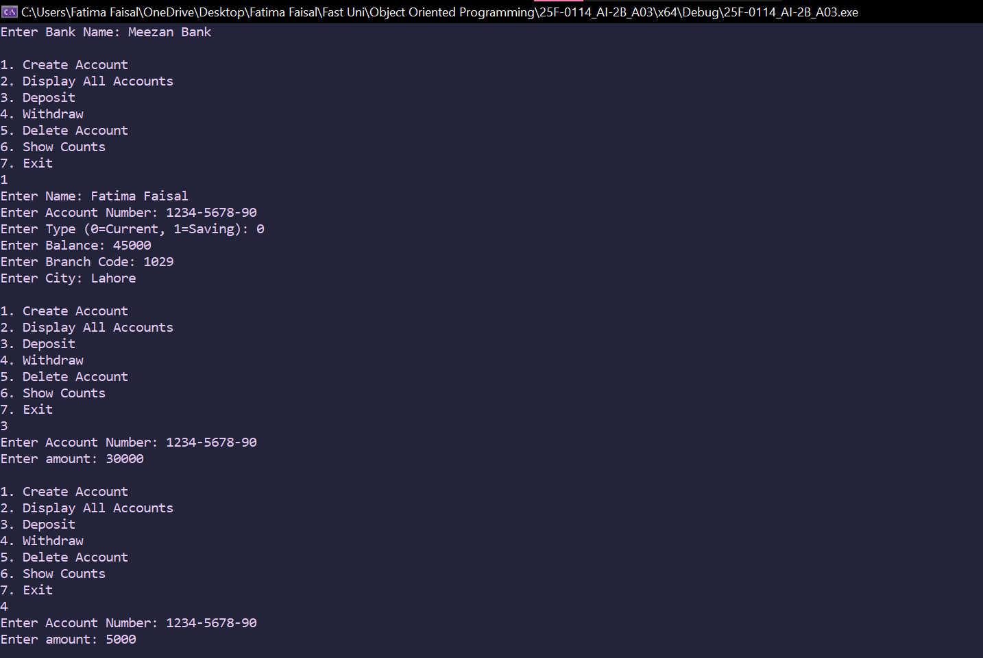
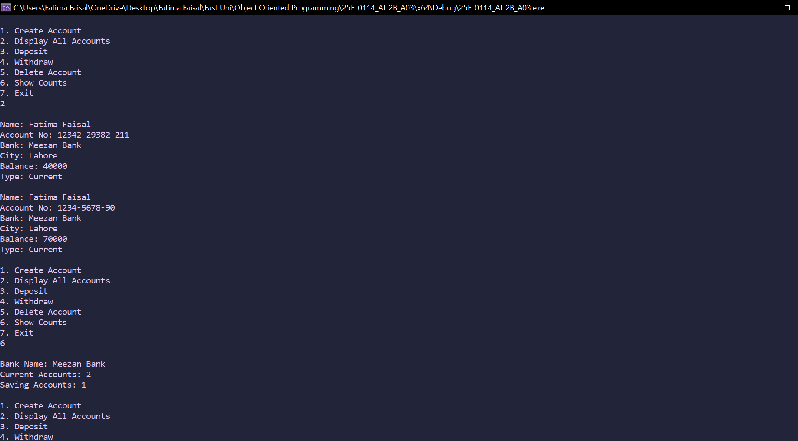
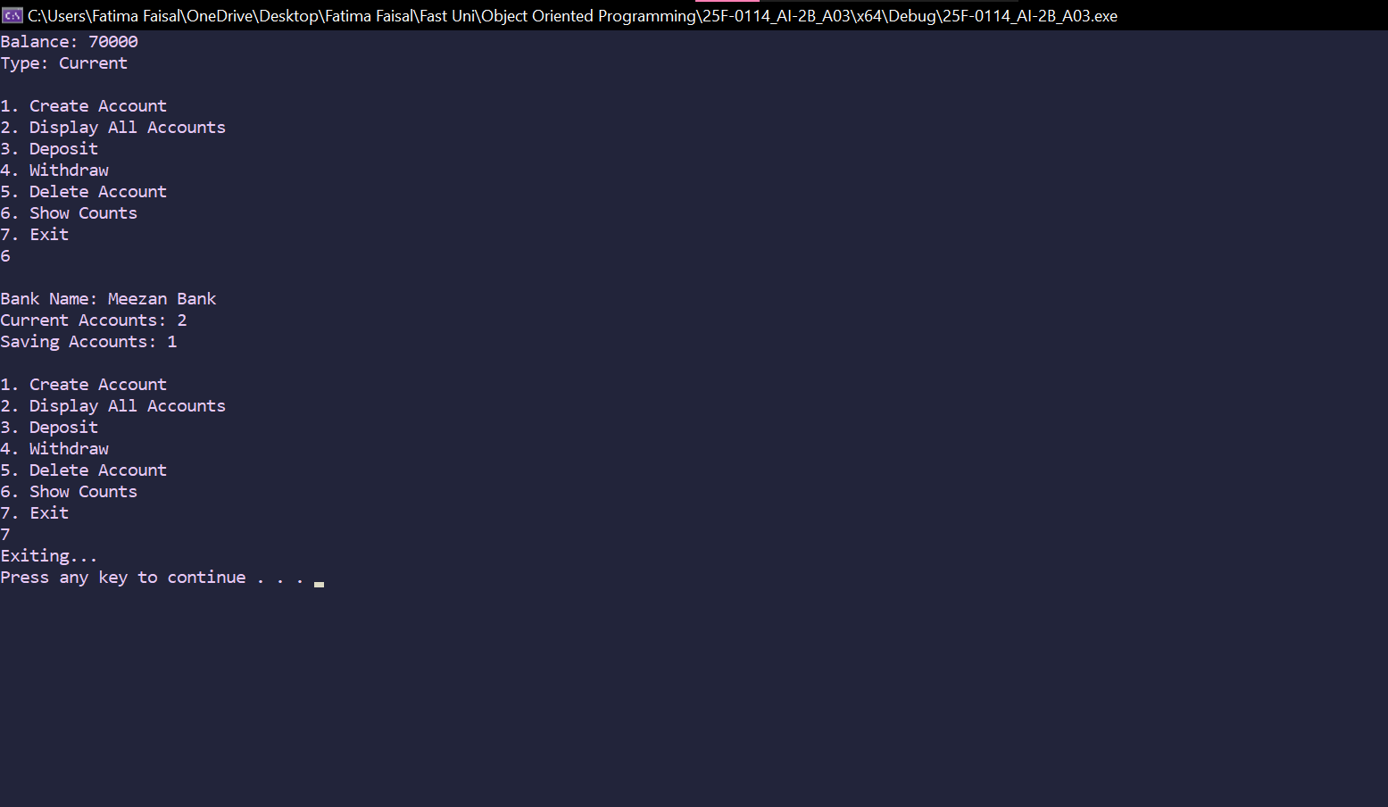
Question 2)
#include<iostream>
using namespace std;

class HotDogStand
{
private:
int id;
int sold;
static int total;
public:
HotDogStand(int i, int s)
{
id = i;
sold = s;
total += sold;
}

void justSold()
{
sold++;
total++;
}

int returnSold()
{
return sold;
}

static int returnTotal()
{
return total;
}
};

int HotDogStand::total = 0;

int main()
{
HotDogStand stand1(001, 0);
HotDogStand stand2(002, 0);
HotDogStand stand3(003, 0);

stand1.justSold();
stand1.justSold();
stand1.justSold();
stand2.justSold();
stand3.justSold();
stand3.justSold();

cout << "Stand 1 sold " << stand1.returnSold() << " today\n";
cout << "Stand 2 sold " << stand2.returnSold() << " today\n";
cout << "Stand 3 sold " << stand3.returnSold() << " today\n";

cout << "Total hot dogs sold by all stands: " << HotDogStand::returnTotal() << endl;

system("pause");
return 0;
}
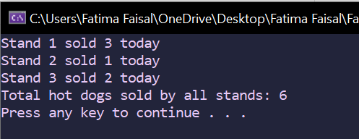

Question 3)
#include<iostream>
#include<string>
#include<fstream>
using namespace std;

struct Student
{
string name;
string cnic;
string gender;
float cgpa;
};

class Sections
{
private:
Student students[40];
string section;
string classTeacher;
int count = 0;

public:
void editSection()
{
cout << "Enter new section: ";
cin >> section;
cout << "Enter class teacher:";
cin >> classTeacher;
}

void addStudent()
{
cin.ignore();
if (count >= 40)
{
cout << "Section is full\n";
return;
}

cout << "Enter Name: ";
getline(cin, students[count].name);

cout << "Enter CNIC: ";
getline(cin, students[count].cnic);

cout << "Enter Gender: ";
getline(cin, students[count].gender);

cout << "Enter CGPA: ";
cin >> students[count].cgpa;
cin.ignore();

count++;
}

void updateStudent()
{
cin.ignore();
string Cnic;
cout << "Enter CNIC of student to update: ";
getline(cin, Cnic);

for (int i = 0; i < count; i++)
{
if (students[i].cnic == Cnic)
{
cout << "Enter New Name: ";
getline(cin, students[i].name);

cout << "Enter New Gender: ";
getline(cin, students[i].cnic);

cout << "Enter New CGPA: ";
getline(cin, students[i].gender);

return;
}
}

cout << "Student is not found\n";
}

void printList()
{
cout << "\n==== Student Details ====\n";
cout << "\nSection: " << section << endl;
cout << "Teacher: " << classTeacher << endl;

for (int i = 0;i < count;i++)
{
cout << "\nStudent " << i + 1 << endl;
cout << "Name: " << students[i].name << endl;
cout << "CNIC: " << students[i].cnic << endl;
cout << "Gender: " << students[i].gender << endl;
cout << "CGPA: " << students[i].cgpa << endl;
}
}

string getSection() const
{
return section;
}

void save(ofstream& write)
{
write << section << endl;
write << classTeacher << endl;
write << count << endl;

for (int i = 0; i < count; i++)
{
write << students[i].name << endl;
write << students[i].cnic << endl;
write << students[i].gender << endl;
write << students[i].cgpa << endl;
}
}

void open(ifstream& read)
{
getline(read, section);
getline(read, classTeacher);
read >> count;
read.ignore();

for (int i = 0; i < count; i++)
{
getline(read, students[i].name);
getline(read, students[i].cnic);
getline(read, students[i].gender);
read >> students[i].cgpa;
read.ignore();
}
}
};

int main()
{
int num, choice = 0, index;

cout << "Enter number of sections: ";
cin >> num;

Sections* sections = new Sections[num];

do
{
cout << "\n=== MENU ===\n";
cout << "1. Edit Section\n";
cout << "2. Add Student\n";
cout << "3. Update Student\n";
cout << "4. Print Students\n";
cout << "5. Print Sections\n";
cout << "6. Save to File\n";
cout << "7. Load from File\n";
cout << "8. Exit\n";
cin >> choice;

switch (choice)
{
case 1:
cout << "Enter Section index: ";
cin >> index;
sections[index].editSection();
break;
case 2:
cout << "Enter Section index: ";
cin >> index;
sections[index].addStudent();
break;
case 3:
cout << "Enter Section index: ";
cin >> index;
sections[index].updateStudent();
break;
case 4:
cout << "Enter Section index: ";
cin >> index;
sections[index].printList();
break;
case 5:
for (int i = 0;i < num;i++)
{
cout << "Section " << i + 1 << ":" << sections[i].getSection() << endl;
}
break;
case 6:
{
ofstream write;
write.open("data.txt");
write << num << endl;

for (int i = 0;i < num;i++)
{
sections[i].save(write);
}

write.close();
break;
}
case 7:
{
ifstream read;
read.open("data.txt");
read >> num;
read.ignore();

delete[] sections;
sections = new Sections[num];

for (int i = 0;i < num;i++)
{
sections[i].open(read);
}

read.close();
break;
}
case 8:
cout << "Exiting...\n";
break;
default:
cout << "Invalid Choice\n";
}
} while (choice != 8);

delete[] sections;

system("pause");
return 0;
}
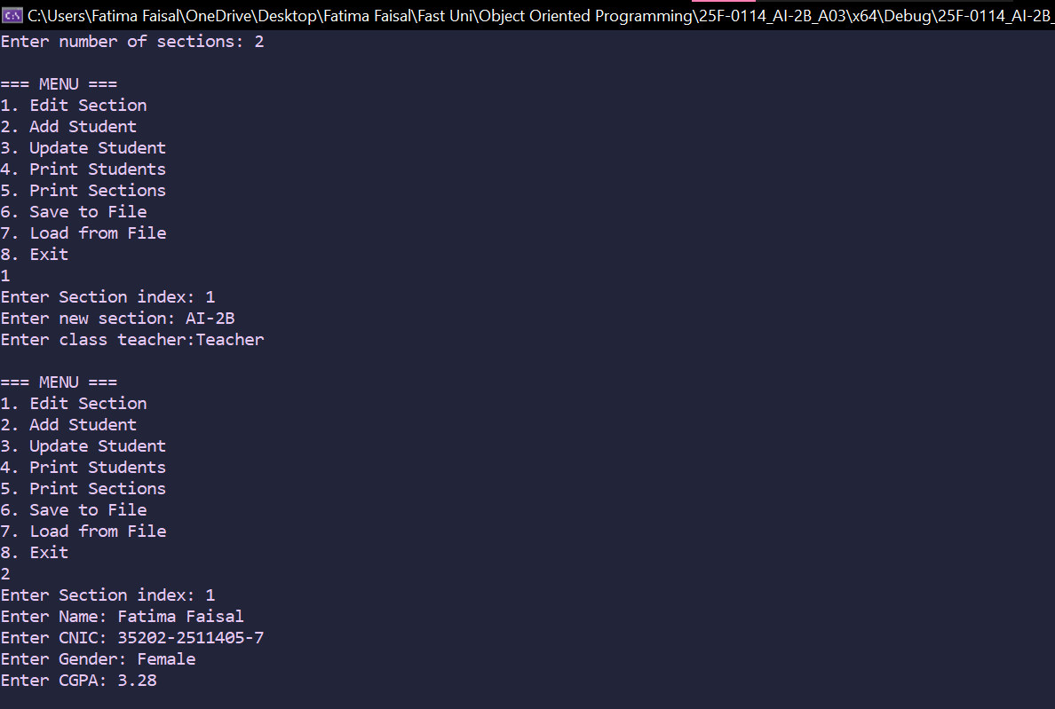
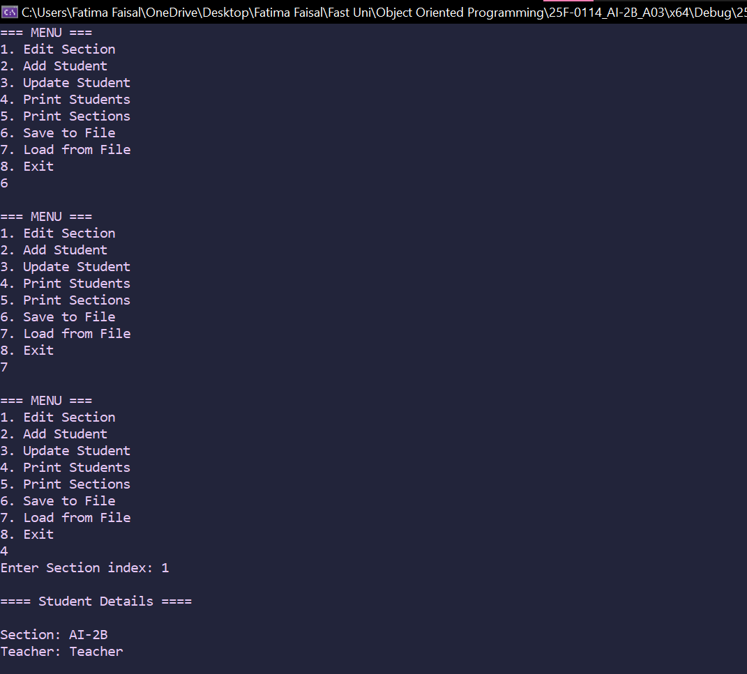
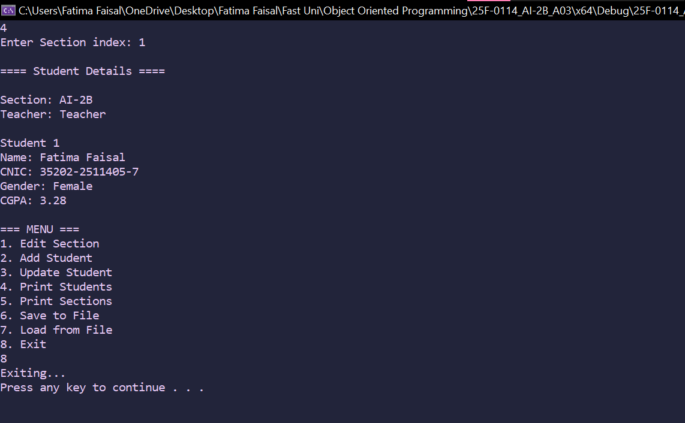
Question 4)
#include<iostream>
using namespace std;

class Tollbooth
{
private:
unsigned int total;
double amount;
public:
Tollbooth()
{
total = 0;
amount = 0;
}

void payingCar()
{
total++;
amount += 50;
}

void noPayCar()
{
total++;
}

void display() const
{
cout << "\nTotal Cars: " << total << endl;
cout << "Total Cash: " << amount << endl;
}
};

int main()
{
Tollbooth b1;
int choice;

do
{
cout << "\n=== Toll Booth Menu ===\n";
cout << "1. To count paying cars\n";
cout << "2. To count Non-paying cars\n";
cout << "3. To print the total cars and total cash\n";
cout << "4. To Exit\n";
cin >> choice;

switch (choice)
{
case 1:
b1.payingCar();
break;
case 2:
b1.noPayCar();
break;
case 3:
b1.display();
break;
case 4:
cout << "Exiting...\n";
break;
default:
cout << "Invalid number, Try again\n";
}
} while (choice != 4);

system("pause");
return 0;
}
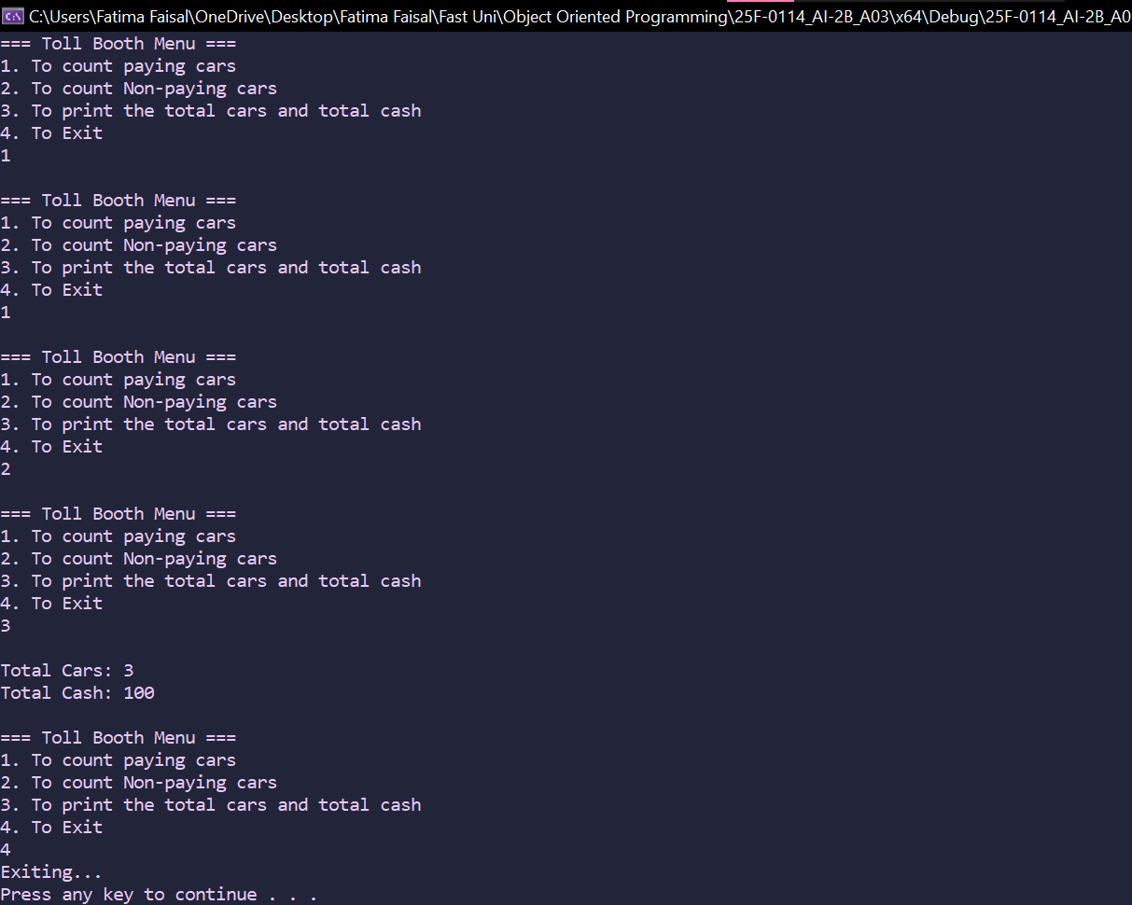
Question 5)
#include<iostream>
using namespace std;

class Time
{
private:
int hours;
int minutes;
int seconds;

public:
Time()
{
hours = 0;
minutes = 0;
seconds = 0;
}

Time(int hour, int min, int sec)
{
hours = hour;
minutes = min;
seconds = sec;
}

void display() const
{
cout << hours << ":" << minutes << ":" << seconds << endl;
}

void addTime(Time t1, Time t2)
{
seconds = t1.seconds + t2.seconds;
minutes = t1.minutes + t2.minutes;
hours = t1.hours + t2.hours;

if (seconds >= 60)
{
minutes = minutes + seconds / 60;
seconds = seconds % 60;
}

if (minutes >= 60)
{
hours = hours + minutes / 60;
minutes = minutes % 60;
}
}
};

int main()
{
const Time t1(12, 59, 30);
const Time t2(2, 30, 10);
Time t3;

t3.addTime(t1, t2);

cout << "Result: ";
t3.display();

return 0;
}
