Task 1:
#include <iostream>
#include <fstream>
#include <string>
using namespace std;
enum Type { Saving, Current };
class Account
{
private:
string name;
string acc_num;
Type type;
double cur_bal;
string bank_name;
string branch_code;
string city;
static int cur_count;
static int sav_count;
public:
Account()
{
name = "Account Holder Name";
acc_num = "123456789";
type = Current;
cur_bal = 10000;
bank_name = "Bank";
branch_code = "Branch";
city = "City";
}
Account(string a, string b, Type c, double d, string e, string f, string g)
{
name = a;
acc_num = b;
type = c;
cur_bal = d;
bank_name = e;
branch_code = f;
city = g;
if (c == 1)
sav_count++;
else
cur_count++;
}
static void getAccCounts()
{
cout << "\nCount of Current Accounts: " << cur_count;
cout << "\nCount of Saving Accounts: " << sav_count;
}
void deposit(double input)
{
cur_bal += input;
cout << "\nDeposit Succesful";
}
string getAccount()
{
return acc_num;
}
void setValues()
{
int n;
cin.ignore();
cout << "Enter account holder name: ";
getline(cin, name);
cout << "Enter account number: ";
getline(cin, acc_num);
cout << "Enter account type (1 for saving, 2 for current): ";
cin >> n;
if (n == 1)
type = Saving;
else
type = Current;
cout << "Enter Current Balance: ";
cin >> cur_bal;
cin.ignore();
cout << "Enter bank name: ";
getline(cin, bank_name);
cout << "Enter branch code: ";
getline(cin, branch_code);
cout << "Enter city: ";
getline(cin, city);
}
void withdraw(double withdraw)
{
if (cur_bal > withdraw)
cout << "\nWithdraw amount is grater than current available balance.";
else
{
cur_bal -= withdraw;
cout << "\nWithdraw Succesful.";
}
}
void display()
{
cout << "\nHolder Name: " << name;
cout << "\nBank Name: " << bank_name;
cout << "\nCity: " << city;
cout << "\nCurrent Account Balance: " << cur_bal << endl;
}
void deleteAccount()
{
name = "Account Holder Name";
acc_num = "123456789";
type = Current;
cur_bal = 10000;
bank_name = "Bank";
branch_code = "Branch";
city = "City";
}
void balanceAccountType()
{
if (type == 0)
sav_count--;
else
cur_count--;
}
void shiftAccounts(Account* ptr[], int n)
{
for (int i = n; i < 99; i++)
{
ptr[i]->name = ptr[i + 1]->name;
ptr[i]->acc_num = ptr[i + 1]->acc_num;
ptr[i]->type = ptr[i + 1]->type;
ptr[i]->cur_bal = ptr[i + 1]->cur_bal;
ptr[i]->bank_name = ptr[i + 1]->bank_name;
ptr[i]->branch_code = ptr[i + 1]->branch_code;
ptr[i]->city = ptr[i + 1]->city;
}
ptr[99]->deleteAccount();
}
void load(string name, string acc_num, string temp, double cur_bal, string bank_name, string branch_chode, string city)
{
this->name = name;
this->acc_num = acc_num;
if (temp == "0")
{
this->type = Saving;
sav_count++;
}
else
{
this->type = Current;
cur_count++;
}
this->cur_bal = cur_bal;
this->bank_name = bank_name;
this->branch_code = branch_chode;
this->city = city;
}
void store()
{
ofstream fout;
fout.open("accounts.txt", ios::app);
fout << name << endl << acc_num << endl << type << endl << cur_bal << endl << bank_name << endl << branch_code << endl << city << endl;
}
};
int Account::cur_count = 0;
int Account::sav_count = 0;
int main()
{
ifstream fin;
ofstream fout;
bool f1, f2, f3, f4;
f1 = f2 = f3 = f4 = false;
int i = 0;
string t1, t2, t3;
Account* ptr[100];
for (int i = 0; i < 100; i++)
ptr[i] = new Account;
fin.open("accounts.txt", ios::in);
for (int i = 0; i < 100; i++) //loading from file
{
string name, acc_num, temp, bank_name, branch_code, city;
double cur_bal;
getline(fin, name);
getline(fin, acc_num);
getline(fin, temp);
fin >> cur_bal;
fin.ignore(numeric_limits<streamsize>::max(), '\n');
getline(fin, bank_name);
getline(fin, branch_code);
getline(fin, city);
//cout << endl << name << " " << acc_num << " " << temp << " " << cur_bal << " " << bank_name << " " << branch_code << " " << city << endl; //for debugging
ptr[i]->load(name, acc_num, temp, cur_bal, bank_name, branch_code, city);
}
fin.close();
int choice; //menu-driven system
do {
cout << "\n1. Create A New Account\n2. Deposit Money\n3. Withdraw Money\n4. Display Total Account Type Count\n5. Display Selected Account Details\n6. Display All Account Details\n7. Delete Current Account\n8. Exit\nEnter Choice: ";
cin >> choice;
switch (choice)
{
case 1:
for (i = 0; i < 100; i++)
{
t1 = ptr[i]->getAccount();
if (t1 == "123456789")
{
f1 = true;
break;
}
else
f1 = false;
}
if (f1 == true)
ptr[i]->setValues();
else
cout << "\nNo Space Available.";
break;
case 2:
cin.ignore();
cout << "\nEnter Account Number: ";
getline(cin, t1);
for (int i = 0; i < 100; i++)
{
t2 = ptr[i]->getAccount();
if (t1 == t2)
{
f2 = true;
double amount;
cout << "\nHow much do you want to deposit? ";
cin >> amount;
ptr[i]->deposit(amount);
break;
}
else
continue;
}
if (f2 == true)
cout << "\nDeposited Succesfully.";
else
cout << "\nNo Account Number Found.";
break;
case 3:
cin.ignore();
cout << "\nEnter Account Number: ";
getline(cin, t1);
for (int i = 0; i < 100; i++)
{
t2 = ptr[i]->getAccount();
if (t1 == t2)
{
f3 = true;
double amount;
cout << "\nHow much do you want to withdraw? ";
cin >> amount;
ptr[i]->withdraw(amount);
break;
}
else
continue;
}
if (f3 == true)
cout << "\nWithdrew Succesfully.";
else
cout << "\nNo Account Number Found.";
break;
case 4:
Account::getAccCounts();
break;
case 5:
cin.ignore();
cout << "\nEnter Account Number to Display: ";
getline(cin, t1);
for (int i = 0; i < 100; i++)
{
t2 = ptr[i]->getAccount();
if (t2 == t1)
{
ptr[i]->display();
f4 = true;
break;
}
}
if (f4 == false)
cout << "\nNo Such Account Found.";
break;
case 6:
for (int i = 0; i < 100; i++)
{
t1 = ptr[i]->getAccount();
if (t1 != "123456789")
ptr[i]->display();
else
break;
}
break;
case 7:
cin.ignore();
cout << "\nEnter Account Number That You Want To Delete: ";
getline(cin, t1);
for (int i = 0; i < 100; i++)
{
t2 = ptr[i]->getAccount();
if (t1 == t2)
{
ptr[i]->balanceAccountType();
ptr[i]->deleteAccount();
ptr[i]->shiftAccounts(ptr, i);
break;
}
}
break;
case 8:
cout << "\nExiting: ";
break;
default:
cout << "\nInvalid Choice. Choose Again.";
break;
}
} while (choice != 8);
fout.open("accounts.txt", ios::trunc); //storing
fout.close();
for (int i = 0; i < 100; i++)
ptr[i]->store();
}
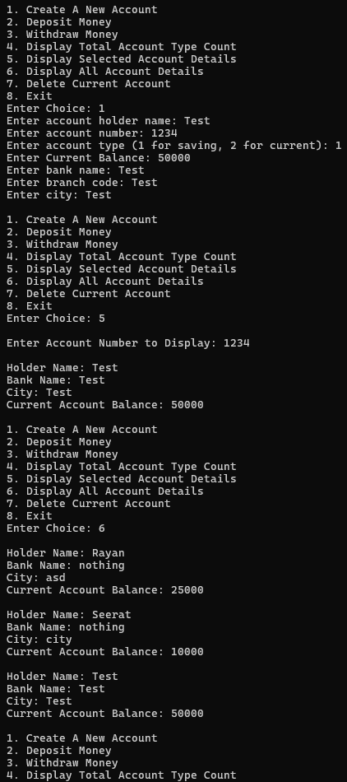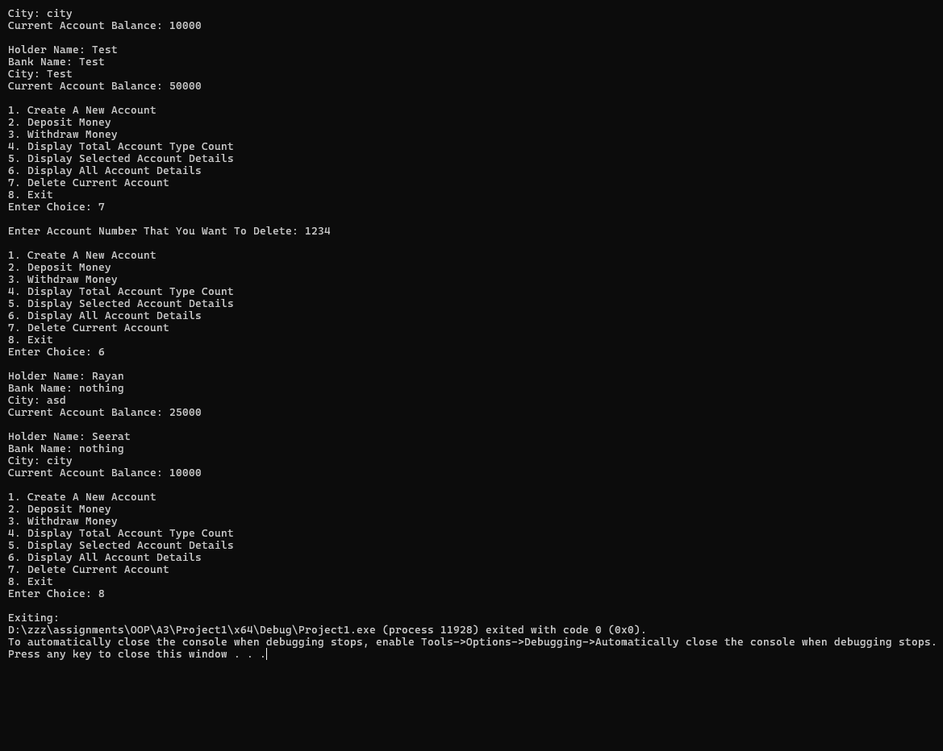

Task 2:
#include <iostream>
using namespace std;
class HotDogStand
{
private:
static int totalSold;
int id;
int sold;
public:
HotDogStand()
{
cout << "\nEnter id of hotdog stand: ";
cin >> id;
cout << "Enter number of hotdogs already sold: ";
cin >> sold;
totalSold += sold;
}
int displayID()
{
return id;
}
void justSold()
{
sold++;
totalSold++;
}
int standSales()
{
return sold;
}
static int TotalSales()
{
return totalSold;
}
};
int HotDogStand::totalSold = 0;

int main()
{
HotDogStand h[3];
int sales, total;
for (int i = 0; i < 3; i++) //Displaying initial values before selling more
{
sales = h[i].standSales();
cout << "\nStand " << h[i].displayID() << " sales are : " << sales;
}
total = HotDogStand::TotalSales();
cout << "\nTotal Sales: " << total;
cout << "\n\nIncreasing sales of each stand by 1....";
for (int i = 0; i < 3; i++)
h[0].justSold();
for (int i = 0; i < 3; i++) //Displaying after values
{
sales = h[i].standSales();
cout << "\nStand " << h[i].displayID() << " sales are : " << sales;
}
total = HotDogStand::TotalSales();
cout << "\nTotal Sales: " << total;
}
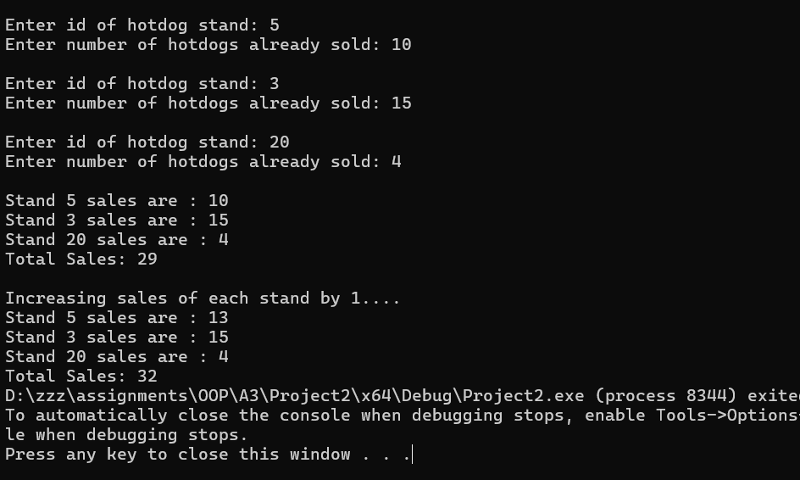
Task 3:
#include <iostream>
#include <fstream>
#include <string>
using namespace std;
struct Student
{
string name;
string cnic;
string gender;
string CGPA;
};

class Section
{
private:
Student s[30];
string sec_name;
string class_teacher;
public:
void secloading(string sect, string teacher)
{
sec_name = sect;
class_teacher = teacher;
}
void stdloading(string name, string cnic, string gender, string cgpa, int index)
{
s[index].name = name;
s[index].cnic = cnic;
s[index].gender = gender;
s[index].CGPA = cgpa;
}
void storing()
{
ofstream fout;
fout.open("data.txt", ios::app);
fout << sec_name << endl << class_teacher << endl;
for (int i = 0; i < 30; i++)
fout << s[i].name << endl << s[i].cnic << endl << s[i].gender << endl << s[i].CGPA << endl;
}
Section() //Only used as an initializer for the file
{
for (int i = 0; i < 30; i++)
{
s[i].name = "student name";
s[i].cnic = "cnic";
s[i].gender = "Z";
s[i].CGPA = "-1";
}
sec_name = "section name";
class_teacher = "class teacher";
}
void editSection()
{
cin.ignore();
cout << "\nEnter Updated Section Name: ";
getline(cin, sec_name);
cout << "Enter Class Teacher: ";
getline(cin, class_teacher);
}
void addStudent()
{
//cin.ignore();
for (int i = 0; i < 30; i++)
{
if (s[i].gender == "Z")
{
cout << "\nEnter name of new student: ";
getline(cin, s[i].name);
cout << "Enter cnic of new student: ";
getline(cin, s[i].cnic);
cout << "Enter gender: ";
getline(cin, s[i].gender);
cout << "Enter CGPA: ";
getline(cin, s[i].CGPA);
break;
}
}
}
void updateStudent()
{
int n;
cout << "Which student do you want to update: ";
cin >> n;
if (n > 30)
{
cout << "\nInvalid Student. Each section only has 30 students each.";
return;
}
cin.ignore();
cout << "\nEnter updated details: ";
cout << "\nName: ";
getline(cin, s[n - 1].name);
cout << "CNIC: ";
getline(cin, s[n - 1].cnic);
cout << "Gender: ";
getline(cin, s[n - 1].gender);
cout << "CGPA: ";
getline(cin, s[n - 1].CGPA);

}
void printList()
{
for (int i = 0; i < 30; i++)
{
cout << "\n\nStudent " << i + 1 << ": ";
if (s[i].gender == "Z")
{
cout << "\nNo Data for this student.\n";
}
else
{
cout << "\nName: " << s[i].name;
cout << "\nCNIC: " << s[i].cnic;
cout << "\nGender: " << s[i].gender;
cout << "\nCGPA: " << s[i].CGPA;
}
}
}
void printSection()
{
if (sec_name == "")
{
cout << "\nNo details for this section.\n";
}
else
{
cout << "\nSection Name: " << sec_name;
cout << "\nClass Teacher: " << class_teacher << endl;
}
}
};

int main()
{
ifstream fin;
ofstream fout;
string sect, teacher, name, cnic, gender, CGPA, waste;
fin.open("data.txt", ios::in);
int choice = 0;
Section* ptr;
int n;
fin >> n; //Inputting number of sections.
fin.ignore();
int sec;
ptr = new Section[n]; //Dynamically allocating memory to the number of sections read from file
int test = 0;
while (!fin.eof()) //Reading from file
{
getline(fin, sect);
getline(fin, teacher);
ptr[test].secloading(sect, teacher);
for (int i = 0; i < 30; i++)
{
getline(fin, name);
getline(fin, cnic);
getline(fin, gender);
getline(fin, CGPA);
ptr[test].stdloading(name, cnic, gender, CGPA, i);
}
test++;
if (test >= n)
break;
}
while (choice != 6)
{
cout << "\n\n1. Edit Section\n2. Add Students\n3. Update Student Data\n4. Print List of Students\n5. Print List of Sections\n6. Save and Exit\nEnter Choice: ";
cin >> choice;
if (choice == 6)
break;
cout << "Enter section: ";
cin >> sec;
if (sec > n)
{
cout << "\nInvalid Section.";
continue;
}
switch (choice)
{
case 1:
ptr[sec - 1].editSection();
break;
case 2:
ptr[sec - 1].addStudent();
break;
case 3:
ptr[sec - 1].updateStudent();
break;
case 4:
ptr[sec - 1].printList();
break;
case 5:
for (int i = 0; i < n; i++)
{
cout << "\nSection " << i + 1 << ": ";
ptr[i].printSection();
}
break;
case 6:
break;
default:
cout << "\nInvalid Choice.";
break;
}
}
cout << "\nEnter updated number of sections: ";
cin >> n;
cout << "\nExiting.";
fout.open("data.txt", ios::trunc);
fout << n << endl;
fout.close();
for (int i = 0; i < n; i++)
ptr[i].storing(); //Storing data in the file at the end.
delete[] ptr;
ptr = nullptr;
}
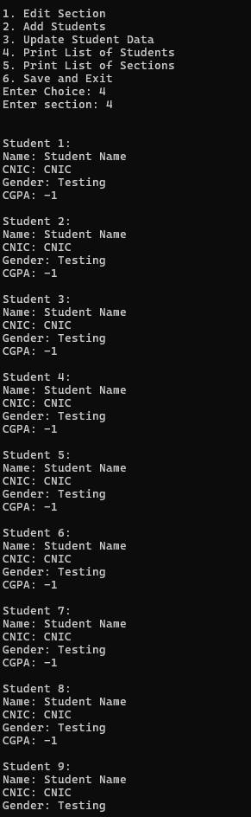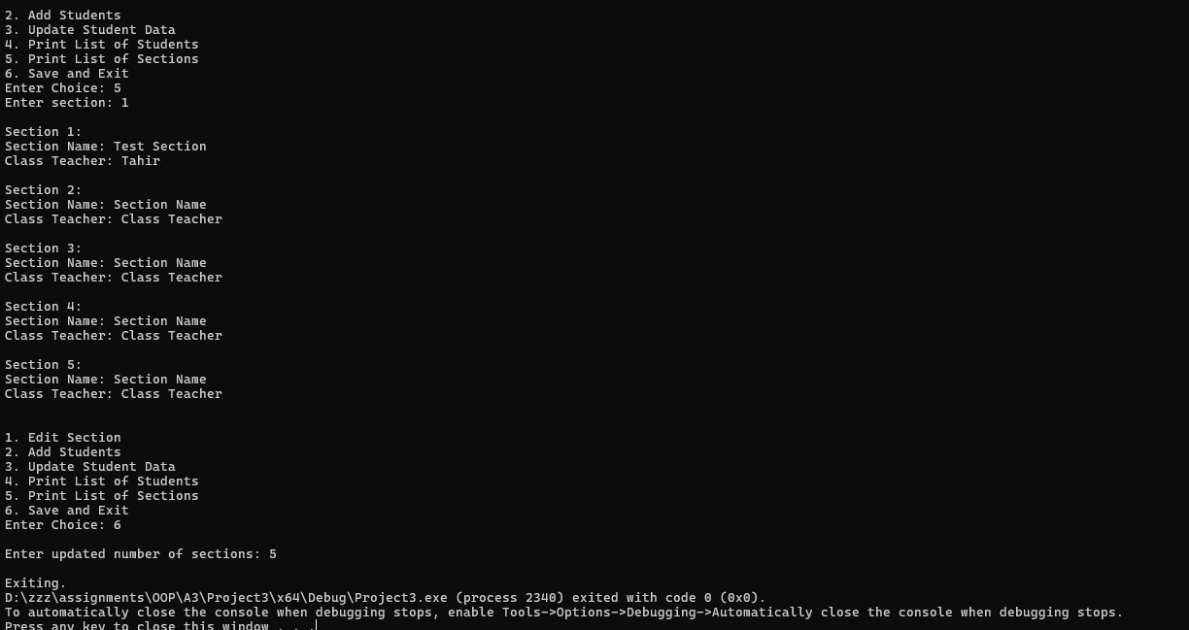

Task 4:
#include <iostream>
using namespace std;
class TollBooth
{
private:
int cars;
double toll;
public:
TollBooth()
{
cars = toll = 0;
}
void payingCar()
{
toll += 50;
cars++;
}
void noPayCar()
{
cars++;
}
void display()
{
cout << "\nTotal Cars Passed: " << cars;
cout << "\nTotal Toll Collected: " << toll;
}
};

int main()
{
int choice = 0;
TollBooth car;
while (choice != 4)
{
cout << "\n1. Paying Car\n2. Non-Paying Car\n3. Display Information\n4. Exit\nEnter your choice: ";
cin >> choice;
switch (choice)
{
case 1:
car.payingCar();
break;
case 2:
car.noPayCar();
break;
case 3:
car.display();
break;
case 4:
cout << "\nExiting.";
break;
default:
cout << "\nInvalid choice.";
}
}
}
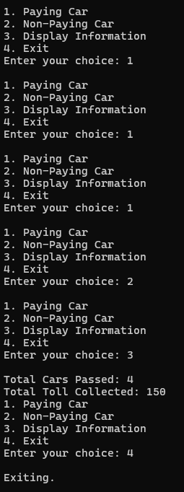
Task 5:
#include <iostream>
using namespace std;
class Time
{
private:
int hours;
int minutes;
int seconds;
public:
Time()
{
hours = minutes = seconds = 0;
}
Time(int a, int b, int c)
{
hours = a;
minutes = b;
seconds = c;
}
void display()
{
cout << hours << ":" << minutes << ":" << seconds;
}
Time add(Time a, Time b)
{
Time temp;
temp.hours = a.hours + b.hours;
temp.minutes = a.minutes + b.minutes;
temp.seconds = a.seconds + b.seconds;
return temp;
}
};
int main()
{
const Time a(5,25,35), b(6,19,24);
Time c;
c = c.add(a, b);
c.display();
}
