OOP | ASSIGNMENT 03
Question 1
#define _CRT_SECURE_NO_WARNINGS
#include <iostream>
#include <cstring>
#include <fstream>
using namespace std;

// enum for account type
enum accType { SAVING , CURRENT};

class Account {
private:
char name[50];
char accNumber[20];
accType type;
double balance;
char bankName[50];
char branchCode[20];
char city[30];

static unsigned int savingCount;
static unsigned int currentCount;

public:

// default constructor
Account() {
strcpy(name, "none");
strcpy(accNumber, "000");
type = SAVING;
balance = 0;
strcpy(bankName, "default bank");
strcpy(branchCode, "000");
strcpy(city, "unknown");

savingCount++;
}

// parameterized constructor
Account(char n[], char acc[], accType t, double bal, char bname[], char bcode[], char c[]) {
strcpy(name, n);
strcpy(accNumber, acc);
type = t;
balance = bal;
strcpy(bankName, bname);
strcpy(branchCode, bcode);
strcpy(city, c);

if (type == SAVING)
savingCount++;
else
currentCount++;
}

// destructor
~Account() {
if (type == SAVING)
savingCount--;
else
currentCount--;
}

// deposit
void deposit(double amt) {
balance += amt;
}

// withdraw
void withdraw(double amt) {
if (amt <= balance) {
balance -= amt;
}
else {
cout << "insufficient balance" << endl;
}
}

// display
void display() {
cout << "name: " << name << endl;
cout << "bank: " << bankName << endl;
cout << "city: " << city << endl;
cout << "balance: " << balance << endl;
cout << endl;
}

// getters
char* getAccNo() {
return accNumber;
}

// static function
static void getAccCounts() {
cout << "saving accounts: " << savingCount << endl;
cout << "current accounts: " << currentCount << endl;
}

// save to file
void writeToFile(ofstream& out) {
out << name << endl;
out << accNumber << endl;
out << type << endl;
out << balance << endl;
out << bankName << endl;
out << branchCode << endl;
out << city << endl;
}

// load from file
void readFromFile(ifstream& in) {
in.getline(name, 50);
in.getline(accNumber, 20);

int t;
in >> t;
type = (accType)t;

in >> balance;
in.ignore();

in.getline(bankName, 50);
in.getline(branchCode, 20);
in.getline(city, 30);

if (type == SAVING)
savingCount++;
else
currentCount++;
}
};

// static variables
unsigned int Account::savingCount = 0;
unsigned int Account::currentCount = 0;

int main() {
Account* arr[100] = { 0 };
int count = 0;

// load file at start
ifstream in("accounts.txt");
if (in) {
while (!in.eof() && count < 100) {
Account* temp = new Account;
temp->readFromFile(in);

if (in.fail()) break;

arr[count++] = temp;
}
in.close();
}

int choice;

do {
cout << "1 create account" << endl;
cout << "2 display all" << endl;
cout << "3 deposit" << endl;
cout << "4 withdraw" << endl;
cout << "5 delete account" << endl;
cout << "6 show counts" << endl;
cout << "7 exit" << endl;
cout << "enter choice: ";
cin >> choice;

if (choice == 1) {
char name[50], acc[20], bank[50], branch[20], city[30];
int t;
double bal;

cout << "enter name: ";
cin.ignore();
cin.getline(name, 50);

cout << "enter acc number: ";
cin.getline(acc, 20);

cout << "enter type (0 for saving, 1 for current): ";
cin >> t;

cout << "enter balance: ";
cin >> bal;

cout << "enter bank name: ";
cin.ignore();
cin.getline(bank, 50);

cout << "enter branch code: ";
cin.getline(branch, 20);

cout << "enter city: ";
cin.getline(city, 30);

arr[count++] = new Account(name, acc, (accType)t, bal, bank, branch, city);
cout << "account created" << endl;
}

else if (choice == 2) {
for (int i = 0; i < count; i++) {
arr[i]->display();
}
}

else if (choice == 3) {
char acc[20];
double amt;
cout << "enter acc number: ";
cin >> acc;

for (int i = 0; i < count; i++) {
if (strcmp(arr[i]->getAccNo(), acc) == 0) {
cout << "enter amount: ";
cin >> amt;
arr[i]->deposit(amt);
}
}
}

else if (choice == 4) {
char acc[20];
double amt;
cout << "enter acc number: ";
cin >> acc;

for (int i = 0; i < count; i++) {
if (strcmp(arr[i]->getAccNo(), acc) == 0) {
cout << "enter amount: ";
cin >> amt;
arr[i]->withdraw(amt);
}
}
}

else if (choice == 5) {
char acc[20];
cout << "enter acc number: ";
cin >> acc;

for (int i = 0; i < count; i++) {
if (strcmp(arr[i]->getAccNo(), acc) == 0) {
delete arr[i];

// shift back
for (int j = i; j < count - 1; j++) {
arr[j] = arr[j + 1];
}
count--;
break;
}
}
}

else if (choice == 6) {
Account::getAccCounts();
}

} while (choice != 7);

// save before exit
ofstream out("accounts.txt");
for (int i = 0; i < count; i++) {
arr[i]->writeToFile(out);
}
out.close();
system("pause");
return 0;
}
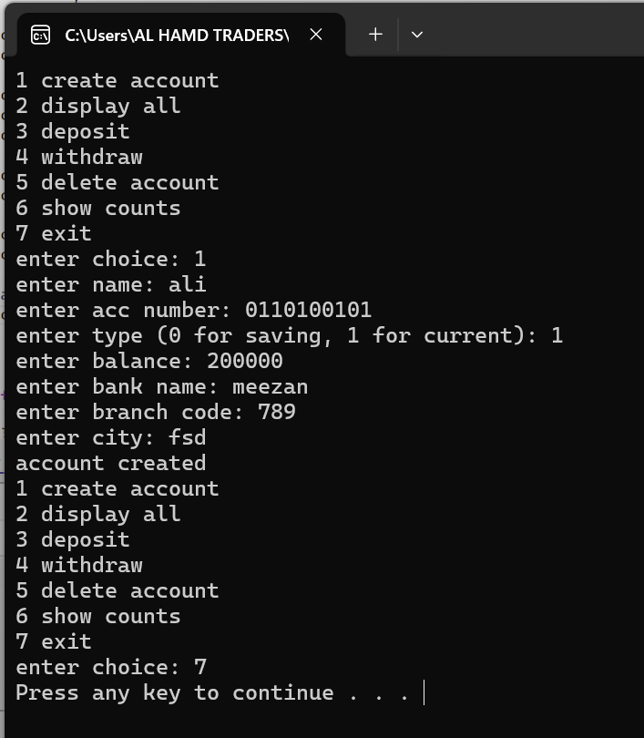

Question 2
#include <iostream>
using namespace std;

class HotDogStand
{
private:
int id;
int sold;

static int totalSold; // total of all stands

public:

// constructor
HotDogStand(int i, int s)
{
id = i;
sold = s;
totalSold += s;
}

// sell one hotdog
void justSold()
{
sold++;
totalSold++;
}

// get individual sales
int getSold()
{
return sold;
}

// static function for total
static int getTotalSold()
{
return totalSold;
}
};

// static variable initialize
int HotDogStand::totalSold = 0;

int main()
{

// creating 3 stands
HotDogStand s1(1, 10);
HotDogStand s2(2, 5);
HotDogStand s3(3, 8);

// selling hotdogs
s1.justSold();
s1.justSold();

s2.justSold();

s3.justSold();
s3.justSold();
s3.justSold();

// display individual
cout << "stand 1 sold: " << s1.getSold() << endl;
cout << "stand 2 sold: " << s2.getSold() << endl;
cout << "stand 3 sold: " << s3.getSold() << endl;

// display total
cout << "total sold by all stands: " << HotDogStand::getTotalSold() << endl;
system("pause");
return 0;
}
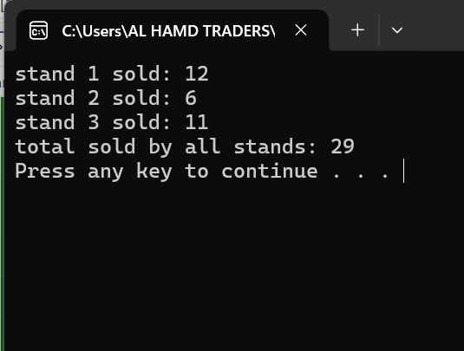
Question 3
#define _CRT_SECURE_NO_WARNINGS
#include <iostream>
#include <cstring>
#include <fstream>
using namespace std;

// student struct
struct student {
char name[50];
char cnic[20];
char gender[10];
float cgpa;
};

// section class
class section {
private:
student arr[40];
int count;

char secName[20];
char teacher[50];

public:

// constructor
section() {
count = 0;
strcpy(secName, "none");
strcpy(teacher, "none");
}

// edit section info
void editSection() {
cout << "enter section name: ";
cin.ignore();
cin.getline(secName, 20);

cout << "enter class teacher: ";
cin.getline(teacher, 50);
}

// add student
void addStudent() {
if (count >= 40) {
cout << "section full" << endl;
return;
}

cout << "enter name: ";
cin.ignore();
cin.getline(arr[count].name, 50);

cout << "enter cnic: ";
cin.getline(arr[count].cnic, 20);

cout << "enter gender: ";
cin.getline(arr[count].gender, 10);

cout << "enter cgpa: ";
cin >> arr[count].cgpa;

count++;
}

// update student
void updateStudent() {
char search[20];
cout << "enter cnic to update: ";
cin >> search;

for (int i = 0; i < count; i++) {
if (strcmp(arr[i].cnic, search) == 0) {

cout << "enter new name: ";
cin.ignore();
cin.getline(arr[i].name, 50);

cout << "enter new cgpa: ";
cin >> arr[i].cgpa;

return;
}
}

cout << "student not found" << endl;
}

// print students
void printList() {
cout << "section: " << secName << endl;
cout << "teacher: " << teacher << endl;

for (int i = 0; i < count; i++) {
cout << "name: " << arr[i].name << endl;
cout << "cnic: " << arr[i].cnic << endl;
cout << "gender: " << arr[i].gender << endl;
cout << "cgpa: " << arr[i].cgpa << endl;
cout << endl;
}
}

// get section name
char* getName() {
return secName;
}

// write to file (binary)
void writeToFile(ofstream& out) {
out.write((char*)this, sizeof(section));
}

// read from file
void readFromFile(ifstream& in) {
in.read((char*)this, sizeof(section));
}
};

int main() {

int n;
cout << "enter number of sections: ";
cin >> n;

section* sec = new section[n];

// load file
ifstream in("sections.dat", ios::binary);
if (in) {
for (int i = 0; i < n; i++) {
sec[i].readFromFile(in);
}
in.close();
}

int choice;

do {
cout << "1 edit section" << endl;
cout << "2 add student" << endl;
cout << "3 update student" << endl;
cout << "4 print students" << endl;
cout << "5 print sections" << endl;
cout << "6 exit" << endl;
cout << "enter choice: ";
cin >> choice;

int idx;
if (choice >= 1 && choice <= 4) {
cout << "enter section index: ";
cin >> idx;
}

if (choice == 1) {
sec[idx].editSection();
cout << endl;
cout << "done!" << endl;
cout << endl;
}

else if (choice == 2) {
sec[idx].addStudent();
cout << endl;
cout << "done! " << endl;
cout << endl;
}

else if (choice == 3) {
sec[idx].updateStudent();
cout << endl;
cout << "done! " << endl;
cout << endl;
}

else if (choice == 4) {
sec[idx].printList();
}

else if (choice == 5) {
for (int i = 0; i < n; i++) {
cout << "section " << i << ": " << sec[i].getName() << endl;
}
}

} while (choice != 6);

// save file
ofstream out("sections.dat", ios::binary);
for (int i = 0; i < n; i++) {
sec[i].writeToFile(out);
}
out.close();

delete[] sec;
system("pause");
return 0;
}

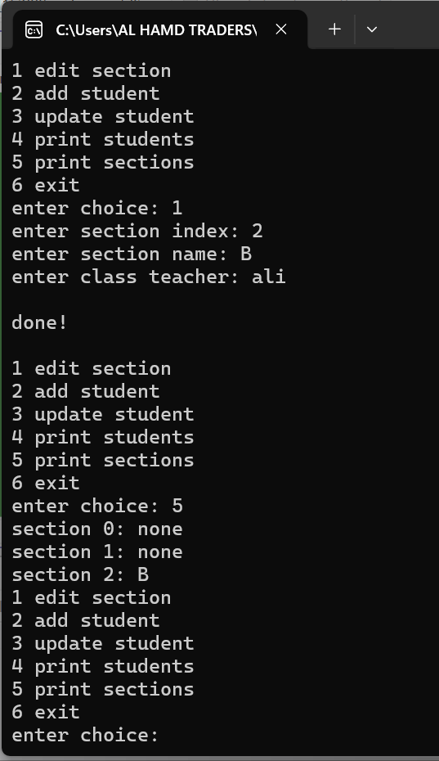
Question 4
#include <iostream>
using namespace std;
// class to model a tollbooth
class tollbooth
{
private:
unsigned int total_cars; // total number of cars
double total_cash; // total cash collected

public:
// constructor initializes both totals to 0
tollbooth()
{
total_cars = 0;
total_cash = 0.0;
}

// function for paying car: increments car count and adds 50 to cash
void payingCar()
{
total_cars++;
total_cash += 50;
}

// function for nonpaying car: increments car count, no cash added
void noPayCar()
{
total_cars++;
}

// display totals, marked const because it doesn't modify anything
void display() const
{
cout << "total cars: " << total_cars << endl;
cout << "total cash: " << total_cash << endl;
}
};

int main()
{
tollbooth tb; // create tollbooth object
char choice;

do
{
// menu for user
cout << "MENU" << endl;
cout << "p - paying car" << endl;
cout<< "n - non paying car" << endl;
cout<< "d - display totals" << endl;
cout<< "q - quit" << endl;
cout << "enter choice: ";
cin >> choice;

if (choice == 'p') {
tb.payingCar();
cout << "car paid!" << endl;
cout << endl;
}
else if (choice == 'n') {
tb.noPayCar();
cout << "car didnt pay!" << endl;
cout << endl;
}
else if (choice == 'd') {
tb.display();
}
else if (choice == 'q') {
cout << "exiting program..." << endl;
}
else {
cout << "invalid choice, try again" << endl;
}

}
while (choice != 'q');
system("pause");
return 0;
}
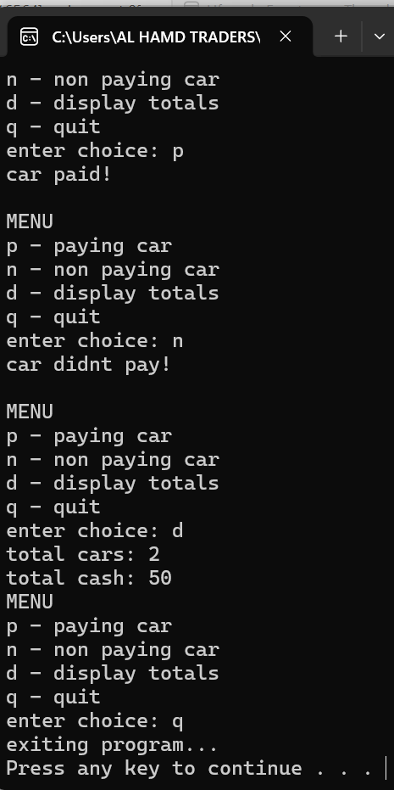

Question 5
#include <iostream>
#include <iomanip>
using namespace std;

class Time {
private:
int hours;
int minutes;
int seconds;

public:
// default constructor
Time() {
hours = 0;
minutes = 0;
seconds = 0;
}

// parameterized constructor
Time(int h, int m, int s) {
hours = h;
minutes = m;
seconds = s;
}

// function to display time in hh:mm:ss format
void display() const {
cout << setw(2) << setfill('0') << hours << ":"
<< setw(2) << setfill('0') << minutes << ":"
<< setw(2) << setfill('0') << seconds << "\n";
}

// function to add another time object to this one
void add(const Time& t1, const Time& t2) {
seconds = t1.seconds + t2.seconds;
minutes = t1.minutes + t2.minutes + seconds / 60;
seconds %= 60;

hours = t1.hours + t2.hours + minutes / 60;
minutes %= 60;

// 12-hour clock adjustment
if (hours > 12) {
hours %= 12;
if (hours == 0) hours = 12;
}
}
};

int main() {
// two initialized time objects
const Time t1(10, 45, 50);
const Time t2(2, 20, 15);

// third object to store result
Time t3;

// add the two times
t3.add(t1, t2);

// display the result
cout << "Time after addition: ";
t3.display();
system("pause");
return 0;
}
