Assignment 03
Question 01

#include<iostream>
#include<string>
using namespace std;
class bankaccount
{
private:
string accountno;
string Name;
double balance;
float branchcode;
string city;
string type1;
public :
enum AccountType { CURRENT, SAVING };
AccountType type;
static unsigned int count;

bankaccount()
{
balance = 0;
count++;
Name = " ";
city=" ";
}
void create(bankaccount* b[], int size)
{
cin.ignore();
string temp;
bool exists;

do
{
exists = false;
cout << "Enter the account no: ";
getline(cin, temp);
for (int i = 0; i < size; i++)
{
if (b[i]->findIndex(temp))
{
exists = true;
cout << "Account number already exists! Try again" << endl;
break;
}
}
} while (exists);
accountno=temp;
cout << "Enter the NAME: ";
getline(cin, Name);

cout << "Enter the branch code: ";
cin >> branchcode;

cout << "Enter the balance: ";
cin >> balance;

cin.ignore();

cout << "Enter city name: ";
getline(cin, city);
int t;
cout << "Enter 1 for current account and 2 for saving account ";
cin >> t;
if (t==1)
{
type = CURRENT;

}
else
{
type = SAVING;
}
}
void deposit()
{
int amount;
cout << "Enter the amount " << endl;
cin >> amount;
balance = balance + amount;
cout << "Successfully deposit your money ." << endl;
}
void withdrawal()
{
int amount;
cout << "Enter amount " << endl;
cin >> amount;
if (amount > balance)
{
cout << "Your balance is not sufficient." << endl;
}
else
{
balance = balance - amount;
cout << "Money withdrawn successfully." << endl;
cout << "Remaining Balance: " << balance << endl;
}
}
bool findIndex(string i)
{
if(i==accountno)
return true;
else
return false;
}
~bankaccount()
{
count--;
}

void show()
{
cout << endl;
cout << "Name :" << Name << endl;
cout << "Bank account :" << accountno << endl;
cout << "Current Balance :" << balance << endl;
cout << "Branch code :" << branchcode << endl;
cout << "Branch city name :" << city << endl;
if (type == CURRENT)
cout << "Account type: CURRENT" << endl;
else
cout << "Account type: SAVING" << endl;
cout << endl;
}
};
unsigned int bankaccount::count = 0;
int main()
{
bankaccount *b[100];
int n;
int size = 0;
do
{
cout << endl;
cout << "Enter 1 for creating an account. " << endl;
cout << "Enter 2 for Add money. " << endl;
cout << "Enter 3 for withdrawal money. " << endl;
cout << "Enter 4 for delete account." << endl;
cout << "Enter 5 for display account " << endl;
cout << "Enter 0 for Exist." << endl;
cout << endl;
cout << "Enter your choice ." << endl;
cin >> n;
switch (n)
{
case 0:
break;
case 1:
{
if (size <= 100)
{
b[size] = new bankaccount();
b[size]->create(b, size);
size++;
}
break;
}
case 2:
{
int n;
bool exist;
string i;
cout << "Enter the Account no " << endl;
cin >> i;
for(n=0;n<size;n++)
{
if(exist=b[n]->findIndex(i))
break;
}
if (exist)
{
b[n]->deposit();
}
else
{
cout << "Account are not create " << endl;
}
break;
}
case 3:
{
int n;
string i;
bool exist;
cout << "Enter the Account no " << endl;
cin >> i;
for(n=0;n<size;n++)
{
exist=b[n]->findIndex(i);
if(exist)
break;
}
if (exist)
{
b[n]->withdrawal();
}
else
{
cout << "Account are not create " << endl;
}
break;
}
case 4:
{
int n;
string m;
bool exist;
cout << "Enter the Account no you want to remove " << endl;
cin >> m;
for(n=0;n<size;n++)
{
exist =b[n]->findIndex(m);
if(exist)
break;
}
if (exist)
{
delete b[n];
for (int i = n; i < size-1; i++)
{
b[i] = b[i + 1];
}
}
else
{
cout << "Account are not create " << endl;
}
size--;
break;
}
case 5:
{
for (int i = 0; i < size; i++)
{
b[i]->show();
}
break;
}
default:
{
cout << "Invalide choice." << endl;
}
}
} while (n != 0);
cout << "TOTAL BANK ACCOUNT ARE MAKE " << bankaccount::count << endl;
}
Output
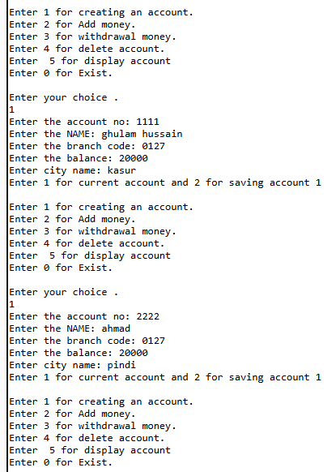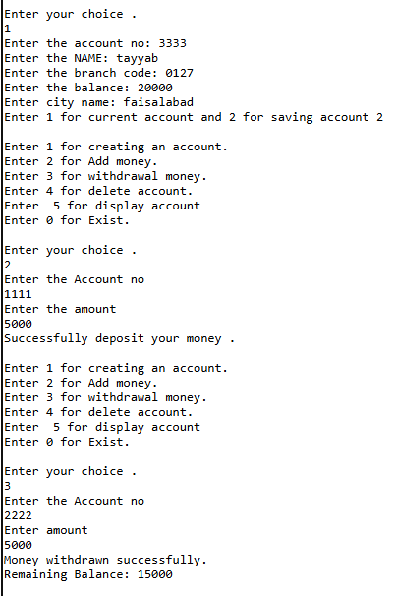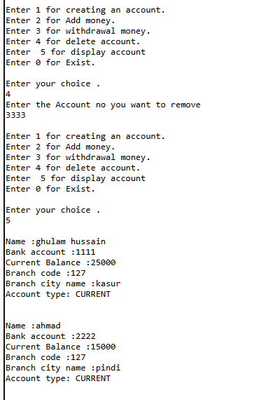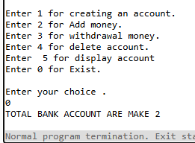

Question 02

#include<iostream>
#include<string>
using namespace std;
class dogname {
private:
int id;
int sold;
public:
static int totaldog;
dogname()
{
id = 0;
sold=0;
}
dogname(int id, int sold)
{
this->id = id;
this->sold = sold;
totaldog += sold;
}
void justsold()
{
sold++;
totaldog++;
}
int getsold()
{
return sold;
}
static int total()
{
return totaldog;
}
};
int dogname::totaldog = 0;
int main()
{
dogname d1(1, 6);
dogname d2(2, 4);
dogname d3(3,8);
d1.justsold();
d2.justsold();
d2.justsold();
d3.justsold();
cout << " sold dog day 1 :" << d1.getsold() << endl;
cout << " sold dog day 2 :" << d2.getsold() << endl;
cout << " sold dog day 3 :" << d3.getsold()<<endl;
cout << " TOtal dog sale all days :" << dogname::total() << endl;
}
Output
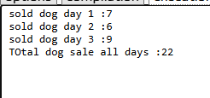

Question 04

#include<iostream>
#include<string>
using namespace std;
class toolboth
{
static unsigned int totalcar;
static double totalamount;
public:
toolboth()
{
totalamount = 0;
totalcar = 0;
}
void payingcar()
{
totalcar++;
totalamount = totalamount + 50;
}
void nopaycar()
{
totalcar++;
}
void display() const
{
cout <<"Total car :" << totalcar << endl;
cout << "Total amount :" << totalamount << endl;
}
};
double toolboth::totalamount = 0;
unsigned int toolboth::totalcar = 0;
int main()
{
toolboth b;
int choice;
do
{
cout << "Enter the 1 for paying car:" << endl;
cout << "Enter the 2 for no paying car:" << endl;
cout << "Enter the 3 for check detail :" << endl;
cout << "Enter the 0 for Exist :" << endl;
cout << "Enter your choices :" << endl;
cin >> choice;
switch (choice)
{
case 1:
{
b.payingcar();
break
}
case 2:
{
b.nopaycar();
break;
}
case 3:
{
b.display();
break;
}
default:
{
cout << " Invalid choice " << endl;
}
}
} while (choice != 0);
}
Output
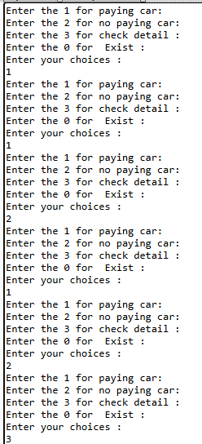
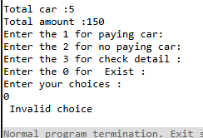

Question 05

#include<iostream>
#include<string>
using namespace std;
class Time {
private:
int hours;
int min;
int sec;
public:
Time()
{
hours = 0;
min = 0;
sec = 0;
}
Time(int h, int m, int s)
{
hours = h;
min = m;
sec = s;
}
void add(Time t1,Time t2)
{
sec = t1.sec + t2.sec;
min = t1.min + t2.min;
hours = t1.hours + t2.hours;
if (sec >= 60)
{
min =min+ sec / 60;
sec =sec % 60;
}
if (min >= 60)
{
hours = hours+min / 60;
min = min% 60;
}
}
void show()
{
cout << " Time " << endl;
cout << hours << ":" << min << ":" << sec << endl;
}
};
int main()
{
Time t1(1, 34, 53);
Time t2(9, 13, 45);

Time t3;
t3.add(t1,t2);
t3.show();
}
Output
