Question 1: Multi-Format Data Serialization System
#include <iostream>
#include <cstring>
#include <fstream>
using namespace std;
enum Type { current, saving, None };
class bank_account
{
char name_depositor[20];
char acc_num[20];
Type type;
double balance;
char bank_name[20];
char branch_code[20];
char city[20];
static int count_current;
static int count_saving;
public:
bank_account()
{
strcpy_s(name_depositor, "NA");
strcpy_s(acc_num, "0");
type = None;
balance = 0.0;
strcpy_s(bank_name, "NA");
strcpy_s(branch_code, "0");
strcpy_s(city, "NA");
}
bank_account(char a[], char acc[], Type type, double balance, char name[], char code[], char city[])
{
strcpy_s(this->name_depositor, a);
strcpy_s(this->acc_num, acc);
this->type = type;
this->balance = balance;
strcpy_s(this->bank_name, name);
strcpy_s(this->branch_code, code);
strcpy_s(this->city, city);
if (type == current)
count_current++;
else
count_saving++;
}
static int getCurrentCount()
{
return count_current;
}
static int getSavingCount()
{
return count_saving;
}
void setAccCounts(char new_bank[])
{
strcpy_s(this->bank_name, new_bank);
}
void deposit(int amount)
{
balance += amount;
}
double get_amount()
{
return this->balance;
}
void set_amount(double new_amount)
{
this->balance = new_amount;
}
void set_depositor(char depositor[])
{
strcpy_s(this->name_depositor, depositor);
}
char* get_depositor()
{
return this->name_depositor;
}
char* get_account_num()
{
return this->acc_num;
}
void set_acc_num(char new_acc[])
{
strcpy_s(this->acc_num, new_acc);
}
Type get_type()
{
return this->type;
}
void set_type(Type new_type)
{
this->type = new_type;
}
char* get_city()
{
return this->city;
}
void set_city(char new_city[])
{
strcpy_s(this->city, new_city);
}
void withdraw(int amount)
{
if (amount <= this->balance)
this->balance -= amount;
}
char* get_bank_name()
{
return this->bank_name;
}
void set_bank_name(char new_name[])
{
strcpy_s(this->bank_name, new_name);
}
void display()
{
cout << "Depositor's Name: " << get_depositor() << endl;
cout << "Bank_Name: " << get_bank_name() << endl;
cout << "City: " << get_city() << endl;
cout << "Account_Balance: " << get_amount() << endl;
}

};
int bank_account::count_current = 0;
int bank_account::count_saving = 0;
int main()
{

bank_account* banks[100] = { nullptr };
int free_position = 0;
int choice;
ifstream read("Account.txt");
while (!read.eof())
{
char name[20], acc[20], bank[20], city[20], branch_code[20];
int type;
double balance;
Type t;
read >> name;
read >> acc;
read >> type;
read >> balance;
read >> bank;
read >> branch_code;
read >> city;
if (type == 0)
t = current;
else
t = saving;
banks[free_position] = new bank_account(name, acc, t, balance, bank, branch_code, city);
free_position++;
}
read.close();
do
{
cout << "1. Create New Account: " << endl;
cout << "2. Deposit Amount: " << endl;
cout << "3. Withdraw Amount: " << endl;
cout << "4. Display All Accounts: " << endl;
cout << "5. Delete Account: " << endl;
cout << "6. Save to File: " << endl;
cout << "0. Exit: " << endl;
cout << "Enter your choice: " << endl;
cin >> choice;
switch (choice)
{
case 1:
char name[20], acc_num[20], bank_name[20], branch_code[20], city[20];
int type;
double balance;
cout << "Enter the depositor name: " << endl;
cin.ignore();
cin.getline(name, 20);
cout << "Enter the account number: " << endl;
cin.getline(acc_num, 20);
cout << "Enter the bank_name: " << endl;
cin.getline(bank_name, 20);
cout << "Enter the branch code: " << endl;
cin.getline(branch_code, 20);
cout << "Enter the city: " << endl;
cin.getline(city, 20);
cout << "Enter the type: 0 for current and 1 for saving" << endl;
cin >> type;
Type t;
if (type == 0)
t = current;
else
t = saving;
cout << "Enter the balance: " << endl;
cin >> balance;
banks[free_position] = new bank_account(name, acc_num, t, balance, bank_name, branch_code, city);
free_position++;
break;
case 2:
{
int amount, index;
cout << "Enter the amount u want to deposit: " << endl;
cin >> amount;
cout << "Enter the acc no. (index) in which u want to deposit: " << endl;
cin >> index;
if (index >= 0 && index < free_position)
banks[index]->deposit(amount);
else
cout << "Invalid index " << endl;
break;
}
case 3:
{
int withdraw;
int index;
cout << "Enter the amount u want to withdraw: " << endl;
cin >> withdraw;
cout << "Enter the index from which u want to with draw: " << endl;
cin >> index;
if (index >= 0 && index < free_position)
banks[index]->withdraw(withdraw);
else
cout << "Invalid index " << endl;
break;
}
case 4:
{
for (int i = 0; i < free_position; i++)
{
banks[i]->display();
}
break;
}
case 5:
{
int index;
cout << "Enter the bank index u want to delete: " << endl;
cin >> index;
if (index >= 0 && index < free_position)
{
delete banks[index];
for (int i = index; i < free_position - 1; i++)
{
banks[i] = banks[i + 1];
}
free_position--;
}
else
cout << "Index not exists " << endl;
break;
}
case 6:
{
ofstream write("Account.txt");
for (int i = 0; i < free_position; i++)
{
write << banks[i]->get_depositor() << " " << banks[i]->get_account_num() << " " << banks[i]->get_type() << " " << banks[i]->get_amount() << " " << banks[i]->get_bank_name() << " " << banks[i]->get_city() << endl;
}
write.close();
cout << "Data successfuly added " << endl;
break;
}

case 0:
cout << "Existed " << endl;
break;
default:
cout << "Invalid choice: " << endl;
}
} while (choice != 0);
}
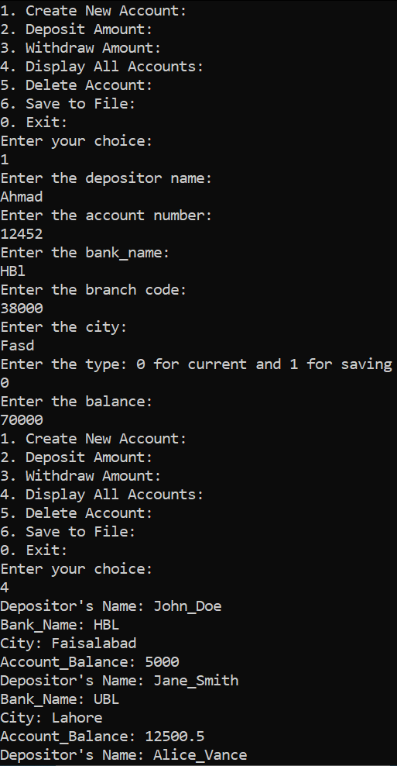
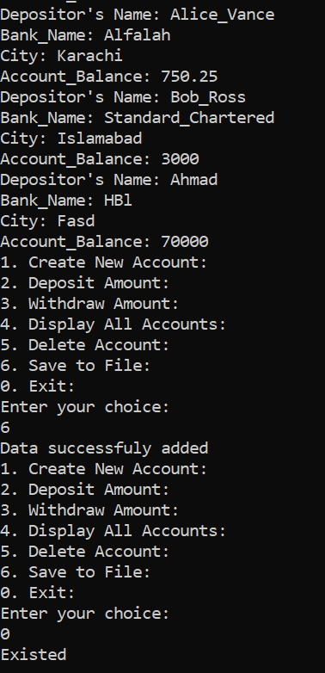
Question 2: Reference-Counted Resource Manager
#include <iostream>
using namespace std;
class HotDogStand
{
int id_num;
int num_hotdog_stand_sold;
static int total_num_hotdog_sold;
public:
HotDogStand()
{
id_num = 0;
num_hotdog_stand_sold = 0;
}
HotDogStand(int id, int num_hotdog_stand_sold) : id_num(id), num_hotdog_stand_sold(num_hotdog_stand_sold)
{
total_num_hotdog_sold += num_hotdog_stand_sold;
}
void justSold()
{
num_hotdog_stand_sold++;
total_num_hotdog_sold++;
}
int display_sold()
{
return num_hotdog_stand_sold;
}
static int display_total()
{
return total_num_hotdog_sold;
}
};
int HotDogStand::total_num_hotdog_sold = 0;
int main()
{
HotDogStand h1;
HotDogStand h2(233, 5);
HotDogStand h3(123, 10);
cout << "Stand individual values: " << endl;
h1.justSold();
h2.justSold();
h3.justSold();
cout << h1.display_sold() << endl;
cout << h2.display_sold() << endl;
cout << h3.display_sold() << endl;
cout << "Total hot dogs sold from each stand: " << endl;
cout << HotDogStand::display_total();
}
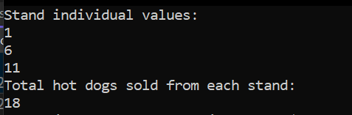
Question 3:
#include <iostream>
#include <string>
using namespace std;
struct student
{
string name;
int cnic;
char gender;
float cgpa;
};
class section
{
student students[20];
string section_name;
string class_teacher;
int free_position;
public:
section()
{
free_position = 0;
for (int i = 0; i < 20; i++)
{
students[i].name = " ";
students[i].cnic = 0;
students[i].gender = 'N';
students[i].cgpa = 0.0;
}
}
section(student students [], int size, string name, string class_teacher)
{
free_position = 0;
for (int i = 0; i < size; i++)
{
this->students[i] = students[i];
free_position++;
}
this->section_name = name;
this->class_teacher = class_teacher;
}
void editSection()
{
cout << "Enter the section_name to replace: " << endl;
cin >> this->section_name;
cout << "Enter the class_teacher name to replace: " << endl;
cin >> this->class_teacher;
}
void addStudent()
{
cout << "Enter the student name to add: " << endl;
cin >> students[free_position].name;
cout << "Enter the cnic number to add: " << endl;
cin >> students[free_position].cnic;
cout << "Enter the gender: " << endl;
cin >> students[free_position].gender;
cout << "Enter the cgpa: " << endl;
cin >> students[free_position].cgpa;
free_position++;
}
void updateStudent()
{
int index;
cout << "Enter the index in which u want to do changes: " << endl;
cin >> index;
if (index >= 0 && index < free_position)
{
cout << "Enter the student name to update: " << endl;
cin >> students[index].name;
cout << "Enter the cnic number to update: " << endl;
cin >> students[index].cnic;
cout << "Enter the gender: " << endl;
cin >> students[index].gender;
cout << "Enter the cgpa: " << endl;
cin >> students[index].cgpa;
}
}
void printList()
{
cout << "students details: " << endl;
for (int i = 0; i < free_position; i++)
{
cout << "Name: " << students[i].name << endl;
cout << "CNIC: " << students[i].cnic << endl;
cout << "Gender: " << students[i].gender << endl;
cout << "CGPA: " << students[i].cgpa << endl;
}
cout << "Section details: " << endl;
cout << "Section Name: " << this->section_name << endl;
cout << "Class_Teacher Name: " << this->class_teacher << endl;
}
};
int main()
{
int num;
cout << "Enter the number of objects u want to create: " << endl;
cin >> num;
section* ptr = new section[num];
int choice;
do
{
int index;
cout << "Enter 1: for edit section Attributes: " << endl;
cout << "Enter 2: for add student in a section: " << endl;
cout << "Enter 3: for update the student of a section: " << endl;
cout << "Enter 4: for print the list of students of a section: " << endl;
cout << "Enter 5: for print the list of sections: " << endl;
cout << "Enter 0: to exit " << endl;
cout << "Enter the choice: " << endl;
cin >> choice;
switch (choice)
{
case 1:
{
cout << "Enter the index: " << endl;
cin >> index;
ptr[index].editSection();
break;
}
case 2:
{
cout << "Enter the index: " << endl;
cin >> index;
ptr[index].addStudent();
break;
}
case 3:
{
cout << "Enter the index: " << endl;
cin >> index;
ptr[index].updateStudent();
break;
}
case 4:
{
cout << "Enter the index: " << endl;
cin >> index;
ptr[index].printList();
break;
}
case 5:
for (int i = 0; i < num; i++)
{
ptr[i].printList();
}
break;
case 0:
cout << "Exited " << endl;
break;
default:
cout << "Invalid choice: " << endl;
}
} while (choice != 0);
delete[] ptr;
}
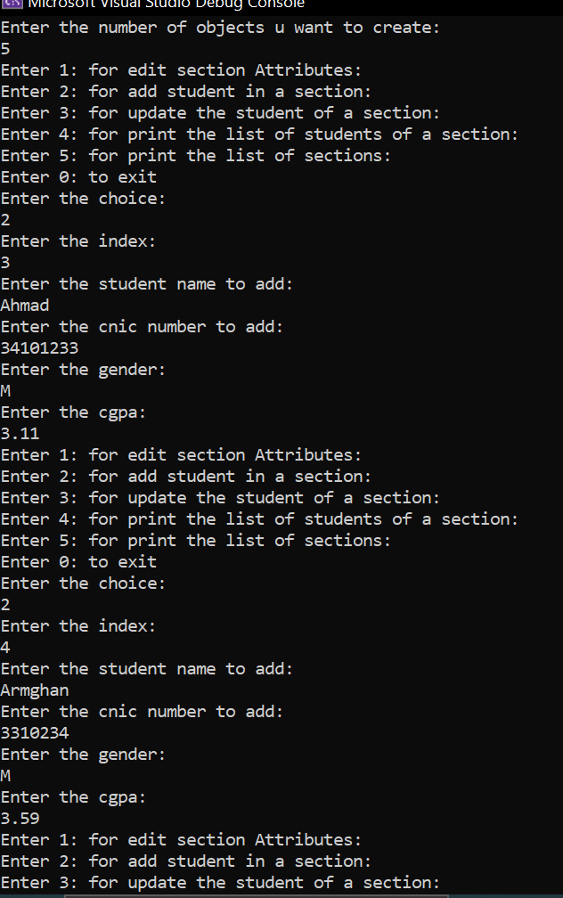
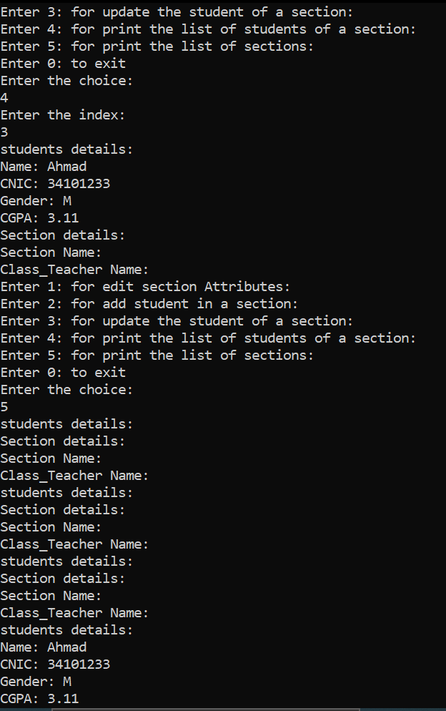
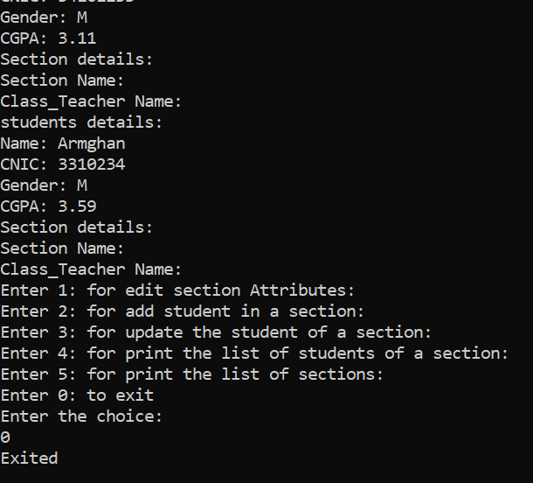
Question 4:
#include <iostream>
using namespace std;
class tollbooth
{
int total_cars;
double total_amount;
public:
tollbooth()
{
total_cars = 0;
total_amount = 0;
}
void payingCar()
{
total_cars++;
total_amount += 50;
}
void noPayCar()
{
total_cars++;
}
void display() const
{
cout << "Total Cars pass by: " << total_cars << endl;
cout << "Total amount that is collected is: " << total_amount << endl;
}
};
int main()
{
tollbooth* ptr = new tollbooth;
int choice;
do
{
cout << "------Menu------ " << endl;
cout << "Enter 1: to count a paying car " << endl;
cout << "Enter 2: to count a non paying car " << endl;
cout << "Enter 3: to display " << endl;
cout << "Enter 4: to exit " << endl; // Added exit option
cout << "Enter your choice: " << endl;
cin >> choice;
switch (choice)
{
case 1:
{
ptr->payingCar();
break;
}
case 2:
{
ptr->noPayCar();
break;
}
case 3:
{
ptr->display();
break;
}
case 4:
cout << "Exited ";
break;
default:
cout << "Invalid choice ";
}

} while (choice != 4);

delete ptr;
}
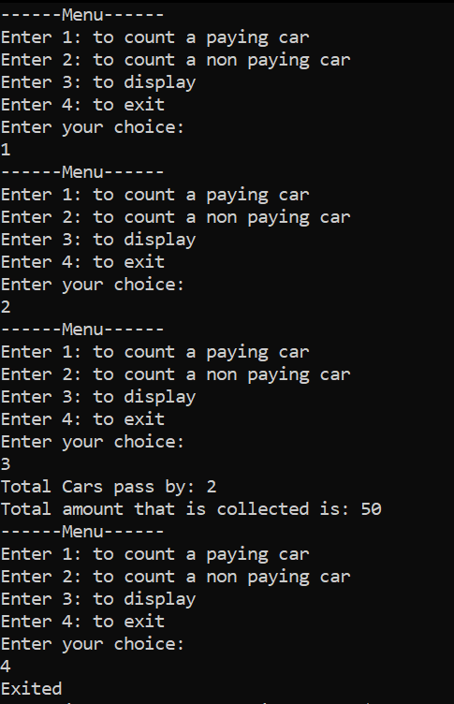
Question 5:
#include <iostream>
using namespace std;
class Time
{
int hours;
int min;
int sec;
public:
Time()
{
this->hours = 0;
this->min = 0;
this->sec = 0;
}
Time(int hours, int min, int sec)
{
this->hours = hours;
this->min = min;
this->sec = sec;
}
void display() const
{
cout << this->hours << ":" << this->min << ":" << this->sec << endl;
}
void add(Time obj1, Time obj2)
{
this->hours = obj1.hours + obj2.hours;
this->min = obj1.min + obj2.min;
this->sec = obj1.sec + obj2.sec;
}
};
int main()
{
Time obj1(11, 12, 34);
Time obj2(11, 15, 15);
Time obj3;
obj3.add(obj1, obj2);
obj1.display();
obj2.display();
obj3.display();
}
