ASSIGNMENT NO 3
QUESTION NO 1 :
#include<iostream>
#include<cstring>
#include<fstream>
using namespace std;

enum Type { CURRENT, SAVING };

class BankAccount
{
private:
char name[80];
char number[80];
char bank[80];
char code[50];
char location[80];
Type accType;
double money;

static int currentTotal;
static int savingTotal;

public:
BankAccount()
{
name[0] = '\0';
number[0] = '\0';
bank[0] = '\0';
code[0] = '\0';
location[0] = '\0';
money = 0;
}

BankAccount(const char* n, const char* num, Type t, double m,
const char* b, const char* c, const char* loc, bool countFlag = true)
{
strcpy_s(name, n);
strcpy_s(number, num);
accType = t;
money = m;
strcpy_s(bank, b);
strcpy_s(code, c);
strcpy_s(location, loc);

if (countFlag)
{
if (t == CURRENT)
currentTotal++;
else
savingTotal++;
}
}

const char* getName() { return name; }
const char* getNumber() { return number; }
const char* getBank() { return bank; }
const char* getCode() { return code; }
const char* getLocation() { return location; }
double getMoney() { return money; }
Type getType() { return accType; }

void addMoney(double amt)
{
if (amt > 0)
money += amt;
}

void takeMoney(double amt)
{
if (amt <= money)
money -= amt;
else
cout << "Not enough balance\n";
}

void show()
{
cout << "\n----- Account Info -----\n";
cout << "Holder: " << name << endl;
cout << "Acc No: " << number << endl;
cout << "Type: " << (accType == CURRENT ? "Current" : "Saving") << endl;
cout << "Balance: " << money << endl;
cout << "Bank: " << bank << endl;
cout << "City: " << location << endl;
cout << "------------------------\n";
}

static void showCounts()
{
cout << "Current Accounts: " << currentTotal << endl;
cout << "Saving Accounts: " << savingTotal << endl;
}
};

int BankAccount::currentTotal = 0;
int BankAccount::savingTotal = 0;

int main()
{
BankAccount* list[100];
int total = 0;

ifstream fin("accounts.txt");

char n[80], num[80], b[80], c[50], loc[80];
int t;
double m;

while (fin.getline(n, 80, ','))
{
if (strlen(n) == 0) continue;
if (!fin.getline(num, 80, ',')) break;
if (!(fin >> t)) break;
fin.ignore();
if (!(fin >> m)) break;
fin.ignore();
if (!fin.getline(b, 80, ',')) break;
if (!fin.getline(c, 50, ',')) break;
if (!fin.getline(loc, 80)) break;

list[total] = new BankAccount(n, num, (t == 0 ? CURRENT : SAVING), m, b, c, loc);
total++;
}
fin.close();

int option;

do
{
cout << "\n1. New Account\n2. Show All\n3. Remove\n4. Deposit\n5. Withdraw\n6. Counts\n7. Exit\n";
cout << "Choose: ";
cin >> option;
cin.ignore();

if (option == 1)
{
char n[80], num[80], b[80], c[50], loc[80];
int t;
double m;

cout << "Name: ";
cin.getline(n, 80);
cout << "Account No: ";
cin.getline(num, 80);
cout << "Type (0 Current / 1 Saving): ";
cin >> t;
cout << "Balance: ";
cin >> m;
cin.ignore();
cout << "Bank: ";
cin.getline(b, 80);
cout << "Code: ";
cin.getline(c, 50);
cout << "City: ";
cin.getline(loc, 80);

list[total] = new BankAccount(n, num, (t == 0 ? CURRENT : SAVING), m, b, c, loc);
total++;
}

else if (option == 2)
{
if (total == 0)
cout << "No data found\n";
else
for (int i = 0; i < total; i++)
list[i]->show();
}

else if (option == 3)
{
char num[80];
cout << "Enter account no: ";
cin.getline(num, 80);

for (int i = 0; i < total; i++)
{
if (strcmp(list[i]->getNumber(), num) == 0)
{
delete list[i];
for (int j = i; j < total - 1; j++)
list[j] = list[j + 1];

total--;
cout << "Deleted\n";
break;
}
}
}

else if (option == 4)
{
char num[80];
double amt;

cout << "Account no: ";
cin.getline(num, 80);
cout << "Amount: ";
cin >> amt;
cin.ignore();

for (int i = 0; i < total; i++)
if (strcmp(list[i]->getNumber(), num) == 0)
list[i]->addMoney(amt);
}

else if (option == 5)
{
char num[80];
double amt;

cout << "Account no: ";
cin.getline(num, 80);
cout << "Amount: ";
cin >> amt;
cin.ignore();

for (int i = 0; i < total; i++)
if (strcmp(list[i]->getNumber(), num) == 0)
list[i]->takeMoney(amt);
}

else if (option == 6)
{
BankAccount::showCounts();
}

} while (option != 7);

ofstream fout("accounts.txt");

for (int i = 0; i < total; i++)
{
fout << list[i]->getName() << ","
<< list[i]->getNumber() << ","
<< (list[i]->getType() == CURRENT ? 0 : 1) << ","
<< list[i]->getMoney() << ","
<< list[i]->getBank() << ","
<< list[i]->getCode() << ","
<< list[i]->getLocation() << endl;
}

fout.close();

for (int i = 0; i < total; i++)
delete list[i];

return 0;
}

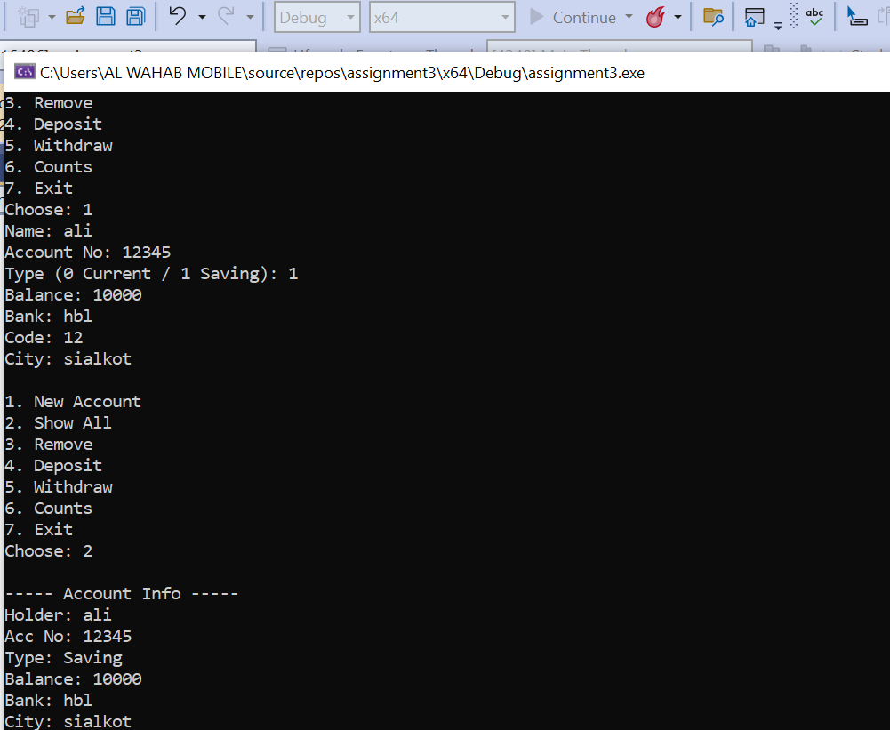

QUESTION NO 2 :
#include <iostream>
using namespace std;

class hotdogstand
{
private:
int id;
int sold;

public:
static int getsold;
// Default constructor
hotdogstand()
{
id = 0;
sold = 0;
}

// Parameterized constructor
hotdogstand(int a, int b)
{
id = a;
sold = b;
getsold += b; // Add initial sold to total
}

// Increment hot dogs sold by 1
void justsold()
{
sold++;
getsold++;
}

// Return number of hot dogs sold by this stand
int getSold()
{
return sold;
}

// Static method: total sold by all stands
static int totalbyallstands()
{
return getsold;
}

// Display info
void display()
{
cout << "The id is " << id << " and the hot dogs sold are " << sold << endl;
}
};

// Initialize static variable
int hotdogstand::getsold = 0;

int main()
{
hotdogstand h1(101, 5);
h1.justsold();
h1.justsold();
h1.justsold(); // h1 total sold: 8

hotdogstand h2(102, 6);
h2.justsold(); // h2 total sold: 7

hotdogstand h3(103, 7);
h3.justsold();
h3.justsold(); // h3 total sold: 9

// Display each stand
h1.display();
h2.display();
h3.display();

// Display total sold by all stands
cout << "Total sold by all stands: " << hotdogstand::totalbyallstands() << endl;

return 0;
}

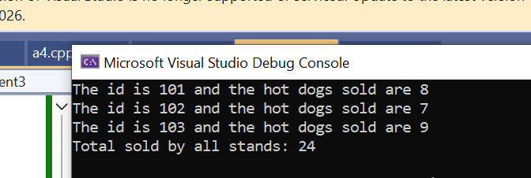
QUESTION NO 3 :

#define _CRT_SECURE_NO_WARNINGS
#include<iostream>
#include<string>
using namespace std;

struct student
{
string name;
int cnic;
float cgpa;
string gender;
};

class section
{
private:
student arr[30];
string sectionname;
string teacher;
int studentcount = 0;

public:

void editsection()
{
cin.ignore();
cout << "Enter the section name: ";
getline(cin, sectionname);

cout << "Enter the teacher name: ";
getline(cin, teacher);
}

void addstudent()
{
cin.ignore();

cout << "Enter student name: ";
getline(cin, arr[studentcount].name);

cout << "Enter CNIC: ";
cin >> arr[studentcount].cnic;

cout << "Enter CGPA: ";
cin >> arr[studentcount].cgpa;

cin.ignore();
cout << "Enter Gender: ";
getline(cin, arr[studentcount].gender);

studentcount++;

cout << "Student added successfully!\n";
}

void updatestudent()
{
int index;

cout << "Enter student number to update: ";
cin >> index;

if (index >= 0 && index < studentcount)
{
cin.ignore();

cout << "Enter new name: ";
getline(cin, arr[index].name);

cout << "Enter new CNIC: ";
cin >> arr[index].cnic;

cout << "Enter new CGPA: ";
cin >> arr[index].cgpa;

cin.ignore();
cout << "Enter new Gender: ";
getline(cin, arr[index].gender);
}
else
{
cout << "Invalid student index\n";
}
}

void printstudent()
{
cout << "\nSection: " << sectionname << endl;
cout << "Teacher: " << teacher << endl;

for (int i = 0; i < studentcount; i++)
{
cout << "\nStudent " << i << endl;
cout << "Name: " << arr[i].name << endl;
cout << "CNIC: " << arr[i].cnic << endl;
cout << "CGPA: " << arr[i].cgpa << endl;
cout << "Gender: " << arr[i].gender << endl;
}
}
};

int main()
{
int n;
cout << "How many sections you want to create: ";
cin >> n;

section* ptr = new section[n];

int choice = 0;

while (choice != 5)
{
cout << "\n--- Menu ---\n";
cout << "1. Edit Section\n";
cout << "2. Add Student\n";
cout << "3. Update Student\n";
cout << "4. Print Section Students\n";
cout << "5. Exit\n";

cout << "Enter choice: ";
cin >> choice;

if (choice == 1)
{
ptr[0].editsection();
}
else if (choice == 2)
{
ptr[0].addstudent();
}
else if (choice == 3)
{
ptr[0].updatestudent();
}
else if (choice == 4)
{
ptr[0].printstudent();
}
else if (choice == 5)
{
cout << "Exiting...\n";
}
else
{
cout << "Invalid choice\n";
}
}

delete[] ptr;

return 0;
}

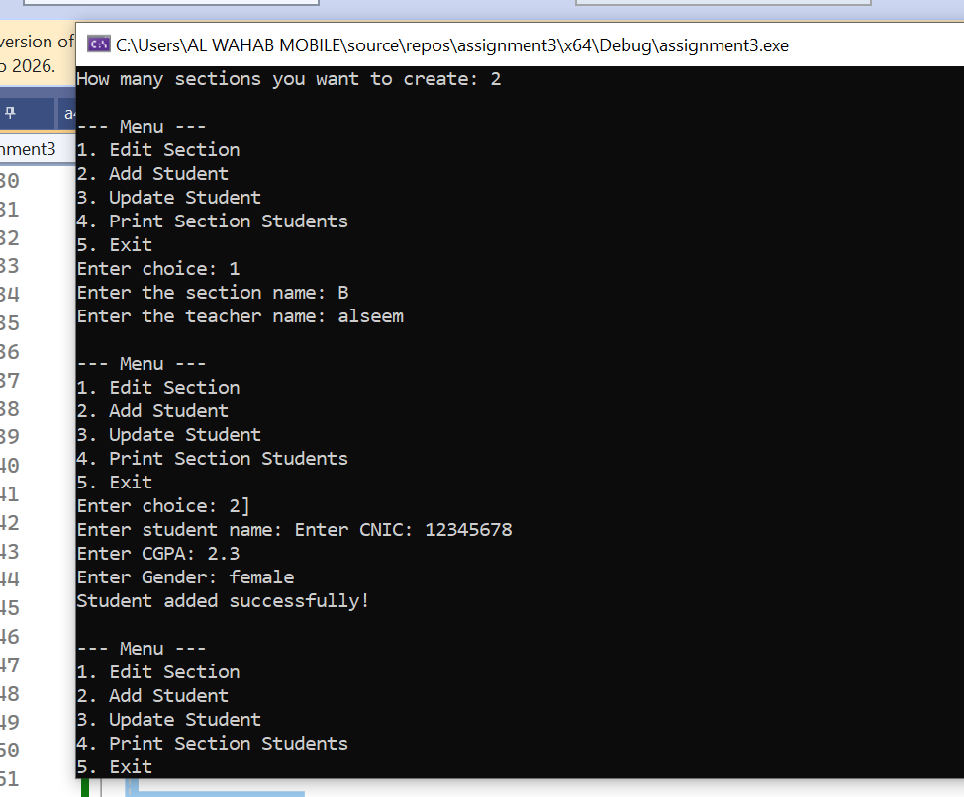

QUESTION NO 4 :

#include<iostream>
using namespace std;

class TollSystem
{
private:
int totalCars;
double totalAmount;

public:
TollSystem()
{
totalCars = 0;
totalAmount = 0;
}

void addPaidCar()
{
totalCars++;
totalAmount += 50;
}

void addFreeCar()
{
totalCars++;
}

void showData() const
{
cout << "\n===== Toll Booth Report =====\n";
cout << "Cars Passed: " << totalCars << endl;
cout << "Money Collected: " << totalAmount << endl;
cout << "=============================\n";
}
};

int main()
{
TollSystem booth;
int option;

do
{
cout << "\n1. Car with Payment\n";
cout << "2. Car without Payment\n";
cout << "3. Show Report\n";
cout << "4. Quit\n";
cout << "Select option: ";
cin >> option;

if (option == 1)
{
booth.addPaidCar();
}
else if (option == 2)
{
booth.addFreeCar();
}
else if (option == 3)
{
booth.showData();
}
else if (option == 4)
{
cout << "Program closed.\n";
}
else
{
cout << "Wrong option, try again.\n";
}

} while (option != 4);

return 0;
}
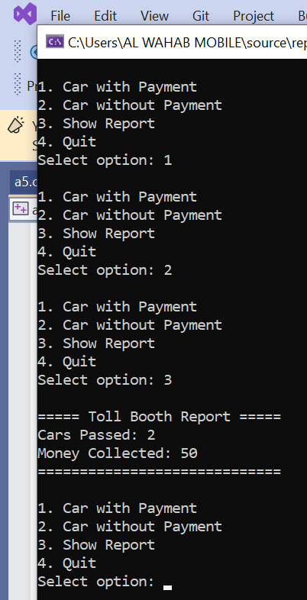

QUESTION NO 5 :

#include<iostream>
using namespace std;

class Clock
{
private:
int h;
int m;
int s;

public:
Clock()
{
h = 0;
m = 0;
s = 0;
}

Clock(int hr, int mn, int sc)
{
h = hr;
m = mn;
s = sc;
}

void show() const
{
cout << "\n----- Time -----\n";
cout << h << ":"
<< (m < 10 ? "0" : "") << m << ":"
<< (s < 10 ? "0" : "") << s << endl;
cout << "----------------\n";
}

void sumTime(const Clock& a, const Clock& b)
{
int totalSec = a.s + b.s;
int totalMin = a.m + b.m;
int totalHr = a.h + b.h;

totalMin += totalSec / 60;
s = totalSec % 60;

totalHr += totalMin / 60;
m = totalMin % 60;

h = totalHr;
}
};

int main()
{
Clock c1(2, 10, 50);
Clock c2(3, 05, 30);
Clock result;

result.sumTime(c1, c2);
result.show();

return 0;
}
