Oop assignment 3
Sameer 25f-0006
Question 1=
#define _CRT_SECURE_NO_WARNINGS
#include<iostream>
#include<string>
#include<cstring>
#include<fstream>
using namespace std;
enum accountkitype
{
saving, current
};
class bankaccount
{
private:
char depositerkanam[100];
char accountkanumber[100];
double accountmeinbalance;
static char bankkaname[100];

char city[100];
static unsigned int current_count;
static unsigned int saving_count;
accountkitype type;
public:

bankaccount():type(current)
{
strcpy(depositerkanam, "");
strcpy(accountkanumber, "");
accountmeinbalance = 0;
strcpy(bankkaname, "");
strcpy(city, "");
if (type == current)
current_count++;
else
saving_count++;

}
bankaccount(char depositerkanam[],char accountkanumber[],int accountmeinbalance,char bankkaname[],char city[],accountkitype type)
{

strcpy(this->depositerkanam, depositerkanam);
strcpy(this->accountkanumber, accountkanumber);
this->accountmeinbalance = accountmeinbalance;
strcpy(this->bankkaname, bankkaname);

strcpy(this->city, city);
this->type = type;
if (this->type == current)
current_count++;
else
saving_count++;

}
static void getaccountcount()
{
strcpy(bankkaname, "MEEZAN");
}
void deposit()
{
int deposit;
cout << "enter deposit amount " << endl;
cin >> deposit;
this->accountmeinbalance += deposit;

}
void withdraw()
{
int with;
cout << "enter withdraw amount " << endl;
cin >> with;
this->accountmeinbalance -= with;
}
char* getacc()
{
return this->accountkanumber;
}
char* getname()
{
return this->depositerkanam;
}
double getbalanace()
{
return this->accountmeinbalance;
}
char*getcity()
{
return this->city;
}
int gettype()
{
return this->type;
}

void display()
{
cout << "depositer name =" << this->depositerkanam<<endl;
cout << "account number =" << this->accountkanumber<<endl;
cout << "branch name =" << this->bankkaname<<endl;
cout << "city= " << this->city << endl;
cout << "balance=" << this->accountmeinbalance;
cout << endl;

}

};
void save(bankaccount* bank[100])
{
int index = -1;
bool found = false;
ofstream file("account.txt");
if (!file)
{
cout << "file not found " << endl;
}
for (int i = 0; i < 100; i++)
{
if (bank[i] != NULL)
{
index=i;
file << bank[index]->getacc()<<" " << bank[index]->getbalanace()<<" " << bank[index]->getname()<<" " << bank[index]->getcity()<<" " << bank[index]->gettype() << endl;

}
}
file.close();

}
unsigned int bankaccount::current_count = 0;
unsigned int bankaccount::saving_count = 0;
char bankaccount::bankkaname[100];
int main()
{
accountkitype type;
bankaccount* bank[100] = { NULL };
char depositerkanam[100];
char accountkanumber[100];
double accountmeinbalance;
char bankkaname[100];
char branch_ka_code[100];
char city[100];
int choice;
int type1;

int index = 0;

do
{
cout << "enter 1 to create a account" << endl;
cout << "enter 2 to delete a account" << endl;
cout << "enter 3 to deposit" << endl;
cout << "enter 4 to withdraw " << endl;
cout << "enter 5 to display" << endl;
cout << "enter 6 to save to file " << endl;
cout << "enter 7 to exit " << endl;
cin >> choice;

switch (choice)
{

case 1:
index++;

char name[50], bankname[50], city[50], accno[50];
int amount;
cout << "name =";
cin >> name;
cout << "acc no= ";
cin >> accno;
cout << "bank name= ";
cin >> bankname;
cout << "amount = ";
cin >> amount;
cout << "city =";
cin >> city;
cout << "enter 0 for saving " << endl;
cout << "enter 1 for current " << endl;
cin >> type1;

bank[index] = new bankaccount(name, accno, amount, bankname, city, (accountkitype)type1);
cout << "acount created sucesfully" << endl;
break;
case 2:
{
char new_accno[50];
cout << "enter account number " << endl;
cin >> new_accno;
bool found = false;
index = -1;
for (int i = 0; i < 100; i++)
{
if (bank[i] != NULL)
{
if (strcmp(new_accno, bank[i]->getacc()) == 0)
{
index = i;
found = true;
break;

}
}

}
if (found)
{
delete bank[index];
cout << "accout deleted" << endl;
}

break;
}
case 3:
{
index = -1;
char new_accno[10];
cout << "enter account number " << endl;
cin >> new_accno;
bool found = false;
for (int i = 0; i < 100; i++)
{
if (bank[i] != NULL)
{
if (strcmp(new_accno, bank[i]->getacc()) == 0)
{
index = i;
found = true;
break;

}
}
}
if (found)
{
bank[index]->deposit();
cout << "balance deposited succesfully" << endl;
}
break;
}
case 4:
{
index = -1;
char new_accno[10];
cout << "enter account number " << endl;
cin >> new_accno;
bool found = false;
for (int i = 0; i < 100; i++)
{
if (bank[i] != NULL)
{
if (strcmp(new_accno, bank[i]->getacc()) == 0)
{
index = i;
found = true;
break;
}

}
}
if (found)
{
bank[index]->withdraw();
cout << "withdarwn succesfully" << endl;
}
break;
}
case 5:
{
bool found;
char new_accno[10];
index = -1;
cout << "enter account number " << endl;
cin >> new_accno;
for (int i = 0; i < 100; i++)
{
if (bank[i] != NULL)
{

if (strcmp(new_accno, bank[i]->getacc()) == 0)
{
index = i;
found = true;
break;
}

}
}

if (found)
{
bank[index]->display();
}
break;
}
case 6:
{
save(bank);
break;
}
case 7:

{
cout << "program exited" << endl;
break;
}
default:

{
cout << "invalid" << endl;
break;
}

}

} while (choice !=7);
}

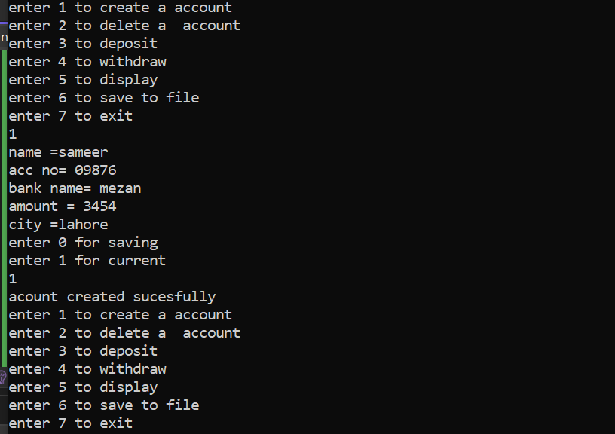
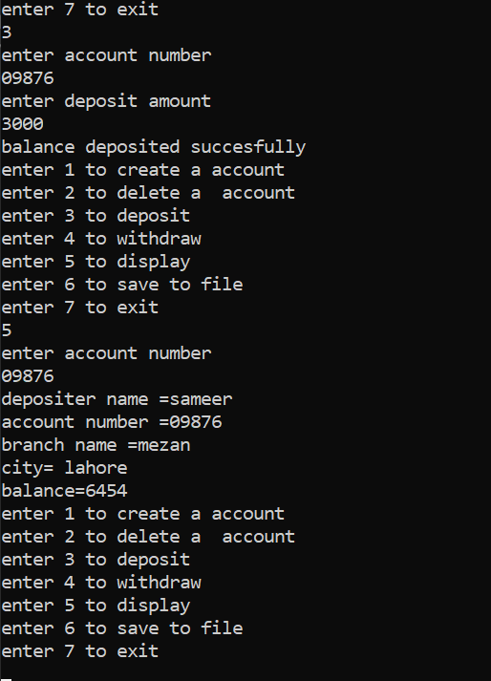
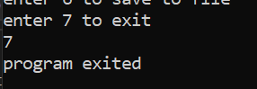
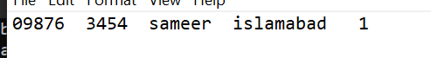
Question 2
#include<iostream>
#include<string>
using namespace std;
class hotdogstand
{
private:
int stands_id;
int soldper_day;
public:
static int sold_allstands;
hotdogstand(int n, int m)
{
stands_id = n;
soldper_day = m;
sold_allstands += m;
}
void justsold()
{
soldper_day++;
sold_allstands++;
}
int getsold()
{
return soldper_day;

}
static void totalhotdogs()
{

cout << "the total hotdog sold by all the stands are " << endl;
cout << sold_allstands << endl;

}

};
int hotdogstand::sold_allstands = 0;
int main()
{
int id;
int sold;
cout << "enter the id " << endl;
cin >> id;
cout << "enter the initial sold value " << endl;
cin >> sold;
hotdogstand h1(id, sold);
cout << "enter the id " << endl;
cin >> id;
cout << "enter the initial sold value " << endl;
cin >> sold;
hotdogstand h2(id, sold);
cout << "enter the id " << endl;
cin >> id;
cout << "enter the initial sold value " << endl;
cin >> sold;
hotdogstand h3(id, sold);

h1.justsold();
h2.justsold();
h3.justsold();

int sold1, sold2, sold3;
sold1 = h1.getsold();
cout << "the hot dog sold are " << sold1 << endl;
sold2 = h2.getsold();
cout << "the hot dog sold are " << sold2 << endl;
sold3 = h3.getsold();
cout << "the hot dog sold are " << sold3 << endl;

hotdogstand::totalhotdogs();

}
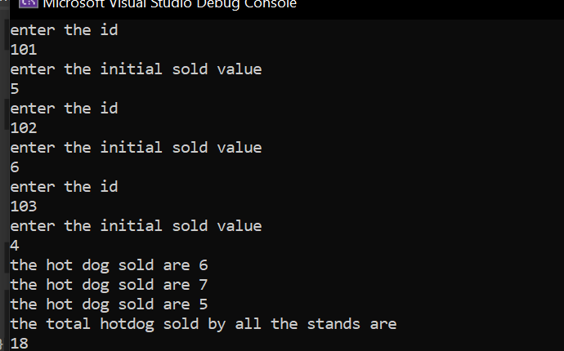
Question 3=
#include<iostream>
#include<string>
using namespace std;
struct student
{
string name;
int cnic;
string gender;
int cgpa;

};
class section
{
private:
student obj[39];
string section_name;
string teacher;
int student_count = 0;
int total_sections = 0;
public:
void editsection()
{
cout << "enter the section name " << endl;
getline(cin, section_name);
cout << "enter the teacher name " << endl;
getline(cin, teacher);

}
void addstudent()
{

cout << "enter the name " << endl;
getline(cin, obj[student_count].name);
cin.ignore();
cout << "ente the cnic " << endl;
cin >> obj[student_count].cnic;
cin.ignore();
cout << "enter the gender " << endl;
cin >> obj[student_count].gender;
cout << "enter the gpa " << endl;
cin >> obj[student_count].cgpa;

student_count++;

}
void updatelist()
{
int new_student;
cout << "which student data you want to update " << endl;
cin >> new_student;
if (new_student<0 || new_student>student_count)
{
cout << "print invalid student" << endl;
cin >> new_student;
}
string new_name;
int new_cnic;
int new_gpa;

obj [new_student];

cout << "enter the new name" << endl;
getline(cin, obj[new_student].name = new_name);
cout << "enter the new cnic " << endl;
cin >> obj[new_student].cnic;
new_cnic = obj[new_student].cnic;
cin.ignore();
cout << "enter new gpa" << endl;
cin >> obj[new_student].cgpa;
new_gpa= obj[new_student].cgpa;

}
void printlist()
{
cout << "the students pf the section are " << endl;
for (int i = 0; i < student_count; i++)
{
cout << "name =" << obj[i].name << endl;
cout << "cnic = " << obj[i].cnic << endl;
cout << "gender= " << obj[i].gender << endl;
cout << "cgpa= " << obj[i].cgpa << endl;
}
}
void printlistsections()
{
cout << "the list of sections are " << endl;
for (int i = 0; i <=total_sections; i++)
{
cout << "sections are " << section_name << endl;
}

}

};
int main()
{
int n;
cout << "enter the number of sections you want to create " << endl;
cin >> n;
section* arr = new section[n];
int choice;
do
{
cout << "enter the choice " << endl;
cin >> choice;
int index;
switch (choice)
{
case 1:
cout << "index =" << endl;
cin >> index;
cin.ignore();
arr[index].editsection();
break;
case 2:
cout << "index =" << endl;
cin >> index;
cin.ignore();
arr[index].addstudent();
break;
case 3:
cout << "index =" << endl;
cin >> index;
cin.ignore();
arr[index].updatelist();
break;
case 4:
cout << "index =" << endl;
cin >> index;
cin.ignore();
arr[index].printlist();
break;
case 5:
cout << "index =" << endl;
cin >> index;
arr[index].printlistsections();
break;
case 6:
cout << "program exited " << endl;
break;

default :
cout << "invalid " << endl;
break;

}

} while (choice!=6);

}
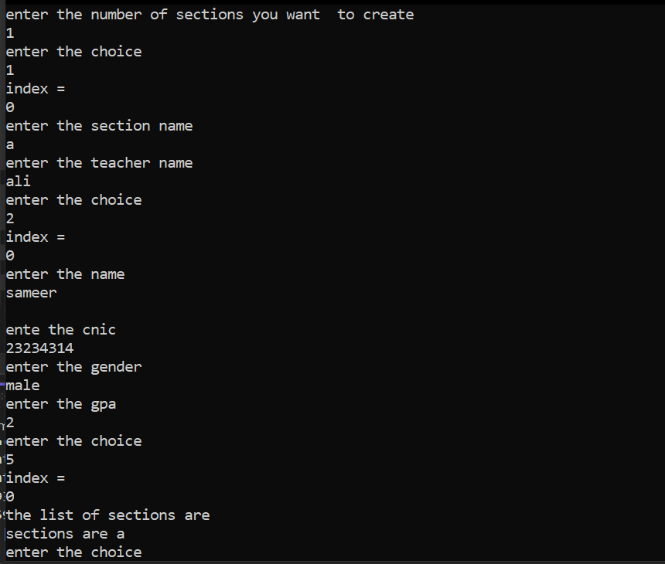
Question 4=
#include<iostream>
#include<string>
using namespace std;
class tollbooth
{
private:
long unsigned int total_cars ;
double amount_collected ;
public:
tollbooth()
{
total_cars = 0;
amount_collected = 0;

}
void payingcar()
{
total_cars++;
amount_collected += 50;

}
void nopayingcars()
{
total_cars++;
amount_collected;

}
void display() const
{
cout << "the total cars are " << total_cars << endl;
cout << "the amount collected is " << amount_collected << endl;
}

};
int main()
{
tollbooth t;
int choice;
do
{
cout << "enter choice " << endl;
cin >> choice;
switch (choice)
{
case 1:
t.payingcar();
break;
case 2:
t.nopayingcars();
break;
case 3:
t.display();
break;
case 4:
cout << "program exited " << endl;
break;
default:
cout << "invalid" << endl;
break;

}
} while (choice != 4);

}
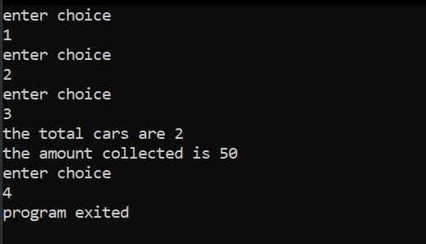
Queston 5=
#include<iostream>
using namespace std;

class time
{
private:
int hours;
int minutes;
int seconds;

public:
time()
{
hours = 0;
minutes = 0;
seconds = 0;
}

time(int x, int y, int z)
{
hours = x;
minutes = y;
seconds = z;
}

void display() const
{
cout << hours << ":" << minutes << ":" << seconds << endl;
}

void add(const time& t1, const time& t2)
{
hours = t1.hours + t2.hours;
minutes = t1.minutes + t2.minutes;
seconds = t1.seconds + t2.seconds;
}
};

int main()
{
time t1;
time t2(6, 12, 4);
time t3(1,25,5);

t3.add(t1, t2);
t3.display();

return 0;
}
