OOP-ASSIGNMENT-3
2.
#include<iostream>
using namespace std;
class Hotdogstand {
int id;
int noofhotdogs;
public:
Hotdogstand() {
cout << "Enter ID number of hotdog stand";
cin >> id;
cout << "Enter number of hotdogs sold in a day ";
cin >> noofhotdogs;
}
void justsold() {
noofhotdogs++;
}
int sold() {
return noofhotdogs;
}
static int noofhotdogssold;
static int hotdogs() {
return noofhotdogssold++;
}
};
int Hotdogstand::noofhotdogssold = 0;
int main() {
Hotdogstand* h = new Hotdogstand[3];
h[0].justsold();
h[1].justsold();
h[2].justsold();
cout << "Hot dog stands " << endl;
for (int i = 0;i < 3;i++)
cout << h[i].sold() << " " << endl;
cout << "Hot dogs sold " << endl;
for(int i=0;i<3;i++)
cout << h[i].hotdogs() << " " << endl;
return 0;
}
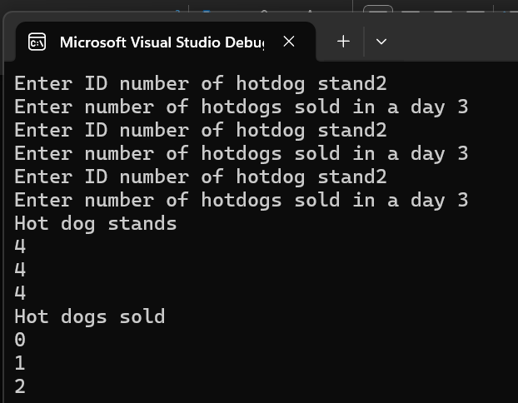

4.
#include<iostream>
using namespace std;
class Toll {
unsigned int totalcars;
double totalmoney;
public:
Toll() {
totalcars = 0;
totalmoney = 0;
}
void payingcar() {
totalcars++;
totalmoney = totalmoney + 50;
cout << "Paying car Status " << endl;
cout << "Total cars " << totalcars << "Total money " << totalmoney;
}
void nopaycar() {
totalcars++;
totalmoney = totalmoney + 0;
cout << "No paying car status " << endl;
cout << "Total cars" << totalcars << "Total money " << totalmoney;
}
void display() const {
cout << "Total number of cars " << totalcars << endl;
cout << "Total money from cars " << totalmoney << endl;
}
};
int main() {
Toll t1;
int key;
cout << "Enter key for car toll management" << endl << "1. Paying Car " << endl << "2. Non paying car " << endl;
cin >> key;
if (key == 1) {
t1.payingcar();
}
else if (key == 2) {
t1.nopaycar();
}
else {
t1.payingcar();
t1.nopaycar();
t1.display();
}
return 0;
}
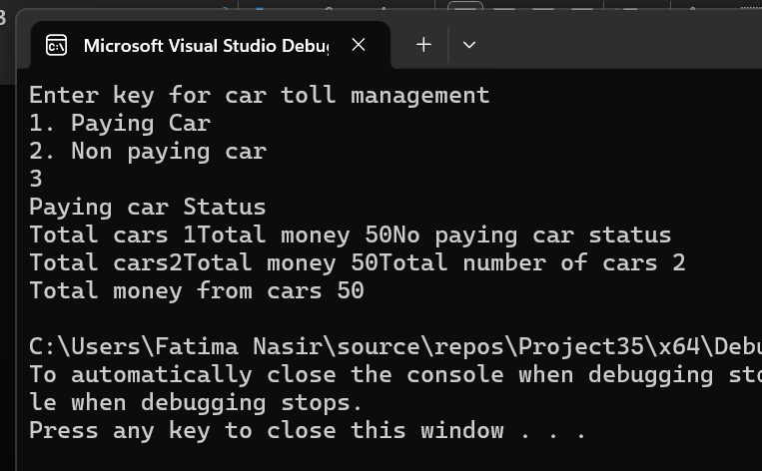

5.
#include<iostream>
using namespace std;
class Time {
int hours;
int minutes;
int seconds;
public:
Time() {
hours = 0;
minutes = 0;
seconds = 0;
}
Time(int h,int m,int s) {
hours = h;
minutes = m;
seconds = s;
}
void display() const {
cout << hours << " : " << minutes << " : " << seconds << endl;
}
Time add(Time t1,Time t2) const {
return Time(hours + t2.hours, minutes + t2.minutes, seconds + t2.seconds);

}
};
int main() {
Time t1;
Time t2(11, 59, 59);
Time t3;
t3=t2.add(t1, t2);
t3.display();
return 0;

}
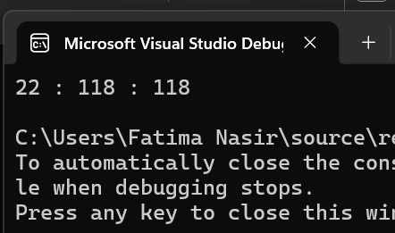

1.
#define _CRT_SECURE_NO_WARNINGS
#include <iostream>
#include <fstream>
#include <string>

using namespace std;

enum accounttype { //enum for account type
current,
saving
};

class account {
private:
char name[50];
char accnum[20];
const accounttype type;
double balance;
char bankname[50];
char branchcode[20];
char city[50];

static unsigned int currentcount;
static unsigned int savingcount;
static char globalbank[50];

public:
account() : type(saving), balance(0.0) //initializer
{
strcpy_s(name, "unknown");
strcpy_s(accnum, "0000");
savingcount++;
}

account(const char* n, const char* num, accounttype t, double bal,const char* bank, const char* branch, const char* cty) : type(t), balance(bal)
{
strncpy(name, n, 49);
name[49] = '\0';
strncpy(accnum, num, 19);
accnum[19] = '\0';
strncpy(bankname, bank, 49);
bankname[49] = '\0';
strncpy(branchcode, branch, 19);
branchcode[19] = '\0';
strncpy(city, cty, 49); city[49] =
'\0';
if (type == current)
currentcount++;
else
savingcount++;
}

~account()
{
if (type == current) {
if (currentcount > 0)
currentcount--; }
else
{
if (savingcount > 0)
savingcount--; }
}

static void setbankname(const char* bn) {
strncpy(globalbank, bn, 49);
globalbank[49] = '\0';
}

static const char* getbankname() {
return globalbank;
}

static unsigned int getcurrentcount()
{
return currentcount;
}
static unsigned int getsavingcount()
{
return savingcount;
}

void setname(const char* n)
{
strncpy(name, n, 49); name[49] = '\0';
}
void setaccnum(const char* num)
{
strncpy(accnum, num, 19); accnum[19] = '\0';
}
void setbalance(double b) {
balance = b;
}
void setbranchcode(const char* b)
{
strncpy(branchcode, b, 19); branchcode[19] = '\0';
}
void setcity(const char* c) {
strncpy(city, c, 49); city[49] = '\0';
}
void setbankname_inst(const char* b) {
strncpy(bankname, b, 49); bankname[49] = '\0';
}

const char* getname() const
{
return name;
}
const char* getaccnum() const {
return accnum;
}
accounttype gettype() const
{
return type;
}
double getbalance() const {
return balance;
}
const char* getbankname_inst() const {
return bankname;
}
const char* getbranchcode() const {
return branchcode;
}
const char* getcity() const {
return city;
}

void deposit(double amount) {
if (amount <= 0) {
cout << "invalid deposit amount.\n";

}
balance += amount;
cout << " Balance is : " << balance << "\n";
}

void withdraw(double amount) {
if (amount <= 0) {
cout << "invalid withdraw amount.\n";
return;
}
if (amount > balance) {
cout << "insufficient balance. available: " << balance << "\n";
return;
}
balance -= amount;
cout << "withdrawn " << amount << ". new balance: " << balance << "\n";
}

void display() const {
cout << "name : " << name << "\n";
cout << "acc number : " << accnum << "\n";
cout << "type : " << (type == current ? "current" : "saving") << "\n";
cout << "bank : " << bankname << "\n";
cout << "branch : " << branchcode << "\n";
cout << "city : " << city << "\n";
cout << "balance : " << balance << "\n";
cout << "-----------------------------\n";
}

void savetofile(ofstream& ofs) const {
ofs << name << "\n"
<< accnum << "\n"
<< (int)type << "\n"
<< balance << "\n"
<< bankname << "\n"
<< branchcode << "\n"
<< city << "\n";
}
};

unsigned int account::currentcount = 0;
unsigned int account::savingcount = 0;
char account::globalbank[50] = "national bank";

void clearinput() {
char ch;
while (cin.get(ch) && ch != '\n');
}

void loadfromfile(account* arr[], int& count) {
ifstream ifs("accounts.txt");
if (!ifs.is_open())
cout << "File opened successfully ";
char n[50], num[20], bank[50], branch[20], cty[50];
int t;
double bal;

while (count < 100) {
ifs.getline(n, 50);
if (ifs.eof())
break;
ifs.getline(num, 20);
ifs >> t;
ifs >> bal;
ifs.ignore();
ifs.getline(bank, 50);
ifs.getline(branch, 20);
ifs.getline(cty, 50);
if (ifs.fail()) break;
arr[count++] = new account(n, num, (accounttype)t, bal, bank, branch, cty);
}
ifs.close();
}

void savetofile(account* arr[], int count) {
ofstream ofs("accounts.txt");
if (!ofs.is_open()) {
cout << "could not open file.\n";
return;
}
for (int i = 0; i < count; i++) {
arr[i]->savetofile(ofs);
}
ofs.close();
cout << "data saved to accounts.txt\n";
}

void createaccount(account* arr[], int& count) {
if (count >= 100) {
cout << "account limit reached.\n";
return;
}

char n[50], num[20], bank[50], branch[20], cty[50];
int t;
double bal;

cout << "enter name: ";
cin.getline(n, 50);
cout << "enter account number: ";
cin.getline(num, 20);
cout << "account type (0=current, 1=saving): ";
cin >> t;
cout << "initial balance: ";
cin >> bal;
clearinput();
cout << "bank name: ";
cin.getline(bank, 50);
cout << "branch code: ";
cin.getline(branch, 20);
cout << "city: ";
cin.getline(cty, 50);

arr[count++] = new account(n, num, (accounttype)t, bal, bank, branch, cty);
cout << "account created successfully.\n";
}

void displayall(account* arr[], int count) {
if (count == 0) {
cout << "no accounts found.\n";
return;
}
for (int i = 0; i < count; i++) {
cout << "[" << i + 1 << "] ";
arr[i]->display();
}
cout << "current accounts: " << account::getcurrentcount()
<< " saving accounts: " << account::getsavingcount() << "\n";
}

void deleteaccount(account* arr[], int& count) {
if (count == 0) {
cout << "no accounts to delete.\n";
return;
}
displayall(arr, count);
cout << "enter account index to delete: ";
int idx;
cin >> idx;
clearinput();
idx--;
if (idx < 0 || idx >= count) {
cout << "invalid index.\n";
return;
}
delete arr[idx];
for (int i = idx; i < count - 1; i++) {
arr[i] = arr[i + 1];
}
arr[--count] = nullptr;
cout << "account deleted.\n";
}

void depositwithdraw(account* arr[], int count, bool isdeposit) {
if (count == 0) { cout << "no accounts.\n"; return; }
displayall(arr, count);
cout << "select account index: ";
int idx;
cin >> idx;
double amt;
cout << "enter amount: ";
cin >> amt;
clearinput();
idx--;
if (idx < 0 || idx >= count) { cout << "invalid index.\n"; return; }
if (isdeposit) arr[idx]->deposit(amt);
else arr[idx]->withdraw(amt);
}

int main() {
account* arr[100] = { nullptr };
int count = 0;

account::setbankname("national bank");
loadfromfile(arr, count);
cout << "loaded " << count << " account(s) from file.\n";

int choice;
do {
cout << " Bank account system \n";
cout << "1. create account\n";
cout << "2. display all accounts\n";
cout << "3. deposit\n";
cout << "4. withdraw\n";
cout << "5. delete account\n";
cout << "6. save to file\n";
cout << "7. exit\n";
cout << "enter choice: ";
cin >> choice;
clearinput();
switch (choice) {
case 1: createaccount(arr, count); break;
case 2: displayall(arr, count); break;
case 3: depositwithdraw(arr, count, true); break;
case 4: depositwithdraw(arr, count, false); break;
case 5: deleteaccount(arr, count); break;
case 6: savetofile(arr, count); break;
case 7:
savetofile(arr, count);
for (int i = 0; i < count; i++)
delete arr[i];
cout << "goodbye.\n";
break;
default:
cout << "invalid option.";
}
} while (choice != 7);

return 0;

