Object oriented programming assignment 3
Task 1:
#include<iostream>
#include<fstream>
#include<cstring>
using namespace std;
class Account
{
public:
enum AccountType
{
CURRENT,
SAVING
};
private:
char name[50];
char accNo[20];
const AccountType type;
double bal;
static char bankName[50];
char branch[20];
char city[20];
static unsigned int curCount;
static unsigned int savCount;

public:
// Default constructor
Account() : type(SAVING)
{
strcpy(name, "N/A");
strcpy(accNo, "0");
strcpy(branch, "N/A");
strcpy(city, "N/A");
bal = 0;
savCount++;
}
// Parameterized constructor
Account(char n[], char a[], AccountType type, double b, char br[], char c[]) : type(type)
{
strcpy(name, n);
strcpy(accNo, a);
strcpy(branch, br);
strcpy(city, c);
bal = b;
if (type == CURRENT)
curCount++;
else
savCount++;
}
// Destructor
~Account()
{
if (type == CURRENT)
curCount--;
else
savCount--;
}
// Static function to set bank name
static void setBankName(char b[])
{
strcpy(bankName, b);
}
// Static function to get bank name
static char* getBankName()
{
return bankName;
}
// Static function to show the count
static void showCounts()
{
cout << "Current Accounts: " << curCount << endl;
cout << "Saving Accounts: " << savCount << endl;
cout << "Total: " << curCount + savCount << endl;
}
void deposit(double amount)
{
if (amount > 0)
bal += amount;
else
cout << "Invalid amount!" << endl;
}
void withdraw(double amount)
{
if (amount > 0 && amount <= bal)
bal -= amount;
else
cout << "Insufficient balance!" << endl;
}
// Display
void display()
{
cout << "\nName: " << name << endl;
cout << "Bank: " << bankName << endl;
cout << "City: " << city << endl;
cout << "Balance: " << bal << endl;
cout << "Acc No: " << accNo << endl;
cout << "Type: " << (type == CURRENT ? "Current" : "Saving") << endl;
}
// Getter
char* getAccNo()
{
return accNo;
}
// Save to file
void save(ofstream& out)
{
out << name << "\n";
out << accNo << "\n";
out << type << "\n";
out << bal << "\n";
out << branch << "\n";
out << city << "\n";
}
};
// Static initialization
char Account::bankName[50] = "MyBank";
unsigned int Account::curCount = 0;
unsigned int Account::savCount = 0;

int main()
{
Account* arr[100];
for (int i = 0; i < 100; i++)
arr[i] = nullptr;

int count = 0;
// Load from file
ifstream in("accounts.txt");
if (in)
{
char name[50], acc[20], branch[20], city[20];
int type;
double bal;

while (count < 100 && in >> name >> acc >> type >> bal >> branch >> city)
{
arr[count] = new Account(name, acc,(Account::AccountType)type, bal, branch, city);
count++;
}
in.close();
cout << count << " accounts loaded." << endl;
}
int choice;
do
{
cout << "\n1. Create" << endl;
cout << "2. Display" << endl;
cout << "3. Deposit" << endl;
cout << "4. Withdraw" << endl;
cout << "5. Delete" << endl;
cout << "6. Show Counts" << endl;
cout << "0. Exit" << endl;
cout << "Choice: ";
cin >> choice;
if (choice == 1)
{
if (count >= 100)
{
cout << "Maximum accounts reached!" << endl;
continue;
}
char name[50], acc[20], branch[20], city[20];
int t;
double bal;

cout << "Name: ";
cin >> name;
cin.ignore();
cout << "Acc No: ";
cin >> acc;
cin.ignore();
cout << "Type (0=Current, 1=Saving): ";
cin >> t;
cout << "Balance: ";
cin >> bal;
cout << "Branch: ";
cin >> branch;
cout << "City: ";
cin >> city;

arr[count++] = new Account(name, acc, (Account::AccountType)t, bal, branch, city);
cout << "Account created!" << endl;
}
else if (choice == 2)
{
if (count == 0)
{
cout << "No accounts!" << endl;
continue;
}
for (int i = 0; i < count; i++)
arr[i]->display();
Account::showCounts();
}
else if (choice == 3)
{
char acc[20]; double amt;
cout << "Acc No: "; cin >> acc;
bool found = false;
for (int i = 0; i < count; i++)
{
if (strcmp(arr[i]->getAccNo(), acc) == 0)
{
cout << "Amount: "; cin >> amt;
arr[i]->deposit(amt);
found = true;
break;
}
}
if (!found) cout << "Account not found!" << endl;
}
else if (choice == 4)
{
char acc[20]; double amt;
cout << "Acc No: "; cin >> acc;
bool found = false;
for (int i = 0; i < count; i++)
{
if (strcmp(arr[i]->getAccNo(), acc) == 0)
{
cout << "Amount: "; cin >> amt;
arr[i]->withdraw(amt);
found = true;
break;
}
}
if (!found) cout << "Account not found!" << endl;
}
else if (choice == 5)
{
char acc[20];
cout << "Acc No: "; cin >> acc;
bool found = false;
for (int i = 0; i < count; i++)
{
if (strcmp(arr[i]->getAccNo(), acc) == 0)
{
delete arr[i];
for (int j = i; j < count - 1; j++)
{
arr[j] = arr[j + 1];
}
arr[count - 1] = nullptr;
count--;
found = true;
cout << "Account deleted" << endl;
break;
}
}
if (!found) cout << "Account not found" << endl;
}
else if (choice == 6)
{
Account::showCounts();
}
} while (choice != 0);
// Save to file
ofstream out("accounts.txt");
for (int i = 0; i < count; i++)
arr[i]->save(out);
out.close();
cout << "Accounts saved" << endl;
// Free memory
for (int i = 0; i < count; i++)
{
delete arr[i];
arr[i] = nullptr;
}
}

Accounts.txt:

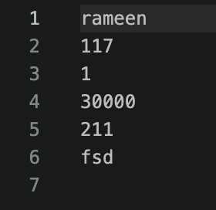
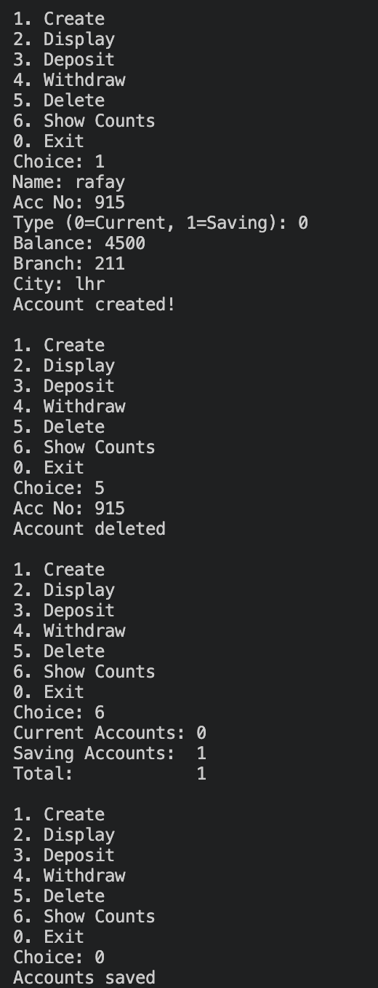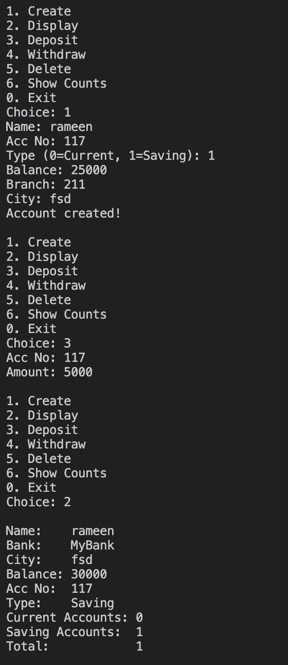
Task 2:
#include<iostream>
using namespace std;
class HotDogStand
{
private:
int id;
int hotdogsSold; // 1 stand sy
static int totalSold; // sab stands k mila k

public:
// Constructor
HotDogStand(int i, int sold)
{
id = i;
hotdogsSold = sold;
totalSold += sold;
cout << "Stand " << id << " created!" << endl;
}
// Destructor
~HotDogStand()
{
cout << "Stand " << id << " closed." << endl;
}
void justSold()
{
hotdogsSold++;
totalSold++;
cout << "Stand " << id << " sold a hotdog! "<< "Stand total: " << hotdogsSold << endl;
}
int getSold()
{
return hotdogsSold;
}
int getID()
{
return id;
}
void display()
{
cout << "Stand ID: " << id << endl;
cout << "Stand Sold: " << hotdogsSold << endl;
}
static int getTotalSold()
{
return totalSold;
}
};
// Static variable define
int HotDogStand::totalSold = 0;
int main()
{
HotDogStand* s1 = new HotDogStand(1, 0);
HotDogStand* s2 = new HotDogStand(2, 0);
HotDogStand* s3 = new HotDogStand(3, 0);
cout << endl << "===Stand 1 ===" << endl;
s1->justSold();
s1->justSold();
s1->justSold(); // 3 hotdogs
cout << endl << "===Stand 2 ===" << endl;
s2->justSold();
s2->justSold(); // 2 hotdogs
cout << endl << "===Stand 3 ===" << endl;
s3->justSold();
s3->justSold();
s3->justSold();
s3->justSold(); // 4 hotdogs
//Summary
cout << endl << "=== summary ===" << endl;
s1->display();
cout << endl;
s2->display();
cout << endl;
s3->display();
cout << endl;
cout << "Total Hotdogs Sold : " << HotDogStand::getTotalSold() << endl;
//Delete
cout << endl << "════ Closing Stands ════" << endl;
delete s1;
delete s2;
delete s3;

}
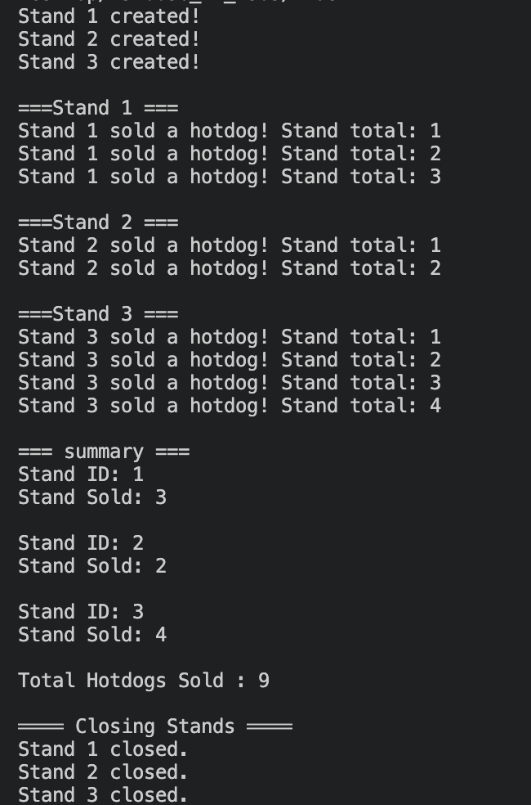
Task 4:
#include<iostream>
using namespace std;

class tollbooth
{
private:
unsigned int totalCars;
double totalCash;
public:
// Constructor
tollbooth()
{
totalCars = 0;
totalCash = 0;
}
void payingCar()
{
totalCars++;
totalCash += 50;
cout << "Paying car passed. Added 50 cash" << endl;
}
void noPayCar()
{
totalCars++;
cout << "Non-paying car passed. No cash added." << endl;
}
// Display const because just reading
void display() const
{
cout << "Total Cars: " << totalCars << endl;
cout << "Total Cash: " << totalCash << " rupees" << endl;
}
// same goes for these
unsigned int getCars() const { return totalCars; }
double getCash() const { return totalCash; }
};

int main()
{
tollbooth* tb = new tollbooth();
char choice;
cout << "============================" << endl;
cout << " TOLL BOOTH SYSTEM " << endl;
cout << "============================" << endl;
cout << "P = Paying car" << endl;
cout << "N = Non-paying car" << endl;
cout << "D = Display totals" << endl;
cout << "E = Exit" << endl;
cout << "-----------------------------" << endl;

do
{
cout << "\nEnter choice: ";
cin >> choice;
if(choice == 'p' || choice == 'P')
{
tb->payingCar();
}
else if(choice == 'n' || choice == 'N')
{
tb->noPayCar();
}
else if(choice == 'd' || choice == 'D')
{
cout << endl;
tb->display();
}
else if(choice != 'e' && choice != 'E')
{
cout << "Invalid choice!" << endl;
}

} while(choice != 'e' && choice != 'E');
// Final display
cout << endl << "════ Final Report ════" << endl;
tb->display();
// Free memory
delete tb;
tb = nullptr;
cout << "Goodbye!" << endl;
}
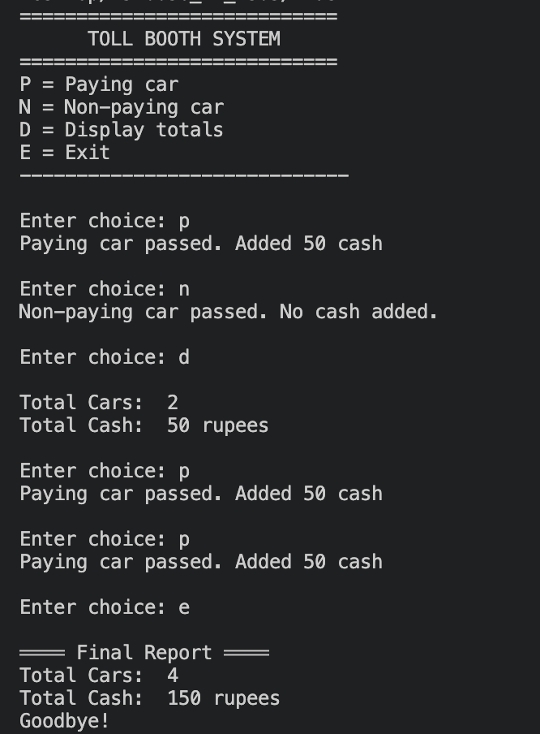
Task 5:
#include<iostream>
#include<iomanip>
using namespace std;
class time2
{
private:
int hours;
int minutes;
int seconds;
public:
// Default constructor
time2()
{
hours = 0;
minutes = 0;
seconds = 0;
}
// Parameterized constructor
time2(int h, int m, int s)
{
hours = h;
minutes = m;
seconds = s;
}
// Display in 11:59:59 format
void display() const
{
cout << setw(2) << setfill('0') << hours << ":"
<< setw(2) << setfill('0') << minutes << ":"
<< setw(2) << setfill('0') << seconds << endl;
}
// const parameters t1 t2 change nahi honge
void add(const time2& t1, const time2& t2)
{
seconds = t1.seconds + t2.seconds;
minutes = t1.minutes + t2.minutes + seconds / 60;
hours = t1.hours + t2.hours + minutes / 60;
seconds %= 60;
minutes %= 60;
hours %= 24;
}
};
int main()
{
const time2 t1(11, 40, 23);
const time2 t2(7, 55, 77);
time2 t3;
cout << "Time 1: ";
t1.display();
cout << "Time 2: ";
t2.display();
// Add karo
t3.add(t1, t2);
cout << "Result: ";
t3.display();
}

