OOP SPRING 2026 (All Section)
ASSIGNMENT#3

TASK#5:
#include <iostream>
using namespace std;

class Time
{
private:
int h;
int min;
int sec;

public:
Time()
{
this->h = 0;
this->min = 0;
this->sec = 0;
}
Time(int h, int m, int s)
{
this->h = h;
this->min = m;
this->sec = s;
}
void display() const
{
cout << h << ":" << min << ":" << sec << endl;
}
void add(const Time t1, const Time t2)
{
this->sec = t1.sec + t2.sec;
this->min = t1.min + t2.min;
this->h = t1.h + t2.h;
if(this->sec >= 60)
{
this->sec -= 60;
this->min++;
}
if(this->min >= 60)
{
this->min -= 60;
this->h++;
}
}
};

int main()
{
const Time t1(2,15,15);
const Time t2(1,30,30);
Time t3;
t3.add(t1, t2);
t3.display();

return 0;
}
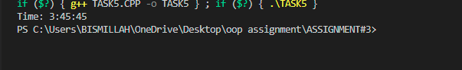
TASK#4:
#include <iostream>
using namespace std;

class tollbooth
{
private:
unsigned int totalCars;
double totalCash;

public:
tollbooth()
{
totalCars = 0;
totalCash = 0.0;
}
void payingCar()
{
totalCars++;
totalCash += 50;
}
void noPayCar()
{
totalCars++;
}

void display() const
{
cout << "\nTotal Cars: " << totalCars;
cout << "\nTotal Cash: " << totalCash << " RS\n";
}
};

int main()
{
tollbooth booth;
char choice;
for( ; ; )
{
cout << "\n Toll Booth Menu";
cout << "\np --> Paying Car";
cout << "\nn --> Non-Paying Car";
cout << "\nd --> Display";
cout << "\ne --> Exit";
cout << "\nEnter choice: ";
cin >> choice;
if (choice == 'p')
booth.payingCar();
else if (choice == 'n')
booth.noPayCar();
else if (choice == 'd')
booth.display();
else if (choice == 'e')
{
cout << "\nProgram Ended\n";
break;
}
}
return 0;
}

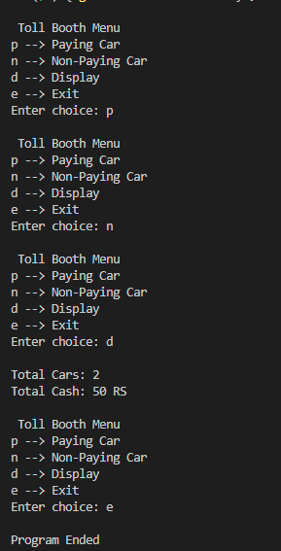
TASK#2:
#include <iostream>
using namespace std;

class HotDogStand
{
private:
int ID;
int hotDogsSold;

static int totalHotDogsSold;

public:

HotDogStand(int id, int sold)
{
ID = id;
hotDogsSold = sold;
}
void justSold()
{
hotDogsSold++;
totalHotDogsSold++;
}
static int getTotalSold()
{
return totalHotDogsSold;
}
void display() const
{
cout << "Stand ID: " << ID<< ", Hot Dogs Sold: " << hotDogsSold << endl;

}
};

int HotDogStand::totalHotDogsSold = 0;

int main()
{

HotDogStand stand1(111, 0);
HotDogStand stand2(222, 0);
HotDogStand stand3(333, 0);
stand1.justSold();
stand1.justSold();
stand2.justSold();
stand3.justSold();
stand3.justSold();
stand3.justSold();
stand1.display();
stand2.display();
stand3.display();
cout << "\nTotal Hot Dogs Sold all stands: "
<< HotDogStand::getTotalSold() << endl;

return 0;
}

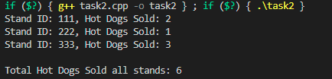
TASK#1:

#include <iostream>
#include <fstream>
#include <cstring>
using namespace std;

class Account
{
public:
enum AccType { CURRENT, SAVING };

private:
char name[50];
char accNumber[20];
AccType type;
double balance;
char bankName[50];
char branchCode[20];
char city[30];

static unsigned int currentCount;
static unsigned int savingCount;

public:
Account()
{
strcpy(name, "");
strcpy(accNumber, "");
strcpy(bankName, "");
strcpy(branchCode, "");
strcpy(city, "");
balance = 0;
type = SAVING;
savingCount++;
}

void input()
{
int t;
cout << "Enter Name: ";
cin >> name;
cout << "Enter Account Number: ";
cin >> accNumber;
cout << "Enter Bank Name: ";
cin >> bankName;
cout << "Enter Branch Code: ";
cin >> branchCode;
cout << "Enter City: ";
cin >> city;
cout << "Enter Balance: ";
cin >> balance;
cout << "Enter Type (0 Current / 1 Saving): ";
cin >> t;

type = (t == 0) ? CURRENT : SAVING;

if (type == CURRENT)
currentCount++;
else
savingCount++;
}

void deposit(double amount)
{
balance += amount;
}

void withdraw(double amount)
{
if (amount <= balance)
balance -= amount;
else
cout << "Insufficient Balance\n";
}

void display() const
{
cout << "\nName: " << name;
cout << "\nAccount: " << accNumber;
cout << "\nBank: " << bankName;
cout << "\nCity: " << city;
cout << "\nBalance: " << balance << endl;
}

static void showCounts()
{
cout << "\nCurrent Accounts: " << currentCount;
cout << "\nSaving Accounts: " << savingCount << endl;
}

void save(ofstream &out)
{
out << name << endl;
out << accNumber << endl;
out << type << endl;
out << balance << endl;
out << bankName << endl;
out << branchCode << endl;
out << city << endl;
}

void load(ifstream &in)
{
int t;
in >> name;
in >> accNumber;
in >> t;
type = (t == 0) ? CURRENT : SAVING;
in >> balance;
in >> bankName;
in >> branchCode;
in >> city;

if (type == CURRENT)
currentCount++;
else
savingCount++;
}
};

unsigned int Account::currentCount = 0;
unsigned int Account::savingCount = 0;

int main()
{
Account* arr[100];
int count = 0;

ifstream in("accounts.txt");
if (in)
{
while (!in.eof())
{
Account* temp = new Account;
temp->load(in);
if (in)
arr[count++] = temp;
else
delete temp;
}
in.close();
}

int choice;

do
{
cout << "\n1. Create Account";
cout << "\n2. Display All";
cout << "\n3. Deposit";
cout << "\n4. Withdraw";
cout << "\n5. Delete Account";
cout << "\n6. Show Counts";
cout << "\n7. Exit";
cout << "\nEnter: ";
cin >> choice;

if (choice == 1)
{
if (count < 100)
{
arr[count] = new Account;
arr[count]->input();
count++;
}
}

else if (choice == 2)
{
for (int i = 0; i < count; i++)
arr[i]->display();
}

else if (choice == 3)
{
int i;
double amt;
cout << "Index: ";
cin >> i;
cout << "Amount: ";
cin >> amt;
if (i >= 0 && i < count)
arr[i]->deposit(amt);
}

else if (choice == 4)
{
int i;
double amt;
cout << "Index: ";
cin >> i;
cout << "Amount: ";
cin >> amt;
if (i >= 0 && i < count)
arr[i]->withdraw(amt);
}

else if (choice == 5)
{
int i;
cout << "Index: ";
cin >> i;

if (i >= 0 && i < count)
{
delete arr[i];
for (int j = i; j < count - 1; j++)
arr[j] = arr[j + 1];
count--;
}
}

else if (choice == 6)
{
Account::showCounts();
}

} while (choice != 7);

ofstream out("accounts.txt");
for (int i = 0; i < count; i++)
arr[i]->save(out);
out.close();

for (int i = 0; i < count; i++)
delete arr[i];

return 0;
}
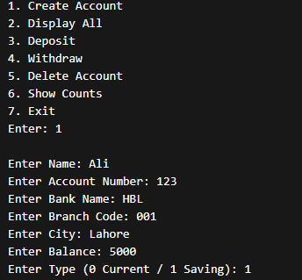

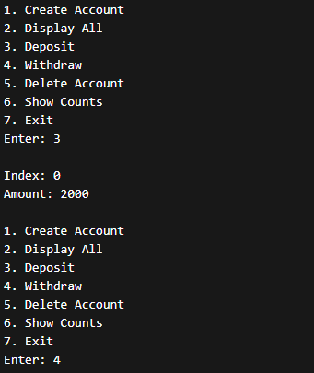
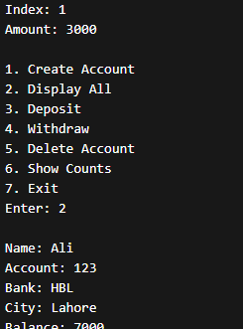
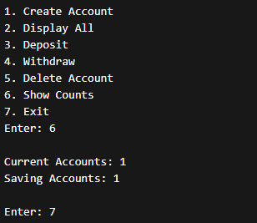
TASK#3:
PENDING…….

