OOP
Object Oriented Programming
F25-0013
Assignment #03

Question 2:
#include<iostream>
using namespace std;
class HotDogStand
{
private:
int HdID;
int HdSold;
public:
static int TotalHdSold;
HotDogStand(int id, int s)
{
HdID=id;
HdSold=s;
TotalHdSold+=s;
}
void JustSold()
{
HdSold++;
TotalHdSold++;

}
int HdPerDay()
{
return HdSold;
}
static int GetTotalHd()
{
return TotalHdSold;
}

};

int HotDogStand::TotalHdSold=0;
int main()
{
HotDogStand h1(1,20);
HotDogStand h2(2,50);
HotDogStand h3(3,2);
h1.JustSold();
h2.JustSold();
h3.JustSold();
cout<<"HotDogs Sold per day by stand 1 ="<<" "<<h1.HdPerDay()<<endl;
cout<<"HotDogs Sold per day by stand 2 ="<<" "<<h2.HdPerDay()<<endl;
cout<<"HotDogs Sold per day by stand 3 ="<<" "<<h3.HdPerDay()<<endl;

cout<<"\nTotal HotDogs Sold="<<" "<<HotDogStand::GetTotalHd()<<endl;

cin.ignore();
cin.get();
}
Output:
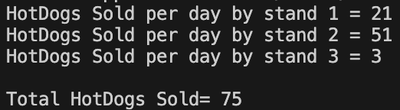

Question 4:
#include<iostream>
using namespace std;
class TollBooth
{
private:
unsigned int TotalCars;
double TotalAmount;
public:
TollBooth()
{
TotalCars=0;
TotalAmount=0;
}
void payingCar()
{
TotalCars++;
TotalAmount+=50;
}
void noPayCar()
{
TotalCars++;
}
void display() const
{
cout<<"|Total number of Cars|= "<<TotalCars<<endl;
cout<<"|Total Cash Amount|= "<<TotalAmount<<endl;
}

};

int main()
{
TollBooth t;
int choice;
do
{
cout<<"\nEnter 1 for Paying Car.\n"<<"Enter 2 for nonPaying Car.\n"<<"Enter 3 for Displaying values.\n"<<"Enter 4 for Exit.\n"<<endl;
cout<<"Enter choice = "<<endl;
cin>>choice;

switch(choice)
{
case 1:
t.payingCar();
break;
case 2:
t.noPayCar();
break;
case 3:
t.display();
break;
case 4:
cout<<"Exit!"<<endl;
break;
default:
cout<<"Invalid Choice"<<endl;
break;
}

} while (choice!=4);

cin.ignore();
cin.get();

}
Output:
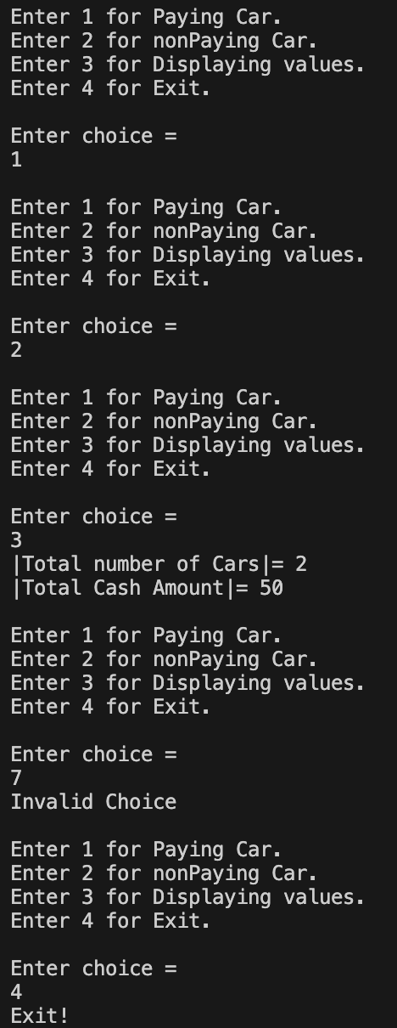

Question 5:
#include<iostream>
using namespace std;
class Time
{
private:
int hours;
int minutes;
int seconds;
public:
Time()
{
hours=0;
minutes=0;
seconds=0;
}
Time(int h, int m, int s)
{
hours=h;
minutes=m;
seconds=s;
}
void add(Time t,Time t1)
{
hours=t.hours+t1.hours;
minutes=t.minutes+t1.minutes;
seconds=t.seconds+t1.seconds;
if(seconds>=60)
{
minutes+=seconds/60;
seconds=seconds%60;
}
if(minutes>=60)
{
hours+=minutes/60;
minutes=minutes%60;
}
}
void Display()const
{
cout<<"\n|FORMAT|"<<" "<<hours<<":"<<minutes<<":"<<seconds<<endl;
}
};

int main()
{
Time const t(2,50,600);
Time const t1(5,20,1);
Time tResult;
tResult.add(t,t1);
tResult.Display();

cin.ignore();
cin.get();
}
Output:


Question 3:
#include<iostream>
#include<fstream>
using namespace std;
struct Students
{
string name;
int cnic;
string gender;
float cgpa;
};
class Section
{
private:
Students arr[40];
char secName;
string teacher;
int count;
public:
Section()
{
secName='A';
teacher="None";
count=0;
}
void editSection(int choice)
{
if(choice==0)
{
cout<<"Enter new section name= ";
cin>>secName;
}
else if(choice==1)
{
cout<<"Enter new class teacher= ";
cin>>teacher;
}
}
void addStudent(string n,long long int c,string g,float cg)
{
if(count<40)
{
arr[count].name=n;
arr[count].cnic=c;
arr[count].gender=g;
arr[count].cgpa=cg;
count++;
}
else
{
cout<<"Section Full!"<<endl;
}
}
void updateStudent(int choice,int index)
{
if(index<0 || index>=count)
{
cout<<"Invalid index"<<endl;
return;
}

if(choice==0)
{
cout<<"Enter new name= ";
cin>>arr[index].name;
}
else if(choice==1)
{
cout<<"Enter new cnic= ";
cin>>arr[index].cnic;
}
else if(choice==2)
{
cout<<"Enter new gender= ";
cin>>arr[index].gender;
}
else if(choice==3)
{
cout<<"Enter new cgpa= ";
cin>>arr[index].cgpa;
}
}

void printList()
{
cout<<"Section "<<secName<<" | Teacher= "<<teacher<<endl;

for(int i=0;i<count;i++)
{
cout<<"\nStudent "<<i+1<<endl;
cout<<"Name= "<<arr[i].name<<endl;
cout<<"CNIC= "<<arr[i].cnic<<endl;
cout<<"Gender= "<<arr[i].gender<<endl;
cout<<"CGPA= "<<arr[i].cgpa<<endl;
}
}

int getCount()
{
return count;
}

Students getStudent(int i)
{
if(i<0 || i>=count)
{
return Students();
}
return arr[i];
}

char getSectionName()
{
return secName;
}

string getTeacher()
{
return teacher;
}

void setSectionName(char s)
{
secName=s;
}

void setTeacher(string t)
{
teacher=t;
}

};

int main()
{
int size,choice;
Section* ptr;
ifstream fin("data.txt");
if(fin)
{
fin>>size;
ptr=new Section[size];
for(int i=0;i<size;i++)
{
char sec;
string teacher;
int students;
if(!(fin>>sec>>teacher>>students)) break;
ptr[i].setSectionName(sec);
ptr[i].setTeacher(teacher);

for(int j=0;j<students;j++)
{
string n,g;
long long int c;
float cg;
if(!(fin>>n>>c>>g>>cg)) break;
ptr[i].addStudent(n,c,g,cg);
}
}
fin.close();
}
else
{
cout<<"Enter number of sections= ";
cin>>size;
ptr=new Section[size];
for(int i=0;i<size;i++)
{
char sec;
string teacher;
cout<<"\nEnter section name: ";
cin>>sec;
ptr[i].setSectionName(sec);
cout<<"Enter teacher name: ";
cin>>teacher;
ptr[i].setTeacher(teacher);
int s;
cout<<"Enter number of students: ";
cin>>s;

for(int j=0;j<s;j++)
{
string n,g;
long long int c;
float cg;
cout<<"Enter name= ";
cin>>n;
cout<<"Enter CNIC= ";
cin>>c;
cout<<"Enter gender= ";
cin>>g;
cout<<"Enter CGPA= ";
cin>>cg;
ptr[i].addStudent(n,c,g,cg);
}
}
}
do
{
cout<<"\nEnter\n 1.Edit Section\n2.Add Student\n3.Update Student\n4.Print Section Students\n5.Print All Sections\n6.Save & Exit\n"<<endl;
cin>>choice;
switch(choice)
{
case 1:
{
int sec,ch;
cout<<"Enter section index= "<<endl;
cin>>sec;
if(sec<0 || sec>=size) break;
cout<<"0.Section Name 1.Teacher\n";
cin>>ch;
ptr[sec].editSection(ch);
break;
}
case 2:
{
int sec;
cout<<"Enter section index= ";
cin>>sec;
if(sec<0 || sec>=size) break;
string n,g;
long long int c;
float cg;
cout<<"Enter name= ";
cin>>n;
cout<<"Enter CNIC= ";
cin>>c;
cout<<"Enter gender= ";
cin>>g;
cout<<"Enter CGPA= ";
cin>>cg;

ptr[sec].addStudent(n,c,g,cg);
break;
}
case 3:
{
int sec,index,ch;
cout<<"Enter section index= ";
cin>>sec;
if(sec<0 || sec>=size) break;
cout<<"Enter student index= ";
cin>>index;
cout<<"0.Name 1.CNIC 2.Gender 3.CGPA\n";
cin>>ch;
ptr[sec].updateStudent(ch,index);
break;
}
case 4:
{
int sec;
cout<<"Enter section index= ";
cin>>sec;
if(sec<0 || sec>=size) break;
ptr[sec].printList();
break;
}
case 5:
{
for(int i=0;i<size;i++)
{
cout<<"\n| Section "<<i<<" |\n";
ptr[i].printList();
}
break;
}
case 6:
{
ofstream fout("data.txt");
fout<<size<<endl;
for(int i=0;i<size;i++)
{
fout<<ptr[i].getSectionName()<<" "
<<ptr[i].getTeacher()<<" "
<<ptr[i].getCount()<<endl;
for(int j=0;j<ptr[i].getCount();j++)
{
Students s=ptr[i].getStudent(j);
fout<<s.name<<" "
<<s.cnic<<" "
<<s.gender<<" "
<<s.cgpa<<endl;
}
}
fout.close();
cout<<"Data Saved!"<<endl;
break;
}
}
}

while(choice!=6);
delete[] ptr;

cin.ignore();
cin.get();

}
Output:

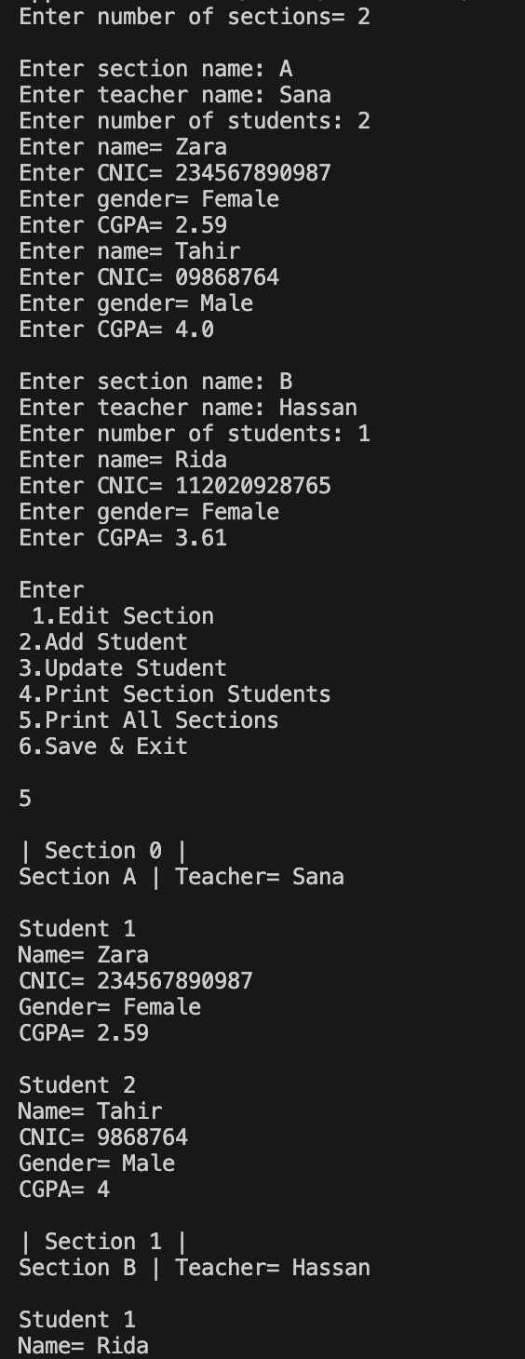
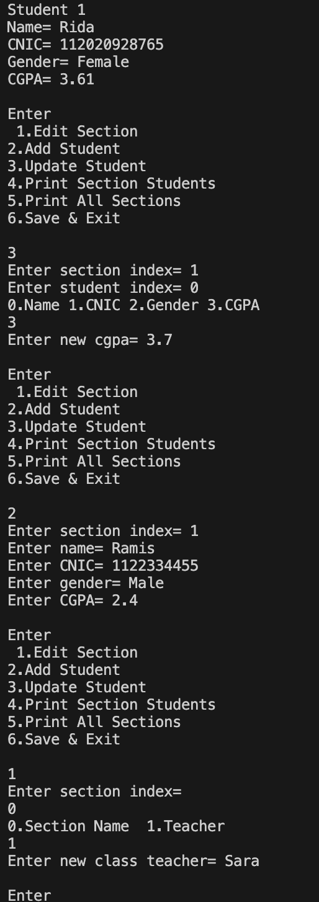
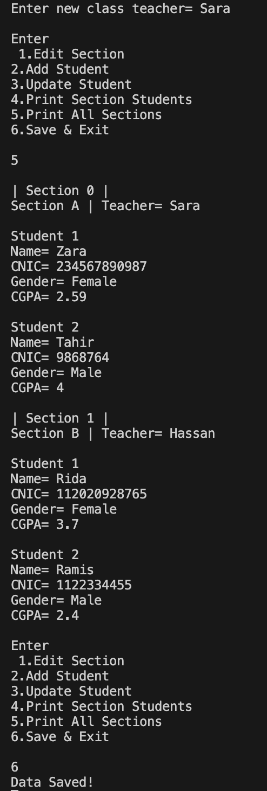
Question 1:
#include<iostream>
#include<fstream>
#include<cstring>
using namespace std;
enum AccountType { Current, Saving };
class BankAccount
{
private:
char name[50];
char num[30];
const AccountType type;
double balance;
char BankName[50];
char code[20];
char city[50];
static unsigned int currentCount;
static unsigned int savingCount;
public:
BankAccount() : type(Saving)
{
strcpy(name, "Not Defined");
strcpy(num, "0");
balance = 0;
strcpy(BankName, "Not Defined");
strcpy(code, "0");
strcpy(city, "Not Defined");
savingCount++;
}
BankAccount(char n[], char no[], double b, char bank[], char c[], char ci[], AccountType t) : type(t)
{
strcpy(name, n);
strcpy(num, no);
balance = b;
strcpy(BankName, bank);
strcpy(code, c);
strcpy(city, ci);
if (t == Saving)
savingCount++;
else
currentCount++;
}
static unsigned int getAccCounts()
{
return savingCount + currentCount;
}
void Deposit(double amount)
{
balance += amount;
}
void Withdraw(double amount)
{
if (amount <= balance)
{
balance -= amount;
}
else
{
cout << "Low Balance!" << endl;
}
}
void Display()
{
cout << "Name: " << name << endl;
cout << "Bank: " << BankName << endl;
cout << "City: " << city << endl;
cout << "Balance: " << balance << endl;
}
char* getName()
{
return name;
}
char* getNumber()
{
return num;
}
double getBalance()
{
return balance;
}
char* getBank()
{
return BankName;
}
char* getCode()
{
return code;
}
char* getCity()
{
return city;
}

const char* getTypeString()
{
if (type == Saving)
return "Saving";
else
return "Current";
}

~BankAccount()
{
if (type == Saving)
savingCount--;
else
currentCount--;
}

};

unsigned int BankAccount::currentCount = 0;
unsigned int BankAccount::savingCount = 0;

int main()
{
const int size = 100;
BankAccount* acc[size];
for (int i = 0; i < size; i++)
acc[i] = NULL;

ifstream infile("accounts.txt");
if (infile)
{
char n[50], no[30], bank[50], cod[20], ci[50], type[20];
double b;
while (infile >> n >> no >> type >> b >> bank >> cod >> ci)
{
AccountType t;
if (strcmp(type, "Saving") == 0)
t = Saving;
else
t = Current;

for (int i = 0; i < size; i++)
{
if (acc[i] == NULL)
{
acc[i] = new BankAccount(n, no, b, bank, cod, ci, t);
break;
}
}
}
infile.close();
}
int choice;
do
{
cout << "\n1. Create Account";
cout << "\n2. Display All Accounts";
cout << "\n3. Delete Account";
cout << "\n4. Exit";
cout << "\nEnter choice: ";
cin >> choice;
switch (choice)
{
case 1:
{
char n[50], no[30], bank[50], cod[20], ci[50];
double b;
int ch;
cout << "Enter 0 for Saving, 1 for Current: ";
cin >> ch;
AccountType t;
if (ch == 0)
t = Saving;
else
t = Current;
cout << "Enter Name: ";
cin >> n;
cout << "Enter Account Number: ";
cin >> no;
cout << "Enter Balance: ";
cin >> b;
cout << "Enter Bank Name: ";
cin >> bank;
cout << "Enter Branch Code: ";
cin >> cod;
cout << "Enter City: ";
cin >> ci;

for (int i = 0; i < size; i++)
{
if (acc[i] == NULL)
{
acc[i] = new BankAccount(n, no, b, bank, cod, ci, t);
break;
}
}
break;

}
case 2:
{
cout << "\nAll Accounts:";
for (int i = 0; i < size; i++)
{
if (acc[i] != NULL)
{
cout << "\nAccount " << i + 1 << endl;
acc[i]->Display();
}
}
break;

}

case 3:
{
int index;
cout << "Enter index to delete: ";
cin >> index;
if (acc[index] != NULL)
{
delete acc[index];

for (int i = index; i < size - 1; i++)
{
acc[i] = acc[i + 1];
}

acc[size - 1] = NULL;

cout << "Deleted!\n";
}
else
cout << "Invalid index!\n";

break;

}
case 4:
{
ofstream file("accounts.txt");
for (int i = 0; i < size; i++)
{
if (acc[i] != NULL)
{
file << acc[i]->getName() << " "
<< acc[i]->getNumber() << " "
<< acc[i]->getTypeString() << " "
<< acc[i]->getBalance() << " "
<< acc[i]->getBank() << " "
<< acc[i]->getCode() << " "
<< acc[i]->getCity() << endl;
}
}
file.close();
cout << "Data saved. Exit.\n";
break;
}
default:
cout << "Invalid choice!"<<endl;

}

} while (choice != 4);
cin.ignore();
cin.get();

}
Output:

