Question no: 01
#include <iostream>
#include <cstring>

using namespace std;

enum account_status { Current, Saving };

class BankAccount {
private:
char name[30], city[30], account_number[30], branch_code[30];
static char bank_name[30];
double balance;
static unsigned int current_count;
static unsigned int saving_count;
account_status as;

public:
// Default constructor
BankAccount() {
strcpy_s(name, sizeof(name), "unknown");
strcpy_s(account_number, sizeof(account_number), "unknown");
strcpy_s(branch_code, sizeof(branch_code), "unknown");
strcpy_s(city, sizeof(city), "unknown");
balance = 0.0;
as = Current;
current_count++;
}

// Parameterized constructor
BankAccount(const char* name, const char* account_number, account_status status,
const char* branch, const char* city_name, double bal)
{
strcpy_s(this->name, sizeof(this->name), name);
strcpy_s(this->account_number, sizeof(this->account_number), account_number);
strcpy_s(this->branch_code, sizeof(this->branch_code), branch);
strcpy_s(this->city, sizeof(this->city), city_name);

this->balance = bal;
this->as = status;

if (as == Current)
current_count++;
else
saving_count++;
}

// Destructor
~BankAccount() {
if (as == Current)
current_count--;
else
saving_count--;
}

// Static function to set/get bank name
static void setBankName(const char* name) {
strcpy_s(bank_name, sizeof(bank_name), name);
}

static const char* getBankName() {
return bank_name;
}

void DepositFunction(double amount) {
balance += amount;
}

void withdraw(double amount) {
if (balance >= amount)
balance -= amount;
else
cout << "Insufficient balance!" << endl;
}

void display() const {
cout << "Depositor Name: " << name << endl;
cout << "Account Number: " << account_number << endl;
cout << "Balance: " << balance << endl;
cout << "Bank Name: " << bank_name << endl;
cout << "Branch Code: " << branch_code << endl;
cout << "City: " << city << endl;
cout << "Account Status: " << (as == Current ? "Current" : "Saving") << endl;
cout << "Current Accounts: " << current_count << " | Saving Accounts: " << saving_count << endl;
cout << "------------------------------" << endl;
}
};

// Define static members
char BankAccount::bank_name[30] = "Default Bank";
unsigned int BankAccount::current_count = 0;
unsigned int BankAccount::saving_count = 0;

int main() {
BankAccount::setBankName("Meezan Bank");

// Initial array of pointers
BankAccount* arr[3] = {
new BankAccount("Alice", "ACC1001", Current, "BR001", "Goth Hashim", 1000),
new BankAccount("Bob", "ACC1002", Current, "BR002", "Goth Hashim", 2000),
new BankAccount("Charlie", "ACC1003", Saving, "BR003", "Goth Hashim", 3000)
};

int choice;
double amount;

// Menu Driven Program
do {
cout << "\nWelcome to Meezan Bank! " << endl;
cout << "1) Display Data\n2) Deposit\n3) Withdraw\n0) Proceed to dynamic entry" << endl;
cout << "Choice: ";
cin >> choice;

switch (choice) {
case 1:
for (int i = 0; i < 3; i++) arr[i]->display();
break;
case 2:
cout << "Enter deposit: "; cin >> amount;
arr[0]->DepositFunction(amount);
break;
case 3:
cout << "Enter withdrawal: "; cin >> amount;
arr[0]->withdraw(amount);
break;
case 0: break;
default: cout << "Invalid choice!" << endl;
}
} while (choice != 0);

// Implementation of adding new accounts
int n;
cout << "\nHow many accounts do you want to add? ";
cin >> n;

int oldSize = 3;
int l = oldSize + n;
BankAccount** newAccount = new BankAccount * [l];

// Copy existing pointers
for (int i = 0; i < oldSize; i++)
newAccount[i] = arr[i];

// Input new accounts
for (int i = oldSize; i < l; i++) {
char name[30], accNum[30], branch[30], city[30];
int type;
double bal;
cout << "\nAccount " << i + 1 << " details:" << endl;
cout << "Name: "; cin >> name;
cout << "Acc Num: "; cin >> accNum;
cout << "Type (0=Current, 1=Saving): "; cin >> type;
cout << "Branch: "; cin >> branch;
cout << "City: "; cin >> city;
cout << "Balance: "; cin >> bal;

newAccount[i] = new BankAccount(name, accNum, (account_status)type, branch, city, bal);
}

// --- DELETION LOGIC ---
int zn;
cout << "\nEnter a number to delete the account (0 to " << l - 1 << "): ";
cin >> zn;

if (zn >= 0 && zn < l) {
delete newAccount[zn]; // Delete the actual object

int newsize = l - 1;
BankAccount** account = new BankAccount * [newsize];
int c = 0;
for (int i = 0; i < l; i++) {
if (i == zn) continue; // Skip the deleted index
account[c] = newAccount[i];
c++;
}

// Clean up the temporary dynamic container (newAccount array)
delete[] newAccount;

// Point to the finalized list
newAccount = account;
l = newsize;
cout << "Account deleted successfully." << endl;
}

// Display final list
cout << "\n--- Final Account List ---" << endl;
for (int i = 0; i < l; i++) {
newAccount[i]->display();
}

// Final Memory Clean up
for (int i = 0; i < l; i++) {
delete newAccount[i];
}
delete[] newAccount;

return 0;
}

With file handling:
#include <iostream>
//#include <cstring>
//#include <fstream>
//using namespace std;
//
//enum account_status { Current, Saving };
//
//class BankAccount {
//private:
// char name[30], city[30], account_number[30], branch_code[30];
// static char bank_name[30];
// double balance;
// static unsigned int current_count;
// static unsigned int saving_count;
// account_status as;
//
//public:
// BankAccount() {
// strcpy_s(name, sizeof(name), "unknown");
// strcpy_s(account_number, sizeof(account_number), "unknown");
// strcpy_s(branch_code, sizeof(branch_code), "unknown");
// strcpy_s(city, sizeof(city), "unknown");
// balance = 0.0;
// as = Current;
// current_count++;
// }
//
// BankAccount(const char* name, const char* account_number, account_status status,
// const char* branch, const char* city_name, double bal)
// {
// strcpy_s(this->name, sizeof(this->name), name);
// strcpy_s(this->account_number, sizeof(this->account_number), account_number);
// strcpy_s(this->branch_code, sizeof(this->branch_code), branch);
// strcpy_s(this->city, sizeof(this->city), city_name);
// this->balance = bal;
// this->as = status;
//
// if (as == Current)
// current_count++;
// else
// saving_count++;
// }
//
// ~BankAccount() {
// if (as == Current)
// current_count--;
// else
// saving_count--;
// }
//
// static void setBankName(const char* name) { strcpy_s(bank_name, sizeof(bank_name), name); }
// static const char* getBankName() { return bank_name; }
//
// void DepositFunction(double amount) { balance += amount; }
//
// void withdraw(double amount) {
// if (balance >= amount) balance -= amount;
// else cout << "Insufficient balance!" << endl;
// }
//
// void display() const {
// cout << "Depositor Name: " << name << endl;
// cout << "Account Number: " << account_number << endl;
// cout << "Balance: " << balance << endl;
// cout << "Bank Name: " << bank_name << endl;
// cout << "Branch Code: " << branch_code << endl;
// cout << "City: " << city << endl;
// cout << "Account Status: " << (as == Current ? "Current" : "Saving") << endl;
// cout << "Current Accounts: " << current_count << " | Saving Accounts: " << saving_count << endl;
// cout << "------------------------------" << endl;
// }
//
// // Getters for file handling
// const char* getName() const { return name; }
// const char* getAccountNumber() const { return account_number; }
// const char* getBranchCode() const { return branch_code; }
// const char* getCity() const { return city; }
// double getBalance() const { return balance; }
// account_status getAccountStatus() const { return as; }
//
// // Setters for file handling
// void setAccount(const char* n, const char* acc, account_status type,
// const char* branch, const char* cty, double bal) {
// strcpy_s(name, sizeof(name), n);
// strcpy_s(account_number, sizeof(account_number), acc);
// strcpy_s(branch_code, sizeof(branch_code), branch);
// strcpy_s(city, sizeof(city), cty);
// balance = bal;
// as = type;
// }
//};
//
//// Static members
//char BankAccount::bank_name[30] = "Default Bank";
//unsigned int BankAccount::current_count = 0;
//unsigned int BankAccount::saving_count = 0;
//
//int main() {
// BankAccount::setBankName("Meezan Bank");
//
// const char* filepath = "C:\\Users\\Kubra Nazli\\Documents\\accounts.txt";
//
// // Array of 3 pointers
// BankAccount* arr[3] = { nullptr, nullptr, nullptr };
// int l = 0; // Current number of accounts
//
// // ---- Load from file ----
// ifstream fin(filepath, ios::binary);
// if (fin) {
// int count;
// fin.read((char*)&count, sizeof(count));
// l = count > 3 ? 3 : count; // max 3
// for (int i = 0; i < l; i++) {
// char name[30], accNum[30], branch[30], city[30];
// int type;
// double bal;
// fin.read(name, sizeof(name));
// fin.read(accNum, sizeof(accNum));
// fin.read((char*)&type, sizeof(type));
// fin.read(branch, sizeof(branch));
// fin.read(city, sizeof(city));
// fin.read((char*)&bal, sizeof(bal));
// arr[i] = new BankAccount(name, accNum, (account_status)type, branch, city, bal);
// }
// fin.close();
// }
//
// int choice;
// double amount;
//
// do {
// cout << "\nWelcome to Meezan Bank! " << endl;
// cout << "1) Display Data\n2) Deposit\n3) Withdraw\n4) Add New Account\n0) Exit" << endl;
// cout << "Choice: ";
// cin >> choice;
//
// switch (choice) {
// case 1:
// for (int i = 0; i < l; i++) arr[i]->display();
// break;
// case 2:
// if (l > 0) {
// cout << "Enter deposit: "; cin >> amount;
// arr[0]->DepositFunction(amount);
// }
// else cout << "No accounts exist!\n";
// break;
// case 3:
// if (l > 0) {
// cout << "Enter withdrawal: "; cin >> amount;
// arr[0]->withdraw(amount);
// }
// else cout << "No accounts exist!\n";
// break;
// case 4:
// if (l < 3) {
// char name[30], accNum[30], branch[30], city[30];
// int type; double bal;
// cout << "Name: "; cin >> name;
// cout << "Acc Num: "; cin >> accNum;
// cout << "Type (0=Current,1=Saving): "; cin >> type;
// cout << "Branch: "; cin >> branch;
// cout << "City: "; cin >> city;
// cout << "Balance: "; cin >> bal;
// arr[l++] = new BankAccount(name, accNum, (account_status)type, branch, city, bal);
// }
// else cout << "Maximum 3 accounts reached!\n";
// break;
// case 0:
// // ---- Save to file on exit ----
// {
// ofstream fout(filepath, ios::binary | ios::out);
// fout.write((char*)&l, sizeof(l));
// for (int i = 0; i < l; i++) {
// char name[30] = { 0 }, accNum[30] = { 0 }, branch[30] = { 0 }, city[30] = { 0 };
// strncpy_s(name, arr[i]->getName(), sizeof(name) - 1);
// strncpy_s(accNum, arr[i]->getAccountNumber(), sizeof(accNum) - 1);
// strncpy_s(branch, arr[i]->getBranchCode(), sizeof(branch) - 1);
// strncpy_s(city, arr[i]->getCity(), sizeof(city) - 1);
// int type = (arr[i]->getAccountStatus() == Current) ? 0 : 1;
// double bal = arr[i]->getBalance();
// fout.write(name, sizeof(name));
// fout.write(accNum, sizeof(accNum));
// fout.write((char*)&type, sizeof(type));
// fout.write(branch, sizeof(branch));
// fout.write(city, sizeof(city));
// fout.write((char*)&bal, sizeof(bal));
// }
// fout.close();
// }
// break;
// default: cout << "Invalid choice!\n";
// }
//
// } while (choice != 0);
//
// // ---- Clean memory ----
// for (int i = 0; i < l; i++)
// delete arr[i];
//
// return 0;
//}

Output:
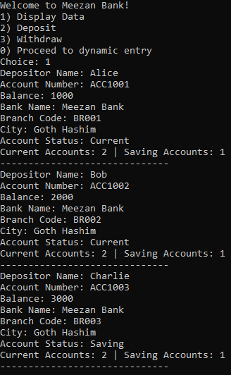
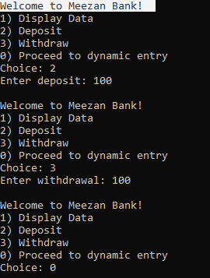
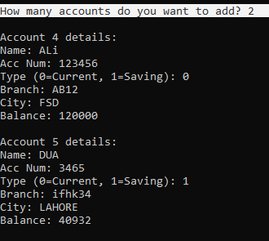

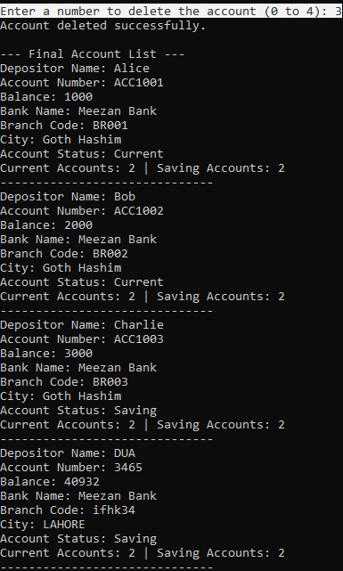

Question no: 02
#include <iostream>
using namespace std;

class HotDogStand
{
private:
int id;
int sold; // per stand sales
static int totalSold; // overall sales

public:
// Constructor
HotDogStand(int i, int s)
{
id = i;
sold = s;
totalSold += s;
}

// Sell one hotdog
void justSold()
{
sold++;
totalSold++;
}

// Get sales of this stand
int getSales()
{
return sold;
}

// Get total sales
static int getTotalSales()
{
return totalSold;
}
};

// Initialize static variable
int HotDogStand::totalSold = 0;

int main()
{
// Create 3 stands
HotDogStand h1(101, 0);
HotDogStand h2(102, 0);
HotDogStand h3(103, 0);

// Simulate sales
h1.justSold();
h1.justSold();

h2.justSold();

h3.justSold();
h3.justSold();
h3.justSold();

// Output
cout << "Stand 1 Sales: " << h1.getSales() << endl;
cout << "Stand 2 Sales: " << h2.getSales() << endl;
cout << "Stand 3 Sales: " << h3.getSales() << endl;

cout << "Total Sales: " << HotDogStand::getTotalSales() << endl;

return 0;
}

Output:
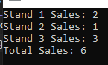

Question no: 03
#include <iostream>
#include <string>
using namespace std;
struct Student
{
string name;
float CGPA;
string gender;
int CNIC;
};
class section
{
private:
string section, teacher;
int n;
Student* stu;
public:
void addStudents()
{
cout << "How many students ?" << endl;
cin >> n;
stu = new Student[n];
for (int i = 0;i < n;i++)
{
cout << "Enter the name : " << endl;
cin >> stu[i].name;
cout << "Enter the gender : " << endl;
cin >> stu[i].gender;
cout << "Enter the cnic : " << endl;
cin >> stu[i].CNIC;
cout << "Enter the fcgpa : " << endl;
cin >> stu[i].CGPA;
}
}
void editStudents()
{
cout << "Enter section :" << endl;
cin >> section;
cout << "Enter the name of teacher:" << endl;
cin >> teacher;

}
void UpdateStidents()
{
int newsize;
cout << "Enter the no of new student : " << endl;
cin >> newsize;
int l = n + newsize;
Student* S;
S = new Student[l];
for (int i = 0;i < n;i++)
{
S[i] = stu[i];
}
for (int i = n; i < l; i++)
{
cout << "Enter data for student " << i + 1 << endl;
cin >> S[i].name;
cin >> S[i].CNIC;
cin >> S[i].gender;
cin >> S[i].CGPA;
}
delete[] stu;

stu = S;

n = l;
}
void printList()
{
cout << "-----------------------------" << endl;
cout << "Section : " << section << endl;
cout << "Teacher name : " << teacher<< endl;
for(int i=0;i<n;i++)
{
cout << "/nStudent : " << i + 1 << endl;
cout << "Student name : " << stu[i].name << endl;
cout << "CNIC : " << stu[i].CNIC << endl;
cout << "Gender : " << stu[i].gender<< endl;
cout << "CGPA : " << stu[i].CGPA<< endl;
}
}
};
int main()
{
section* ptr1;
int n,c;
cout << "Enter the number of sections : " << endl;
cin >> n;
ptr1 = new section[n];
ptr1[0].editStudents();
ptr1[0].addStudents();
ptr1[0].UpdateStidents();
ptr1[0].printList();
}

Output:
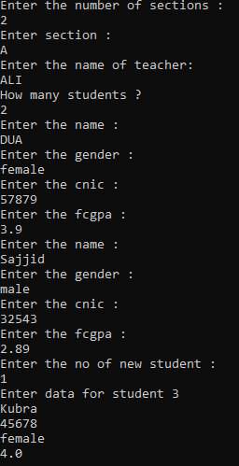
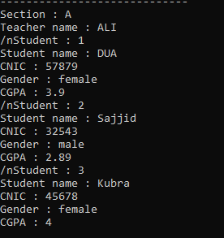

Question no: 04
#include <iostream>
#include <string>
using namespace std;
class tollbooth
{
private:
static int count_cars;
static double amount;
public:
static void payingCar()
{
count_cars++;
amount += 50;
}
static void NopayingCar()
{
count_cars++;
}
void display() const
{
cout << "Total Cars passesd : " << count_cars << endl;
cout << "Total amount collected : " << amount << endl;
}
};
int tollbooth::count_cars = 0;
double tollbooth::amount = 0;
int main()
{
tollbooth t1;
cout << "Welcome to tollbooth : " << endl;

char key;
do {
cout << "Press 'p' for paying car, 'n' for non-paying, 'd' to display, 'q' to quit: ";
cin >> key;
if (key == 'p') t1.payingCar();
else if (key == 'n') t1.NopayingCar();
else if (key == 'd') t1.display();
} while (key != 'q');
}

Output:
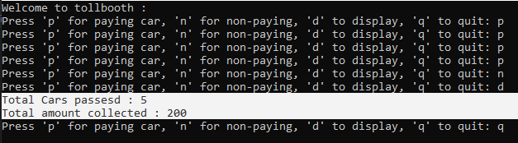

Question no: 05
#include <iostream>
#include <string>
using namespace std;
class Time
{
private:
int h, m, s;
public:
Time() : h(0),m(0),s(0)
{

}
Time(int h, int m, int s)
{
this->h = h;
this->m = m;
this->s = s;
}
void display()
{
cout << h << " : " << m << " : " << s << endl;
}
Time add(const Time&p)
{
h = h + p.h;
m = m + p.m;
s = s + p.s;
return Time(h, m, s);
}
};
int main()
{
Time t1(1,10,34), t2(3,35,12), t3;
cout << "First object : " << endl;
t1.display();
cout << "Second object : " << endl;
t2.display();
cout << "Sum is : " << endl;
t3 = t1.add(t2);
t3.display();
}

Output:
