Question 01:
#define _CRT_SECURE_NO_WARNINGS
#include<iostream>
#include<cstring>
#include<string>
#include<fstream>
using namespace std;
static int i = 0;
enum accountKiType
{
current,saving
};
class bankAccount
{
private:
char name[20];
char accountKaNumber[25];
const accountKiType Type;
double balance;
static char bankKaName[20];
char branchKaCode[20];
char city[20];
static unsigned int totalCurrent;
static unsigned int totalSaving;
public:
bankAccount():Type(current)
{
strcpy(name, "unknown");
strcpy(accountKaNumber, "notAssigned");
balance = 0;
strcpy(branchKaCode, "yaadNahi");
strcpy(city, "gumnaam");
totalCurrent++;
}
bankAccount(char name[],char accountKaNumber[], accountKiType t ,double balance, char branchKaCode[], char city[]) :Type(t)
{
strcpy(this->name, name);
strcpy(this->accountKaNumber, accountKaNumber);
this->balance = balance;
strcpy(this->branchKaCode, branchKaCode);
strcpy(this->city, city);
((Type == current) ? totalCurrent++ : totalSaving++);
}
static void setAccName(char n[])
{
strcpy(bankKaName, n);
}
static void getAccName()
{
cout <<"Bank Account Name: " << bankKaName<<endl;
}
static void getAccCounts()
{
cout << "total Current accounts: " << totalCurrent << endl;
cout << "total Saving accounts: " << totalSaving << endl;
}
void depositAmount(int deposit)
{
if (deposit > 0)
{
balance += deposit;
cout << "balance Updated" << endl;
}
else
{
cout << "Invalid deposit amount." << endl;
}
}
void withdrawAmount(int withdraw)
{
if (withdraw <= balance)
{
balance -= withdraw;
cout << "The transection done sucessfully" << endl;
}
else
{
cout << "Invalid amount entered." << endl;
}
}
void display()
{
cout << "\naccount details:" << endl << endl;
cout << "Name: " << name << endl;
cout << "Bank Name: " << bankKaName << endl;
cout << "City: " << city << endl;
cout << "Account Balance: " << balance << endl;
}
void inputData(string fileName)
{

ofstream fout(fileName, ios::app);
if (!fout) {
cout << "File not found!" << endl;
}
else
{
fout <<endl<< name <<" " << accountKaNumber<<" " << branchKaCode<<" " << city<<" " << Type<<" " << balance;
}
fout.close();
}
char* getName() { return name; }
char* getAccNum() { return accountKaNumber; }
char* getBranch() { return branchKaCode; }
char* getCity() { return city; }
int getType() { return Type; }
double getBalance() { return balance; }
};
unsigned int bankAccount::totalCurrent = 0;
unsigned int bankAccount::totalSaving = 0;
char bankAccount::bankKaName[20] = "Askari";
void dataLoading(string fileName, bankAccount* b[100])
{
char name[20], accountKaNumber[25], branchKaCode[20], city[20];
int totalCurrent, totalSaving, temp;
accountKiType type;
double balance;
ifstream fin(fileName);
if (!fin) {
cout << "File not found!" << endl;
}
else
{
while (fin >> name >> accountKaNumber >> branchKaCode >> city >> temp >> balance)
{
type = static_cast<accountKiType>(temp);
b[i] = new bankAccount(name, accountKaNumber, type, balance, branchKaCode, city);
i++;
}
}
fin.close();
}
int accountFinder(bankAccount* b[100])
{
char name[20];
cout << "Enter your name: ";
cin >> name;
for (int x = 0; x < i; x++)
{
if (strcmp(b[x]->getName(), name) == 0)
{
return x;
}
}
cout << "Name not found" << endl;
return -1;
}
int main()
{
char name[20], accountKaNumber[25], branchKaCode[20], city[20];
int temp;
accountKiType type;
double balance;
bankAccount* b[100];
dataLoading("accounts.txt", b);
int choice=0;
while (choice != 9)
{
cout << "Enter 1 to create a new account." << endl;
cout << "Enter 2 to delete any account." << endl;
cout << "Enter 3 to change bank Name." << endl;
cout << "Enter 4 to check Bank Name." << endl;
cout << "Enter 5 to check number of current and saving accounts." << endl;
cout << "Enter 6 to deposit money." << endl;
cout << "Enter 7 to withdraw money." << endl;
cout << "Enter 8 to see the account details." << endl;
cout << "Enter 9 to exit." << endl;
cout << "Enter you choice: ";
cin >> choice;
switch (choice)
{
case 1:
i++;
cout << "Enter the holder Name: ";
cin >> name;
cout << "Enter the account Number: ";
cin >> accountKaNumber;
cout << "Enter the Branch Code: ";
cin >> branchKaCode;
cout << "Enter the city: ";
cin >> city;
cout << "Enter the account type 0 for current 1 for saving: ";
cin >> temp;
type = static_cast<accountKiType>(temp);
cout << "Enter you balance: ";
cin >> balance;
b[i] = new bankAccount(name, accountKaNumber, type, balance, branchKaCode, city);
b[i]->inputData("accounts.txt");
break;
case 2:
{
int del;
cout << "Which account you want to delete from 1-" << i << " : ";
cin >> del;
delete b[del - 1];
b[del - 1] = nullptr;
for (int x = del - 1; x < i - 1; x++)
{
b[x] = b[x + 1];
}
b[i - 1] = nullptr;
i--;
ofstream fout("accounts.txt", ios::out);

if (!fout)
{
cout << "File error!" << endl;
}
else
{
for (int x = 0; x < i; x++)
{
fout << b[x]->getName() << " " << b[x]->getAccNum() << " " << b[x]->getBranch() << " " << b[x]->getCity() << " " << b[x]->getType() << " " << b[x]->getBalance() << endl;
}
}
fout.close();
break;
}
case 3:
{
char bankName[20];
cout << "Enter new bank Name: ";
cin >> bankName;
b[i]->setAccName(bankName);
break;
}
case 4:
b[i]->getAccName();
break;
case 5:
b[i]->getAccCounts();
break;
case 6:
{
int nameIndex = accountFinder(b), deposit;
if (nameIndex == -1)
{
cout << "Name not found!"<<endl;
}
else
{
cout << "Enter the amount you want to deposit: ";
cin >> deposit;
b[nameIndex]->depositAmount(deposit);
}
break;
}
case 7:
{
int nameIndex = accountFinder(b), withdraw;
if (nameIndex == -1)
{
cout<<"Name not found!"<<endl;
}
else
{
cout << "Enter the amount you want to deposit: ";
cin >> withdraw;
b[nameIndex]->withdrawAmount(withdraw);
}
break;
}
case 8:
{
int nameIndex = accountFinder(b);
if (nameIndex == -1)
{
cout << "Name not found!" << endl;
}
else
{
b[nameIndex]->display();
}
break;
}
case 9:
break;
default:
cout << "invalid input";
}
}
cout << "\n THANK YOU!" << endl;}
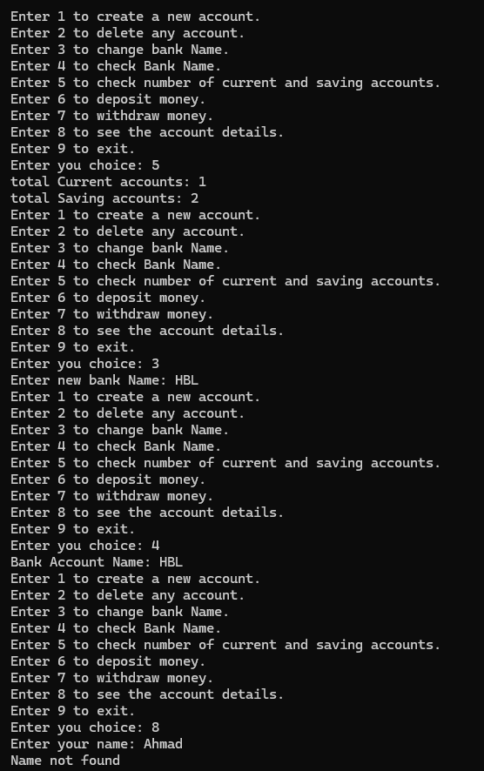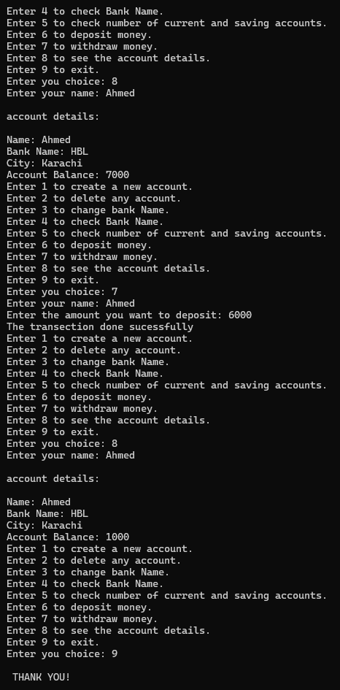
Txt file:
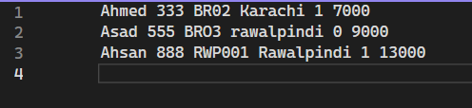

Question 03:
#include<iostream>
#include<string>
#include<fstream>
using namespace std;
int totalSec;
struct Students
{
string Name;
int cnic;
char gender;
float cgpa;
};
class Section
{
private:
Students st[39];
char secName;
string classTeacher;
public:
int totalSt;
Section()
{
secName = 'x';
classTeacher = "Unknown";
totalSt = 0;
}
Section(char secName,string classTeacher,int totalSt)
{
this->secName = secName;
this->classTeacher = classTeacher;
this->totalSt = totalSt;
}
void editSection()
{
int choice;
cout << "1 to edit the Section Name. " << endl;
cout << "2 to edit the class Teacher Name. " << endl;
cout << "Enter your choice: ";
cin >> choice;
switch (choice)
{
case 1:
cout << "Enter the updated section name: ";
cin >> secName;
break;
case 2:
cout << "Enter the updated class Teacher name: ";
cin >> classTeacher;
break;
default:
cout << "Invalid Choice!" << endl;
}
}
void addStudent()
{
cout << "Enter the Student Name: ";
cin >> st[totalSt].Name;
cout << "Enter the Student cnic: ";
cin >> st[totalSt].cnic;
cout << "Enter the Student Gender (m/f): ";
cin >> st[totalSt].gender;
cout << "Enter the Student CGPA: ";
cin >> st[totalSt].cgpa;
totalSt++;
}
void updateStudent()
{
string stName;
int toUpdate,i;
cout << "Enter the student Name: ";
cin >> stName;
for (i = 0; i < totalSt; i++)
{
if (st[i].Name == stName)
{
toUpdate = i;
break;
}
}
if (i == totalSt)
{

cout << "Name not found. "<<endl;
}
else
{
int choice;
cout << "1 to update CNIC." << endl;
cout << "2 to update Gender." << endl;
cout << "3 to update CGPA." << endl;
cout << "Enter your choice: ";
cin >> choice;
switch (choice)
{
case 1:
cout << "Enter the new CNIC: ";
cin >> st[toUpdate].cnic;
cout << "updated successfuly"<<endl;
break;
case 2:
cout << "Enter the new Gender (m/f): ";
cin >> st[toUpdate].gender;
cout << "updated successfuly" << endl;
break;
case 3:
cout << "Enter the new CGPA: ";
cin >> st[toUpdate].cgpa;
cout << "updated successfuly" << endl;
break;
default:
cout << "Invalid input!" << endl;
}
}
}
void printList()
{
cout << "List of Students of section "<<secName<<" : " << endl;
cout << "Teacher Name: " << classTeacher << endl;
for (int i = 0; i < totalSt; i++)
{
cout << "Student " << i + 1 << " : " << endl;
cout << "Name: " << st[i].Name << endl;
cout << "CNIC: " << st[i].cnic<<endl;
cout << "Gender: " << st[i].gender<<endl;
cout << "CGPA: " << st[i].cgpa<<endl<<endl;
}

}
void setStudents(string name,int cnic,char gender,float cgpa,int stNum)
{
this->st[stNum].Name = name;
this->st[stNum].cnic = cnic;
this->st[stNum].gender = gender;
this->st[stNum].cgpa = cgpa;
}
char getSec()
{
return secName;
}
void updateFile()
{
ofstream fout("data.txt", ios::app);
if (!fout)
{
cout << "file not found!";
}
else
{
fout << secName << " " << classTeacher << endl;
fout << totalSt << endl;

for (int i = 0; i < totalSt; i++)
{
fout << st[i].Name << " " << st[i].cnic << " " << st[i].gender << " " << st[i].cgpa << endl;
}
}
fout.close();
}
};
void loadData(Section*& s)
{
ifstream fin("data.txt");
if (!fin)
{
cout << "TXT file not found." << endl;
}
else
{
char secName,gender;
string classTeacher,name;
int totalSt,cnic;
float cgpa;
fin >> totalSec;
s = new Section[totalSec];
for (int i = 0; i < totalSec; i++)
{
fin >> secName;
fin >> classTeacher;
fin >> totalSt;
s[i] = Section(secName, classTeacher, totalSt);
for (int j = 0; j < totalSt; j++)
{
fin >> name;
fin >> cnic;
fin >> gender;
fin >> cgpa;
s[i].setStudents(name, cnic, gender, cgpa, j);
}
}
}
fin.close();
}
int main()
{
bool flag=true;
char sec;
int choice = 0,yourSecNum;
Section* s;
loadData(s);
cout << "---Welcome to Student DataBase---" << endl;
while (choice != 6)
{
while (flag)
{
cout << "Enter your section:";
cin >> sec;
for (int i = 0; i < totalSec; i++)
{
if (sec == s[i].getSec())
{
yourSecNum = i;
flag = false;
}
}
if (flag)
{
cout << "Invalid Section!" << endl;
}
}
cout << "1 to Edit Section Attributes." << endl;
cout << "2 to add new student." << endl;
cout << "3 to update student of a Section." << endl;
cout << "4 to print the list of a section." << endl;
cout << "5 to print all sections." << endl;
cout << "6 to exit." << endl;
cout << "Enter your choice: ";
cin >> choice;
switch (choice)
{
case 1:
s[yourSecNum].editSection();
break;
case 2:
s[yourSecNum].addStudent();
break;
case 3:
s[yourSecNum].updateStudent();
break;
case 4:
s[yourSecNum].printList();
break;
case 5:
for (int i = 0; i < totalSec; i++)
{
s[i].printList();
}
break;
case 6:
break;
default:
cout << "invalid section!" << endl;
}
}
ofstream fout("data.txt");
fout << totalSec << endl;
for (int i = 0; i < totalSec; i++)
{
s[i].updateFile();
}
}
Updated Txt file:
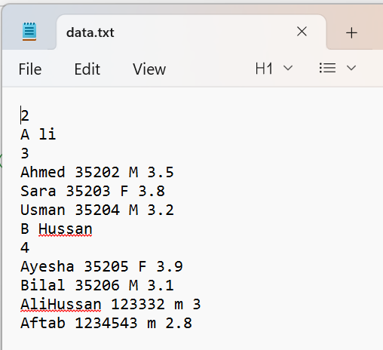
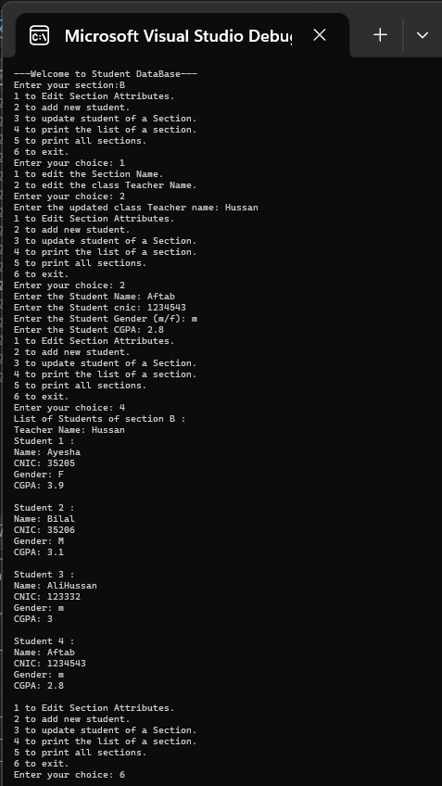

Question 02:
#include<iostream>
using namespace std;
class HotDogStand
{
private:
int id;
int sold;
static int totalSold;
public:
HotDogStand()
{
id = 0;
sold = 0;
}
HotDogStand(int id, int sold)
{
this->id = id;
this->sold = sold;
totalSold += sold;
}
void justSold()
{
sold++;
totalSold++;
}
int showSale()
{
return sold;
}
static int showTotalSale()
{
return totalSold;
}
};
int HotDogStand::totalSold = 0;
int main()
{
HotDogStand h1(100, 22), h2(200, 10), h3(300, 15);
for (int i = 0; i < 5; i++)
h1.justSold();
cout << "Sales of Stand 1: ";
cout<<h1.showSale()<<endl;
cout << "Total Sales of all 3 stands: ";
cout << HotDogStand::showTotalSale() << endl;;
}
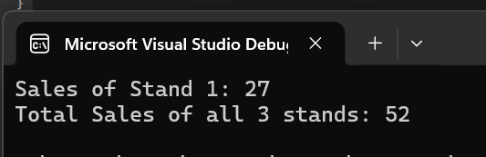
Question 04:
#include<iostream>
using namespace std;
class tollbooth
{
private:
unsigned int totalCars;
double totalAmount;
public:
tollbooth()
{
totalCars = 0;
totalAmount = 0;
}
void payingCar()
{
totalCars++;
totalAmount += 50;
}
void noPayCar()
{
totalCars++;
}
void display() const
{
cout << "Total Cars Passed: " << totalCars<<endl;
cout << "Total Money collected: " << totalAmount<<endl;
}
};

int main()
{
int choice=0;
tollbooth t;
while (choice != 4)
{
cout << "1 for paying car." << endl;
cout << "2 for nonpaying car." << endl;
cout << "3 to see the total cars passed and total amount collected. " << endl;
cout << "4 to exit." << endl;
cout << "Enter your choice: ";
cin >> choice;
switch (choice)
{
case 1:
t.payingCar();
break;
case 2:
t.noPayCar();
break;
case 3:
t.display();
break;
case 4:
break;
default:
cout << "INvalid Choice." << endl;
}
}

}
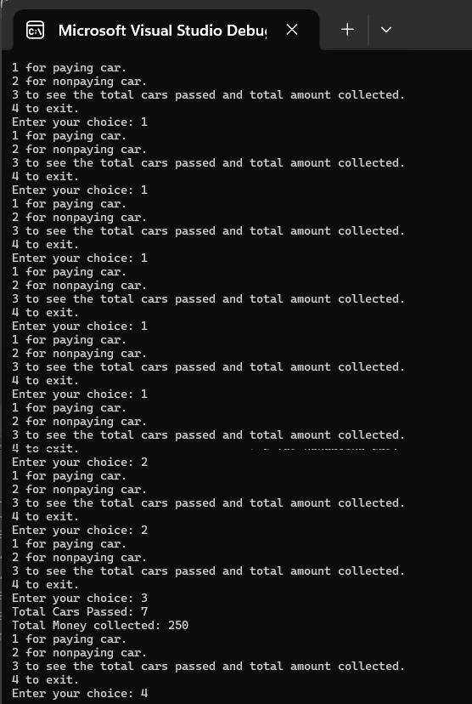
Question 05:
#include<iostream>
using namespace std;
class Time
{
private:
int h;
int m;
int s;
public:
Time()
{
h = 0;
m = 0;
s = 0;
}
Time(int h, int m, int s)
{
this->h = h;
this->m = m;
this->s = s;
}
void add(Time t1, Time t2)
{
this->h = t1.h + t2.h;
this->m = t1.m + t2.m;
this->s = t1.s + t2.s;
if (s > 60)
{
s -= 60;
m++;
}
if (m > 60)
{
m -= 60;
h++;
}
}
void display() const
{
cout << "time: " << h << " : " << m << " : " << s << endl;
}
};

int main()
{
Time t, t1(3, 12, 40), t2(2, 48, 30);
t.add(t1, t2);
t.display();
}
