OOP ASSIGMENT
Syeda Harem Fatima
25F-0049
BSAI-2B
ASG NO 3

QUESTION 1
#define _CRT_SECURE_NO_WARNINGS
#include <iostream>
#include <fstream>
using namespace std;
enum acctype { saving, current };
class bank {
char depositor[50];
char accnum[30];
const acctype type;
double bal;
char bankname[50];
char code[20];
char city[30];
static unsigned int count;

public:
bank() : type(saving) {
strcpy(depositor, "");
strcpy(accnum, "");
bal = 0.0;
strcpy(bankname, "");
strcpy(code, "");
strcpy(city, "");
count++;
}

bank(char* d, char* a, acctype t, double b, char* nm, char* c, char* ct) : type(t) {
strcpy(depositor, d);
strcpy(accnum, a);
bal = b;
strcpy(bankname, nm);
strcpy(code, c);
strcpy(city, ct);
count++;
}

void deposit(double amt)
{
bal += amt;
}

void withdraw(double amt) {
if (amt <= bal) bal -= amt;
else cout << "Insufficient balance" << endl;
}

void display() {
cout << "Depositor: " << depositor << endl;
cout << "Account #: " << accnum << endl;
cout << "Type: " << (type == saving ? "Saving" : "Current") << endl;
cout << "Bank: " << bankname << endl;
cout << "Branch Code: " << code << endl;
cout << "City: " << city << endl;
cout << "Balance: " << bal << endl;
cout << "----------------------" << endl;
}

char* getAccNum() { return accnum; }
acctype getType() { return type; }
static unsigned int getCount()
{ return count; }

// manual string compare
static bool sameAcc(char* a, char* b) {
int i = 0;
while (a[i] && b[i]) {
if (a[i] != b[i]) return false;
i++;
}
return a[i] == b[i];
}

// file save
void saveToFile(ofstream& f) {
f << depositor << endl << accnum << endl << type << endl
<< bal << endl << bankname << endl << code << endl << city << endl;
}

// load helper
static bank* loadFromFile(ifstream& f) {
char d[50], a[30], nm[50], c[20], ct[30]; int t; double b;
if (!f.getline(d, 50))
return nullptr;
f.getline(a, 30);
f >> t;
f.ignore();
f >> b;
f.ignore();
f.getline(nm, 50);
f.getline(c, 20);
f.getline(ct, 30);
return new bank(d, a, (acctype)t, b, nm, c, ct);
}
};

unsigned int bank::count = 0;

// find account index by number
int findAccount(bank* accounts[], int size, char* accNum) {
for (int i = 0; i < size; i++)
if (accounts[i] != nullptr && bank::sameAcc(accounts[i]->getAccNum(), accNum))
return i;
return -1;
}

int main() {
bank* accounts[100] = { nullptr };
int size = 0;
// load file
ifstream fin("accounts.txt");
while (bank* b = bank::loadFromFile(fin)) accounts[size++] = b;
fin.close();
if (size > 0) cout << size << " account loaded from file." << endl;
int choice;
do {
cout << "====== Bank Menu =====" << endl;
cout << "1. Create Account" << endl;
cout << "2. Deposit" << endl;
cout << "3. Withdraw" << endl;
cout << "4. Display All Accounts" << endl;
cout << "5. Delete Account" << endl;
cout << "6. Exit" << endl;
cout << "Enter choice: "; cin >> choice;

switch (choice) {
case 1: {
if (size >= 100)
{ cout << "No free slots!" << endl;
break; }
char d[50], a[30], nm[50], c[20], ct[30];
int tChoice;
double b;
cin.ignore(1000, '\n');
cout << "Depositor Name: "; cin.getline(d, 50);
cout << "Account #: "; cin >> a;
cout << "Account Type (0-Saving,1-Current): ";
cin >> tChoice;
cout << "Initial Balance: ";
cin >> b;
cin.ignore(1000, '\n');
cout << "Bank Name: ";
cin.getline(nm, 50);
cout << "Branch Code: ";
cin >> c;
cin.ignore(1000, '\n');
cout << "City: ";
cin.getline(ct, 30);
acctype t = (tChoice == 0) ? saving : current;
accounts[size++] = new bank(d, a, t, b, nm, c, ct);
cout << "Account created!" << endl;
break;
}
case 2: {
char a[30]; double amt;
cout << "Enter Account #: "; cin >> a;
int idx = findAccount(accounts, size, a);
if (idx != -1)
{ cout << "Amount to deposit: ";
cin >> amt; accounts[idx]->deposit(amt);
cout << "Deposited!" << endl;
}
else
cout << "Account not found!" << endl;
break;
}
case 3: {
char a[30]; double amt;
cout << "Enter Account #: "; cin >> a;
int idx = findAccount(accounts, size, a);
if (idx != -1)
{ cout << "Amount to withdraw: ";
cin >> amt;
accounts[idx]->withdraw(amt);
cout << "Done!" << endl;
}
else cout << "Account not found!" << endl;
break;
}
case 4: {
for (int i = 0; i < size; i++)
if (accounts[i] != nullptr)
accounts[i]->display();
break;
}
case 5: {
char a[30];
cout << "Enter Account #: ";
cin >> a;
int idx = findAccount(accounts, size, a);
if (idx != -1)
{
delete accounts[idx];
for (int j = idx; j < size - 1; j++) accounts[j] = accounts[j + 1];
accounts[size - 1] = nullptr;
size--;
cout << "Account deleted!" << endl;
}
else cout << "Account not found!" << endl;
break;
}
case 6:
{
ofstream fout("accounts.txt");
for (int i = 0; i < size; i++)
if (accounts[i] != nullptr)
accounts[i]->saveToFile(fout);
fout.close();
cout << "Data saved. Exiting." << endl;
break;
}
default: cout << "Invalid choice!" << endl;
}

} while (choice != 6);

for (int i = 0; i < size; i++)
if (accounts[i] != nullptr)
delete accounts[i];

return 0;
}

OUTPUT
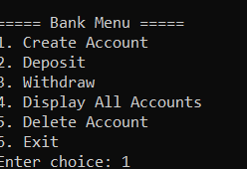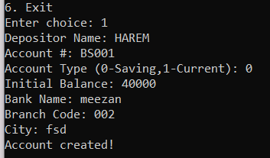
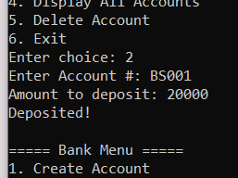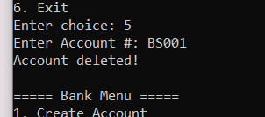
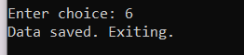

QUESTION 2
#include<iostream>
using namespace std;
class HotDogStand {
int id;
int soldCount;
static int totalSold; // tracks all stands total

public:
// Constructor
HotDogStand(int i, int s)
{
id = i;
soldCount = s;
totalSold += s; // count initial sold too
}
// Calling this every time a hot dog is sold
void justSold()
{
soldCount++;
totalSold++;
}
int getSold()
{
return soldCount;
}

int getId()
{
return id;
}

static int getTotalSold() {
return totalSold;
}
};

int HotDogStand::totalSold = 0;

int main() {
HotDogStand s1(1, 0);
HotDogStand s2(2, 0);
HotDogStand s3(3, 0);

for (int i = 0; i < 3; i++)
s1.justSold(); // Stand 1 sells 3
for (int i = 0; i < 5; i++)
s2.justSold(); // Stand 2 sells 5
for (int i = 0; i < 2; i++)
s3.justSold(); // Stand 3 sells 2

cout << "Stand " << s1.getId() << " sold: " << s1.getSold() << endl;
cout << "Stand " << s2.getId() << " sold: " << s2.getSold() << endl;
cout << "Stand " << s3.getId() << " sold: " << s3.getSold() << endl;
cout << "Total sold by all stands: " << HotDogStand::getTotalSold() << endl;

return 0;
}
OUTPUT
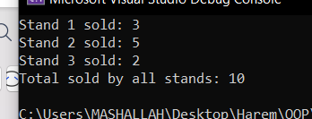
QUESTION 3
#include <iostream>
#include <string>
#include <fstream>
using namespace std;

// Struct for Student
struct Student {
string name;
string cnic;
string gender;
float cgpa;
};

// Class for Section
class Section {
private:
Student students[40];
int studentCount;
string sectionName;
string classTeacher;

public:
// Constructor
Section() {
studentCount = 0;
sectionName = "Not Set";
classTeacher = "Not Set";
}

// Function to edit section attributes
void editSection() {
cout << "Enter Section Name: ";
cin >> sectionName;
cin.ignore(); // clear leftover newline
cout << "Enter Class Teacher Name: ";
getline(cin, classTeacher);
cout << "Section updated successfully" << endl;
}

// Function to add a new student
void addStudent() {
if (studentCount >= 40) {
cout << "Section is full. Cannot add more students." << endl;
return;
}

Student newStudent;
cout << "Enter Student Name: ";
cin.ignore(); // clear any leftover input
getline(cin, newStudent.name);

cout << "Enter CNIC: ";
cin >> newStudent.cnic;

cout << "Enter Gender (M/F): ";
cin >> newStudent.gender;

cout << "Enter CGPA: ";
cin >> newStudent.cgpa;

students[studentCount] = newStudent;
studentCount = studentCount + 1;

cout << "Student added successfully" << endl;
}

// Function to update a student
void updateStudent() {
if (studentCount == 0) {
cout << "No students in this section" << endl;
return;
}

int roll;
cout << "Enter student number to update (1 to " << studentCount << "): ";
cin >> roll;

if (roll < 1 || roll > studentCount) {
cout << "Invalid student number" << endl;
return;
}

int index = roll - 1;

cout << "Enter new Name: ";
cin.ignore();
getline(cin, students[index].name);

cout << "Enter new CNIC: ";
cin >> students[index].cnic;

cout << "Enter new Gender: ";
cin >> students[index].gender;

cout << "Enter new CGPA: ";
cin >> students[index].cgpa;

cout << "Student updated successfully" << endl;
}

// Function to print list of students
void printList() {
cout << "Section: " << sectionName << endl;
cout << "Class Teacher: " << classTeacher << endl;
cout << "Total Students: " << studentCount << endl << endl;

if (studentCount == 0) {
cout << "No students in this section" << endl;
return;
}

for (int i = 0; i < studentCount; i++) {
cout << "Student " << (i + 1) << ":" << endl;
cout << "Name: " << students[i].name << endl;
cout << "CNIC: " << students[i].cnic << endl;
cout << "Gender: " << students[i].gender << endl;
cout << "CGPA: " << students[i].cgpa << endl << endl;
}
}

// Save section to binary file - fixed and simple
void saveToFile(ofstream& file) {
// Save section name
char secName[50] = {0};
int i = 0;
while (i < sectionName.length() && i < 49) {
secName[i] = sectionName[i];
i = i + 1;
}
file.write(secName, 50);

// Save class teacher
char teacher[50] = {0};
i = 0;
while (i < classTeacher.length() && i < 49) {
teacher[i] = classTeacher[i];
i = i + 1;
}
file.write(teacher, 50);

// Save student count
file.write((char*)&studentCount, sizeof(int));

// Save all students
for (int j = 0; j < studentCount; j++) {
// Save name
char sName[50] = {0};
i = 0;
while (i < students[j].name.length() && i < 49) {
sName[i] = students[j].name[i];
i = i + 1;
}
file.write(sName, 50);

// Save CNIC (smaller size)
char sCnic[20] = {0};
i = 0;
while (i < students[j].cnic.length() && i < 19) {
sCnic[i] = students[j].cnic[i];
i = i + 1;
}
file.write(sCnic, 20);

// Save gender
char sGender[10] = {0};
i = 0;
while (i < students[j].gender.length() && i < 9) {
sGender[i] = students[j].gender[i];
i = i + 1;
}
file.write(sGender, 10);

// Save CGPA
file.write((char*)&students[j].cgpa, sizeof(float));
}
}

// Load section from binary file
void loadFromFile(ifstream& file) {
char secName[50] = {0};
file.read(secName, 50);
sectionName = secName;

char teacher[50] = {0};
file.read(teacher, 50);
classTeacher = teacher;

file.read((char*)&studentCount, sizeof(int));

for (int j = 0; j < studentCount; j++) {
char sName[50] = {0};
file.read(sName, 50);
students[j].name = sName;

char sCnic[20] = {0};
file.read(sCnic, 20);
students[j].cnic = sCnic;

char sGender[10] = {0};
file.read(sGender, 10);
students[j].gender = sGender;

file.read((char*)&students[j].cgpa, sizeof(float));
}
}

string getSectionName() {
return sectionName;
}
};

int main() {
Section* sections = NULL;
int numSections = 0;

// Try to load data from file
ifstream inFile("studentdata.bin", ios::binary);
if (inFile.is_open()) {
inFile.read((char*)&numSections, sizeof(int));
if (numSections > 0) {
sections = new Section[numSections];
for (int i = 0; i < numSections; i++) {
sections[i].loadFromFile(inFile);
}
}
inFile.close();
cout << "Data loaded from file successfully" << endl;
}
else {
cout << "No previous data found. Starting fresh." << endl;
}

// If no sections loaded, ask user how many to create
if (numSections == 0) {
cout << "Enter number of sections you want to create: ";
cin >> numSections;
if (numSections > 0) {
sections = new Section[numSections];
}
}

int choice;
int sectionIndex;

do {
cout << "\n=== Student Database Menu ===" << endl;
cout << "1. Edit Section Attributes" << endl;
cout << "2. Add Student in a section" << endl;
cout << "3. Update Student of a section" << endl;
cout << "4. Print List of Students of a section" << endl;
cout << "5. Print List of Sections" << endl;
cout << "6. Exit" << endl;
cout << "Enter your choice: ";
cin >> choice;

if (choice >= 1 && choice <= 5) {
if (numSections == 0) {
cout << "No sections created yet!" << endl;
continue;
}

cout << "Available Sections:" << endl;
for (int i = 0; i < numSections; i++) {
cout << (i + 1) << ". " << sections[i].getSectionName() << endl;
}

cout << "Enter section number: ";
cin >> sectionIndex;
sectionIndex = sectionIndex - 1;

if (sectionIndex < 0 || sectionIndex >= numSections) {
cout << "Invalid section number" << endl;
continue;
}
}

if (choice == 1) {
sections[sectionIndex].editSection();
}
else if (choice == 2) {
sections[sectionIndex].addStudent();
}
else if (choice == 3) {
sections[sectionIndex].updateStudent();
}
else if (choice == 4) {
sections[sectionIndex].printList();
}
else if (choice == 5) {
cout << "\nList of All Sections:" << endl;
for (int i = 0; i < numSections; i++) {
cout << (i + 1) << ". " << sections[i].getSectionName() << endl;
}
}
else if (choice == 6)
{
// Save data to file with error check
ofstream outFile("studentdata.bin", ios::binary);
if (outFile.is_open()) {
outFile.write((char*)&numSections, sizeof(int));
for (int i = 0; i < numSections; i++) {
sections[i].saveToFile(outFile);
}
outFile.close();
cout << "All data saved to file successfully" << endl;
}
else {
cout << "Error: Could not open file for saving!" << endl;
}
}

} while (choice != 6);
// Delete memory at the end
if (sections != NULL) {
delete[] sections;
sections = NULL;
}
cout << "Program ended. Memory cleaned." << endl;
return 0;
}OUTPUT

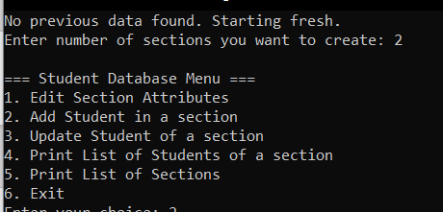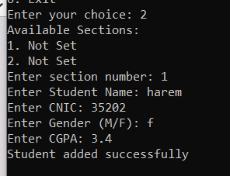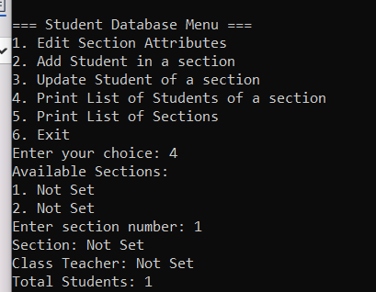
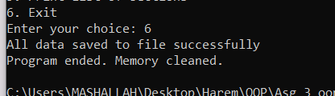

QUESTION 4
#include <iostream>
using namespace std;
// Tollbooth class to track cars and cash collected
class tollbooth {
private:
unsigned int totalCars; // total cars passed
double totalCash; // total money collected

public:
// Constructor - initialize both to 0
tollbooth() {
totalCars = 0;
totalCash = 0.0;
}

// Car paid 50 rupees
void payingCar() {
totalCars++;
totalCash += 50;
}

// Car passed without paying
void noPayCar() {
totalCars++;
}

// Display totals (const - doesn't modify data)
void display() const
{
cout << "Total Cars : " << totalCars << endl;
cout << "Total Cash : " << totalCash << " rupees" << endl;
}
};

int main() {
tollbooth booth;
char choice;

cout << "=== Tollbooth System ===" << endl;
cout << "P - Paying car" << endl;
cout << "N - Non-paying car" << endl;
cout << "D - Display totals" << endl;
cout << "Q - Quit" << endl;

do {
cout << "\nEnter choice: ";
cin >> choice;

if (choice == 'P' || choice == 'p') {
booth.payingCar();
cout << "Paying car counted." << endl;
}
else if (choice == 'N' || choice == 'n') {
booth.noPayCar();
cout << "Non-paying car counted." << endl;
}
else if (choice == 'D' || choice == 'd') {
booth.display();
}
else if (choice == 'Q' || choice == 'q') {
cout << "Final Report:" << endl;
booth.display();
}
else {
cout << "Invalid choice." << endl;
}

} while (choice != 'Q' && choice != 'q');

return 0;
}
OUTPUT
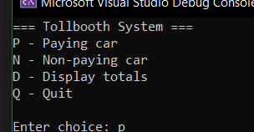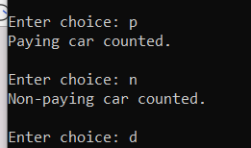
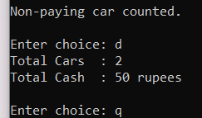c 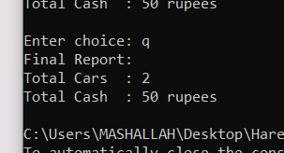
QUESTION 5
#include <iostream>
using namespace std;

class Time {
private:
int hours;
int minutes;
int seconds;

public:
// Default constructor
Time() {
hours = 0;
minutes = 0;
seconds = 0;
}

// Parameterized constructor
Time(int h, int m, int s) {
hours = h;
minutes = m;
seconds = s;
}

// Display in HH:MM:SS format
void display() const {
if (hours < 10) cout << "0";
cout << hours << ":";
if (minutes < 10) cout << "0";
cout << minutes << ":";
if (seconds < 10) cout << "0";
cout << seconds << endl;
}

// Adding two Time objects and store result in calling object
void addTime(const Time t1, const Time t2)
{
int totalSeconds = (t1.hours * 3600 + t1.minutes * 60 + t1.seconds)
+ (t2.hours * 3600 + t2.minutes * 60 + t2.seconds);

hours = totalSeconds / 3600;
totalSeconds = totalSeconds % 3600;
minutes = totalSeconds / 60;
seconds = totalSeconds % 60;
}
};

int main()
{
const Time t1(5, 45, 30);
const Time t2(6, 20, 45);
Time t3;

t3.addTime(t1, t2);

cout << "Time 1 : ";
t1.display();
cout << "Time 2 : ";
t2.display();
cout << "Sum : ";
t3.display();

return 0;
}
OUTPUT
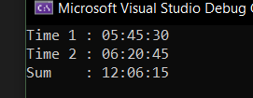

08

