Multi-Tenant SaaS Platform Plan
Contoso Outdoors

Azure Marketplace SaaS Transactable Offer
August 2026

1. Platform Requirements Summary
Dimension | Current State | Target State
Tenant definition | None — single-tenant, single catalogue | One tenant = one retail brand/storefront
Compute | Single App Service B1 | Shared App Service (pooled), scale to stamps
Data | Static JSON files on disk | Tenant-isolated (Cosmos DB or Azure SQL)
Identity | System-assigned managed identity only | Entra ID B2C for end-users + Entra ID for admins
AI/Chat | Chat API stubs (grounded, visual, promptflow) | Per-tenant chat config with usage metering
Marketplace | Not listed | SaaS Transactable on Azure Marketplace
Regions | Single region | Single-region starter → multi-region
Compliance | None specified | SOC 2 readiness recommended

2. Tenant Definition & Business Mapping
A tenant is one retail brand operating a storefront through Contoso Outdoors.
Concept | Maps To
Tenant | A retail brand/company (e.g., Alpine Gear Co.)
Users | Storefront visitors (anonymous or authenticated shoppers)
Tenant admin | Brand owner who manages catalogue, branding, chat config
Subscription | Marketplace purchase → creates tenant with a plan
Environment | Not per-tenant; managed by ISV (dev/staging/prod)

3. Multitenancy Decision Record

Isolation Model: Shared Infrastructure / Isolated Data

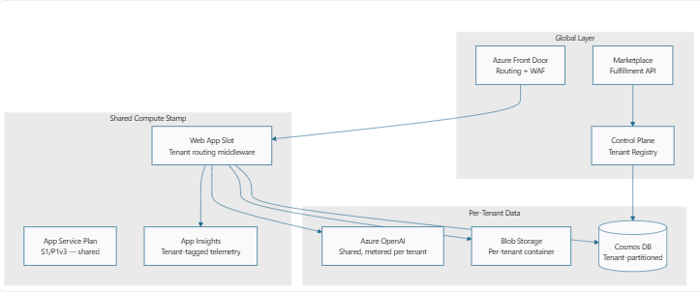
Layer | Model | Rationale
Compute | Shared (pooled) | Low cost; App Service handles routing; rate limiting mitigates noisy neighbor
Data | Isolated (partition key) | Cosmos DB with tenantId partition key — logical isolation, shared throughput
Static assets | Isolated (per-tenant container) | Product images, manuals, branding assets separated per tenant
Identity | Shared Entra ID B2C | Tenant admin mapped via custom claims; shoppers scoped per tenant
AI/Chat | Shared Azure OpenAI | Metered per tenant; system prompt customized per catalog
Networking | Shared Front Door | Custom domain mapping per tenant; shared WAF rules

Tenant Context Propagation
- Request arrives at Front Door — Host header resolves to tenant
- App Service middleware validates tenant, injects tenantId into request context
- API/page handler reads tenantId, queries tenant-scoped data from Cosmos DB
- App Insights logs with tenantId as custom dimension
Tenant ID is derived from authenticated session or host header, never trusted from client input alone. Background jobs receive tenant ID via message metadata, re-validated before processing.

4. Staged Execution Plan

Stage 1: ISV Landing Zone Foundation
Task | Detail
Subscription layout | Platform subscription (shared services) + Workload subscription (SaaS app)
Management groups | ISV root → Platform, Workloads (dev/prod)
RBAC | Least-privilege roles for CI/CD, operators, tenant admins
Policy | Enforce HTTPS, TLS 1.2, tagging, allowed regions
Networking | Front Door → App Service VNet integration → Private endpoints
Monitoring baseline | Log Analytics + App Insights (promote existing setup)

Stage 2a: Tenant Isolation Implementation
- Replace static JSON catalogue with Cosmos DB (partition key: tenantId)
- Create Blob Storage with per-tenant containers for images/manuals
- Add tenant routing middleware to Next.js (resolve host → tenantId)
- Implement tenant-scoped API authorization on all chat and product endpoints

Stage 2b: Tenant Lifecycle Automation

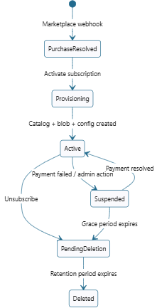
State | Automation
PurchaseResolved | Fulfillment API resolves token, creates tenant record
Provisioning | Create Cosmos DB tenant partition, blob container, seed config
Active | Tenant fully operational, metering active
Suspended | Read-only access, metering paused
PendingDeletion | 30-day data retention, then purge

Stage 2c: Security & Compliance
Control | Implementation
Tenant-context validation | Middleware derives tenantId from auth token; never from query param
Cross-tenant isolation testing | Automated tests: Tenant A cannot read Tenant B data
Secret management | Key Vault per environment; connection strings via managed identity
Data encryption | Cosmos DB SSE (platform default) + TLS in transit
Audit logging | All tenant lifecycle events + admin actions to Log Analytics

Stage 3: SaaS Accelerator & Marketplace

3a: SaaS Accelerator Bootstrap
Component | Purpose
Landing page (/marketplace/activate) | Resolves purchase token, shows plan details, activates subscription
Webhook (/api/marketplace/webhook) | Handles ChangePlan, Suspend, Reinstate, Unsubscribe
Admin portal (/admin) | Tenant management, plan overview, usage dashboard

3b: Fulfillment & Metering
Meter Dimension | Unit | Billing
ai-chat-queries | Per 1,000 requests | Overage above plan inclusion
product-catalogue-size | Per 100 products | Tiered by plan
monthly-storefront-visitors | Per 10,000 unique visitors | Overage above plan cap

Pricing Plans
Plan | Base Price | Included | Overage
Starter | $49/mo | 1 store, 100 products, 1K chat queries | $0.01/query, $5/100 products
Pro | $199/mo | 5 stores, 1K products, 10K chat queries | $0.008/query, $3/100 products
Enterprise | Custom | Unlimited stores, custom SLA | Negotiated

3c: Marketplace Onboarding
Gate | Status
Partner Centre account | ☐ Not started
Publisher profile + legal | ☐ Not started
Offer created (SaaS Transactable) | ☐ Not started
Plans + pricing configured | ☐ Not started
Technical config (landing page + webhook) | ☐ Not started
Private preview testing | ☐ Not started
Certification submission | ☐ Not started
Go-live | ☐ Not started

Stage 4: Scale & SRE
Concern | Approach
SLO | 99.9% availability, p95 response < 500ms
Noisy neighbor | Per-tenant rate limiting on chat API; Cosmos DB RU budgets
Scaling | App Service autoscale (CPU/memory); Cosmos DB autoscale RU
Deployment stamps | Not needed initially; trigger at ~200 tenants or regional expansion
Observability | App Insights with tenantId custom dimension; per-tenant dashboards
Cost allocation | Tag resources + Cosmos DB RU consumption attributed per tenant
DR | Cosmos DB multi-region (when justified); deployment slots for zero-downtime

5. Deployment Blueprint
Track: Single-Region Starter SaaS
Phase | Timeline | Deliverables
Phase 1 — Foundation | Week 1–2 | Resource Group, Front Door + WAF, App Service Plan (S1), Key Vault, Log Analytics + App Insights
Phase 2 — Data Layer | Week 3–4 | Cosmos DB (serverless/autoscale), Blob Storage + CDN, Tenant registry collection, Data migration: JSON → Cosmos DB
Phase 3 — Multi-Tenant App | Week 5–8 | Tenant routing middleware, Per-tenant catalogue API, Per-tenant chat API (metered), Tenant admin portal, Isolation tests
Phase 4 — Marketplace | Week 9–12 | Fulfillment API integration, Landing page + webhook, Metering pipeline, Partner Centre submission, Private preview → Go-live

6. Offer Strategy Decision
Alternative | Verdict | Rationale
SaaS Transactable | ✅ Selected | ISV-hosted, Microsoft-billed, co-sell eligible
Azure Managed Application | ❌ Rejected | Single tenant deploys in customer sub, wrong model
Container offer | ❌ Rejected | Customer-hosted, operational burden on customer
VM offer | ❌ Rejected | Not applicable to web SaaS

7. Marketplace Readiness Checklist
- Entra ID app registration for Marketplace auth
- Fulfillment API v2 webhook endpoint deployed and reachable
- Landing page resolves purchase token and activates subscription
- Metered billing emits usage events within 24 hours
- Cross-tenant data isolation verified by automated tests
- Privacy policy and terms of use URLs configured
- Support contact and help documentation published
- Private preview tested with at least 2 pilot tenants
- Partner Centre offer passes certification validation

8. Day-2 Operations & SRE Control Plan
Area | Controls
Tenant onboarding | Automated provisioning via Marketplace webhook; idempotent; < 60s SLA
Tenant offboarding | 30-day soft-delete; data export available; purge after retention
Incident response | PagerDuty/on-call; per-tenant blast radius assessment; customer comms
Deployment | Blue/green via App Service slots; canary via Front Door traffic splitting
Capacity planning | Monthly tenant density review; stamp scale-out trigger at ~200 tenants
Cost management | Per-tenant cost attribution; monthly margin analysis; plan pricing review
Compliance | Quarterly SOC 2 evidence collection; annual penetration testing

