Name: Bryan Frahm Mark _____________________/50

## Brief introduction __/3

For our game Exit the Hive, I will be in charge of Level Design. I will integrate procedurally generated rooms. Each room type will be randomly filled with objects such as enemies, weapons, or npc’s based on that rooms type.

When the player starts the game, I will have the player spawn in a start room that is designed to give the player an introduction to the games story. Once this interaction happens I will need to generate a world that is connected by a random number of rooms. The player then has to clear the rooms of enemies before the final door is unlocked, which will lead to a boss level.

Once the boss has been defeated, the player may move on into another randomly generated world. This will continue until the player leaves or is killed.

## Use case diagram with scenario __14

### Use Case Diagrams

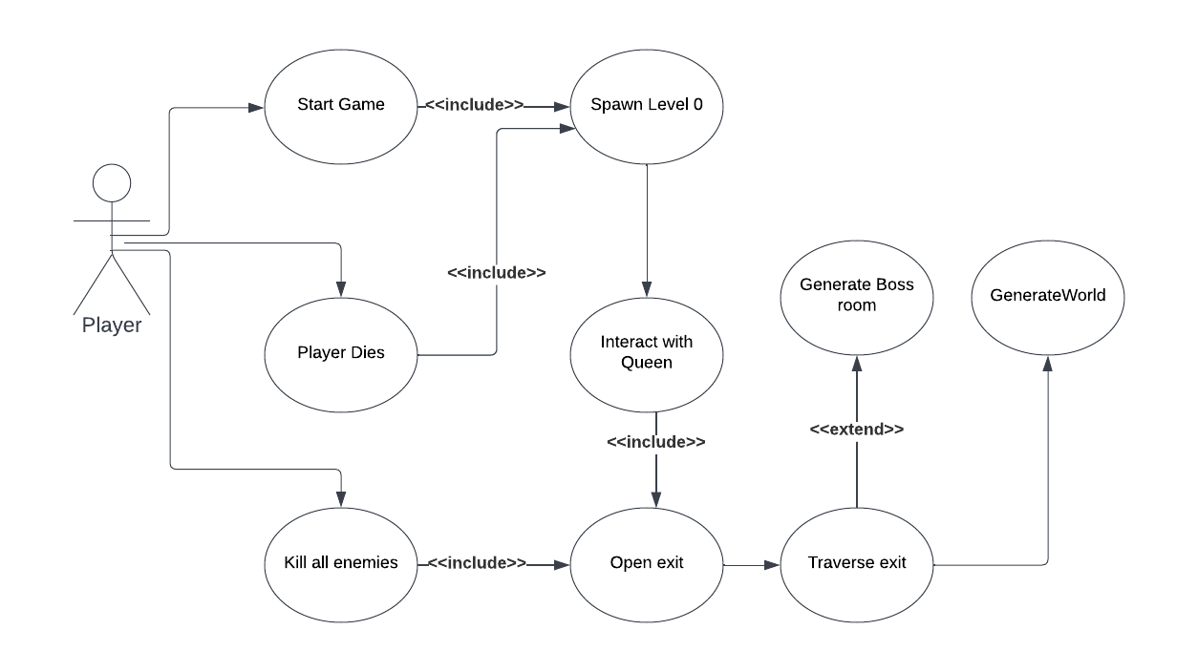

### Scenarios

**Scenario 1**

**Name:** Generate Level

**Summary:** The player triggers a new level to be loaded after moving through an exit that is unlocked either through interaction or killing enemies. The level loaded will either be a starting room, a randomly generated world level, or a boss level. The world level will have multiple room types that will generate.

**Actors:** The player of the game

**Preconditions:** The game has been started and at least the opening level has been loaded.

**Basic sequence:**

**Step 1:** The player interacts with Queen BC in the starting area.

**Step 2:** The exit is opened.

**Step 3:** Once the player moves to the exit a random world will generate.

**Step 4:** The world will generate a number of enemy rooms, empty rooms, item rooms, and one shop room randomly.

**Step 5:** The world will track number of enemies remaining.

**Step 6:** When enemies equal 0 a new boss level will generate.

**Step 7:** When the boss is defeated a new world level will generate.

**Exceptions:**

**Step 1:** The player is killed mid-level.

**Step 2:** The starting level is re-loaded.

**Post conditions:** The player starts in a new generated world.

**Priority:** 1

**ID:** BF1

## Data Flow diagram(s) from Level 0 to process description for your feature _______14

### Data Flow Diagrams

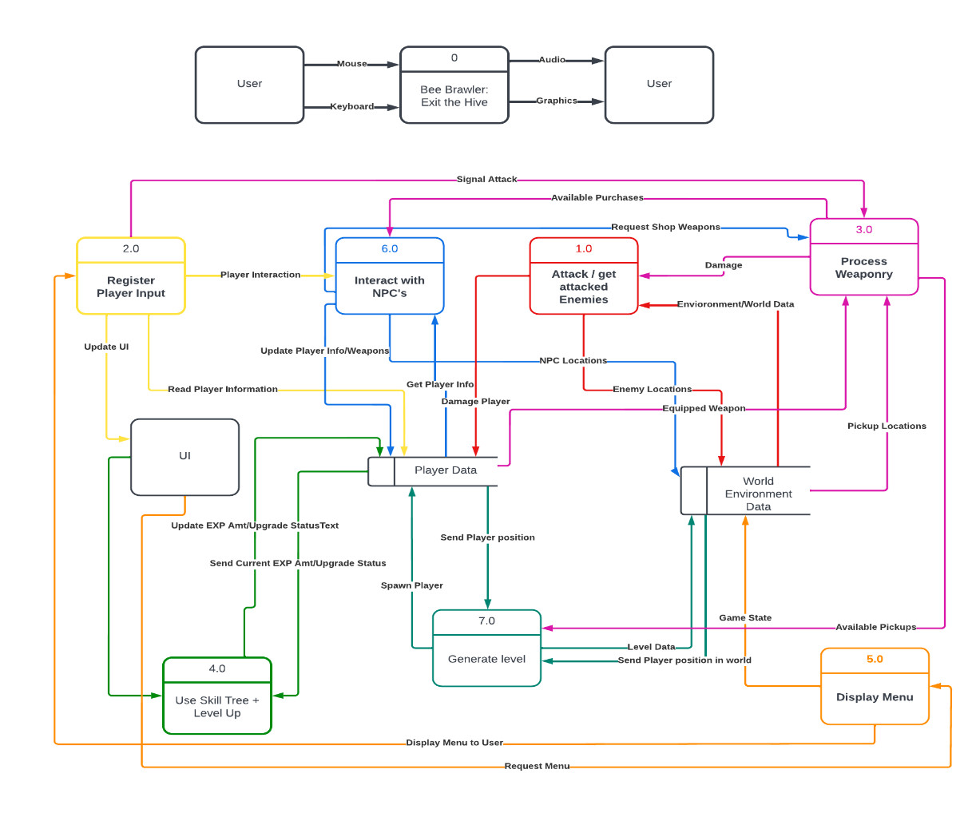

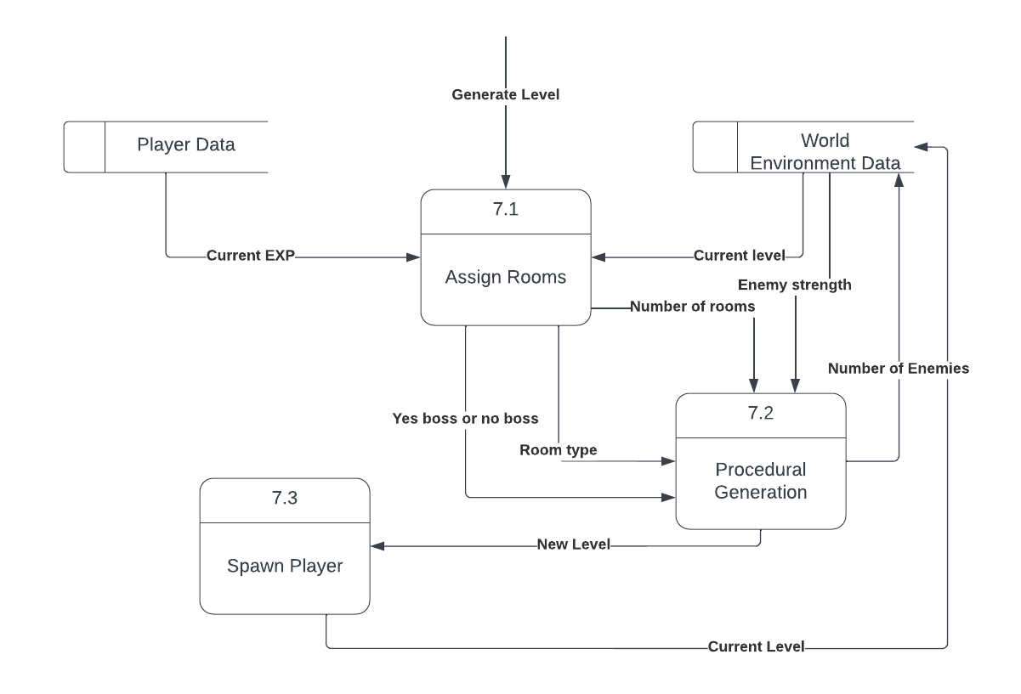

### Process Descriptions

Assign rooms 7.1:

WHILE player is in position exit Do generate level

END WHILE

IF current EXP > BOSS_Spawn Threshold THEN spawn Boss room

ELSE

Enemy Room type amount = Rand % 4 + Current Difficulty

Empty Room type amount = Rand % 10

Shop Room type amount = 1

Exit Room type at end

Procedural Generation7.2:

Enemy Strength = Exp * Current LEVEL mod 5

WHILE Newlevel < Number of Rooms DO Room Spawn

END WHILE

Spawn exit room

## Acceptance Tests ________9

This feature has random generating elements that are affected by the player progress (Experience points and Current level). The acceptance test will test the world generation to make sure there is always a path from the spawn point to the exit point. The room type will also need to be tested to ensure that the correct number of enemy rooms and empty rooms corresponds to EXP and current level number. As well as those rooms are filling with the correct enemy types and item drops.

The Acceptance tests for these features are described below.

**World Generator**

This feature will be automated to run and make 100 world maps. This will be done one each differing difficulty level (1-5) to ensure that room types spawned in are of the correct amount. The input will be the different room types; start room, enemy room, empty room, shop room, and exit room. Each room type will be counted and sent to an output file.

The output file will display room type composition for each world generated at each level. There should be an obvious pattern based on difficulty. There should be no more than 4 enemy rooms in 1 difficulty and no more than 10 enemy rooms in a 5 difficulty as well as no more than 1 start, shop, or exit room.

**Room Generator**

This feature will be checked at the same time as the World Generator. Every enemy or item that is generated will be counted and sent to an output file. This will record number of enemies, difficulty of enemies, number of items, and item stats. These amounts should be lower at lower difficulties, and gradually raise as the difficulty increases.

## Timeline _________/10

### Work items

|  |  |  |
| --- | --- | --- |
| Task | Duration(Hours) | Predecessor Task(s) |
| 1. Start Room Design | 4 |  |
| 1. Start Room Testing | 2 | 1 |
| 1. Room Framework | 10 | 1,2 |
| 1. Room Testing | 5 | 3 |
| 1. Enemy Room Design | 8 | 3,4 |
| 1. Enemy Room Testing | 4 | 5 |
| 1. Boss Room Design | 8 | 3,4 |
| 1. Boss Room Testing | 4 | 7 |
| 1. Procedural World | 10 | 3,4 |
| 1. Final Testing | 6 | 6,8,9 |

### Pert Diagram

10

39

0

33

39

6

33

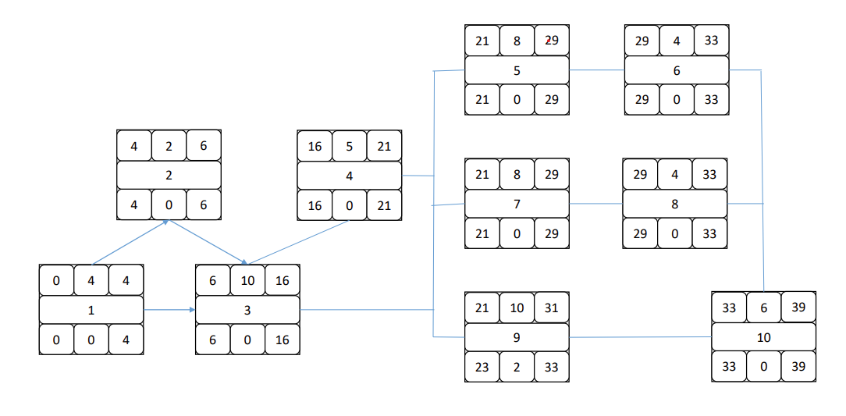

### Gantt timeline

|  |  |  |  |  |  |  |  |  |  |  |  |  |  |  |  |  |  |  |  |  |  |  |  |  |  |  |  |  |  |  |  |  |  |  |  |  |  |  |  |
| --- | --- | --- | --- | --- | --- | --- | --- | --- | --- | --- | --- | --- | --- | --- | --- | --- | --- | --- | --- | --- | --- | --- | --- | --- | --- | --- | --- | --- | --- | --- | --- | --- | --- | --- | --- | --- | --- | --- | --- |
| 1 |  |  |  |  |  |  |  |  |  |  |  |  |  |  |  |  |  |  |  |  |  |  |  |  |  |  |  |  |  |  |  |  |  |  |  |  |  |  |  |
| 2 |  |  |  |  |  |  |  |  |  |  |  |  |  |  |  |  |  |  |  |  |  |  |  |  |  |  |  |  |  |  |  |  |  |  |  |  |  |  |  |
| 3 |  |  |  |  |  |  |  |  |  |  |  |  |  |  |  |  |  |  |  |  |  |  |  |  |  |  |  |  |  |  |  |  |  |  |  |  |  |  |  |
| 4 |  |  |  |  |  |  |  |  |  |  |  |  |  |  |  |  |  |  |  |  |  |  |  |  |  |  |  |  |  |  |  |  |  |  |  |  |  |  |  |
| 5 |  |  |  |  |  |  |  |  |  |  |  |  |  |  |  |  |  |  |  |  |  |  |  |  |  |  |  |  |  |  |  |  |  |  |  |  |  |  |  |
| 6 |  |  |  |  |  |  |  |  |  |  |  |  |  |  |  |  |  |  |  |  |  |  |  |  |  |  |  |  |  |  |  |  |  |  |  |  |  |  |  |
| 7 |  |  |  |  |  |  |  |  |  |  |  |  |  |  |  |  |  |  |  |  |  |  |  |  |  |  |  |  |  |  |  |  |  |  |  |  |  |  |  |
| 8 |  |  |  |  |  |  |  |  |  |  |  |  |  |  |  |  |  |  |  |  |  |  |  |  |  |  |  |  |  |  |  |  |  |  |  |  |  |  |  |
| 9 |  |  |  |  |  |  |  |  |  |  |  |  |  |  |  |  |  |  |  |  |  |  |  |  |  |  |  |  |  |  |  |  |  |  |  |  |  |  |  |
| 1 |  |  |  |  |  |  |  |  |  |  |  |  |  |  |  |  |  |  |  |  |  |  |  |  |  |  |  |  |  |  |  |  |  |  |  |  |  |  |  |