

By: Kevin Dawson

Supervisor: Joseph Kehoe

Functional Specification Document

Abstract

The purpose of this document is to an overview of the expected functionality, non-functional requirements and the design of this application as well as an iterative plan to detail implementation of these functionalities.

Table of Contents

Vision 4

Concept 4

Business Case Summary 4

Business Model Canvas 4

Target Market 6

Data Flow Diagram 6

Level 0 Data Flow Diagram 6

Use Cases 7

Use Case Diagram 7

Brief Use Cases 8

Register Use Case 8

Login Use Case 8

Delete Account Use Case 8

Offer Lift Use Case 9

Accept/Deny Lift Request 9

Search for Lift Use Case 10

Request Lift Use Case 10

Completed Lift Use Case 10

Rate User Use Case 11

Iterations 11

Iteration One 11

UI Setup 11

Database Setup 11

Iteration Two 12

User Registration 12

User Login 12

Google Map Integration 12

Offer Lift 12

Search for Lift & List Options 12

Request a Lift 12

Accepting/Rejecting a Lift Request 13

Iteration Three 13

Complete a Journey 13

Rate a User 13

Non-Functional Requirements 14

Design 14

User Experience (UX) 14

User Interface (UI) 14

Bibliography 16

# Vision

## Concept

Looprac is a car sharing application. The concept of the app is that people from the same area travelling to a mutual destination can find each other and request or offer a lift. It has the idea of reducing the number of cars on the road each day which will in turn reduce the risk of potential accidents and reduce car pollution. There will be two routes that the users can chose from: driver or passenger.

The driver route will allow the user to enter the details such as their name, email address and details of their car such as make, model, colour, registration which is shared with potential passengers to identify the car. They will be able to accept or reject requests based on the passenger user’s information that is sending the request. They will also be able to input the number of trips they are offering whether it is one way, to the destination and back or schedule days during the week in regards to work or college.

The passenger route will allow the user to enter details about themselves such as name and email address. They will be able to search for lifts either through the map UI, by manual search or by having drivers as favourites.

## Business Case Summary

The need for such an app is to offer the customer a mobile option to finding or offering a lift with other customers to a mutual location. Within the Irish market this service mainly exists through websites and not by mobile applications. This application also aims to reduce the number of vehicles on the road each day, by trying to encourage single passenger cars to group up and share one vehicle, in turn reducing the risk of car accidents on the road and reduce pollution levels created from mass vehicle road users. The user segments are drivers and passengers.

## Business Model Canvas

The Business Model Canvas is a strategic template for developing new or documenting new business models. It is a visual chart describing different elements of the product. It is made up of nine key blocks which are:

**Customer Segments**

This area defines the different groups of people or organisations that the product aims to reach or serve. Without the customers there would be no need for the product. With this tool the customers are grouped into distinct segments with common needs, common behaviours or other attributes.

**Value Propositions**

This block describes the value that the product or service is going to offer to the customer segment. The value proposition is the reason customers choose one company over another. It solves a customer problem or serves a customers need.

**Channels**

This block describes how a company communicates with and reaches its customer segments to deliver the value proposition. Channels are the company’s interface with customers.

**Customer Relationships**

This block describes the types of relationships a company establishes with specific customer segments. Relationships can range from personal to automated.

**Revenue Streams**

This block describes the money that the company generates from each customer segment.

**Key Resources**

This block describes the most important assets required to make a business model work. These resources allow the organisation to create and offer a value proposition, reach markets, maintain relationships with customer segments and to earn revenue. Different resources are needed depending on the type of business model.

**Key Partnerships**

This block describes the network of suppliers and partners that make the business model work.

(Osterwalder & Pigneur, 2009)

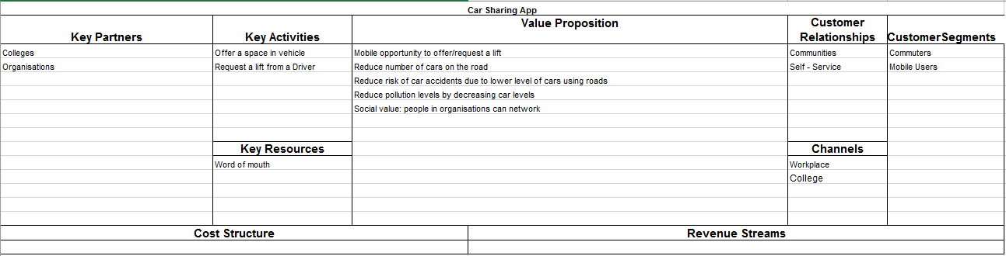

## Target Market

Ireland has the highest penetration of mobile internet users anywhere in Europe, North and South America. Smartphone continues to increase amongst consumers with 90% of over 25’s accessing the internet mostly by smartphone and overall 33% accessing the internet by smartphone only (Connector, 2016). With commuting or travel 74% of people travel by car, 25% travel to work, with 58% drive within Dublin and 74% drive outside of Dublin according to the National Travel Survey 2014 that was published in July 2015 (CSO, 2016). It was shown that people travelled as the driver in private cars for 69.1% of journeys meaning that there are a lot of single car drivers on the road.

(CSO, 2016) 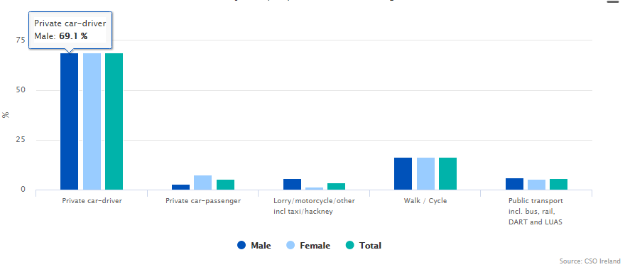

This offers a large target market base and so this apps main target market is aimed at regular smart phone users who commute to work or college, either by car or public transport. The author feels that it is this market base that will benefit the most from use of this app as apart from being environmentally friendly it is financially healthy for the users of the app where cost of transport can be significantly reduced with the ability of them sharing the cost.

# Data Flow Diagram

Data flow diagram is a representation of flow of data in an information system, which is capable of depicting incoming data flow, outgoing data flow and stored data. The DFD does not mention anything about how data flows through the system (Tutorialspoint, 2016). They are made up of entities, processes, data storage and data flow representations.

## Level 0 Data Flow Diagram

This is the highest abstraction level data flow diagram, which depicts the entire system as one diagram concealing all the underlying details, also known as a context level data flow diagram (Tutorialspoint, 2016).

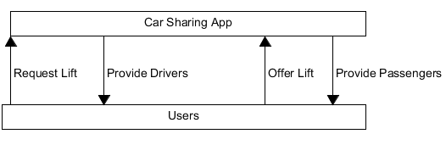

# Use Cases

## Use Case Diagram

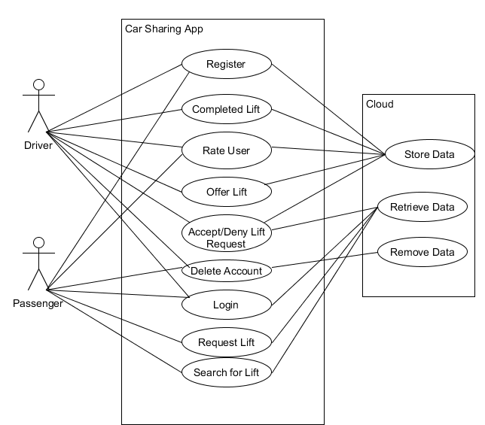

## Brief Use Cases

### Register Use Case

**Name**

Register

**Actors**

User, cloud

**Preconditions**

User has opened the app successfully.

**Description**

The app asks the user to enter their details. The app validates the entered information and stores it to the database. App gives user an acknowledgement that they have successfully registered

### Login Use Case

**Name**

Login

**Actors**

User, cloud

**Preconditions**

User has opened the app successfully.

**Description**

The user selects login. They enter their email address and password and select submit**.** The app validates the information and queries the database. The user is granted access if credentials are correct

### Delete Account Use Case

**Name**

Delete account

**Actors**

User, cloud

**Preconditions**

User wants to delete their account

**Description**

The user selects ‘delete account’ option. The app asks the user if they are sure they want this option. The user selects ‘yes’. The app removes the users’ data from the cloud.

### Offer Lift Use Case

**Name**

Offer Lift

**Actors**

Driver, cloud

**Preconditions**

The driver wishes to offer a lift in their vehicle. The driver selects ‘Offer Lift’

**Description**

The app will ask the driver for their location, destination, the time the lift will take place, how many spaces are available in the car and is it a single or return trip. The app validates this information and sends it to the cloud.

### Accept/Deny Lift Request

**Name**

Accept lift

**Actors**

Driver, passenger, cloud

**Preconditions**

Driver gets a notification that a lift request is waiting for their attention

**Description**

The driver will select the lift request. The app will display details to which lift that the request is for that the driver has previously setup. The app will display the potential passengers name and rating to the driver. The driver can accept the request or deny the request.

### Search for Lift Use Case

**Name**

Search for lift

**Actors**

Passenger, cloud

**Preconditions**

The passenger has opened the app successfully and is looking for available lifts

**Description**

The passenger selects the option ‘available lifts’. The app displays a list of available lifts to the passenger in a ten kilometre radius. The passenger has search filters they can use to adjust the list.

### Request Lift Use Case

**Name**

Request lift

**Actors**

Passenger, cloud

**Preconditions**

The passenger has selected an available lift from the list and wish to send a request

**Description**

The app will query the cloud and display details of the lift and the driver. The passenger will select the request lift option.

### Completed Lift Use Case

**Name**

Completed Lift

**Actors**

Driver, passenger, cloud

**Preconditions**

The driver is close to the destination

**Description**

The app will display a ‘completed’ option. The driver will select the completed option. The app will store the completed journey to the cloud. The app informs the driver and passenger(s) with a message showing them they’re new statistics.

### Rate User Use Case

**Name**

Rate User

**Actors**

User, cloud

**Preconditions**

The destination has been reached and the driver has completed the ‘complete lift’ use case

**Description**

The user is prompted to rate the other users. The app will display a five-star system and allow the user to select between zero stars to five stars. The user submits their rating. The app updates the driver and passenger’s rating in the cloud.

# Iterations

The following sections describe the functionality that is planned before each iteration as well as the differences between what was planned and delivered.

## Iteration One

In iteration one, it is planned to achieve the following functionalities. Due to the short duration of this iteration there will be fewer tasks carried out during it.

### UI Setup

The UI for all the apps screens will be created. This will follow a design which is specified in the design document. The functionality for these screens will be implemented in later iterations.

### Database Setup

This involves setting up the database for the app including the relevant tables. This will be needed in order for other functions of the app such as registering and logging in as well as retrieving and saving user data. The database will also hold journey information so that all completed journeys can be saved.

## Iteration Two

In iteration two the following functionalities are planned to be completed.

### User Registration

This involves the user being able to select register and to fill in the relevant details. They can initially register as a driver or passenger, but this will be able to be changed from within the app. The user’s data will then be synced to the database and the user will be registered to the app.

### User Login

This will be the logic and functionality behind the login use case. This involves validating the users email and password that they enter with the data that is saved in the database and responding accordingly on whether the credentials are correct or not.

### Google Map Integration

By the end of iteration one, it is hoped that Google map will be integrated into the app. This functionality will allow the user to select destinations with the map rather than manually typing in addresses. It will also provide the users with a visual aid of the route that the journey will take.

### Offer Lift

This involves the user, being a driver in this case being able to create an available lift. This will include details about the lift such as location that lift will start, destination, time and date of the lift and whether it is return or not. This will then be saved to the database of available lifts. The available lifts will then be populated into a list.

### Search for Lift & List Options

Functionality that a user can browse the list of available lifts and can alter the filter to broaden or decrease the radius of the search and sort the list. Also, by selecting one display the information regarding the journey and the driver.

### Request a Lift

This involves the user, being a passenger in this case after selecting a lift from the list sending a request to the driver. This will find the driver amongst the collection of drivers that issued the offer and notify them that another user is requesting a space in their vehicle.

### Accepting/Rejecting a Lift Request

This involves a user, being a driver, receiving a notification from another user requesting a space in their vehicle. The driver has two choices, to accept or reject the request.

If the driver accepts the request, the information about the journey will be updated in the database. The driver will receive all information about the passenger. A notification will be returned to the user that issued the request telling them it was accepted and providing them with all the information about the journey.

If the driver rejects the request, it will be followed by an option to block future requests from the user or not. The user that issued the request will be informed of the driver’s decision.

## Iteration Three

In this iteration the following functionalities are planned to be completed.

### Complete a Journey

This functionality involves monitoring the driver’s geolocation. When the driver’s distance is within a short range of the destination an option to ‘complete’ the journey will show up on the driver’s screen. When this has been selected, data about the journey will be displayed such as distance travelled and number of cars reduced on the road – calculated by number of passengers who are also drivers. It will then update the database combining the new distance travelled with what is currently saved.

### Rate a User

This involves allowing users to rate other users they shared a journey with. This will be done by checking the geolocation of all members of the journey to make sure they are at the destination. The users will choose a rating out of five for each other. The database will update their ratings.

# Non-Functional Requirements

Non-functional requirements for this project would be:

1. With registering the process should take no more than one minute from when the user selects ‘Register’ to when they select ‘Submit’, this being that the user is a standard mobile user.
2. The process of offering a lift should take on average between a minute and a minute and a half
   1. This process should work 99% of the time
3. The process of requesting a lift should be completed in less than a minute
   1. This process should work 99% of the time
4. The process of requesting a lift should be able to be completed in less than a minute

# Design

## User Experience (UX)

Mobile phones are a huge part of today’s world, with 4.61 billion mobile users in 2016 and forecasted to hit 4.77 billion in 2017 (Statisa.com, 2016). So it’s important when developing a mobile app to take user experience (UX) into account. Mobile UX is the perception an end user has of the mobile product. With this volume of people with mobile phones the users experience and the flow of the app should be as fluid as possible. There are many design patterns to help with the UX of an app. The app will be designed with accessibility in mind and will provide the main activities of the app to be completed in as few clicks as possible while pushing less important activities to the back. This has the aim of providing quick and easy experience for the user so that the activities of the app may be completed quickly and hassle, this is to provide a positive UX.

## User Interface (UI)

The design of the UI can be the difference between the success or failure of an app. If the app is too complicated to navigate or complete an activity it will turn potential users away from it. With this in mind the UI of this app will be kept simplistic and minimal. There will be no unnecessary UI or “clutter” that could confuse or mislead customers. With the positive UX in mind making the activities of the app to be completed quickly will require clear, concise and quick to follow trail for the user to follow. Screenshots of the potential UI design will be documented in the design document.

# Bibliography

Connector, 2016. *Inforgraphic - Connector.* [Online]   
Available at: http://connector.ie/infographic/  
[Accessed 25 October 2016].

CSO, 2016. *How we Travelled - CSO - Central Statistics Office.* [Online]   
Available at: http://www.cso.ie/en/releasesandpublications/ep/p-nts/nationaltravelsurvey2014/detailedanalysis/howwetravelled/  
[Accessed 25 October 2016].

CSO, 2016. *National Travel Survey 2014 - CSO - Central Statistics Office.* [Online]   
Available at: http://www.cso.ie/en/releasesandpublications/ep/p-nts/nationaltravelsurvey2014/  
[Accessed 25 October 2016].

Osterwalder, A. & Pigneur, Y., 2009. *Business Model Generation.* 1 ed. Amsterdam: Self Published.

Statisa.com, 2016. *Number of mobile phone users worldwide 2013-2019.* [Online]   
Available at: https://www.statista.com/statistics/274774/forecast-of-mobile-phone-users-worldwide/  
[Accessed 22 October 2016].

Tutorialspoint, 2016. *Software Analysis & Design Tools.* [Online]   
Available at: https://www.tutorialspoint.com/software_engineering/software_analysis_design_tools.htm  
[Accessed 27 October 2016].

Tutorialspoint, 2016. *Software Analysis & Design Tools.* [Online]   
Available at: https://www.tutorialspoint.com/software_engineering/software_analysis_design_tools.htm  
[Accessed 1 November 2016].