

By: Kevin Dawson

Supervisor: Joseph Kehoe

USABILITY

Abstract

The purpose of this document is to detail on to use Looprac. This includes installation requirements, installation itself and how to use the different features of the application.

**Table of contents**

1. Introduction 4

2. Installation Requirements 4

3. Installation 4

4. Using Looprac 4

4.1 Mutual Usability 5

4.1.1 The first page 5

4.1.2 Registering 5

4.1.3 Login 6

4.1.4 Viewing My Completed Lifts/ Completed Groups 6

4.1.5 Viewing My Profile 7

4.1.6 Delete My Profile 8

4.1.7 Viewing Leader Board 8

4.2 Usability as a Driver 9

4.2.1 Main Page 9

4.2.2 Registering your car 10

4.2.3 Offer a Lift 11

4.2.4 Viewing My Lifts 12

4.2.5 Viewing My Lift Details 12

4.2.6 Accept or Deny a request from a passenger 13

4.2.7 Starting a Lift 14

4.3 Usability as a Passenger 14

4.3.1 Main Page 14

4.3.2 Search for Lift 15

4.3.3 View My Requests 16

4.3.4 View My Groups 16

4.3.5 Starting a Lift 17

# Introduction

Looprac is a hybrid mobile phone application. The application was developed the mobile platform, it can be used on Android, Windows and IOS. However, the author only developed the application on Android. This document will be on installation and usability for an Android mobile.

# Installation Requirements

Requirements to install Looprac, are that you need to have an Android mobile device. The application was developed and tested on an Android 6.0.1 device. The application will however run on Android versions down to 2.1.

When the application is released for Windows phones and IPhone, the minimum versions it will run on are BlackeBerry OS6 and IOS 4.2.

# Installation

There are currently two ways to install Looprac on your Android device and they involve going to <http://glasnost.itcarlow.ie/~softeng4/C00130965/index.html> and either:

1. Downloading the APK to your mobile device
   1. Find the APK in your filesystem
   2. Install the application from the APK
2. This option requires you to have a QR Scanner application on you mobile.
   1. Scan the QR code on webpage and follow the instructions to install

Method two is the recommended option, as it is quick and easy to do.

# Using Looprac

The following sections will be split into three categories: as a driver, as a passenger and common features for both. Furthermore, for use of this application you are required to:

* Have internet access: whether it is by WIFI or mobile data, you need to be connected to the internet always during use of this application
* Turn your GPS location on: you must have you GPS location enabled on your phone, so that the maps will display, and your location will be displayed on the map.
  + For better accuracy: enable ‘High Accuracy’ in your phones settings with GPS

## Mutual Usability

### 4.1.1 The first page

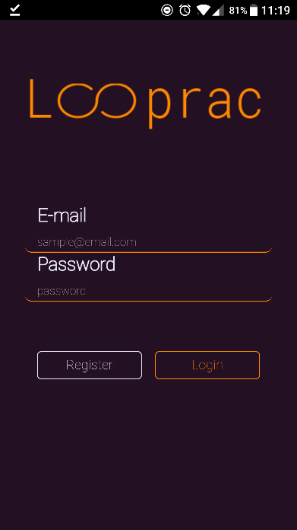

Figure 1

The first page you are presented with when you open Looprac is the login page. As this is your first time using the application, you will select the ‘Register’ button shown in figure 1. This will bring you to the registration page.

### 4.1.2 Registering

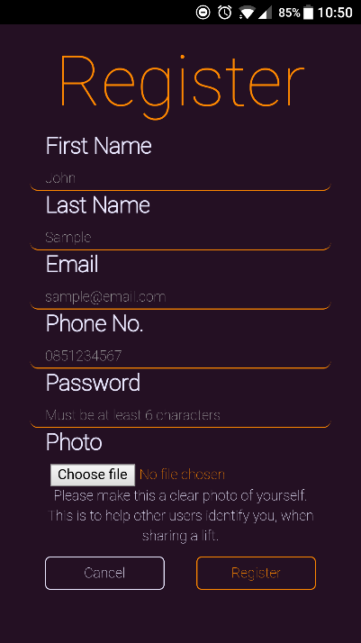

Figures 2 & 3

The register page is where you will register with Looprac and so you can gain access to the application. You will be presented with the screen in figure 2. All fields are required to complete the form. Enter your details into the input fields as the example placeholder show you. The requirement for an image of yourself is to set it as your profile picture and that other users can identify you when sharing lifts.

When you have entered all your details, select ‘Register’ and you will be informed that you have registered with Looprac. You will then be brought back to the login page.

### 4.1.3 Login

You will be presented with the login page, which is shown in figure 1. To gain access to the application, you are required to enter the email address and password that you registered with. When you have entered your credentials, click the ‘Login’ button. If successful, you will be brought to the applications main page. If unsuccessful, you will be asked to recheck you email and password.

### 4.1.4 Viewing My Completed Lifts/ Completed Groups

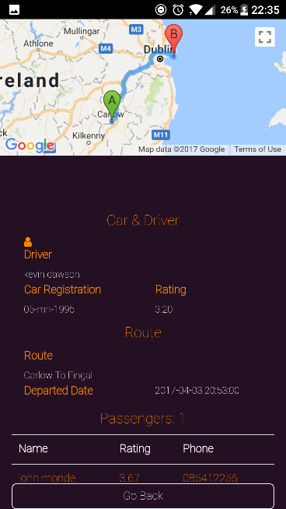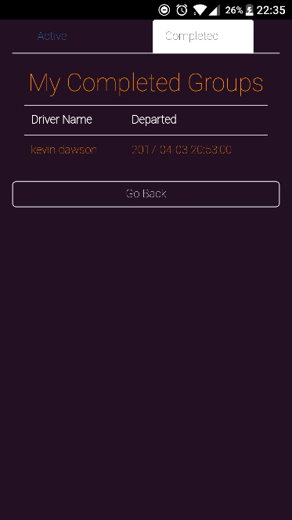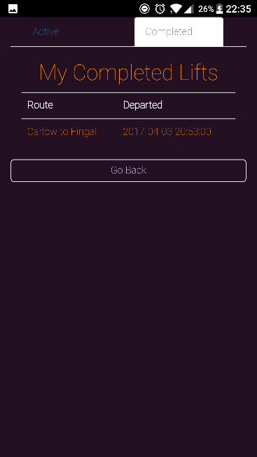

Figures 4, 5 & 6

When you want to view your completed lifts, choose ‘My Lifts’ from the menu in figure 12 and then select the tab labelled ‘Completed’ at the top of the page. If you have any, you will be presented with your completed lifts. They are listed with the name of the route and the time it departed. An example is shown in figure 4.

When you want to view your completed groups, choose ‘My Groups from the menu in figure 12 and then select the tab labelled ‘Completed’ at the top of the page. If you have any, you will be presented with your completed groups. They are listed with the name of the driver and the time it departed. An example is shown in figure 5.

Selecting a group or lift from the list will present a page that displays the details about the lift including the drivers name, car details, the route both displayed on an interactive map and in text and the time it departed. You will also be presented with a list of the passengers that were with you on that lift. You can go to their profiles by clicking on their names. An example of this page is in figure 6.

### 4.1.5 Viewing My Profile

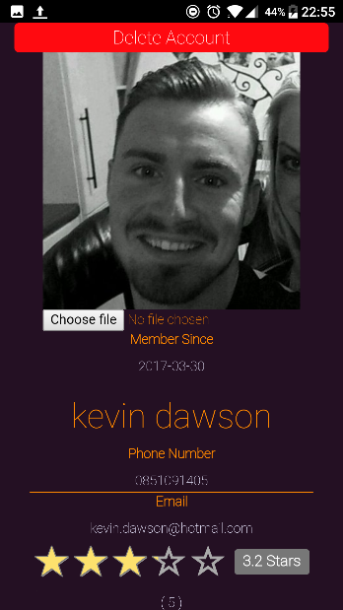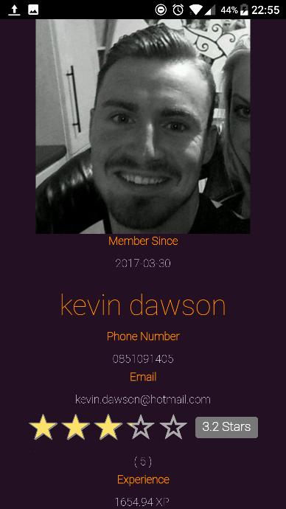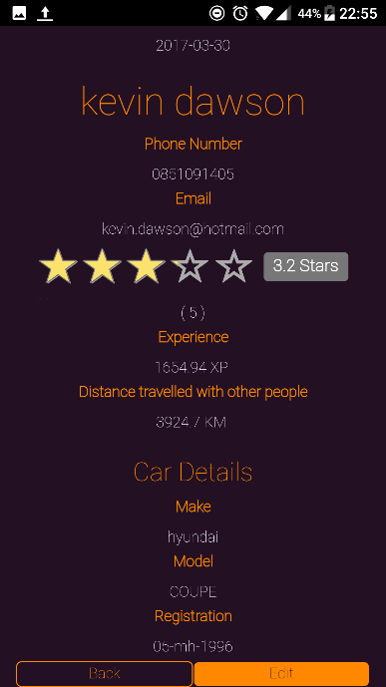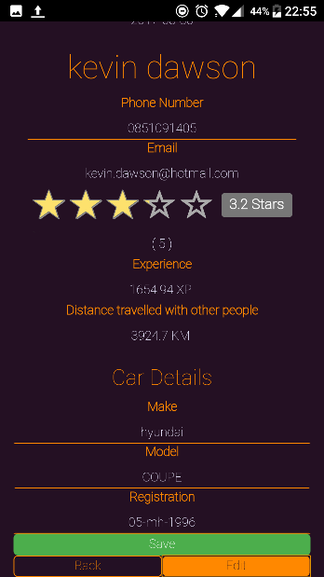

Figures 7 & 8

If you wish to see your profile, select your name underneath your profile picture in the menu, shown in figure 15. You will be brought to your profile which displays your information along with your overall rating, experience, distance travelled and if you have been a driver, the number of passengers you have brought in your car. An example of a profile is shown in figure 7.

You can also edit your details here, by selecting the ‘Edit’ button at the bottom of the page. You can edit you phone number, profile picture and if you have a car registered, you can edit the cars details. Any fields that can be edited are underlined. To save any changes select the ‘Save’ button. An example of this is in figure 8.

You register your car when you offer a lift for the first time. After that, your car details will be displayed here.

### 4.1.6 Delete My Profile

If you wish to delete your profile, navigate to your profile and select the ‘Edit’ button. This will display a delete button at the top of the page, as shown in figure 8. To delete your account, select the ‘Delete’ button. You will be asked to confirm your choice. If you choose yes, you will be informed that your account was deleted and you will be returned to the login page.

### 4.1.7 Viewing Leader Board

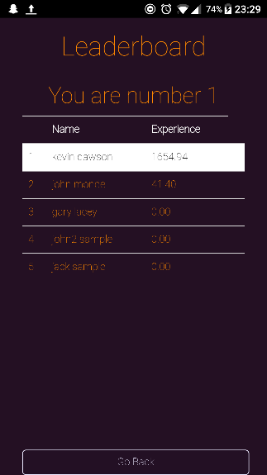

Figure 9

To view the leader board, select the option ‘Leaderboard’ from the menu in figure 15. You will be presented with a table that displays all the users of Looprac. It shows their names and their experience, and ranks them against one another.

Your name and experience will be highlighted in the table to show you where you are. Your rank will also be displayed at the top of the page, as shown in figure 9.

## Usability as a Driver

### 4.2.1 Main Page

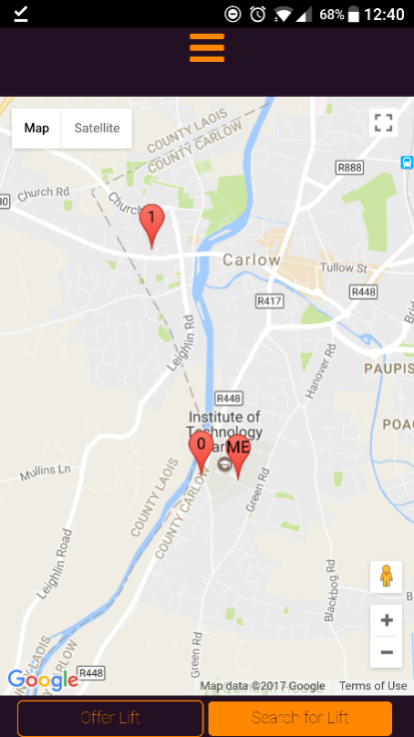

Figure 10

The page displayed in figure 10, is the home page of the application. This is where you are brought to when the application logs you in. You are identified on the map by an icon labelled ‘ME’. This is your current location. The makers labelled ‘0’ and ‘1’ are available lifts in your area. To see the result of clicking on one go to Lift Details subsection in the Passenger section.

To offer a lift you must select the ‘Offer Lift’ button at the bottom of the page in figure 10. If this is your first time offering a lift, you will be prompted to register your car details with the application. You cannot offer a lift without registering your car.

### 4.2.2 Registering your car

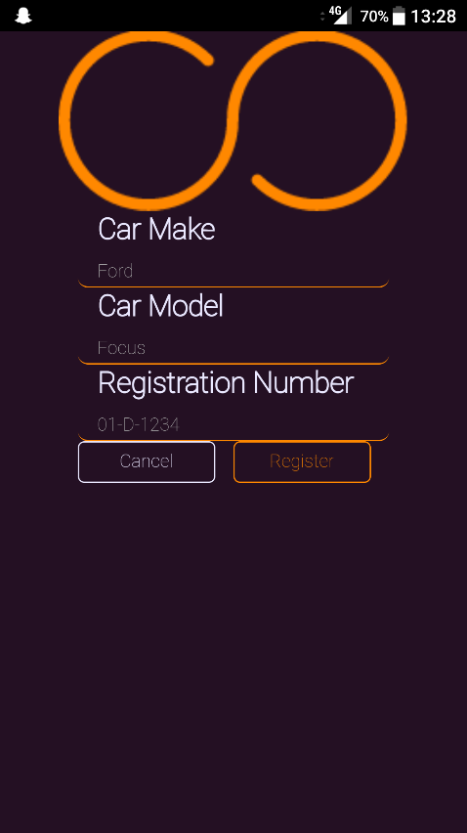

Figure 11

The page displayed in figure 11 is the register car details page. Here, you are required to enter your car make, model and the registration number of your car as shown with the example placeholder. The reason for registering your car and registration number is so that other users can identify your car.

Once you have filled out the details as required, click the ‘Register’ button to proceed to the offer lifts page.

In future, you won’t be brought back to this page when you offer a lift. To view how to change your car details, go to the View My Profile section.

### 4.2.3 Offer a Lift

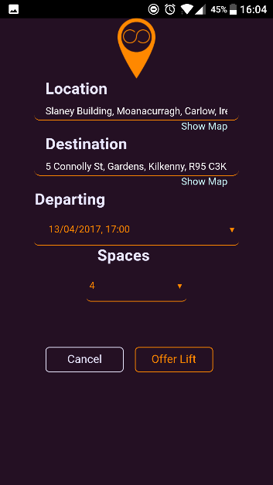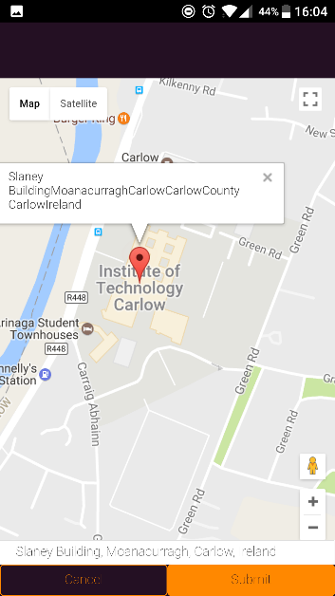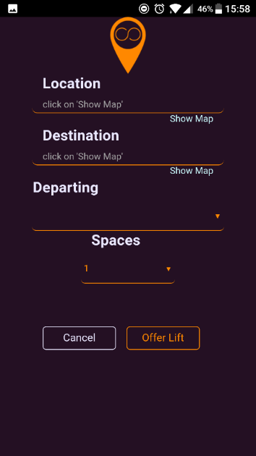

Figures 12, 13 & 14

The offer lift page, as shown in figure 12, is where you offer lifts in Looprac. The application looks for details relevant to the lift such as start location, destination, departing time and the number of spaces you wish to offer. This value defaults to one and is limited to six.

To get the start location click on the ‘Show Map’ button underneath the ‘Location’ input field. When you click on this you are presented with the page shown in figure 13. This is how you select a location. To pick a location, put your finger on the icon on the map and drag it to where you want to drop it. When you let go the icon will display the address of the location that it is currently at. This will also be displayed in the box above the buttons for you. If this is the location you want, click the ‘Submit’ button. You will be brought back to the previous page but now the Location field will be populated with the address you chose from the map page, as shown in figure 14. For destination, the same method is used as above.

For the departing date, you will be presented with a date and time picker, chose a date and time that is past your current time. If you choose and invalid time, for example 07:00 yesterday, the application will alert you that this is not a valid date and to choose one beyond your current point in time.

Next choose the number of seats that you wish to offer in your vehicle. The default value is one and it is limited to six.

When all the above has been completed, click the ‘Offer Lift’ button at the bottom of the page and you will be informed that your lift offer has been submitted. You will then be returned to the main page.

### 4.2.4 Viewing My Lifts

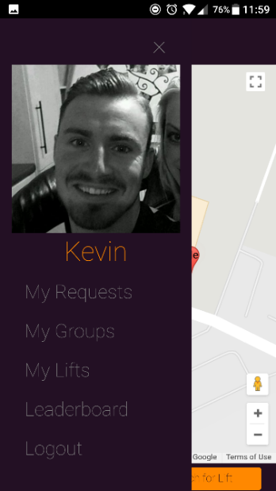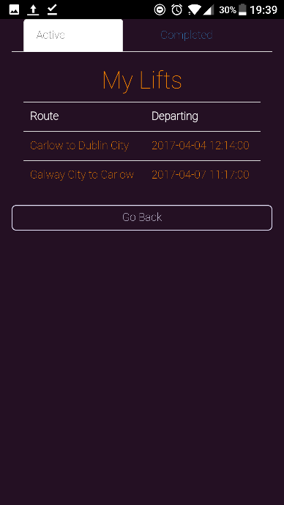

Figures 15 & 16

To view your active lifts on the main page, click the hamburger icon at the top of the page in figure 10. Your menu will then slide out from the left side of the screen. Select ‘My Lifts’ from the menu presented, as shown in figure 15. You will be brought to your lifts. Initially you will be brought to your ‘Active’ lifts as highlighted from the tab at the top of the page, shown I figure 16.

You will be presented with a list of the lifts that you have registered and are active. They are identified by the route of the lift and the departing time.

To view the details of a lift, select it from the list. You will be brought to the Lift Details page, discussed next.

### 4.2.5 Viewing My Lift Details

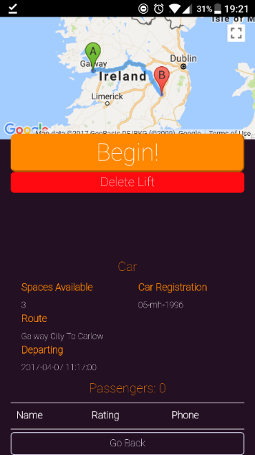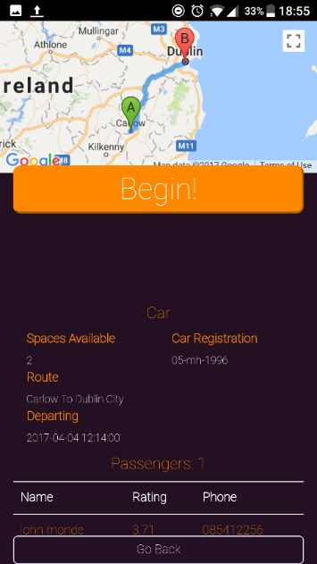

Figures 17 & 18

This is the page you are presented with when you select a lift from figure 16. You will be presented with one of two views. If your lift has no passengers associated with it, that is, you have not accepted any requests for the lift you will be presented with the page in figure 17. In this view, you are presented with details of your lift, including your car details, the route of the lift shown on both a map and the counties or county area’s in text below and an empty passenger table. You will also in this view be presented with the option to delete this lift, as shown in figure 17. You can delete this lift from Looprac by selecting the ‘Delete’ button. You will be asked to confirm your decision, as this operation is destructive, the lift will not be retrieved. You will only be presented with this view if you have no passengers, because if you have passengers, you are committed to them and the lift to follow it through, an example of this view is in figure 18.

### 4.2.6 Accept or Deny a request from a passenger

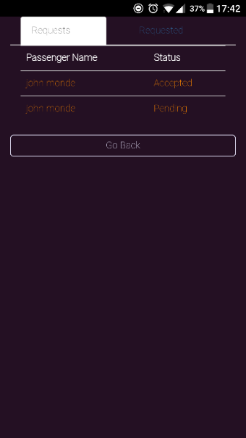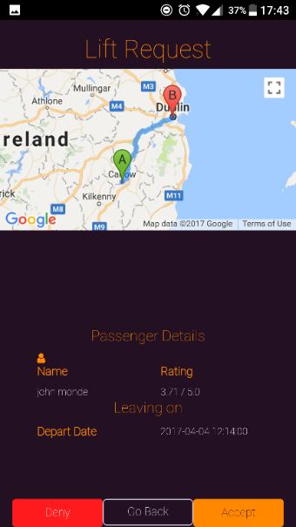

Figures 19 & 20

To see if you have any requests for your active lifts, select ‘My Requests’ from the menu in figure 15. You will be presented with a page that has two tabs ‘Requests’, which are requests from other users and ‘Requested’, which are your requests to other users.

If you have any requests, they are displayed in a list with the passenger’s name and the status of the request. A request can have three states: ‘pending’ when its waiting for a decision to be made, ‘Accepted’ and ‘Denied’. An example is shown in figure 19.

When you select a request, you are presented with a page containing details of the request. These include the passengers name and rating out of five. The lift route displayed on an interactive map and the depart time of the lift. You can choose to see more details about the passenger by clicking the profile icon above the name label, which will bring you to their profile. An example of a request page is shown in figure 20.

If you accept the request, the status of the request for yourself and the passenger is updated, a group is created for you and the passenger for that lift, and your available seats are updated. The group can be viewed in the ‘My Lifts’ details page, which is now updated with the passenger, as shown in figure 18.

If you choose ‘Deny’, the status of the request for yourself and the passenger is updated.

You will then be returned to the main page.

### 4.2.7 Starting a Lift

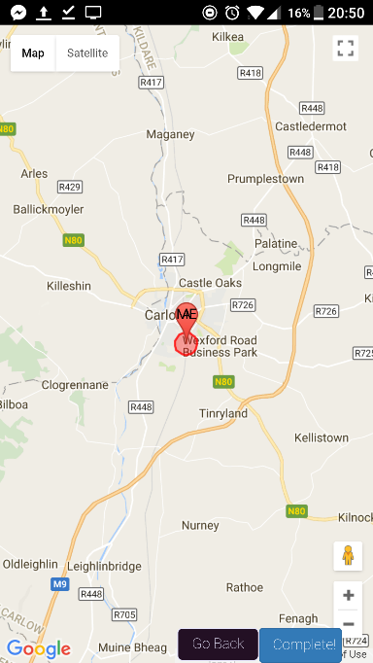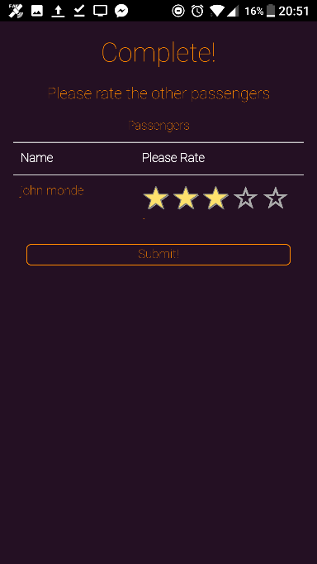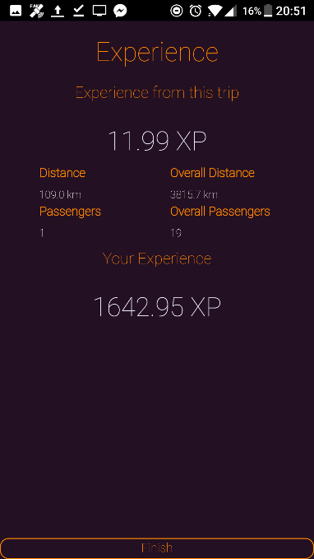

Figures 21, 22 & 23

When it is time to begin a lift, you can begin the lift by selecting the ‘Begin’ button on the lift in figure 18. You can begin a lift if: there are one or more passengers, the current time is within five minutes of the depart time, and your location is within five hundred meters. If any of these are false, you will be prompted with the relevant alert to inform you.

When the lift begins, you will be presented with the page in figure 21. This displays your position, which represents your car group. When you are at your destination, select the ‘Complete’ button. If you are within five hundred meters, shown by the red circle in figure 18, you can complete the lift. If you try complete the lift while outside of the red circle, you will be informed that you are too far from the destination to complete the lift and your position will be updated on the map.

When the lift has been completed, you will be presented with the page in figure 22. This is where you get to rate the passengers of your lift. It is a five-star rating system, with a minimum of one and max rating of five. Choose a rating by selecting a star and it will fill. When you have rated all the passengers, select the ‘Submit’ button.

After you have submitted your ratings, you will be presented with your experience page. This will display to your experience gained from this trip, the distance of the trip and the number of passengers you brought, along with your overall experience, overall distance and overall passengers count. An example is shown in figure 23. When you are finished click the ‘Finish’ button.

## Usability as a Passenger

### Main Page

When you log in you are presented with the page in figure 10. This is the main page where you can choose to offer lifts or search for lifts.

### Search for Lift

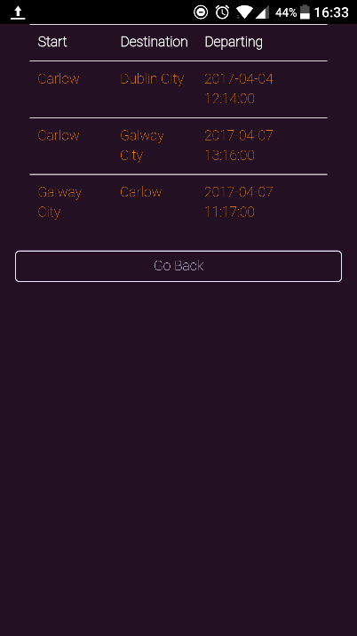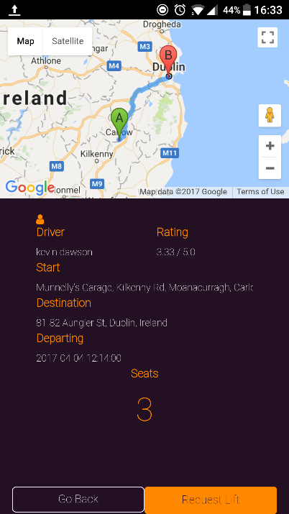

Figure 24 & 25

When you want to search for a lift, select the ‘Search for Lift’ button at the bottom of the page in figure 10. You will then be presented with a list of all available lifts, displaying their start, destination and departing time. An example is shown in figure 24.

To get a lifts details to display, you can do it two ways, you can select it from the list in figure 21, or you can select an icon in figure 10. Both ways will present you with the details of that lift. The page will display the route on an interactive map so you can see exactly where it starts and ends. It will display the drivers name and their rating. You can also select the profile icon above the ‘Driver’ label, to see more details about them. It also shows the start and destination addresses in text and the number of available seats for the lift. An example is shown in figure 25.

To request a seat in the vehicle for that lift, click the ‘Request Lift’ button at the bottom of the page. You will be informed that your request will be sent and to keep an eye on your requests page for the answer. You will then be returned to the main page.

### View My Requests

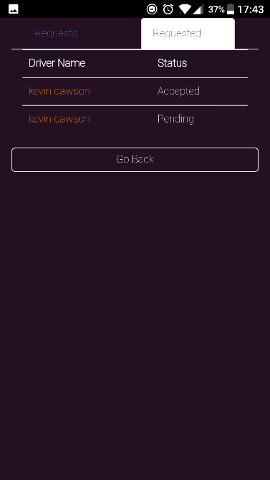

Figure 26

To check the status of your requests, click on the ‘My Requests’ option in the menu in figure 15. Then select the tab labelled ‘Requested’ at the top of the page. If you have requested any lifts, you will be presented with a list of them, displaying the drivers name and the status of the request. A request can have three states: ‘pending’ when its waiting for a decision to be made, ‘Accepted’ and ‘Denied’. An example is shown in figure 26.

If a lift is accepted, you are put into a group with the driver of that lift and any other passengers of that lift.

### View My Groups

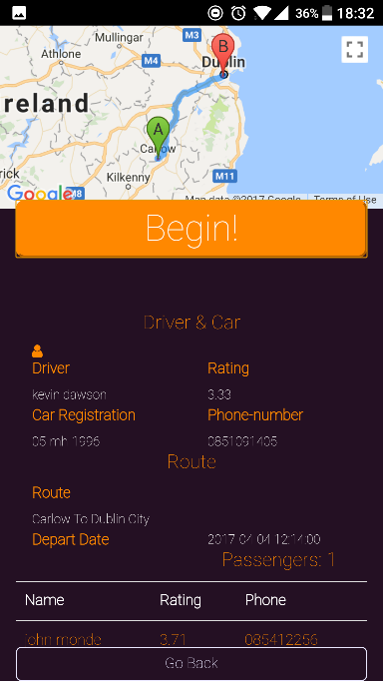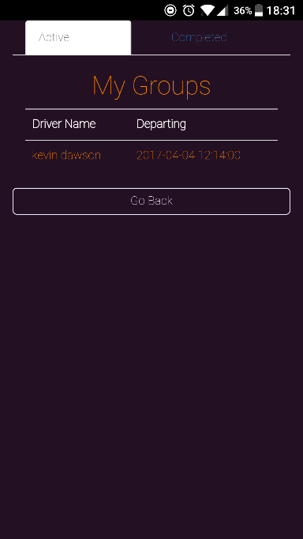

Figures 27 & 28

When you want to view the groups that you are in, select ‘My Groups’ option from the menu in figure 15. If you are in any, you will be presented with a list of groups showing the driver name and departing time, as shown in figure 27.

When you select one from the list, you are brought to the groups details page. Here you are presented with details regarding the lift and group, including the route of the lift on an interactive map, the driver’s details, the departing time and a list of all the passengers in the lift. You can go to any of the passenger’s profiles by selecting them from the list or the drivers profile by selecting the profile icon. An example of this page is shown in figure 28.

### Starting a Lift

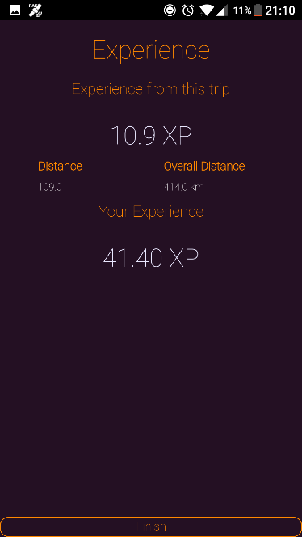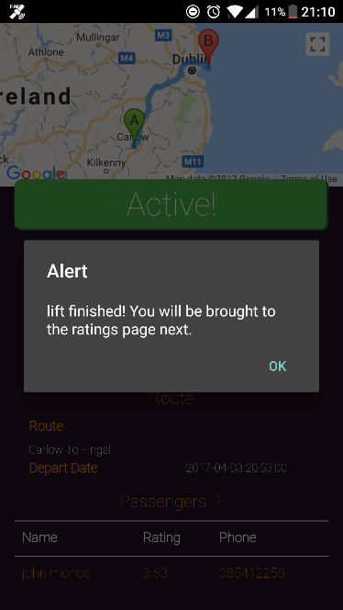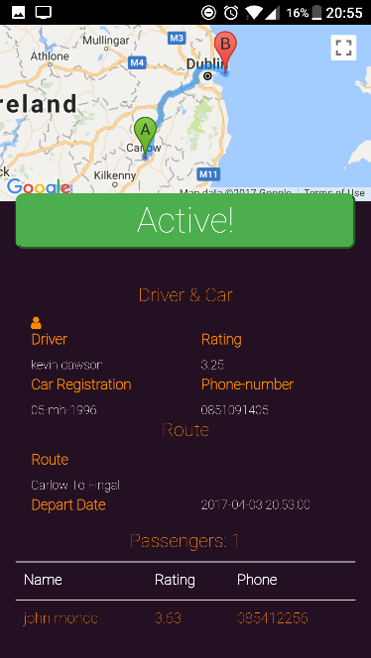

Figures 29, 30 & 31

When it is time to start the lift and you are in the driver’s vehicle, you can select the ‘Begin’ button from the group page, shown in figure 28. The lift can begin if: the current time is five minutes or less away from the depart time and your current location is within five hundred meters of the starting location.

When the lift begins, this will be displayed by the ‘Begin’ button changing to ‘Active’, as shown in figure 29. The lift can only be completed by the driver so this page will remain until the lift is over. When the driver selects to complete the lift, you will be notified by an alert that the lift has ended, shown in figure 30.

When the lift has been completed, you will be presented with the page in figure 22. This is where you get to rate the driver and other passengers of your lift. It is a five-star rating system, with a minimum of one and max rating of five. Choose a rating by selecting a star and it will fill. When you have rated all the passengers and the driver, select the ‘Submit’ button.

After you have submitted your ratings, you will be presented with your experience page. This will display to your experience gained from this trip and the distance of the trip, along with your overall experience and overall distance. An example is shown in figure 31. When you are finished click the ‘Finish’ button. You will be brought back to the main page.