Predicting Breast Tumour Diagnosis from Cell-Nucleus Measurements
DATA601_Lec_03_Group 5 – Project Stage 3: Telling a Story with Data
Written Report
Dingshuo Li ｜ Patrick Pascua｜ Xiaolin Zhang

Introduction and Question of Interest
Tumour measurements can be used to classify a tumour as benign or malignant. A good prediction model for medical professionals using this kind of data would help to identify malignant tumours, while still having a high true positive rate.
The problem of this project is to determine if the ten mean measurements of cell nuclei can be used to differentiate between benign and malignant tumours and predict the diagnosis of tumours. The project evaluates the ability of different models to distinguish tumours using these measurements. The solution is expected to find a model that performs best on the test set with high sensitivity.
The analysis begins with exploratory data analysis, including PCA to identify four variables for visualization. However, all ten mean measurements are used for model training. The project compares three different models: logistic regression, Random Forest, and K-means clustering.
Data Description and Initial Exploration
The dataset used in this project is the Breast Cancer Wisconsin (Diagnostic) dataset from the UCI Machine Learning Repository. It contains 569 observations and 30 numerical features obtained from digitized images of fine needle aspirates (FNA) of breast masses. These features describe different characteristics of cell nuclei. The target variable, benign, is coded as 1 for benign tumours and 0 for malignant tumours. [1]
Among the 569 observations, 357 (62.74%) are benign and 212 (37.26%) are malignant. There are no missing values or duplicate rows in the dataset, so no observations needed to be removed or filled in. Since there are more benign cases than malignant cases, accuracy alone may not be enough to evaluate the models. Therefore, malignant recall is also considered to measure how well each model identifies malignant tumours.
Dataset characteristic | Value
Observations | 569
Numerical tumour measurements | 30
Benign cases | 357 (62.74%)
Malignant cases | 212 (37.26%)
Missing values | 0
Duplicate rows | 0
We focus on the first ten mean measurements. Their scales are quite different. For example, mean area changes between 143.50 and 2501.00, while mean fractal dimension has much smaller values. Therefore, we standardize the measurements for modeling, especially for K-means, so that features with larger numerical scales do not dominate simply because of their units.
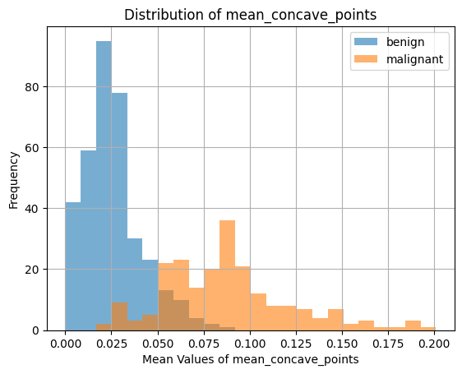
Figure 1. Distribution of mean concave points for benign and malignant tumours.

The data can help differentiate between benign and malignant tumours. First of all, the mean concave points for malignant neoplasms are significantly higher, amounting to 0.0880, as compared to the value of 0.0257 for benign tumours. Secondly, mean texture and mean symmetry were also higher for malignancies, while mean fractal dimension was approximately the same for both types of tumours. Figure 1 indicates that the distribution of malignancies overlaps with the distribution of benign tumours, although the former generally have a higher mean concave points value.
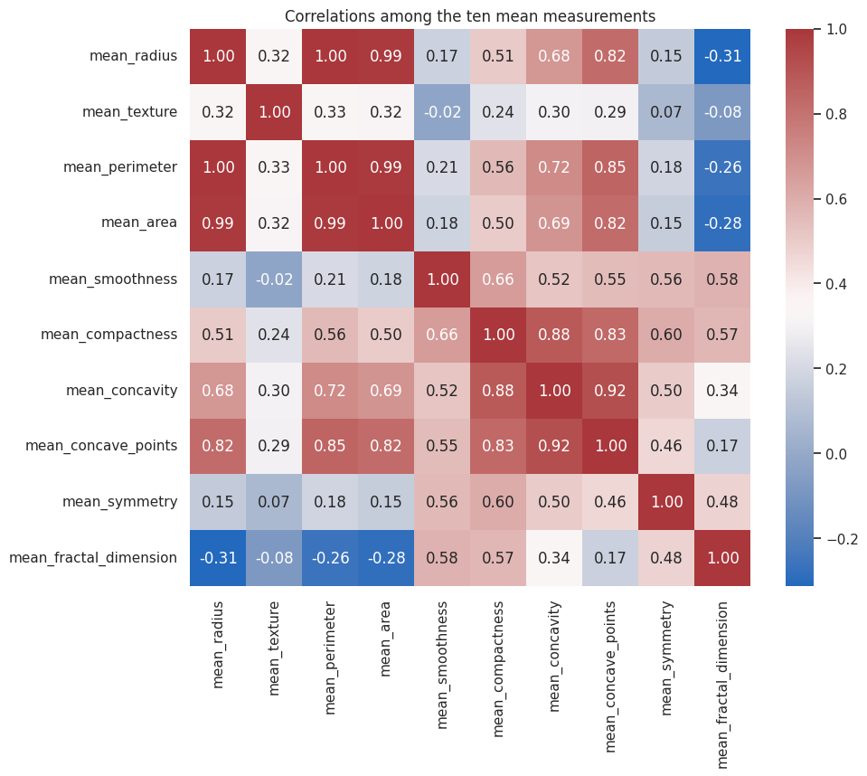
Figure 2. Correlations among the ten mean measurements.
Some mean measurements were also highly correlated with each other, as can be seen in figure 2. For instance, mean concavity and mean concave points had a correlation coefficient of approximately 0.92, while mean compactness and mean concavity had a correlation coefficient of approximately 0.88. These strong correlations may make the logistic regression coefficients difficult to interpret. However, all ten mean features were kept for model training because they may still be useful for prediction.

Data Preparation
The data were split into training and test sets using a stratified 80/20 random split with random_state = 2026, resulting in 455 training and 114 test observations with roughly the same proportions of benign/malignant as the original data. Parameters for standardization were estimated on the training data only and then applied to the test data to prevent leaking of test data information into the training process. Keeping the test data separate from the model training process allows for a more honest assessment of how well the model generalizes to new data.
During the exploratory analysis step, PCA was applied to the standardized ten mean measurements and the variable with the highest absolute loading on each of the first four principal components was identified. The first four principal components accounted for 93.77% of the variance in the data. The four variables identified were mean concave points, mean fractal dimension, mean texture, and mean symmetry. However, PCA was not used to reduce the final model inputs.
For the final models, we used all ten mean measurements rather than the four variables identified by PCA. Since PCA does not consider the diagnosis labels, the variables selected for PCA are not guaranteed to be the best predictors of diagnosis. By retaining the ten features, we also followed the suggestion in the feedback on Project 2.

Models
Logistic Regression
We fit a binary logistic regression using benign diagnosis as the outcome and all ten standardized mean measurements as predictors. Since benign = 1, a negative coefficient implies that a higher measurement is associated with relatively lower estimated odds of a benign diagnosis, with the other predictors held fixed. We chose a logistic regression model because its coefficients are relatively easy to interpret.
Some predictors were highly correlated. For example, the VIF was approximately 1892.82 for mean radius and 2284.07 for mean perimeter. These high VIF values suggest that multicollinearity may affect the interpretation of individual coefficients. However, the model still performed well on the test data.
Random Forest
We fit a Random Forest classifier with 200 trees using the same ten mean measurements. Random Forest is particularly suited to this classification task because it can learn nonlinear patterns and interactions. We also made use of the permutation importance on the test data, to see which variables the fitted model relied on most.

K-means Clustering
We included K-means as an unsupervised comparison using the ten standardized mean measurements. We compared silhouette scores for k = 2 through 14 and selected k = 2. K-means does not take advantage of the diagnosis labels when determining clusters. We fit the model on the training data, and labeled the clusters using the majority diagnosis in each training cluster to compare against the test diagnoses.
Results

Model | Test accuracy | Benign precision | Malignant recall
Logistic Regression | 91.23% | 94.29% | 90.48%
Random Forest | 93.86% | 95.77% | 92.86%
K-means | 89.47% | 88.46% | 78.57%
Table 1. Test-set performance on the same 114 observations.
Random Forest had the highest test accuracy: it correctly classified 107 of 114 observations (93.86%). Logistic regression classified 104 of 114 (91.23%), and K-means classified 102 of 114 (89.47%).
We also looked at malignant recall because missing malignant cases is an important concern. Out of 42 malignant test cases, Random Forest correctly identified 39 (92.86%), logistic regression identified 38 (90.48%), and K-means identified 33 (78.57%). Random Forest performed best on both overall accuracy and malignant recall in this test set.
The difference between the supervised models was not very large: Random Forest had an accuracy 2.63 percentage points higher than logistic regression. This is based on one train/test split, so it does not prove that Random Forest would always be better on new data.

What Variables Matter Most?
Looking at the exploratory plots, it shows that the mean concave points distinguish the two diagnosis groups fairly well. The distributions, however, do overlap. For the Random Forest model, shows that mean concave points and mean texture are the most relevant measures of importance based on permutation. This suggests that both of these measures are important information for predicting the cancer cell type.
Focusing on the logistic regression results, mean concave points and mean texture had negative coefficients (-3.332 and -1.641, respectively). Mean fractal dimension had a positive coefficient (0.324), and mean symmetry had a small negative coefficient (-0.230) with a p-value of 0.527. The reason for this result is due to the possibility of quasi-separation, and the fact that several of the 10 predictors are highly correlated, which suggests that coefficients may not be stable.
Finally, the Random Forest results, which use a different approach from logistic regression, also provide important information about the predictors. On average, shuffling mean concave points decreased accuracy by 5.38 percentage units, while shuffling mean texture decreased accuracy by 2.43 percentage units. Mean fractal dimension had negative importance (shuffling this feature improved accuracy), and mean symmetry was close to having no importance. Having a negative permutation importance does not mean a negative relationship with diagnosis. Rather, it means that shuffling these features did not worsen the prediction of the model.

Discussion: Answering the Question
The results from this project show that the ten mean measures have significant information in distinguishing benign and malignant tumors. The Random Forest model performed the best on this particular test data, giving an accuracy of 93.86% and 92.86% malignant recall. The mean concave points and the mean texture measure were particularly prominent both in our exploration and in the Random Forest importance measures. However, none of the measures was able to perfectly separate diagnoses.
Additionally, for a person interested in the predictive value of these measures, there is a certain trade-off between the interpretation and accuracy. The logistic regression model gives information on how the diagnosis is related to these measures through the coefficients, but the coefficients cannot be interpreted properly because of the multicollinearity. The Random Forest is hard to interpret, but it provided the best test accuracy and malignant recall. Therefore, we have chosen it as our preferred model for this particular project.
The K-means clustering resulted in 89.47% test accuracy. This indicates that the ten measurements have some intrinsic grouping in accordance with the diagnosis, but the groups do not perfectly correspond to the diagnosis labels.

Limitations and Next Steps
Some limitations can be identified in this project. To begin with, one stratified train/test split was used to generate results. A more reliable idea of model performance can be obtained through repeated cross-validation. Besides that, there has been 100% training accuracy in Random Forest with 93.86% test accuracy, which can indicate some overfitting of the model. In addition, Logistic regression also shows higher training accuracy (94.73%) compared to test accuracy (91.23%).
Furthermore, the use of all 10 mean features brought about high multicollinearity in logistic regression with possible quasi-separation warning. Future investigations may compare complete feature models with supervised feature selection techniques or regularized logistic regression methods. Additionally, it is worth checking if other measurements from the full dataset of 30 features will increase malignant recall rate. Now, looking at the permutation importance result on the test set, it shows that it is recommended to have a separate validation set, which will make future comparisons of models more effective.
Finally, while the source and process of getting the dataset is described, the results may not be used as generalizable for all breast cancer patients and cannot be used as some diagnostic tool. The analysis cannot prove that the 569 observations represent the whole patient population or clinical context; thus, more data is critical in using this method in a real-world context.

Conclusion
Overall, the results show that the ten mean cell-nucleus measurements were able to increase the predictability of whether a tumour is benign or malignant. Additionally, the mean concave points and mean texture were useful in our exploratory analysis and Random Forest results. Finally, the model that provided a high predictability on the test set was the Random Forest, with a 93.86% accuracy and 92.86% malignant recall, so we selected it as the preferred model for this project. These findings show promising results for the dataset used in this project, but more testing on new samples is needed before applying the models more broadly.

References
Wolberg, W., Mangasarian, O., Street, N., & Street, W. (1993). Breast Cancer Wisconsin (Diagnostic) [Dataset]. UCI Machine Learning Repository. https://doi.org/10.24432/C5DW2B. [1]

