**Client side Home**

1. Choose 5 different browsers and discuss their particular features – especially focusing on what distinguished them from other browsers. It is important that features listed for different browsers are not too similar.

**Chrome**: The developers of chrome have made a task manager similar to the one that windows has for everything that is running on chrome. This is convenient because you can see which applications are consuming the most memory and so if needed they can be stopped. Another feature is that if all the tabs were accidently closed they can be reopen by pressing Ctrl-Shift-T when opening the browser. Another feature chrome offers is that chrome tells the use which tabs are playing music and the user has the ability to mute them.

**Mozilla**: This browser offers utilities that protect users from harmful sites across the internet. Such utilities include: warnings from malicious sites, blocking of popups, and anti-phishing. Another feature is that of smart bookmarks create a set lists of links depending on your searches which are divided into the following sections: Recently Bookmarked, and Recent Tags, Frequently Visited. Mozilla has also the feature of private browsing which deletes any browsing history that you do online.

**Safari**: In safari one has the ability to select a set of text and once shift-cmd-y is pressed the text will be saved in a sticky note for later use. Safari also comes with an inline dictionary which gives you the definition when a word is highlighted, and the ctrl-cmd-d keys are pressed. Another feature is that for people that do not see very well Safari offers text to speech feature. This is done by selecting blocks of texts which can be converted to voice.

**Microsoft Edge**: This browser is integrated with an A.I called Cortana which can helps you in multiple ways such as: When choosing restaurants Cortana can show you directions and general information that are related to that restaurant, another feature in Microsoft edge is the ability to change the theme of the browser into a dark or a light themed, another feature is that of syncing the browser version of Microsoft Edge with the mobile version. For example, the reading list can be can be saved over to the phone version.

**Opera 11**: Opera 11 offers the users the ability to spectate their emails while they are using the internet. This also has the feature that allows you to view the messages even if you are not connected to the internet. Another useful feature by opera 11 is that of tab previews which provides a preview of all the open tabs when you pull down under the address bar and the tabs section. Another feature is that of opera turbo which reduces internet usage by compressing webpages.

Links: <https://www.makeuseof.com/tag/opera-11-spin/>

: <https://www.cnet.com/how-to/11-chrome-features-youll-wish-youd-known-all-along/>

: <https://danielmiessler.com/blog/8-powerful-features-of-safari-that-few-people-know-about/>

: <https://www.hongkiat.com/blog/microsoft-edge-features/>

: <https://lifehacker.com/392160/top-10-firefox-3-features>

2. In not less than 100 words, explain what scripting is (benefits won’t be accepted as part of the 100 words).

Scripting can be defined as a computer language with several lines of commands in a text file which can be executed without the need for it to be compiled. Instead it interprets the source code one command at a time. Two types of scripting exist which are Client-side scripting and Server-side scripting. The execution of the server side is done on the server while client is executed on the client’s browser. Some examples for Client side are HTML, JavaScript, and CSS while server side has Python, Perl, and PHP. Scripting languages are also designed to be able to communicate and work together with other languages and other programs such as C#, JAVA, and C++.

Links: <https://www.techopedia.com/definition/3873/scripting-language>

3. List 4 benefits of using Client-Side Scripting. Each benefit needs to be explained in the necessary detail.

Client side allows for validation and interactivity by reacting accordingly to the users' behavior. This increases the user friendliness of the entire website and will reduce mistakes that are made by the users. This also will make the website more dynamic which is a major advantage because the website does not feel boring.

Client side is faster than server-side since there is no need for requests that go to and from the central server. This makes testing and using the application faster which is essential because the longer the load time the more impatient the user will get.

Client-side scripting is popular with internet users and this is an advantage because if one requires help it obtained easily from many sites such as stack over flow. This greatly increases the quality of learning how to use scripting languages that produce website that are front end oriented.

Client side provides creators with a certain level of control which allows you develop more beautiful designs for websites since it is directly related to the front-end. Since the creator has a certain level of control, if an idea is needed to be done then it could be achieved as intended by using many of the libraries available which contribute more to the overall control that the creator has.

Links: <https://statesmaneffiomedem.wordpress.com/advantages-and-disadvantages-of-client-side-and-server-side-scripting/>

4. Perform good research on the following:

a) JSON

JSON is short for JavaScript Object Notation and it a format for exchanging data. When data is transmitted between a server and a browser the data type that is exchanged must be text. This way JSON can turn any object in JavaScript into text which will be sent to a server and vice versa. JSON helps the client side because it is taking data from the server which is then converted and to be used later on in the frontend.

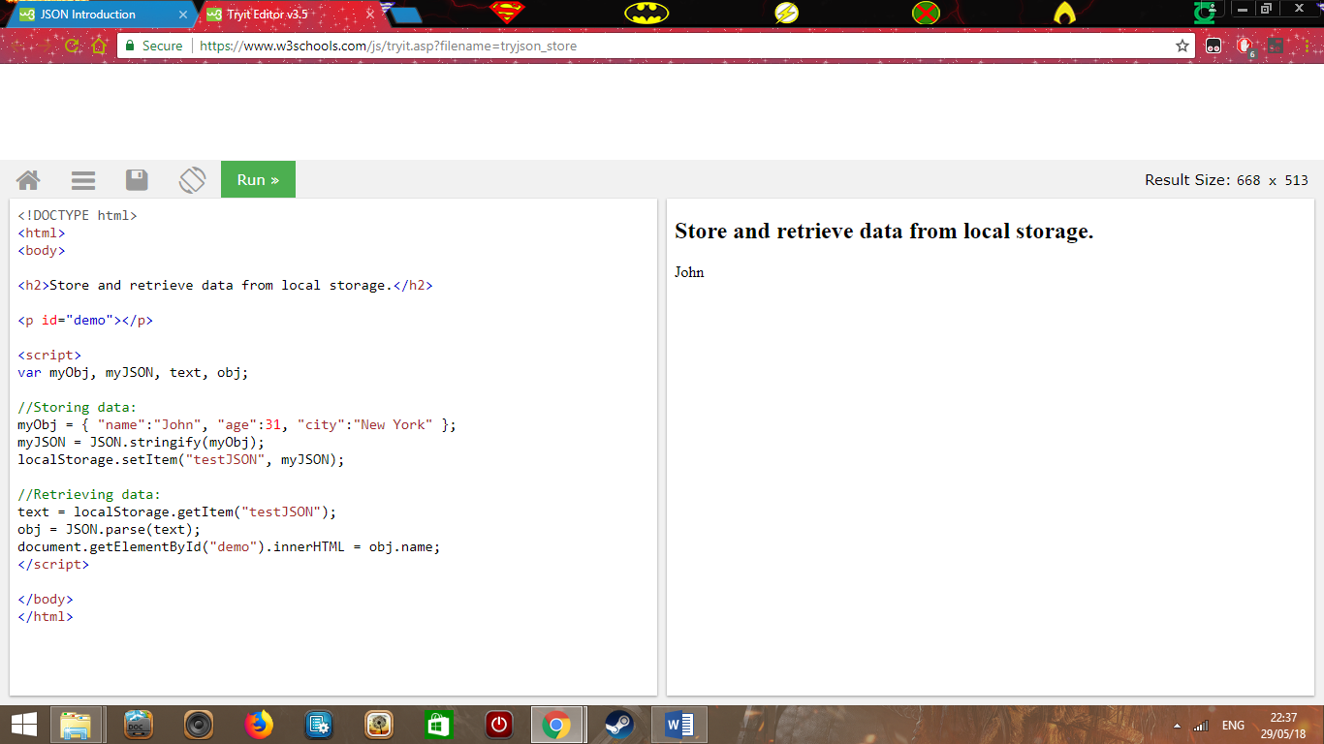

In the above example JSON data is converted to as an object in JavaScript.

b) JQuery

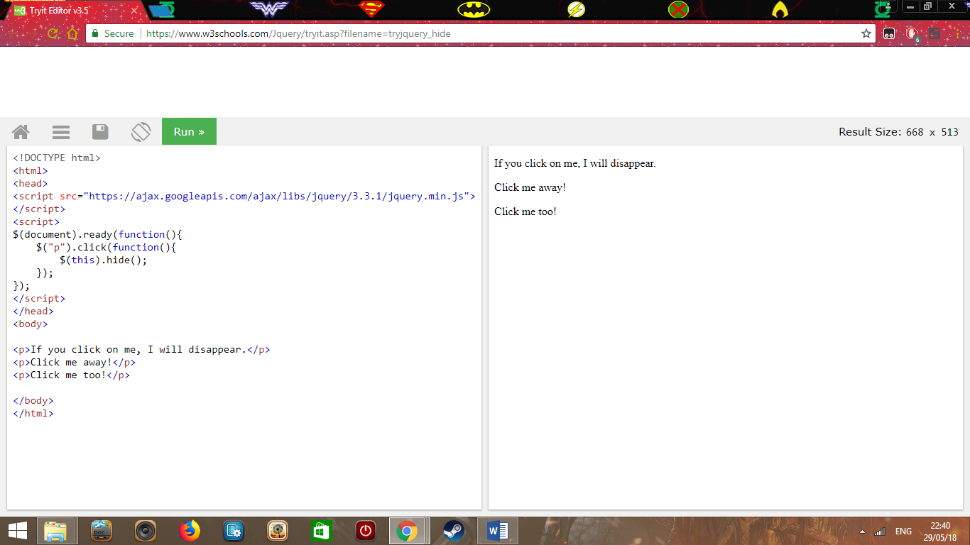JQuery is a JavaScript library used to make websites more advanced by offering features such as animation, manipulation of CSS, and AJAX. JQuery is required in client-side scripting because with it complex validation in forms can be created.

In the above example each time the text is clicked the text will disappear.

c) AJAX

AJAX is short for Asynchronous JavaScript and XML. AJAX is the ability to create more helpful and dynamic websites. AJAX offers multiple features such as that it updates part of the webpage without reloading the entire page. This makes the website much more dynamic because you see values changing continuously. AJAX makes use of client-side scripting to facilitate communication with the web server and information is retrieved using JavaScript.

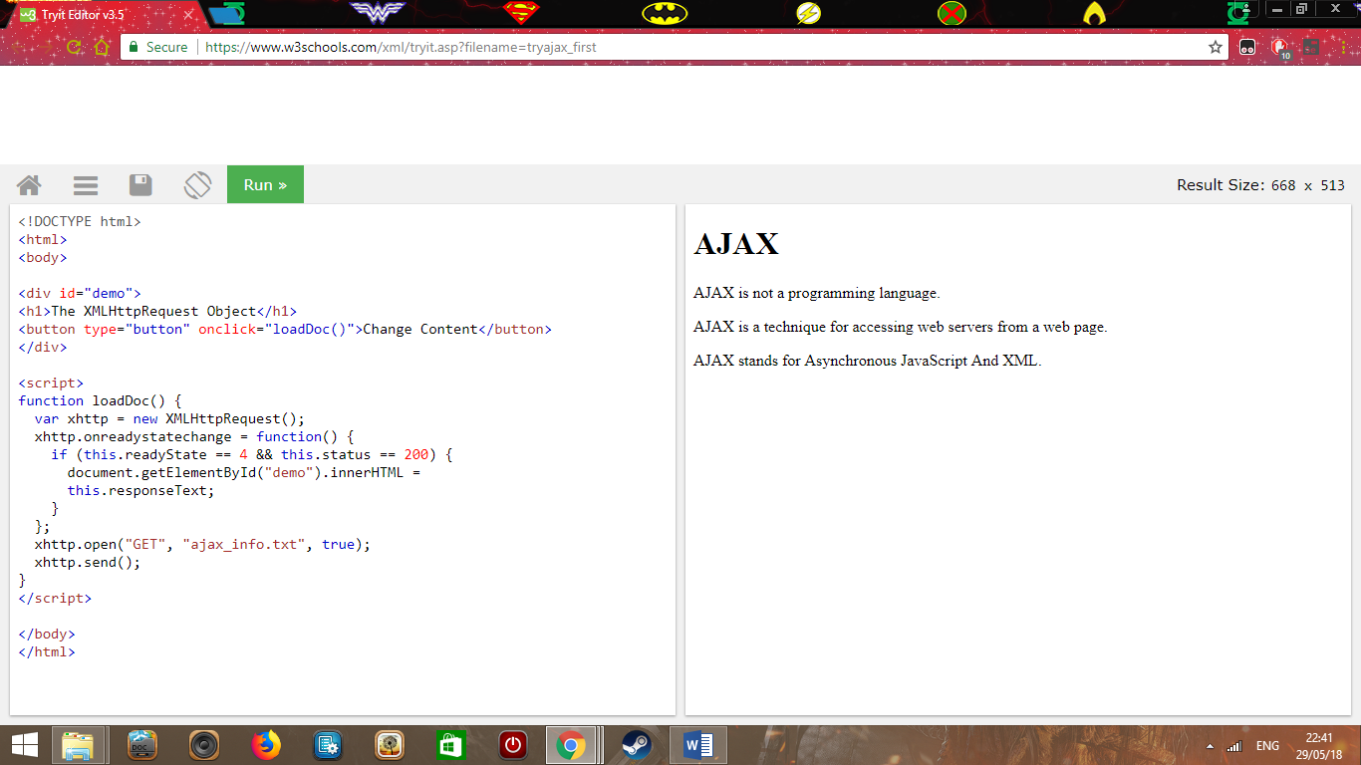

In the above example when the button is clicked a separate file will be opened.

d) Bootstrap

Bootstrap is a framework that makes web development less tedious and easier. It offers readymade code which you would call, and it will be automatically inserted. It will thus add consistency and it will reduce the amount of repetition in the code. Bootstrap will help the client-side because the code is shorter, and this will result in the website which will run faster in the browser.

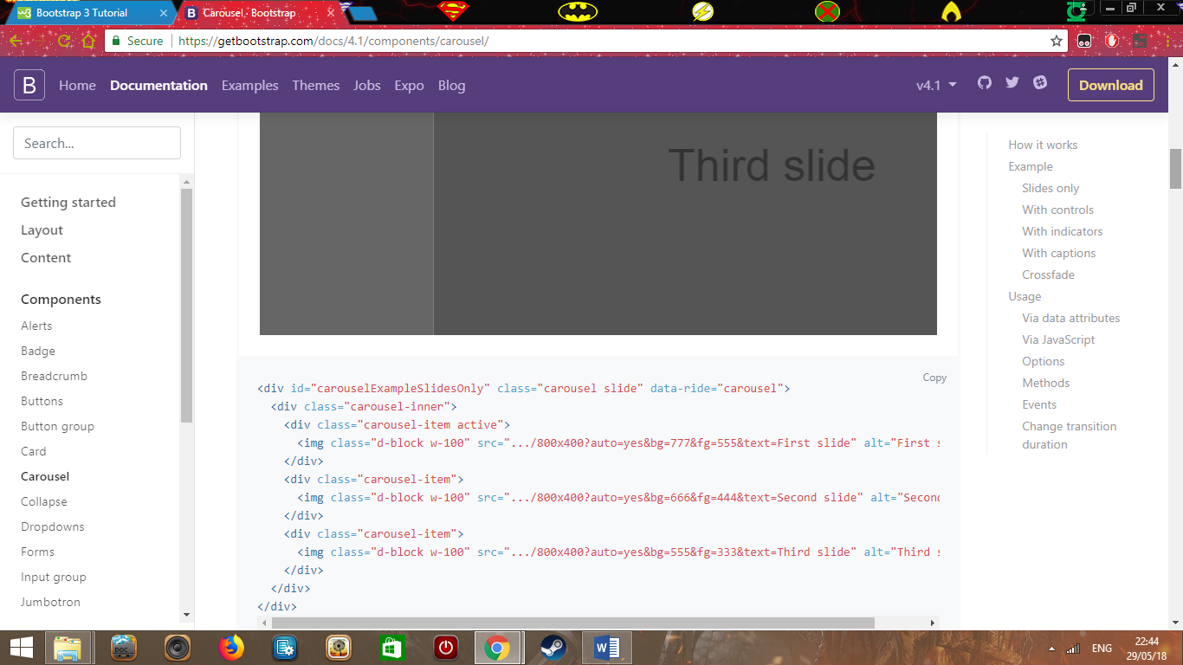In the above example bootstrap is being used to create a gallery.

e) Angular JS

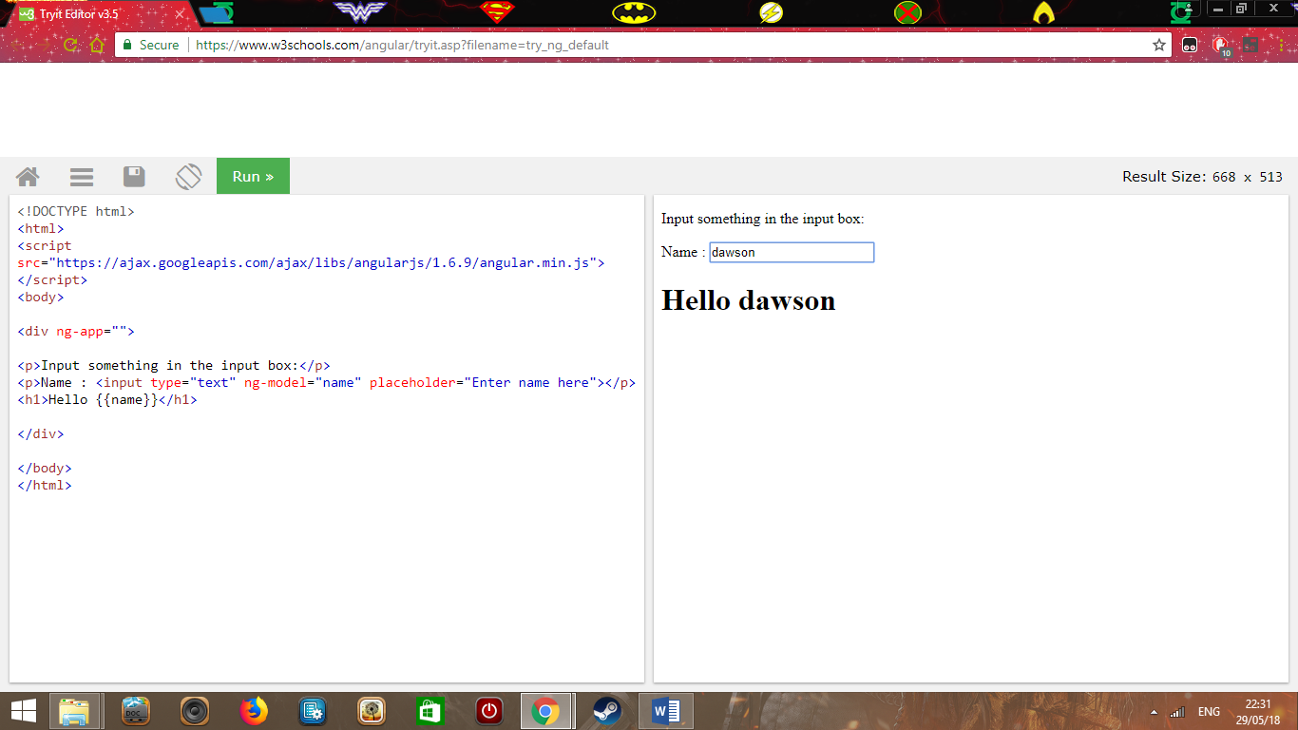 Angular JS is a framework that is owned and developed by Google and its aim is to help developers solve problems while testing and coding. One-way Angular JS can be used in client side is by observing and alerting the user about the current state of the input fields.

In the above example when text is written the text will appear in the moment the user is typing.

You need to explain the technology of each, highlight why they are required in client-side scripting and give examples which you find online.

5. For each of the technology listed in question 4, give 2 detailed advantages.

a) JSON

JSON is fast: This is because the code is short and light weight which processes the data in an efficient way. If one compares it to its counter part xml the difference in speed is shown greatly since xml is not as efficient as JSON when it comes to parsing data.

It is massively available in many browsers: Web developers can thus use JSON when developing the website for multiple browsers because the code does not need to be changed since it will work on many platforms.

Links: <https://ezeelive.com/json-advantages-disadvantages/>

b) JQuery

It is easy to learn and use JQuery in contrast with JavaScript: This is because it requires less lines of code to gain the same result. This will also result in the webpages loading faster since the files are smaller.

JQuery offers a vast collection of libraries and plugins: JQuery offers many plugins and thousands more which are from third party developers. These plugins are used to include specific features in the website which would increase the level of professionality. Since there are many plugins available this will help the developer by having multiple libraries to choose from if he wants to implement a specific feature.

Links: <http://www.jscripters.com/jquery-disadvantages-and-advantages/>

c) AJAX

Network load and bandwidth usage are decreased: This is because only the data that is necessary is taken. Thus, this will make the response time faster which in turn will improve productivity and performance.

More interactivity: With AJAX more interactive and user-friendly websites are created such as a live search which displays recommended items while typing into a search bar. Another example of interactivity are the ratings such as likes or upvotes which are continuously updated. If websites such as Facebook or Reddit reload every time a user comments or give a rating then the website would not work properly since it would continuously be reloading hence why AJAX is used.

Links: <https://techburst.io/5-interesting-things-you-can-do-with-ajax-e63e3e489ce4>

d) Bootstrap

Saving of time: Bootstrap allows you to use ready made templates so that you can work faster on the website which in turn will increase productivity. Moreover, the utilities that are available on bootstrap help save you more time because they can also be responsive and available on multiple browsers.

Customizable: If a web developer wished to use certain templates and only pick out certain features only from that template it could be done. This is possible thanks to Bootstrap customize page which has multiple features displayed and the ones that you do not need are ticked off and a different type of bootstrap is made available.

Links: <https://www.devsaran.com/blog/10-best-reasons-use-bootstrap-amazing-web-designs>

e) Angular JS

Testing is easier: Angular JS allows you to build applications which can be tested since it offers unit testing. By using dependency injections, the code can be isolated and tested separately. Examples of tools that Angular JS offers are: Protractor, Karma, and Jasmine.

Code can be reused: When developing applications with angular JS the code that is written before in the application which is called a component can be called and reused which will save time and increase efficiency. This method could create ready made templates of code which can be reused over and over again when needed.

Links: <https://www.angularminds.com/blog/article/15-top-benefits-of-choosing-angularjs-for-web-app-development.html>

6.

a. Explain what responsive design is

Responsive Web design is when a developer creates a web application that will be flexible in various situations. For example, it will react accordingly to the user’s device depending on the browser that they use, the size of the screen, and whether it is vertical or horizontal. This will result in the website being used by more people because it is more user friendly and more easily accessible.

b. List and explain 2 examples of how responsive design can be implemented

One way for responsiveness to be implemented is to create media query in a CSS file which will be triggered depending on the screen size defined. It is also important that the view port is added into the meta tag in a meta tag inside the head of the webpage. For browsers cross compatibility it is important to install: Modernizr, adaptive.960.js, and Respond.js so that older browsers that do not understand CSS3 could work properly.

Another method to implement responsiveness is to use bootstrap which offers various utilities that can be used which are automatically responsive such as a navbar which changes to a mobile version when the size of the screen is decreased. It is important that the correct class is called since not all utilities are responsive and that the link that connects to bootstrap is included into the head section of the html page.

Links: <https://www.sitepoint.com/understanding-responsive-web-design-cross-browser-compatibility/>

<https://www.uxpin.com/studio/blog/media-queries-responsive-web-design/>

c. Explain the importance of responsive design

If a website is responsive then Google will give it a higher rank which will increase in how many people will see it when searching. Money will also be saved since the owner does not need to pay for two different websites but instead a single site that is accessible in mobile and desktop. Moreover, the text will be readable in an appropriate size instead of having the user zooming which increases the overall quality of the application.

Link: <https://freshsparks.com/why-responsive-design-is-important/>