Mermaid Diagram Test

This document tests Mermaid diagram support in our markdown processor.

Flowchart Example

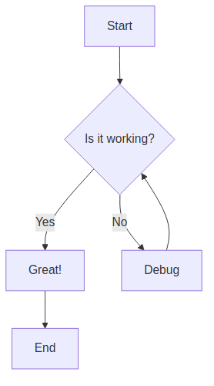

Sequence Diagram

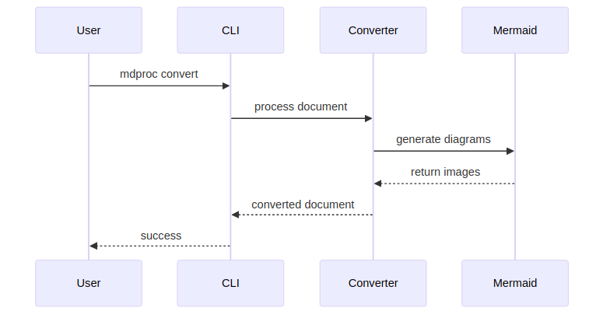

Class Diagram

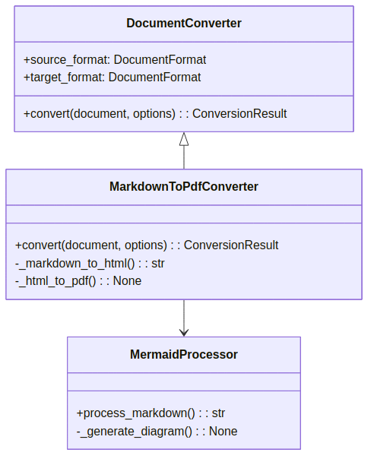

Architecture Overview

This demonstrates how our hexagonal architecture handles Mermaid diagrams:

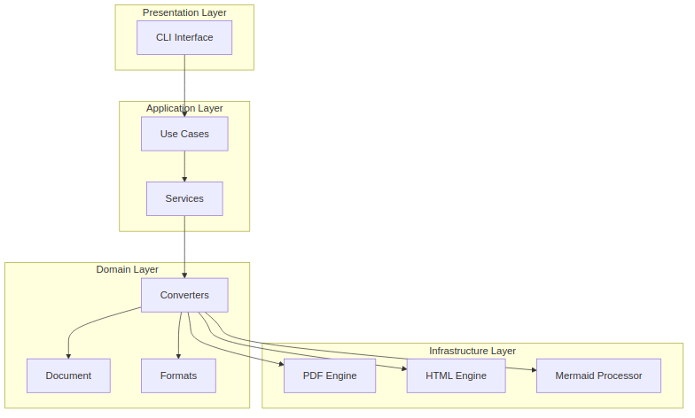

Summary

The Mermaid integration allows us to:

- **Process diagrams** automatically during conversion
- **Support multiple formats** (PNG for PDF, SVG for HTML)
- **Maintain clean architecture** with proper separation of concerns
- **Provide fallback handling** when diagram generation fails
This enhances our document processor significantly for technical documentation!

