Task
- When hovering with the mouse, the background should turn yellow, and the text should become bold.
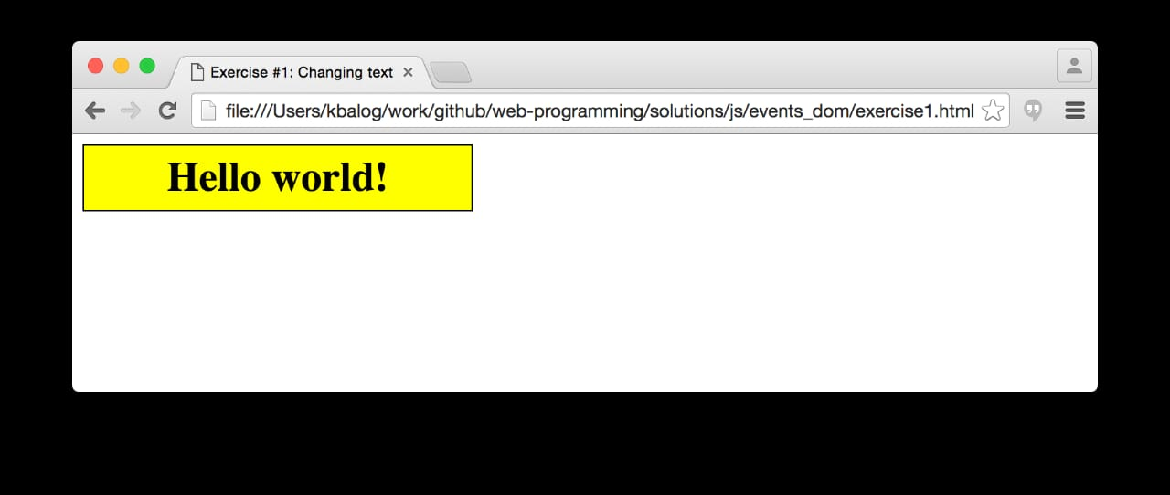

2- In this dropdown menu, you should add a set of country names. When a specific country is selected, its corresponding flag should be displayed.
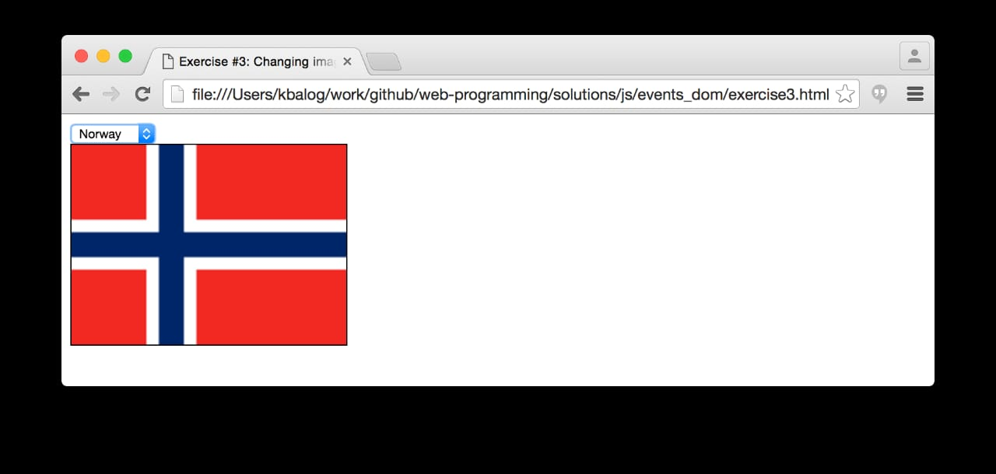

3- You should allow the user to enter a password. When it is too short, it should indicate that it is too short in red, as shown. When the password does not match the confirmation, it should indicate that they do not match.
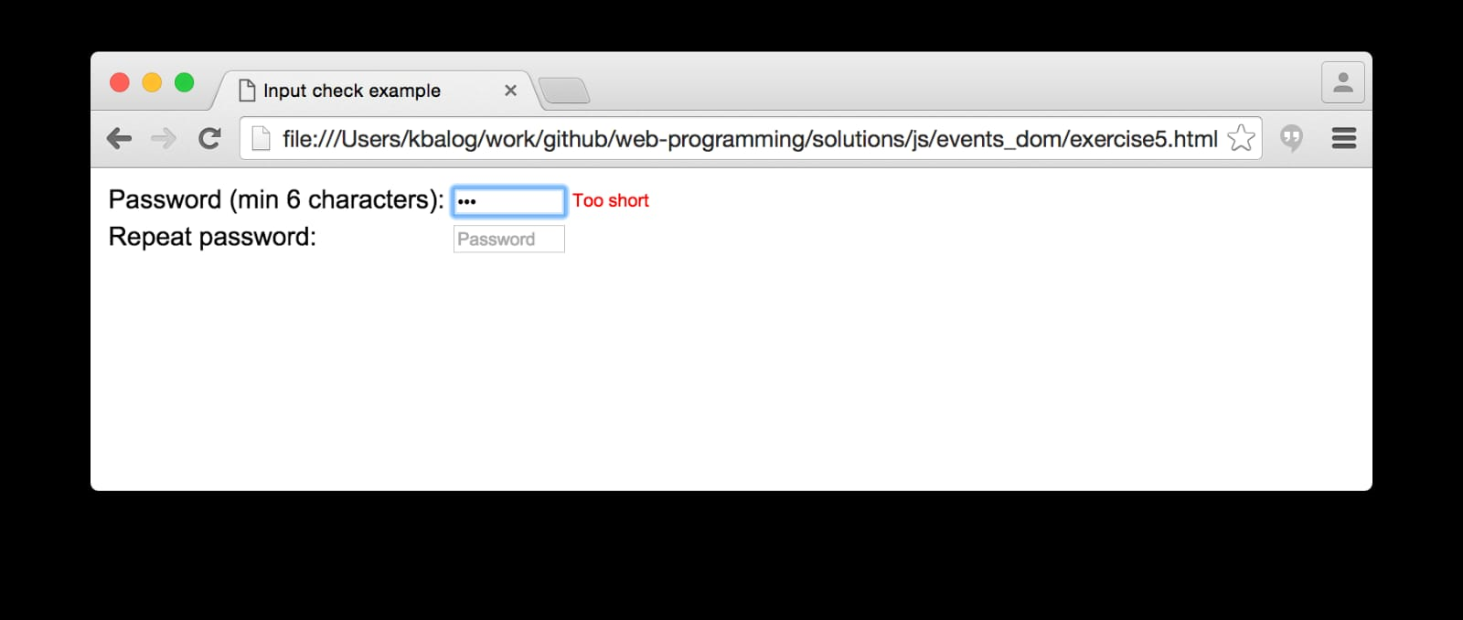
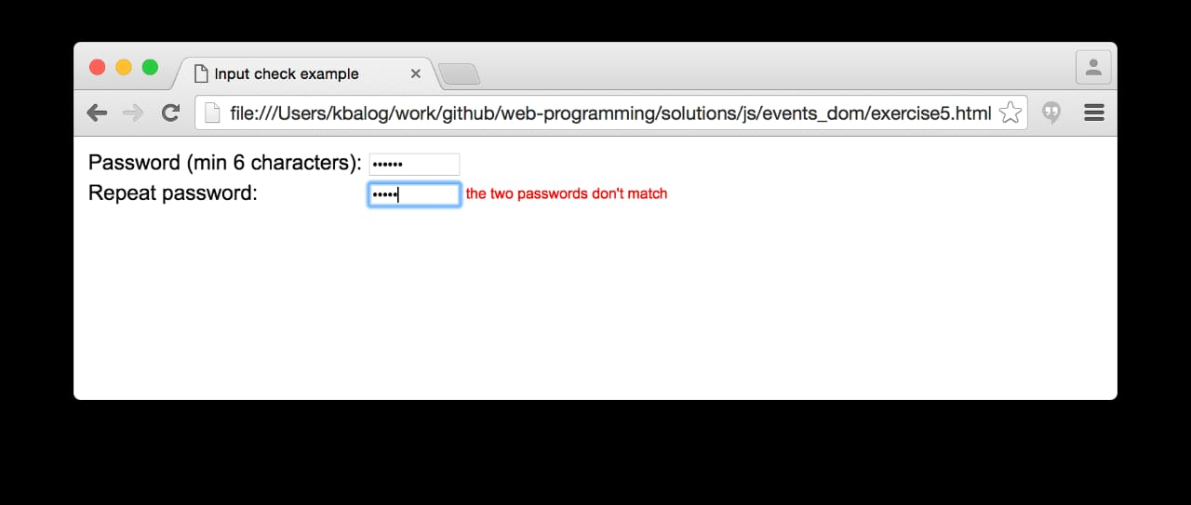
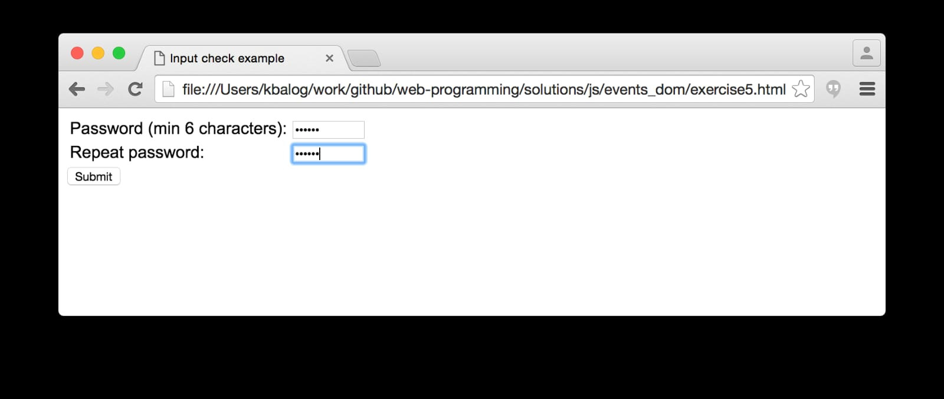

4-The user should be able to show and hide the content as needed.
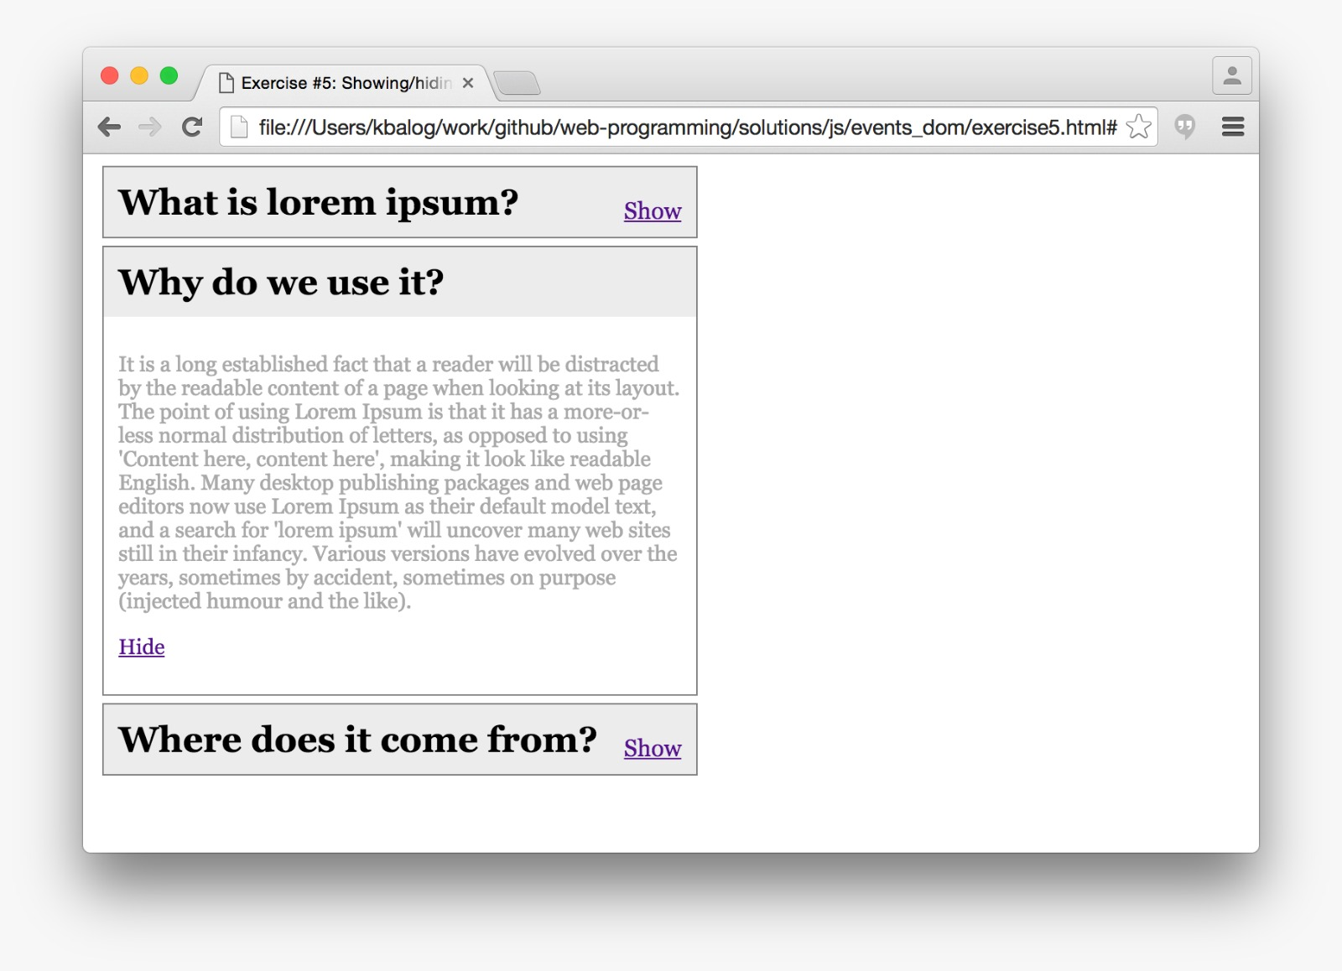
5-When typing any text inside the box, you should be able to edit it, such as changing the font type, making it bold, adding an underline, and adjusting the font size
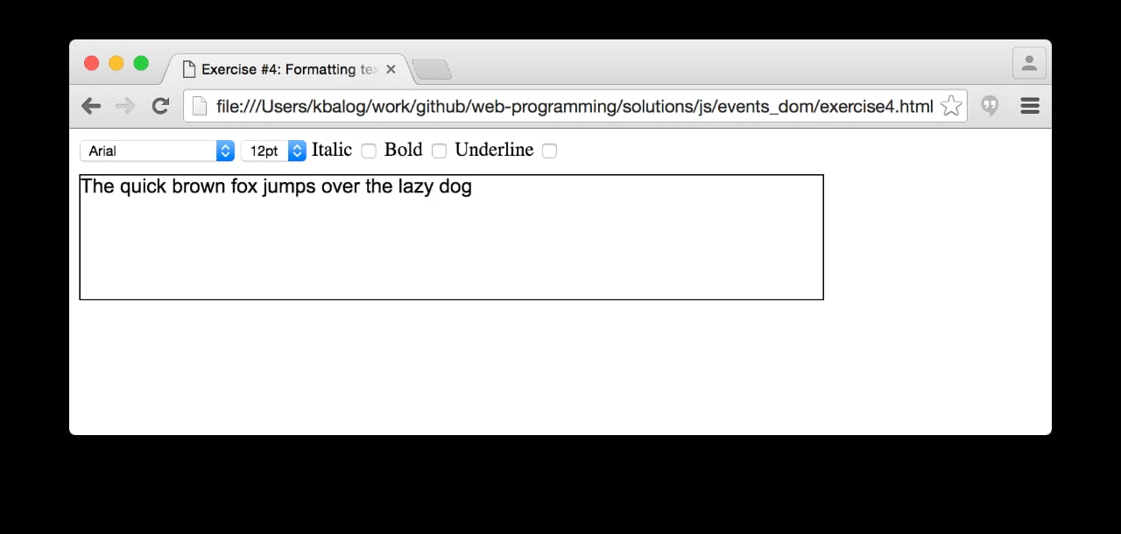

6-The box's color should change using animation based on the desired time, so that the color fluctuates according to a specified time
