Debugging /amp-aicore/src/test/java/org/amnesty/aidoc/UtilTest.java
/amp-aicore/src/main/java/org/amnesty/aidoc/Util.java

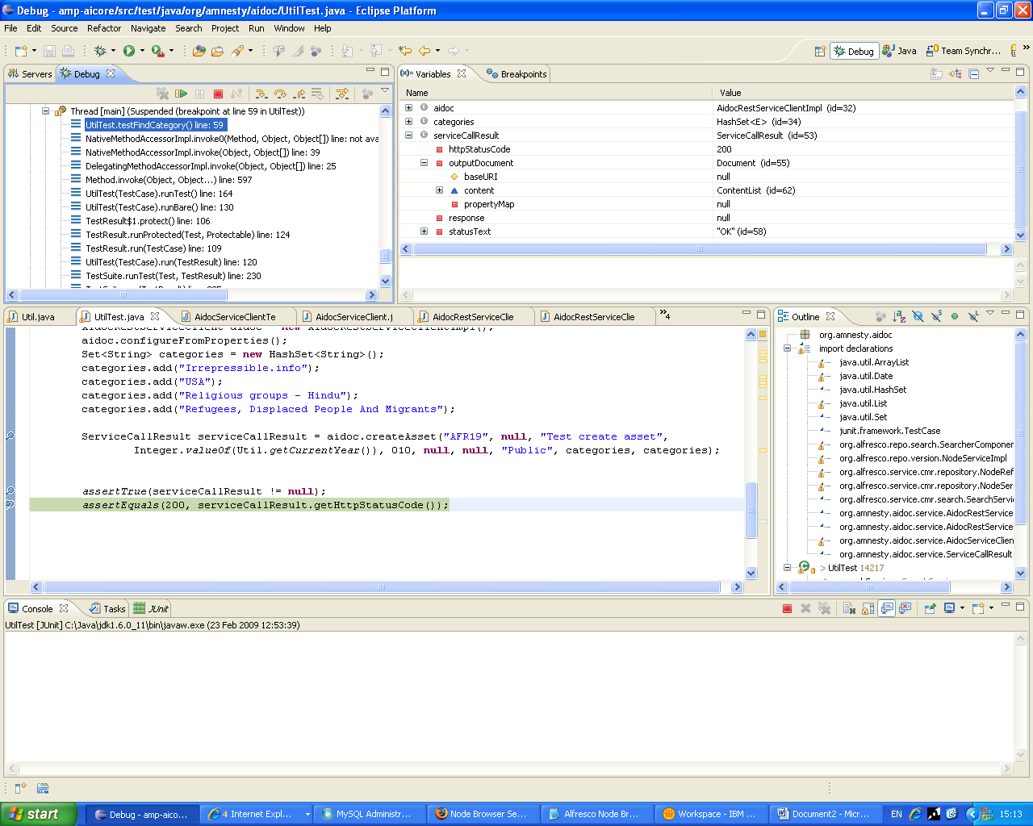

Running the code will insert the following nodes into stores:

Click on workspace://SpacesStore
