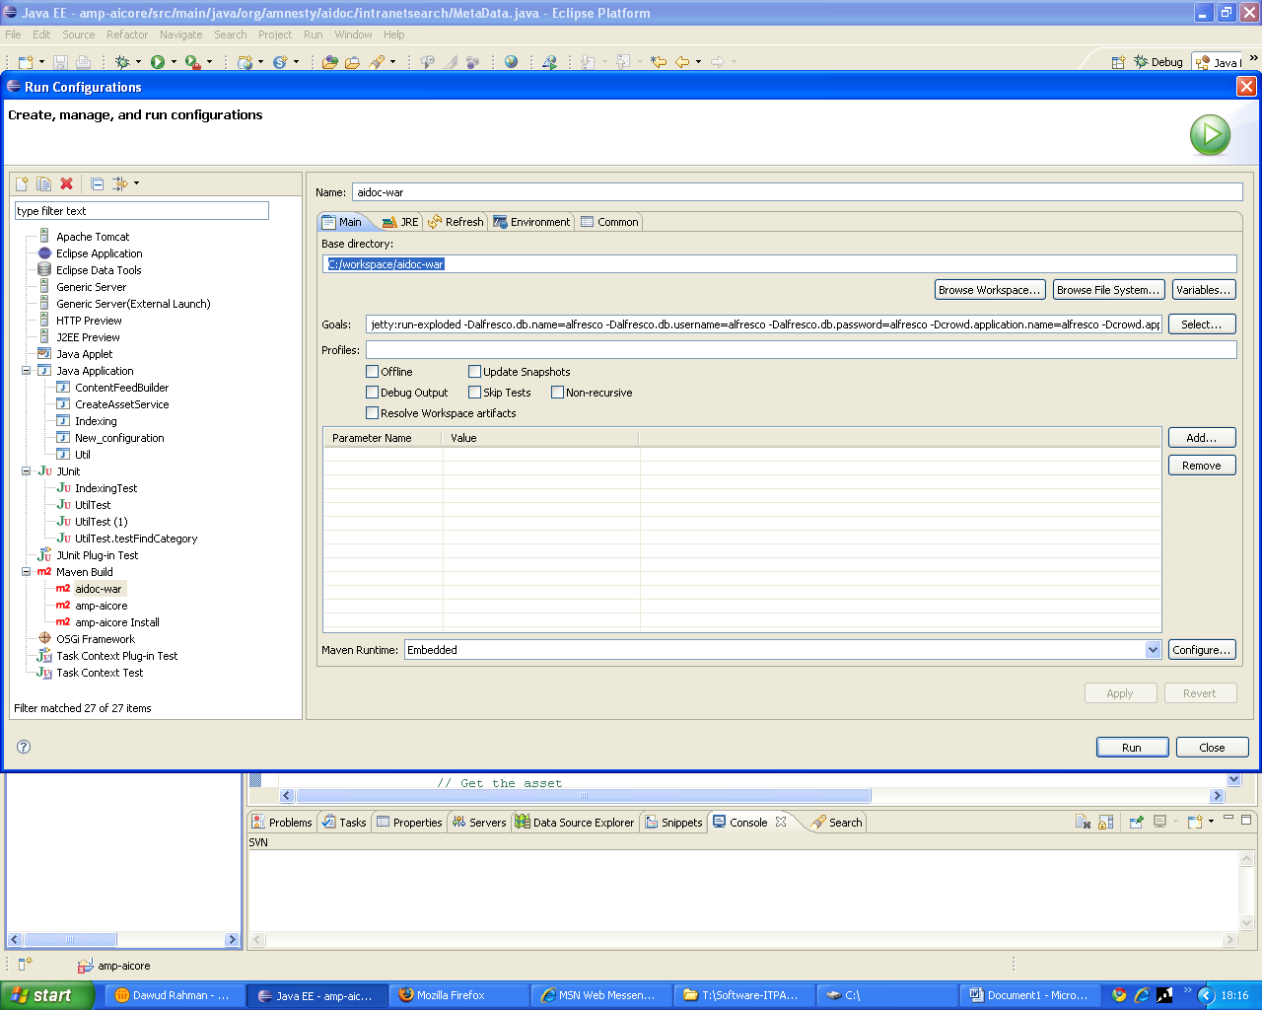

aidoc-war
C:/workspace/aidoc-war

jetty:run-exploded -Dalfresco.db.name=alfresco -Dalfresco.db.username=alfresco -Dalfresco.db.password=alfresco -Dcrowd.application.name=alfresco -Dcrowd.application.password=alfresco -Dcrowd.server.url=http://anaconda.amnesty.org:8080/crowd/services/ -Dalfresco.data.location=./alf_data/content -Dalfresco.index.location=./alf_data/lucene-indexes -Dsystem.bootstrap.config_check.strict=false

amp-aicore
C:/workspace/amp-aicore

integration-test
preparetestwar,webapp

amp-aicore Install
C:/workspace/amp-aicore
Install

