Structured Authoring with WordWorks (Word-XML)

Quick-Start User Guide

**What is WordWorks?**

WordWorks is a template that attaches to Microsoft Word which allows the user to apply styles that structure the document with meaningful tags. Once the styles have been applied it provides the ability to extract well formed and correctly structured XML for multiple use and ingestion into other systems.

Using a combination of Word templates and Word-XML transformation, the solution enables Qualifications Development Teams to 1) produce and supply final-state specifications in PDF format for printing; and 2) output unit narrative in an XML format that can be uploaded to IQS to supply the MyBTEC platform.

**Outcomes:**

|  |
| --- |
| A comprehensive process in how to use simple tools in Word to tag content to generate structured XML |
| Ability to transform content to standards such as PXE in order to flow to multiple assembly methods. In this instance the content will go into IQS Systems |

**WordWorks Tool in the Current Content Creation Process:**

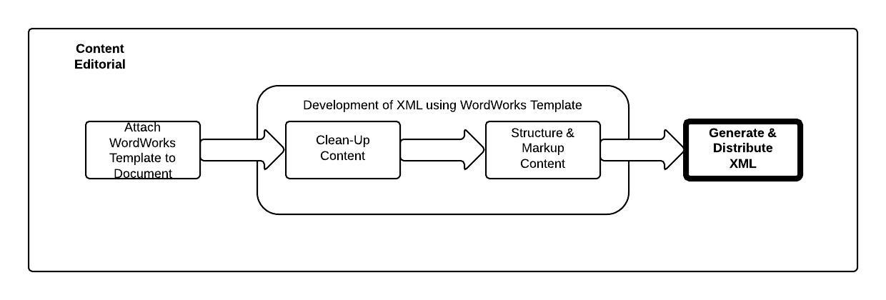

**Description**

|  |
| --- |
| The QDL will install the WordWorks Compatible Folder Structure |
| The QDL will install & attach WordWorks Tool to Authored Content document |
| The QDL will clean up any unnecessary authored formatting |
| The QDL will structure the tag elements within the Word document to generate structure |
| Generate Structured XML and distribute to other systems |

**Roles**

|  |
| --- |
| Super User will be the Technical SME’s for WordWorks |
| QDL are users of WordWorks to tag the content |

**What does WordWorks mean for Qualifications Development?**

*“WordWorks will enable Qualification Developers to mark-up content in specifications making the information far more accessible to other systems such as MyBTEC and Pearson Qualification Gateway. This tool-set also includes a range of automated document clean-up utilities that will make editing specifications much easier, and less time consuming.”*

*“WordWorks is our first step towards global structured content authoring that will bring many benefits to the way we build qualifications across Pearson in the future.”*

**- Paul Winser**

*“This phase of the WordWorks tool is designed to be a stepping-stone towards a long-term approach to content authoring and development, including smart content and improved efficiency.”*

*“Over time we'll be building on the direct quantifiable business benefits of WordWorks (e.g. time/cost reduction, quality improvement).”*

**- Ian Jenkins**

**How can WordWorks help me?**

WordWorks provides an interim step in the current authoring process towards an integrated digital authoring & assembly solution. It delivers the capability for Pearson staff to continue to use current industry standard tools (i.e. Microsoft Word) whilst at the the same time it will not disrupt current processes & workflows into existing systems (e.g. InDesign, PDF, images etc).

Key benefits:

|  |
| --- |
| Easily integrated into the current content creation process using standardised tools, templates, shells and guidelines, yet flexible in how / when / the tool is used |
| Enable content reuse, through alignment with Pearson and instructional standards identified early during content planning |
| Reduce time to market into the myBTEC platform, by simplifying not only production but also the development process in context to the delivery method |
| Minimum investment outlay due to extending the use of existing tools compared to implementation of new systems & processes |
| Very low operational & maintenance costs |
| Very short training time for use of WordWorks tool and processes |

WordWorks works by utilising the Microsoft Word Styles functionality. If you are used to applying all of your formatting directly, for example, to format a heading, you can use the Bold button and the Font and Font Size boxes. Or you can use the Font and Paragraph dialog boxes, which have more options, to help you design text and set alignment and spacing etc.

A style is a specially packaged set of formats that are applied all at one time. The style is there for you to use again and again. You can apply Microsoft Word styles to any text by selecting the text, clicking the Home tab, and choosing a style in the Styles Gallery.

WordWorks is essentially a ‘*apply styles to your content*’ toolbar. Using styles helps to streamline the editing of documents and the creation of the structure. The default Microsoft Word styles will not allow you to structure the specification document accordingly so a new set of styles has been created for this purpose. These new styles have been created so that they can be used to correctly identify all the different elements in a specification document.

Essentially, there are three different types of styles to facilitate the tagging of the document:

* Section Tags

These tags are used to identify the all the different sections that comprise a Unit

* Type Tags

These tags are used to identify the type of elements within each section.

* Presentation Tags

These tags are used to identify any presentation specific content. WordWorks allows for cases where it is essential to retain any formatting that has been used to emphasise certain text

The table below details the finite styles that are available to markup the document:

|  |  |  |
| --- | --- | --- |
| **Section Tags** | **Type Tags** | **Presentation Tags** |
| Unit Properties | Title / Subtitle / Heading |  |
| Introduction | Text | 1. Alphabetical List |
| Learning Aim and Unit Content | List | * Bulleted List |
| Assessment Criteria | Unit Title, Unit Level & Unit Type, Unit Size and Assessment Type | 1. Numbered List |
| Teacher Guidance | Guided Learning Hours | **Bold** Text |
| Suggested Assignment Outlines |  | *Italic Text* |

Once these styles have been applied to the text in the Unit document, the extracted document will be a well formed tagged XML that can be repurposed, reused and ingested into multiple systems.

**How do I get started?**

WordWorks has been designed to be very simple to use. It is available as a self download & self installation application. WordWorks will not change or affect any existing processes that are used for creating, reviewing and editing specifications content. WorkWorks is an extra step at the end of the content creation lifecycle that allows for the Unit created in Microsoft Word to be converted into well formed and structured XML.

The steps to create the XML from Word documents are:

1. Download the WordWorks Tool
2. Create a copy of the document and use the copy to work with WordWorks
3. Accept all changes in the document.
4. Attach the WordWorks tool to the Microsoft Word Unit document
5. Use WordWorks to:
   1. Remove any unnecessary applied formatting & correcting common mistake by running cleanup functionality
   2. Bring Up Style Inspector - This will display the applied style wherever the cursor is:
      1. Select Home Tab
      2. Open Styles Window
      3. Select Style Inspector Window
   3. Apply the styles to “tag” the content
6. Generate XML from the documents once the WordWorks styles have been applied
7. Transform the WordWorks XML into format to upload into IQS
8. Distribute XML to IQS team

**Download the WordWorks Tool**

The WordWorks tool is available to download [here](https://drive.google.com/a/pearson.com/?tab=mo#folders/0B0uHhv6CP7k7Y0c2Zm1vYlBtQlU). The full URL for WordWorks is located at the end of this document. If you do not have access to download, you will be presented with an option to request access.

Once you have access, then download WordWorks and save it to your local machine. WordWorks is only supported on the following versions of Microsoft Word:

* Microsoft Word 2007
* Microsoft Word 2010

**Create a copy of the document**

A copy of the document should be created in the same folder. It is best practise to use the word “**copy_**” to precede the filename and to use this copy version to work with WordWorks. This will provide an additional safety net should you wish to go back to the original document.

**Track Changes**

In some situations when there are track changes in the document that have not been accepted, then this can affect the output into the XML. Best practise is to make sure that all the track changes elements have been resolved prior to starting the WordWorks process.

**Installing WordWorks to the Microsoft Word Unit Document**

WordWorks tool is simple to install. You must open the Unit document that you are going to apply the structure to and attach the WordWorks by attaching the template using the Templates and add-ins option under the Word Options Menu. Full instructions on how to install the WordWorks tool can be found in the WordWorks Super User Guide which is available to download [here](https://docs.google.com/a/pearson.com/file/d/0B4erhRG1MnIbSnl4Z3NHbDVyNlk/edit). The full URL for this guide is located at the end of this document.

**Using the WordWorks Template**

Full instructions on how to use the WordWorks template can be found in the WordWorks Super User guide and is available to download. The full URL is shown at the end of this document.

This section attempts to visually demonstrate how WordWorks can be used to markup the unit.

It outlines all the steps to use to styles for a unit.

Within the styles palette there is an option to ‘Clear previous formatting’ that can be useful if there is styling information persisting in your text that you would like to remove.

**General Styles - Getting Used to the Styles Palette!**

This shows the various elements in the document and the corresponding style tags that could be used to apply the tagging. When the style tags that are called ***Inline*** need to be applied then these have to be applied after the **text** style has been styled using the Text style tag. This is demonstrated here with the Unit Level, Unit Type, Unit Size & Assessment Type. This is the same when the **Bold** and **Italics** style is applied.

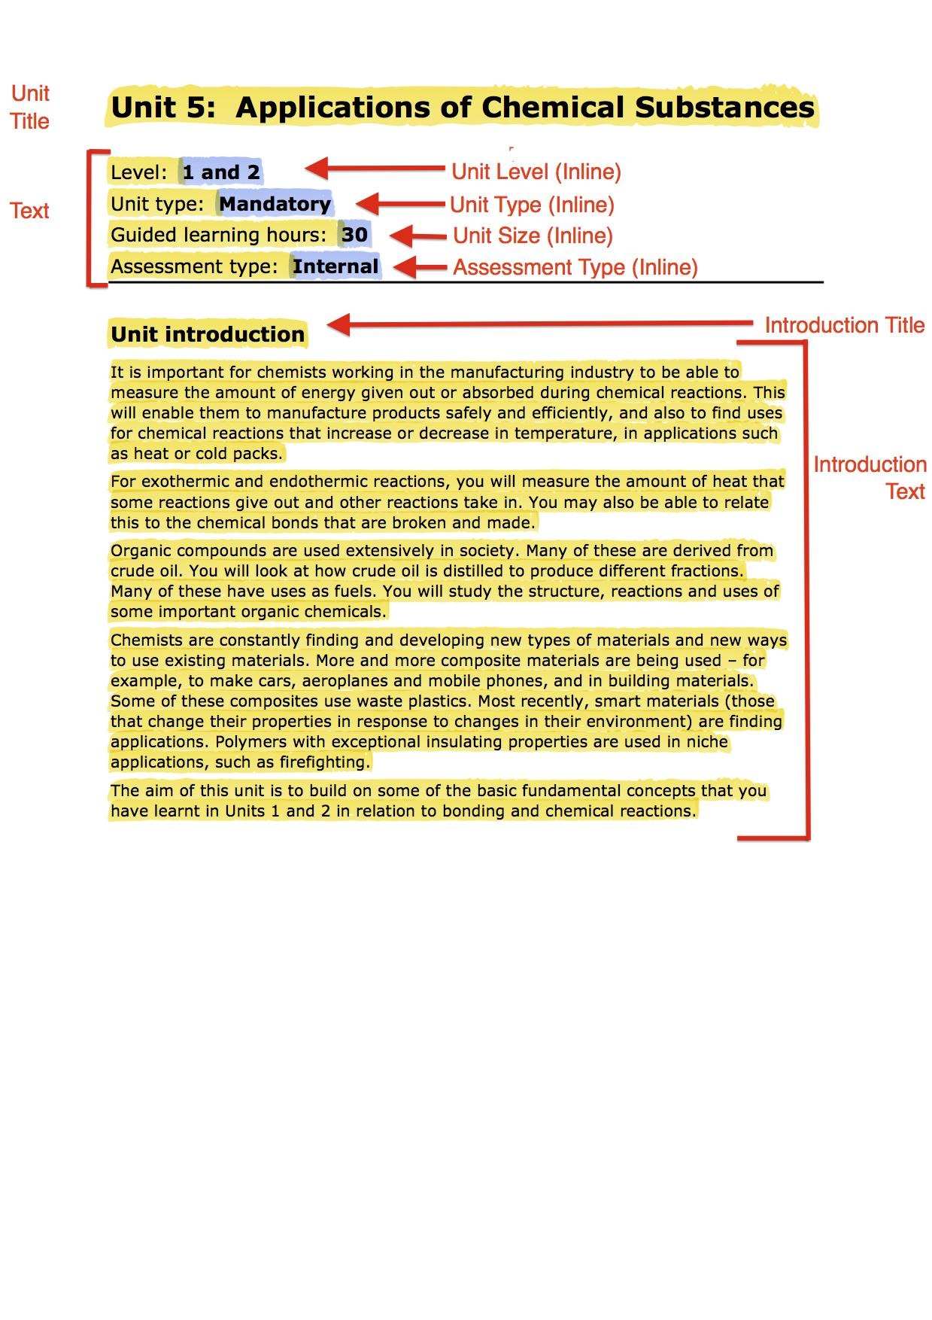

**Using the Style Palette to tag the Learning Aim**

This shows you the various Styles to use on the elements that make up the contents within the learning aim. This displays the style tags that are used to style a Alphabetical List.

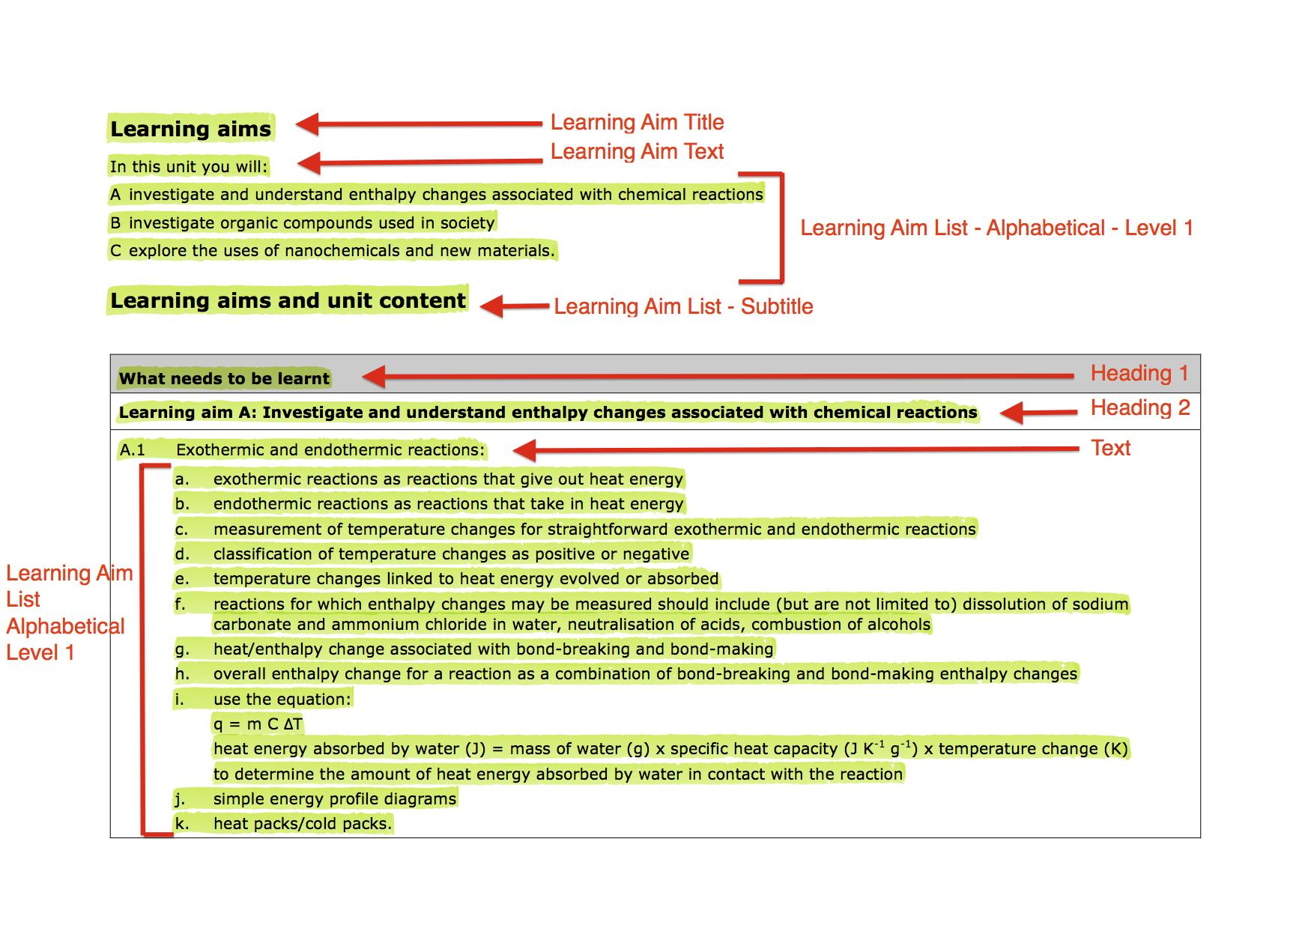

**Using the Style Palette to Style Assessment Criteria in a table**

This shows how the Styles palette should be used to apply the Assessment Criteria styles. It shows that all the cells within a table need to be styled individually. The individual assessment criteria should be styled in Italics so that the XML generation stage can correctly identify the individual

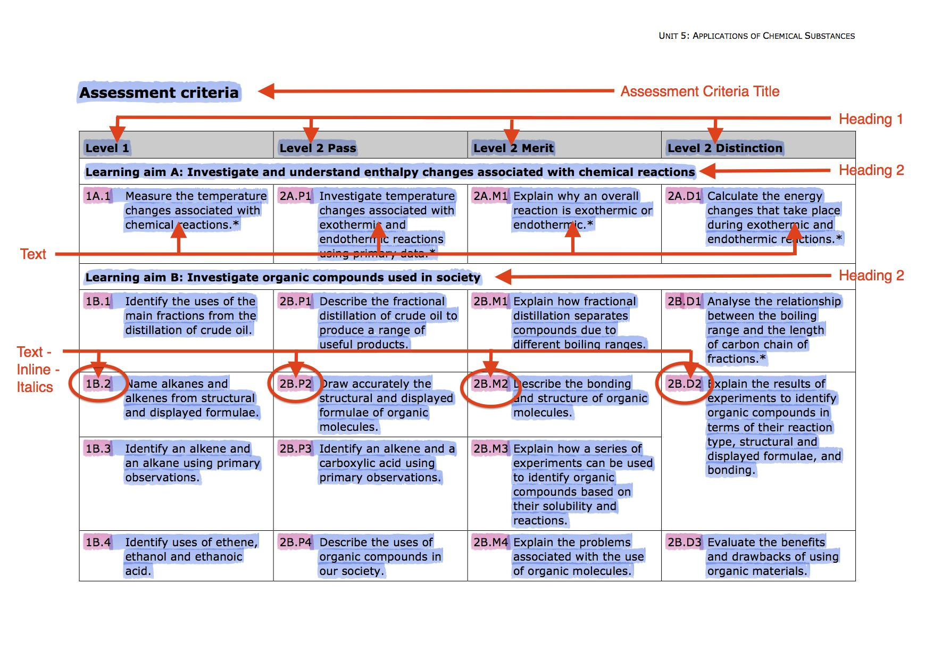

**Using various styles to Style in Teacher Guidance**

This shows how the tags from the styles palette are used to tag the Teacher Guidance section of the unit.

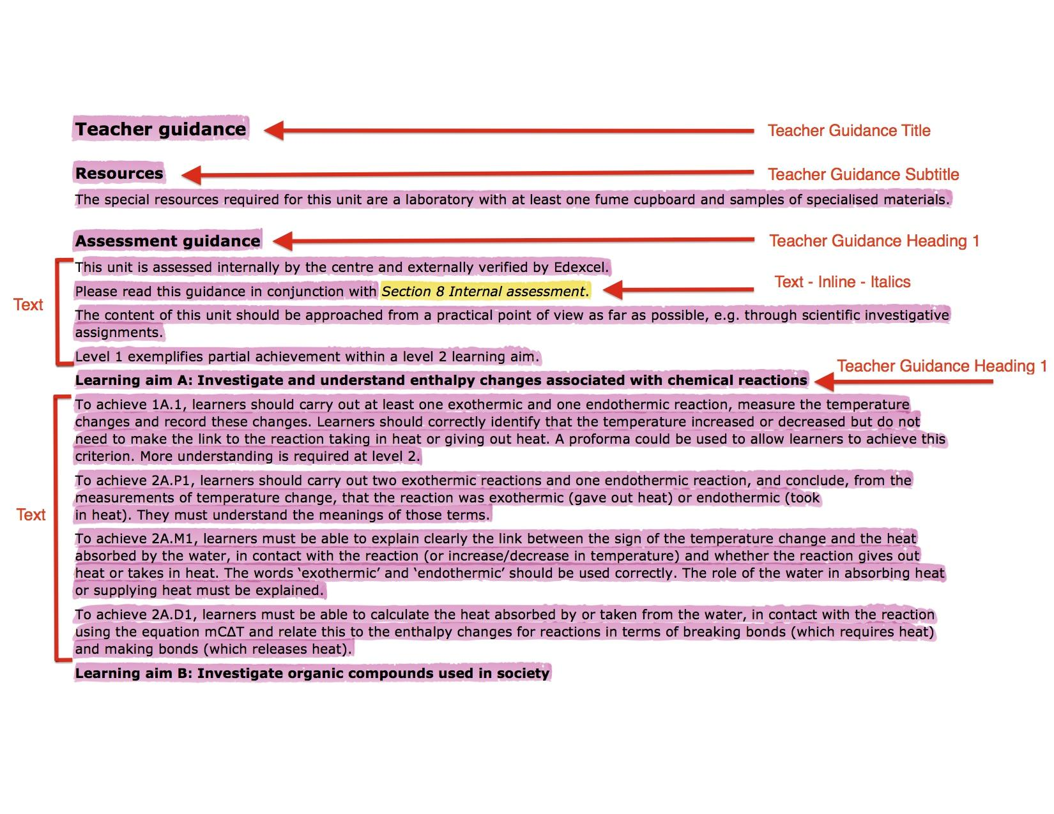

**TIP: Apply Previous Styling**When blocks of text require the same styling, then it is possible to use the *“Apply Previous Styling”* . This is similar to the *paint* functionality in Microsoft Word, Microsoft Excel etc. Using the *“Apply Previous Styling”* functionality will apply the the same style on the highlighted block of text. Further information can be found in the WordWorks User Manual.

**Extraction & Transformation to IQS XML**

Once the styles have been applied, the XML will need to be generated for each unit. Use the WordWorks tool to extract the XML. The XML will be saved into the same directory as the original unit. This XML is created as a proprietary “WordWorks” format to allow conversion to multiple formats.

For the purpose of this use case, the XML will need to be converted into the appropriate format to be ingested into the IQS system to be made available in the MyBTEC system.

The diagram below describes the process of how the XML is generated and then flows into the MyBTEC system.

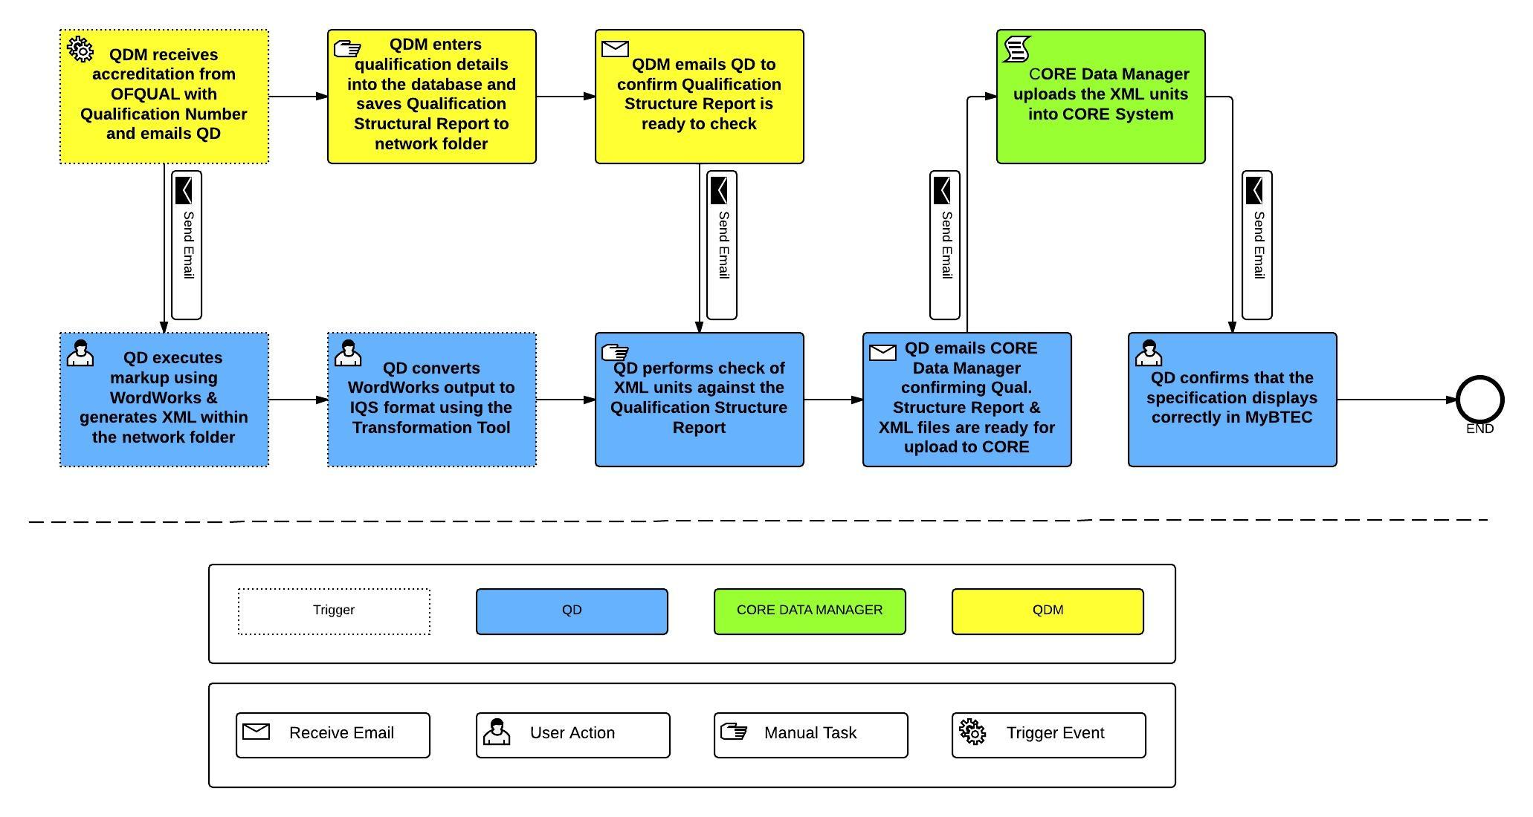

**BTEC Transformer**

The tool that is used to perform the transformation of the WordWorks XML into IQS XML format is called the BTEC Transformer. The BTEC Transformer tool is located in the BTEC Transformer folder within in the folder structure for the BTEC specification.

To start the transformation the user should double click on the “BTEC Transformer” icon. This will display a window to inform the user that all the units will be transformed into the IQS format. The tool will traverse all the folders that contain the units and transform the WordWorks XML files. A new XML file in the correct format for IQS will be generated for each unit in the same folder as the original WordWorks XML file. The name of the file will be the <UAN-Number>.xml.

The display window will provide a running output of all the transformations whilst they are being processed. This window will also provide necessary error messages in the case that any of the transformations were unsuccessful. There will also be an error report created that will provide more detailed and descriptive messages as to the unit that was not able to be transformed and the reasons. This will allow the user to rectify the problem and re-run the WordWorks extraction and subsequently the BTEC Transformer.

Where can I get help and support?

In the event of a support issue, all queries should go to the Super Users in the first instance. During the course of each new release Content Management Services will provide full support for break fix and assistance with training for a period of two weeks from acceptance of delivery.

The WordWorks tool is installed locally on each individual users’ computer and hence does not require regular backups. The tool is available from a centrally stored location so is available to download and install should the need arise to re-install.

If the Super User is not able to resolve the problem, then they will escalate the issue to the CMS Team.

Emergency issues that cause business critical problems with the tool will be worked on with the highest priority and an emergency release will be distributed at the earliest opportunity.

Enhancements and change requests and lower priority issues with the WordWorks tool will be incorporated into quarterly releases. Requests for these changes need to go through the Super USers and prioritised accordingly.

**Further Support/Self Learning**

The WordWorks Tool has been designed to be simple to use. The functionality provided by the WordWorks tool is common Microsoft Word functionality that is used to format text.

Sample documents for use with the WordWorks tool have been provided which are can be used to markup & create XML for the purpose of self training, along with a WordWorks Super User Guide.

1. Sample Units downloaded [here](https://drive.google.com/a/pearson.com/#folders/0B1C2M-lk9t-xLXpTNkttX0MtUkE)
2. Read the WordWorks Super User Guide located [here](https://docs.google.com/a/pearson.com/file/d/0B4erhRG1MnIbSnl4Z3NHbDVyNlk/edit).
3. A Series of Self Help Instructions can be downloaded [here](https://docs.google.com/a/pearson.com/spreadsheet/ccc?key=0AlC2M-lk9t-xdHd5NFBZai0yVUlCSE9yVnVfS0lzQ0E&usp=drive_web#gid=0)
4. A series of practise cases can be downloaded [here](https://drive.google.com/a/pearson.com/#folders/0B1C2M-lk9t-xRjBZVGs1QTFEMWM)
5. Any further questions can be sent to the Super User.
6. Requests for further training sessions can be sent via the Super User.

**Super Users**

|  |  |  |
| --- | --- | --- |
| **Name** | **Email** | **Role** |
| Paul Winser | paul.winser@pearson.com | Qualification Developer |
| Andres Vergara | andres.vergara@pearson.com | Qualification Developer |
| Alex Martin | alex.martin@pearson.com | Qualification Developer |
| Nisha Sampat | nisha.sampat@pearson.com | Project Coordinator |
| Kay Wright | kay.wright@pearson.com | Editorial Manager |
| Dee Evans | dee.evans@pearson.com | Editorial Manager |

**Application & Reference Location**

|  |  |  |
| --- | --- | --- |
| **Application Name** | **URL** | **Description** |
| [WordWorks](https://drive.google.com/a/pearson.com/?tab=mo#folders/0B0uHhv6CP7k7Y0c2Zm1vYlBtQlU) | https://drive.google.com/a/pearson.com/?tab=mo#folders/0B0uHhv6CP7k7Y0c2Zm1vYlBtQlU | The WordWorks Tool. This is the template that will attach to the Microsoft Word specification documents |
| [Sample Units Documents](https://drive.google.com/a/pearson.com/?tab=mo#folders/0B1C2M-lk9t-xLXpTNkttX0MtUkE) | https://drive.google.com/a/pearson.com/?tab=mo#folders/0B1C2M-lk9t-xLXpTNkttX0MtUkE | This is a sample set of Units documents that can be used for training purposes. |
| [WordWorks Super User Guide](https://docs.google.com/a/pearson.com/file/d/0B4erhRG1MnIbSnl4Z3NHbDVyNlk/edit) | https://docs.google.com/a/pearson.com/file/d/0B4erhRG1MnIbSnl4Z3NHbDVyNlk/edit | A detailed user guide that contains instructions on how to attach WorkWorks and contains references material for all the WordWorks functionality |
| [Self Help Instruction & Tests](https://docs.google.com/a/pearson.com/spreadsheet/ccc?key=0AlC2M-lk9t-xdFdVUUp2QnNGeU9IeFFwNF9LSHpiT3c&usp=drive_web#gid=0) | https://docs.google.com/a/pearson.com/spreadsheet/ccc?key=0AlC2M-lk9t-xdFdVUUp2QnNGeU9IeFFwNF9LSHpiT3c&usp=drive_web#gid=0 | A series of self-help instructions on how to apply the WordWorks functionality to the sample |