本文包含11、12、15、17、20、21、22年的英一图画题大作文真题范文，以及19、21年的英二图表题大作文真题范文

# 11年真题（英一）

信件

## 真题范文

The picture virtually drips with sarcasm when it comes to how we behave towards our environment. It can be seen that, two tourists sit and eat snacks in a boat, casually throwing their rubbish into the lake which is full of pollutants.

关于我们对待环境的行为，这张图片充满了讽刺。如图，两个游客坐在船上一边吃零食，一边随手把垃圾丢进满目垃圾的湖水里。

Behind such phenomenon lies a perception that, people’s misbehaviors have weighed on our beautiful landscape, and much of this can be blamed on our lack of environmental awareness. Admittedly, modernization, urbanization and industrialization have put us on the trajectory of rapid development while bringing us great convenience. However, on the flip side, man-made damage is felt everywhere in day-to-day life, and it is exemplified by the case illustrated in the above picture. For this reason, we should recalibrate our way of interacting with the environment since sustainable development is subject to the harmonious coexistence between man and nature.

这种现象揭示出，人们的不当行为给我们的美丽家园造成了沉重的负担，而这在很大程度上归咎于人们缺乏环保意识。诚然，现代化、城市化和工业化进程使我们走上了快速发展的轨道，同时给我们带来了极大的便利。然而，从另一方面来看，我们在生活中随处可以感受到人为因素造成的破坏，图片中的事例就说明了这一点。鉴于此，我们应该重新调整人类与环境的互动方式，因为可持续发展取决于人与自然的和谐共存。

Therefore, at the center of this issue is the need to reduce pollution from all sources. This is the right approach for us to protect our environmental future, and it will put everyone in a better position to embrace our nature.

因此，问题的核心是要减少各个源头的污染。这是保护环境的正确途径，并使我们更好地拥抱自然。

## 真题范文

The picture virtually drips with inspiration when it comes to how we perceive losses in life. It can be seen that, a man stands still in depression, sighing for the loss when he saw a fallen bottle with water leaking away. But the other man takes it quite easy and feels lucky for the rest.

关于我们如何看待生活中的得失，这张图片充满了启示。图中有个人呆呆地站在那儿，看着倾倒漏水的瓶子，哀叹损失，一脸沮丧。但另外一个人表现得很轻松，感觉能剩下一点还是很幸运的。

Behind this instructive drawing lies a perception that, optimism is an essential ingredient of happiness, and it lights the way to helpful actions. However, more than often, people tend to be mired in pessimism when there is a loss, slamming the door of optimism about what they have been left. This lack of positive attitude is what often leads us to a dark mood, and acts as a drag on our practice of moving ahead. Actually, happiness is measured by our own feeling of satisfaction, and a positive mindset is the very condition to impel man to unfold his power. So, see the bright side when facing a setback. This is a recipe for a satisfying life, and will yield fruitful results.

这幅具有启发性的图画揭示出，乐观是幸福感的基本要素，可以引导我们采取有益的行动。然而，更多时候，人们会因为失去而陷入悲观，却没有乐观地看到自己还有些什么。这种积极态度的缺失往往使我们陷入负面情绪，阻碍了我们前进的脚步。其实，幸福是由我们自身的满足感来衡量的，而积极的心态正是推动人们施展能力的条件。因此，面对挫折时要看到光明的一面，这是美好生活的秘诀，并将使你硕果累累。

In a nutshell, only by translating our attitude into a positive one, can we redirect our mind instead of focusing on the negative experiences. This is the right approach for us to keep a positive outlook in work and life.

总之,只有转化为积极的态度，我们才能调整思维，而不是纠结于那些消极的经历。这是我们在工作和生活中保持积极心态的正确方法。

# 15年真题（英一）

卡通人物

## 真题范文

The picture virtually drips with sarcasm when it comes to communication problems in the era of mobile phones. It can be seen that, a group of friends gather around a table in a party, all staring at their mobile phones as if they are isolated from each other.

关于手机时代的沟通问题，这张图片充满了讽刺。如图，一群朋友围桌聚餐，却各自盯着自己的手机，仿佛彼此孤立一般。

Behind such phenomenon lies a perception that, digital devices have disrupted our traditional way of interactions, and much of this can be blamed on our indulgence in the virtual world. Admittedly, modern communication tools have put us on the trajectory of instant connections while bringing us great convenience. However, on the flip side, increasing isolation is felt in our day-to-day life, and it is actually exemplified by the case illustrated in the above picture. For this reason, we should recalibrate our way of communication since harmonious relationship is subject to real interpersonal interactions.

这种现象揭示出，数字设备已经干扰了人们传统的交流方式，这在很大程度上归咎于，我们过于沉溺于虚拟世界当中。无可否认，现代通讯工具使我们实现了即联即通，给我们带来了极大的便利。然而，从另一方面来看，人与人之间却越发疏离，图片中的事例就说明了这一点。鉴于此，我们应该重新调整彼此的沟通方式，因为和谐的关系取决于真正的人际互动。

In a nutshell, at the center of this issue is the need to shift our focus from a virtual world to the tangible reality. This is the right approach to engage with each other, and it will put us in a better position to get closer.

简言之，问题的核心是我们需要将关注点从虚拟世界转向真切的现实世界。这才是有利于沟通的正确途径，可以使人与人之间更加亲近。

# 2017年真题

## 真题范文

The picture virtually drips with sarcasm when it comes to the difference between “having books” and “reading books”. It can be seen that, a man leisurely sits in a chair, saying with satisfaction that he owns a lot of books, although without reading them at all. By contrast, the boy on the right-hand side of the picture is making an actual plan of reading 20 books before the end of the year.

关于“有书”和“读书”之别，这张图片充满了讽刺。如图，一个男人悠哉地坐在椅子上，心满意足地说，他有很多书，但他根本就没有读过。与之形成对比的是，图片右侧的男孩正在制定切实的读书计划，要在年内读完20本书。

Behind this instructive drawing lies a perception that, our satisfaction of “having books” will eat into our motive of “reading books”. Admittedly, there is a convenient excuse for delaying our reading, and it all boils down to a lack of motivated intention. However, tangible action is the very condition to impel man to unfold his power. Likewise, the ripple effect of massive reading allows us to tap into our potential and sow a sense of confidence. All this gives enough grounds for reading books instead of having books only. So, make a plan of reading right away. It promises to put you on the road to a treasure of knowledge.

这幅具有启发性的图画表明，我们对“有书”的满足感会削减我们“读书”的积极性。诚然，（我们）很容易找到借口，把阅读行动一拖再拖，这都是因为我们缺乏主动性。然而，切实的行动是促使人们施展能力的条件。同样，大量阅读的涟漪效应能够使我们挖掘自身潜力，并获得自信心。鉴于此，我们应该去阅读书籍，而不只是满足于拥有书籍。立即制定你的读书计划吧，这将助你通向知识的宝库。

Therefore, only by taking the initiative to read, can we really benefit from books. This is the right approach to acquire knowledge, and it will put us in a better position to prepare for a more fruitful future.

因此，只有主动阅读，才能真正从书本中受益。这是获取知识的正确方法，可以使我们在未来收获更多。

# 20年真题（英一）

## 真题范文

The picture casts intense light on the importance of cultivating a good habit. It can be seen that, a girl is doing her homework, feeling that things should be done as early as possible. By contrast, the boy on the right-hand side of the picture sits in front of the desk, saying that he will put things off until the last minute.

这张图片着重强调了养成好习惯的重要性。如图，一个女孩儿正在做作业，觉得事情应该尽早完成。相比之下，图片右侧的男孩儿则坐在书桌前，说不到最后不动手。

Behind this instructive drawing lies a perception that, never put off till tomorrow what may be done today. Admittedly, there is a convenient excuse for delaying our work until the last minute, and it all boils down to a lack of a good habit in time management. However, initiative spirit is the very condition to impel man to unfold his power. Likewise, the ripple effect of motivated actions allows us to tap into our potential and sow a sense of satisfaction. All this gives enough grounds for avoiding being a laggard. So, get hands on your task. It promises to put you on the road to fruitful results.

这幅富有启发性的图画点出了“今日事今日毕”的道理。的确，（我们）很容易找到借口，把工作拖到最后一刻，这皆因我们缺乏时间管理的良好习惯。然而，主动性是推动人们施展能力的条件。同样，积极行动的涟漪效应能够使我们挖掘自身潜力，并获得满足感。鉴于此，我们应该拒绝拖沓。立即着手你的工作吧，这将助你收获累累硕果。

In a nutshell, at the center of this issue is the need to foster a good habit of seizing the time. This is the right approach to become more efficient, and it will put us in a better position to lift our performance.

简言之，问题的核心是需要培养利用时间的好习惯。这是高效做事的正确方法，可以使我们有更好的表现。

# 21年真题（英一）

## 真题范文

The picture gives us a window to examine the meaning of following one’s heart. It can be seen that, a father stands in front of his son, encouraging him to get rid of concern about studying Chinese drama if it is what he truly likes.

这张图片开启了一扇窗，让我们看到了追随我心的意义。如图，一位父亲鼓励儿子，只要真心喜欢，就去学习中国戏剧，不要在乎别人的看法。

Behind the father’s instructive words lies a perception that, interest is an essential ingredient of motivated studies, and it lights the way to real devotion. However, more than often, we are mired in others’ judgement, killing our chances of choosing what we truly like. This lack of independence is what often leads us to a puppet life, and acts as a drag on our pursuit of the things we dream about. Actually, the value of life is measured by our own feeling of satisfaction, and interest is the very condition to impel man to unfold his power. So, follow your heart when making a decision. This is a recipe for a satisfying life, and will yield fruitful results.

父亲的教诲揭示出一个道理，兴趣是产生学习动力的基本要素，可以使人真正地投入进去。然而，更多时候，我们会被别人的评判所羁绊，放弃了自己真正喜欢的东西。这种自主性的缺乏使我们成为了提线木偶，阻碍了我们追求自己的梦想。其实，人生是由我们自身的满足感来衡量的，而兴趣正是推动人们施展能力的条件。因此，在做决定时要追随我心，这是美好生活的秘诀，并将使你的人生硕果累累。

Therefore, don’t surrender to general opinions. Only by translating “what we truly like” into “what we actually do”, can we find the right approach to shape the yet-to-be-made future with more delicious experiences.

因此，不要屈从于大众看法。只有把“真正喜欢的东西”转化为“切实去做的事情”，我们才能在美好的体验中去塑造未来。

Emerging from the cartoon is an eye-catching scene that a fmstrated boy, wearing a suit of opera costiune, is complaining that his classmates do not like his show because they think it is too boring. His father, however, is encouraging his son to stick to his interests. The author of the cartoon invites us to focus on a truth that we are not supposed to blindly follow or obey others’ opinions but stick with yourself.

This picture underscores the significant role that the being yourself plays tu our daily life. In reality. sticking with yourself not only constantly facilities the healthy growth of our mindset. making it more Likely for us to becon winners in in a particular field. If you are yourself at work.

20

you will eithei- thrive or wither, and if you wither chances are that you are in the wrong place to begin with. Thus, as long as you cariy on doing what feels right. it will all turn out right.

When it comes to being yourself, there can be a lot of pressure from the outside world as it tries to influence who you are. But please rcmncmbcr that you can do the right thing regardless of what others are doing. Be who you are, and never ever apologize for that!

**22年真题（英一）**

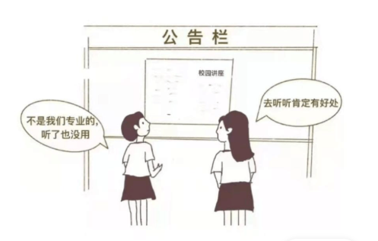

真题范文

The picture virtually drips with inspiration when it comes to the attitude towards knowledge acquirement. It can be seen that, two students saw the same poster of a lecture in their campus, one taking it as nothing useful for her major, but another viewing it as a chance for self-enhancement.

关于获取知识的态度，这张图片充满了启示。如图，两个学生在校园里看到了同一张讲座海报，一个人认为这对她的专业没有用处，而另一个人则认为这是一个自我提升的机会。

Behind this instructive drawing lies a perception that, students tend to focus on the practical purpose of knowledge acquirement. Admittedly, there is a convenient excuse for ignoring the seemingly useless in their studies, and it all boils down to a lack of broader vision. However, a wide range of learning is the very condition to connect the dots in our future development. Likewise, the ripple effect of comprehensive knowledge allows us to tap into our potential and sow a sense of confidence. All this gives enough grounds to learn extensively and set our sight on a far horizon.

这幅具有启发性的图画揭示出，学生在获取知识时比较注重实用目的。诚然，（人们）很容易找到借口，不去学习那些看似与学业无关的东西，而这皆因缺乏广阔的视野。然而，广泛的知识涉猎才是我们在未来发展中连点成线、施展能力的条件。同样，广博知识的涟漪效应能够使我们挖掘自身潜力，并获得自信心。鉴于此，我们应该广泛地学习知识，并将视线放长远一些。

So, stay hungry, stay foolish. It promises more opportunities to push the boundaries of possibility, and will put us in a better position to prepare for a fruitful future.

因此，求知若渴，虚心若愚。这样，你将拥有更多的机会，挑战更多的可能性，并能够以更好的姿态在未来收获更多。

# 2023真题（英一）

Unfolded in the elaborately painted cartoon is an eve-catching and thought-stimulating scene; some young men are rowing dragon boats, and a large number of people crowded to watch the game. An aged grandma turned to her spouse and said cheerfully: “it is wonderful that the Dragon Boat racing is getting increasingly lively in our village.” Apparently, what the cartoonist attempts to emphasize is the inheritance of traditional culture.

There is no denying that our Chinese. in recent years. have been attaching great importance to the carrying of the traditional culture and bringing it to vitality. Traditions are supposed to be inherited and advocated from one generation to another. Like tangible cultural heritages such as Great Wall and the Forbidden City, intangible cultural heritages like Peking Opera and celebration of traditional festivals are equally crucial. As a country consisting of a great diversity of ethnic groups and with time-honored history and civilization. China abounds in intangible cultural heritages, which connect modern people to the historical past. allowing them to acquire a cultural and historical identity. Without cultural heritages, we would be rendered absolutely rootless and we would lind it hard to cope with challenges at present and in the future.

However, the modernization process poses mounting threats to intangible heritages. It is also pathetic to see elderly people in possession of such legacies pass away without transmitting them to the ‘ounger generation. (‘onfronted with those challenges, we should both preserve and rejuvenate our ancestral heritages so that we can help contribute to cultural diversity of the world.

Unfolded in the elalmtely-painted left cartoon is an enlightening scene that Iwo citizens are ioggmg in the public Illness area and a young adult nearby proudly says, The new park which was built near my home is so desirable”. In the right bar chart, we can see that the number of parks in a city rose sharply from 406 in 202() In 607 in 2022. I here is no doubt that its symbolic meaning subtly conveyed should be given (Jeep consideration.

What the picture and the chart convey arc a favorable phenomenon that even more people now increasingly pay close attention to doing exercise, which is .ital to a society. The following factors, from my perspective, might illustrate this theme First and loremosi, doing exercise is beneficial to physical health and it can help reduce obesity and lower fat content by promoting blood circulation. This is why more youngsters are willing to participate in exercise regularly. What’s more, it can be utirihuied lo ihe relevant policy from our government to promote the growth of parks According to a survey conducted by China Research Center, up to I (XX) new parks were built last year all over the nation in order to encourage citizens to do exercise.

In summary, acUse naiionsidc involvement in physical exercise brings dual benefits of physical and mental wellness I he government should strengthen prornotwn and encoulagemeul to help citizens develop good exercise habits and routines (hily with participation from all sectors of the socicly can we build a physically strong and energelic commumtv

**19年真题（英二）**

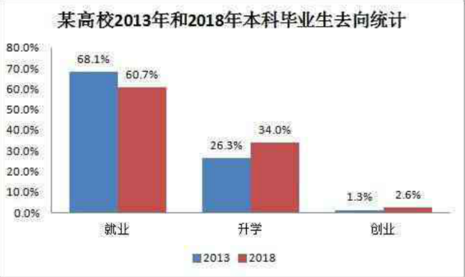

真题范文

The column chart allows us a holistic view of the choices after graduation in a certain college in 2013 and 2018. To be specific, the graduates choosing to work constitute a massive 68.1% in 2013 and 60.7% in 2018, followed by those going for further study (26.3% in 2013 and 34.0% in 2018) and those for starting a business (1.3% in 2013 and 2.6% in 2018). Overall, there is an upward trend in the choices of pursuing further study and starting a business, but a downward trend in choosing to work.

该柱状图让我们对某高校2013年和2018年的毕业选择情况有了整体了解。具体来说，2013年和2018年选择就业的毕业生分别占了68.1%和60.7%，其次是选择继续深造的毕业生（2013年为26.3%，2018年为34.0%）和创业的毕业生（2013年为1.3%，2018年为2.6%）。总体来说，选择升学和创业的人数有上升的趋势，而选择就业的人数则有所下降。

Such information brings clarity to the pattern of graduates’ choices, and it can be further interpreted as follows: Firstly, the shrinking number of graduates choosing to work is the result of sluggish job market. Secondly, the competitive environment is an impetus for the rising number of those advancing their studies. Thirdly, opportunities abound in the world today, and this led to a rise in the total number of college startups, but this group is still way outnumbered by the former two since very few people are prepared to face a volatile future.

该信息清楚地说明了毕业生的选择概况，并可进一步解释如下：首先，选择工作的毕业生人数减少，这是就业市场不景气的结果。其次，竞争环境激烈，这是推动升学人数上升的动力。第三，当今世界，机会比比皆是，这使大学生创业的总体人数有所上升，但这一群体仍然远远不及前两个群体的人数，因为很少有人做好准备，去面对一个不太稳定的未来。

In the final analysis, the number of graduates going for entrepreneurship is expected to keep growing in the near years, and it offers us a promising vision of a more dynamic market.

总之，毕业生创业的人数在近些年还会持续增长，这让我们有望看到一个更具活力的市场。

**21年真题（英二）**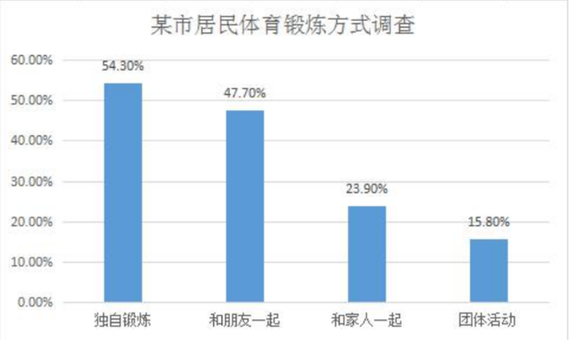

套用示例

The column chart allows us a holistic view of different ways adopted by residents in a certain city for doing physical exercises. To be specific, people opting for exercising alone constitute a majority (54.30%), followed by those doing it with friends (47.70%). In contrast, fewer people choose to exercise with their family (23.90%) or in groups (15.80%).

该柱状图让我们对某市居民体育锻炼的几种方式有了全面的了解。具体来说，选择独自锻炼的人占大多数（54.30%），其次是和朋友一起锻炼的人（47.70%）。相比之下，选择与家人一起锻炼（23.90%）或团体活动的人数（15.80%）较少。

Such information brings clarity to the pattern of people’ exercising preferences, and it can be further interpreted as follows: Firstly, most people enjoy the freedom of exercising alone, because this means a changeable schedule and mind relaxation. Secondly, the longing for communication is rooted in the hearts of all men, and it justifies people’s choice of doing exercise with their friends, but fewer people would choose a family member since they have spent too much time together. Thirdly, group activities are not conveniently available anywhere and anytime. This led to a weak number of people exercising in groups.

该信息清楚地说明了人们的锻炼偏好，并可进一步解释如下：首先，大多数人喜欢独自锻炼带来的自由感，因为这意味着时间自如、心灵放松。其次，人们都有交流的愿望，所以愿意选择和朋友一起锻炼，但选择和家人一起锻炼的人数比较少，因为他们平时在一起的时间已经很长了。第三，团体活动不是随时随地就可以参加的，致使选择团体锻炼的人数很少。

In the final analysis, there will remain diversified ways for physical exercises in the near years, and it offers us a promising vision of a fitness-for-all society.

总之，在近些年，体育锻炼的方式仍将呈现多样化的特点，我们有望看到一个全民健身的社会。