[Evan Vucci/AP](https://photos.aap.com.au/search/20240722146487681253)

**Can Kamala Harris win the US presidency after Joe Biden’s withdrawal? Here’s what the polls say**

Published: July 22, 2024 2.26am BST

**Author**

1. [**[](https://theconversation.com/profiles/adrian-beaumont-98965)Adrian Beaumont**](https://theconversation.com/profiles/adrian-beaumont-98965)

Election Analyst (Psephologist) at The Conversation; and Honorary Associate, School of Mathematics and Statistics, The University of Melbourne

**Disclosure statement**

Adrian Beaumont does not work for, consult, own shares in or receive funding from any company or organisation that would benefit from this article, and has disclosed no relevant affiliations beyond their academic appointment.

**Partners**

[University of Melbourne](https://theconversation.com/institutions/the-university-of-melbourne-722)

[University of Melbourne](https://theconversation.com/institutions/the-university-of-melbourne-722) provides funding as a founding partner of The Conversation AU.

[View all partners](https://theconversation.com/global/partners)

**We believe in the free flow of information**

Republish our articles for free, online or in print, under Creative Commons licence.

Republish this article

[Email](mailto:?subject=Can%20Kamala%20Harris%20win%20the%20US%20presidency%20after%20Joe%20Biden%E2%80%99s%20withdrawal%3F%20Here%E2%80%99s%20what%20the%20polls%20say%20%E2%80%94%20The%20Conversation&body=Hi.%20I%20found%20an%20article%20that%20you%20might%20like%3A%20%22Can%20Kamala%20Harris%20win%20the%20US%20presidency%20after%20Joe%20Biden%E2%80%99s%20withdrawal%3F%20Here%E2%80%99s%20what%20the%20polls%20say%22%20%E2%80%94%20https%3A%2F%2Ftheconversation.com%2Fcan-kamala-harris-win-the-us-presidency-after-joe-bidens-withdrawal-heres-what-the-polls-say-235185)

[X (Twitter)](http://twitter.com/intent/tweet?text=Can+Kamala+Harris+win+the+US+presidency+after+Joe+Biden%E2%80%99s+withdrawal%3F+Here%E2%80%99s+what+the+polls+say&url=https%3A%2F%2Ftheconversation.com%2Fcan-kamala-harris-win-the-us-presidency-after-joe-bidens-withdrawal-heres-what-the-polls-say-235185%3Futm_source%3Dtwitter%26utm_medium%3Dbylinetwitterbutton&utm_campaign=none&via=ConversationEDU)

[Facebook30](http://www.facebook.com/sharer.php?u=https%3A%2F%2Ftheconversation.com%2Fcan-kamala-harris-win-the-us-presidency-after-joe-bidens-withdrawal-heres-what-the-polls-say-235185%3Futm_source%3Dfacebook%26utm_medium%3Dbylinefacebookbutton)

[LinkedIn](http://www.linkedin.com/shareArticle?mini=true&source=The+Conversation&summary=The+United+States+election+will+be+held+on+November+5.+On+Sunday+US+time%2C+President+%5BJoe+Biden+withdrew%5D%28https%3A%2F%2Fwww.abc.net.au%2Fnews%2F2024-07-22%2Fjoe-biden-steps-aside-as-democratic-presidential-cand...&title=Can+Kamala+Harris+win+the+US+presidency+after+Joe+Biden%E2%80%99s+withdrawal%3F+Here%E2%80%99s+what+the+polls+say&url=https%3A%2F%2Ftheconversation.com%2Fcan-kamala-harris-win-the-us-presidency-after-joe-bidens-withdrawal-heres-what-the-polls-say-235185%3Futm_source%3Dlinkedin%26utm_medium%3Dbylinelinkedinbutton)

[Print](https://theconversation.com/can-kamala-harris-win-the-us-presidency-after-joe-bidens-withdrawal-heres-what-the-polls-say-235185)

The United States election will be held on November 5. On Sunday US time, President [Joe Biden withdrew](https://www.abc.net.au/news/2024-07-22/joe-biden-steps-aside-as-democratic-presidential-candidate-2024/104124806) from the presidential election contest and endorsed his vice president, Kamala Harris.

It’s not certain, but very likely Harris will now be the Democratic candidate to face former Republican president Donald Trump in November. During the [Democratic presidential primaries](https://www.thegreenpapers.com/P24/D) held early this year, Biden won about 95% of all delegates to the August 19–22 Democratic convention. These delegates are likely to support Harris given Biden’s endorsement.

Since the debate with Trump on June 27 that was widely thought to have been a disaster for Biden, he has faced pressure to withdraw. In an [Ipsos poll](https://abcnews.go.com/Politics/trump-favorability-rises-shooting-majority-americans-biden-end/story?id=112112043) for US ABC News that was released before Biden’s withdrawal on Sunday, Democratic voters wanted Biden to withdraw by 60–39.

Following the assassination attempt against Trump on July 13 and the Republican convention from July 15–18, Trump’s lead over Biden in the [FiveThirtyEight aggregate of national polls](https://projects.fivethirtyeight.com/polls/president-general/2024/national/) had increased to 3.2 points from 1.9 points on July 13, the largest margin since the aggregate began in March. Vote shares were 43.5% Trump, 40.2% Biden and 8.7% for Robert F. Kennedy Jr.

I’ve [written previously](https://theconversation.com/labour-landslide-at-uk-election-biden-drops-in-us-polls-after-debate-234067) that the presidency is not decided by the national popular vote. Instead each state has a certain amount of Electoral Votes (EVs), mostly based on population, with each state awarding their EVs winner takes all. It takes 270 EVs to win. The EV system is likely to skew to Trump, so Biden was further behind than in the national polls.

Biden will continue as president until his term ends in January 2025. His net approval in the [FiveThirtyEight aggregate](https://projects.fivethirtyeight.com/biden-approval-rating/) is -17.7, with 56.2% disapproving and 38.5% approving. His net approval is worse than other previous presidents at this point in their term, except George Bush Sr and Jimmy Carter.

Trump’s net favourability in the [FiveThirtyEight aggregate](https://projects.fivethirtyeight.com/polls/favorability/donald-trump/) is -12.0, with 53.7% unfavourable and 41.7% favourable. His ratings are relatively unchanged since April. Unfortunately, FiveThirtyEight has no favourability ratings for Harris.

**Will Harris win?**

It’s too soon to analyse Harris vs Trump polls. Harris had not been a presidential candidate before today and name recognition of Biden explains his often better numbers than Harris. A recent national YouGov poll for CBS News gave Trump a five-point lead over Biden and a three-point lead over Harris.

There are two things that should advantage Harris. One is that economic data has improved, with inflation dropping and real earnings up. The other is that, while Biden would have been almost 82 by the election, Harris [will only be 60](https://en.wikipedia.org/wiki/Kamala_Harris) by then. Trump is 78, so the age split that was unfavourable to Biden will be favourable to Harris.

[[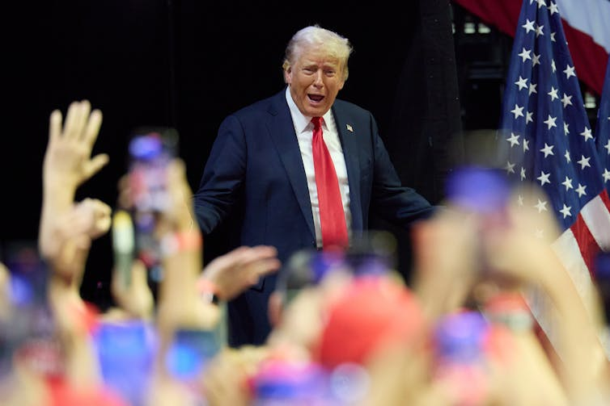](https://images.theconversation.com/files/608381/original/file-20240722-17-r55dqj.jpg?ixlib=rb-4.1.0&q=45&auto=format&w=1000&fit=clip)](https://images.theconversation.com/files/608381/original/file-20240722-17-r55dqj.jpg?ixlib=rb-4.1.0&q=45&auto=format&w=1000&fit=clip)

It’s too early to tell what a contest between Donald Trump and Kamala Harris might look like in the polls. [Allison Dinner/EPA](https://photos.aap.com.au/search/20240721140030492240)

Nevertheless, nominating a candidate who has not been battle-tested in the primaries is very risky. When Harris ran for president in 2020, she withdrew from the contest in December 2019, before any primaries.

However, with Biden’s age of great concern to voters, and with him already behind Trump, switching to a new candidate could prove a sensible move for the Democrats. Changes in prime minister have worked for Australian parties in the past, with Malcolm Turnbull winning the 2016 federal election after replacing Tony Abbott, and Scott Morrison winning in 2019 after replacing Turnbull.

While Biden has been losing, US Senate polls in the presidential swing states of [Pennsylvania](https://projects.fivethirtyeight.com/polls/senate/2024/pennsylvania/), Nevada, Wisconsin, Michigan and Arizona suggest the Democratic candidates are winning, and doing much better than Biden. So perhaps Democrats just have a Biden problem.

**US earnings up**

In June, [headline inflation](https://www.bls.gov/news.release/pdf/cpi.pdf) dropped 0.1% after being unchanged in May and 12-month inflation dropped to 3.0%, the lowest it has been since June 2023. Core inflation was up 0.1% in June after increasing 0.2% in May and has increased 3.3% in the last 12 months, the smallest increase since April 2021.

The low inflation in May and June has boosted real (inflation-adjusted) earnings in those months, with [real hourly earnings](https://www.bls.gov/news.release/realer.t01.htm) up 0.9% for May and June and real weekly earnings up 0.7%. In the 12 months to June, real hourly earnings are up 0.8% and real weekly earnings up 0.6%.

In June, a net 206,000 [jobs were added](https://www.bls.gov/news.release/empsit.nr0.htm), but the unemployment rate increased 0.1% to 4.1%. This is the highest unemployment rate since [November 2021](https://www.bls.gov/charts/employment-situation/civilian-unemployment-rate.htm).