**With Biden gone, Trump will need a new attack plan for the younger Kamala Harris**

Published: July 22, 2024 6.23pm BST

**Author**

1. [**[](https://theconversation.com/profiles/christopher-featherstone-1337066)Christopher Featherstone**](https://theconversation.com/profiles/christopher-featherstone-1337066)

Associate Lecturer, Department of Politics, University of York

**Disclosure statement**

Christopher Featherstone does not work for, consult, own shares in or receive funding from any company or organisation that would benefit from this article, and has disclosed no relevant affiliations beyond their academic appointment.

**Partners**

[University of York](https://theconversation.com/institutions/university-of-york-1344)

[University of York](https://theconversation.com/institutions/university-of-york-1344) provides funding as a member of The Conversation UK.

[View all partners](https://theconversation.com/global/partners)

**We believe in the free flow of information**

Republish our articles for free, online or in print, under Creative Commons licence.

Republish this article

[Email](mailto:?subject=With%20Biden%20gone%2C%20Trump%20will%20need%20a%20new%20attack%20plan%20for%20the%20younger%20Kamala%20Harris%20%E2%80%94%20The%20Conversation&body=Hi.%20I%20found%20an%20article%20that%20you%20might%20like%3A%20%22With%20Biden%20gone%2C%20Trump%20will%20need%20a%20new%20attack%20plan%20for%20the%20younger%20Kamala%20Harris%22%20%E2%80%94%20https%3A%2F%2Ftheconversation.com%2Fwith-biden-gone-trump-will-need-a-new-attack-plan-for-the-younger-kamala-harris-235236)

[X (Twitter)](http://twitter.com/intent/tweet?text=With+Biden+gone%2C+Trump+will+need+a+new+attack+plan+for+the+younger+Kamala+Harris&url=https%3A%2F%2Ftheconversation.com%2Fwith-biden-gone-trump-will-need-a-new-attack-plan-for-the-younger-kamala-harris-235236%3Futm_source%3Dtwitter%26utm_medium%3Dbylinetwitterbutton&utm_campaign=none&via=ConversationUK)

[Facebook30](http://www.facebook.com/sharer.php?u=https%3A%2F%2Ftheconversation.com%2Fwith-biden-gone-trump-will-need-a-new-attack-plan-for-the-younger-kamala-harris-235236%3Futm_source%3Dfacebook%26utm_medium%3Dbylinefacebookbutton)

[LinkedIn](http://www.linkedin.com/shareArticle?mini=true&source=The+Conversation&summary=When+Joe+Biden+%5Bwithdrew+from+the+presidential+election%5D%28https%3A%2F%2Ftheconversation.com%2Fcan-kamala-harris-win-the-us-presidency-after-joe-bidens-withdrawal-heres-what-the-polls-say-235185%29+race+he+cha...&title=With+Biden+gone%2C+Trump+will+need+a+new+attack+plan+for+the+younger+Kamala+Harris&url=https%3A%2F%2Ftheconversation.com%2Fwith-biden-gone-trump-will-need-a-new-attack-plan-for-the-younger-kamala-harris-235236%3Futm_source%3Dlinkedin%26utm_medium%3Dbylinelinkedinbutton)

[Print](https://theconversation.com/with-biden-gone-trump-will-need-a-new-attack-plan-for-the-younger-kamala-harris-235236)

When Joe Biden [withdrew from the presidential election](https://theconversation.com/can-kamala-harris-win-the-us-presidency-after-joe-bidens-withdrawal-heres-what-the-polls-say-235185) race he changed the nature of the campaign. In the three weeks following the notorious presidential debate, Biden’s withdrawal came to be seen as a matter of when, not if. Now the Democratic party’s ticket is in flux and its campaign will look very different to the one Biden would have fought.

Biden has endorsed his vice-president Kamala Harris and many of the party’s big beasts have followed suit. The talk behind closed doors is very much of how a transition can be managed that will unify the party. It is already unified in its praise for Biden’s [“patriotism and "selflessness”](https://apnews.com/article/biden-withdraws-reaction-republicans-democrats-2a0a80121ef1b09a16a88cba6af6f90b), which in itself is a selling point to the small but incredibly crucial percentage of swing voters who remain undecided.

But one thing Biden’s withdrawal achieved immediately was to wrest the news agenda from Donald Trump. For the past few weeks, certainly since the June 28 election debate which revealed the extent to which Biden was struggling with age-related cognitive impairment, the Trump campaign has had the run of the news coverage.

Biden’s age became the key issue in the campaign. Trump dominated the debate without any of his offputting bluster. So the campaign narrative was already framed by the Republicans as one of “our guy’s strength v their guy’s fragility”.

Then came the [attempted assassination](https://www.nytimes.com/article/shooting-trump-rally.html) of July 13. That photo, the pumping fists to the cries of “fight, fight, fight”. Biden meanwhile was mistaking Ukrainian president, Volodymyr Zelensky, for “President Putin” and referred to “vice-president Trump”, when he meant Harris. The ecstatic Republican National Convention appeared to be as much a revivalist tent meeting as a political process. The Maga faithful didn’t so much nominate Trump as crown him.

Trump, meanwhile, basking in the warmth of so much love, was able to appear magnanimous. No more vicious divisive rhetoric, he said. He would become a unifier. Of course, this didn’t last as long as it took him to make his acceptance speech as GOP nominee on July 18.

But all that changed when Biden withdrew. Suddenly age is not a problem for the Democrats. But it is for the Republicans whose candidate, at 78, would be the oldest president ever elected into power. Age is a Trump card the Democrats now hold.

**GOP rethink?**

So the GOP strategy will need to be rethought. We’re already seeing that. Ads attacking Harris are accusing her of culpability and complicity in [“covering up” Biden’s mental decline](https://www.politico.com/news/2024/07/21/trump-campaign-kamala-harris-nominee-00170110). The GOP is also trying to hammer home Harris’s lacklustre performance in tightening up on [illegal immigration](https://www.politico.com/news/2024/07/17/republicans-kamala-harris-attack-immigration-00168940) on America’s southern borders. So far, a minor adjustment rather than a major rethink.

The problem for Trump’s pollsters and strategists is that they don’t know who Harris will pick as a running mate. In fact, they can’t be 100% sure she will even end up on the ticket. This makes it hard to plan a concerted campaign.

Harris has her frailties – she’s from California, which is anathema to many hardline Republicans as it smells of “small l” liberal. She’s a woman – and a woman of colour to boot. And the GOP has its share of racists and sexists.

But it’s generally thought that Trump’s Maga base is nailed on. Trump [famously said](https://www.npr.org/sections/thetwo-way/2016/01/23/464129029/donald-trump-i-could-shoot-somebody-and-i-wouldnt-lose-any-voters): “I could stand in the middle of Fifth Avenue and shoot somebody, and I wouldn’t lose any voters, OK?” And as far as his Maga base is concerned, this is probably not far off the mark.

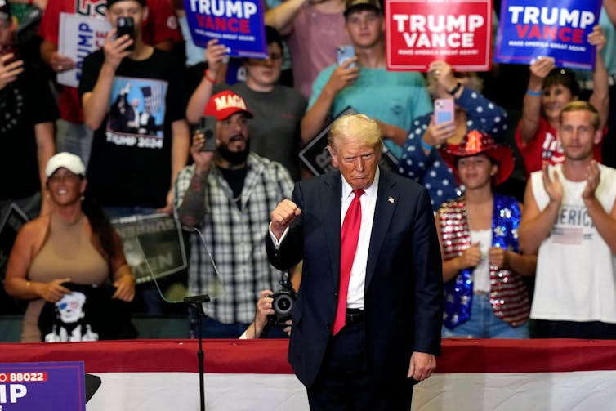

No more Mr Nice Guy: Donald Trump at a rally in Grand Rapids, Michigan, July 20. AP Photo/Carlos Osorio

But this campaign is likely to focus on a relatively few people in a handful of key swing states who have not yet made up their minds about which way they are going to vote. And it’s also going to be decided on turnout.

There were signs that Biden might struggle to mobilise the black vote that had been so effective for him in the past. Harris is more likely going to be able to deliver those crucial constituents.

**‘Crazy as a bed bug’**

Then there are the “soft” Republicans and undecideds who Trump may need to put him into the White House once more. This was where his new, post-assassination unifying stance was supposed to come in: it would reassure those who had previously thought him intemperate or just downright unpleasant.

But this new milder Trump vanished as soon as the former president made it clear he was going off-piste and ignoring the teleprompter during his acceptance speech which brought the Republican National Convention to a close, with its bizarre rambling references to having dinner with Hannibal Lecter, the psychopathic cannibal from the movie Silence of the Lambs.

Following several weeks where the Biden campaign had to defend their candidate’s mental competence, now it’s the Republicans who have a candidate whose judgment becomes increasingly the issue for those voters who are now watching very closely for indications of character.

And episodes like his [rally speech](https://www.reuters.com/world/us/trump-hold-first-campaign-rally-after-assassination-attempt-2024-07-20/) at the weekend in Grand Rapids, Michigan – a key swing state – where he referred to the former House speaker Nancy Pelosi as a “dog” and “as crazy as a bed bug” could well increasingly start to look like liabilities if the race starts to become close.