**e Trump assassination attempt has upended the US election race. So, what happens next?**

Published: July 15, 2024 2.36am BST

**Author**

1. [**[](https://theconversation.com/profiles/lester-munson-1476430)Lester Munson**](https://theconversation.com/profiles/lester-munson-1476430)

Non-Resident Fellow, United States Studies Centre, University of Sydney

**Disclosure statement**

Lester Munson does not work for, consult, own shares in or receive funding from any company or organisation that would benefit from this article, and has disclosed no relevant affiliations beyond their academic appointment.

**Partners**

[University of  Sydney](https://theconversation.com/institutions/university-of-sydney-841)

[University of Sydney](https://theconversation.com/institutions/university-of-sydney-841) provides funding as a member of The Conversation AU.

[View all partners](https://theconversation.com/global/partners)

**We believe in the free flow of information**

Republish our articles for free, online or in print, under Creative Commons licence.

Republish this article

[Email](mailto:?subject=The%20Trump%20assassination%20attempt%20has%20upended%20the%20US%20election%20race.%20So%2C%20what%20happens%20next%3F%20%E2%80%94%20The%20Conversation&body=Hi.%20I%20found%20an%20article%20that%20you%20might%20like%3A%20%22The%20Trump%20assassination%20attempt%20has%20upended%20the%20US%20election%20race.%20So%2C%20what%20happens%20next%3F%22%20%E2%80%94%20https%3A%2F%2Ftheconversation.com%2Fthe-trump-assassination-attempt-has-upended-the-us-election-race-so-what-happens-next-234658)

[X (Twitter)](http://twitter.com/intent/tweet?text=The+Trump+assassination+attempt+has+upended+the+US+election+race.+So%2C+what+happens+next%3F&url=https%3A%2F%2Ftheconversation.com%2Fthe-trump-assassination-attempt-has-upended-the-us-election-race-so-what-happens-next-234658%3Futm_source%3Dtwitter%26utm_medium%3Dbylinetwitterbutton&utm_campaign=none&via=ConversationEDU)

[Facebook105](http://www.facebook.com/sharer.php?u=https%3A%2F%2Ftheconversation.com%2Fthe-trump-assassination-attempt-has-upended-the-us-election-race-so-what-happens-next-234658%3Futm_source%3Dfacebook%26utm_medium%3Dbylinefacebookbutton)

[LinkedIn](http://www.linkedin.com/shareArticle?mini=true&source=The+Conversation&summary=It+is+tempting+to+draw+grand+conclusions+from+the+assassination+attempt+on+former+president+Donald+Trump+this+weekend.+The+coarse+rhetoric+currently+in+vogue+in+American+politics%2C+not+to+mention+th...&title=The+Trump+assassination+attempt+has+upended+the+US+election+race.+So%2C+what+happens+next%3F&url=https%3A%2F%2Ftheconversation.com%2Fthe-trump-assassination-attempt-has-upended-the-us-election-race-so-what-happens-next-234658%3Futm_source%3Dlinkedin%26utm_medium%3Dbylinelinkedinbutton)

[Print](https://theconversation.com/the-trump-assassination-attempt-has-upended-the-us-election-race-so-what-happens-next-234658)

It is tempting to draw grand conclusions from the assassination attempt on former president Donald Trump this weekend. The coarse rhetoric currently in vogue in American politics, not to mention the Capitol riot on January 6, 2021, provide plenty of fodder for this kind of speculation.

In reality, the shooting, while horrible, does not come as a total surprise in the context of American history or even in the current presidential campaign.

Divisive and extreme political campaigns from both parties are now the norm. Criminal prosecutions of Trump and President Joe Biden’s son Hunter have become politicised. And American voters are more often driven to vote against the other party’s candidate than to vote for their own.

Yes, activists and officials in both parties will try to use the shooting for campaign advantage by tapping into voters’ emotions. Politicians will accentuate the horror of the attempted assassination and declare various phenomena as “existential threats” or use similar apocalyptic language.

But the overall political environment, while uncomfortable, embarrassing and occasionally deeply concerning, is not entirely unprecedented or even an extreme example of American political life.

To put it plainly: American politics has always been a bloody fight.

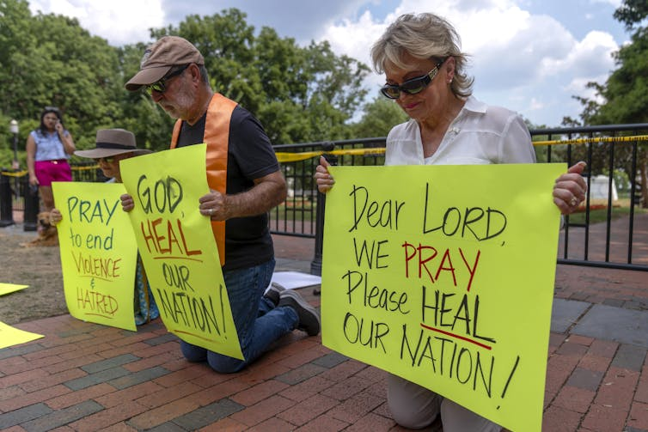

Protesters calling for an end to political violence near the White House. Mark Schiefelbein/AP

**A history of political violence**

In the [latter half of the 20th century](https://www.politico.com/news/2024/07/14/trump-shot-history-assassins-00168058), one American president was assassinated (John F. Kennedy), another was wounded (Ronald Reagan) and another targeted (Gerald Ford). In addition, two major presidential candidates were assassinated (Robert F. Kennedy) or nearly so (George Wallace). Numerous other plots were disrupted.

American politics from the 1960s to the early 1980s were incredibly divisive and violent. During just the years 1971 and 1972, more than 2,500 politically motivated bombings [occurred](https://time.com/4501670/bombings-of-america-burrough/) in the United States (nearly five per day), mostly from left-wing protesters against the war in Vietnam.

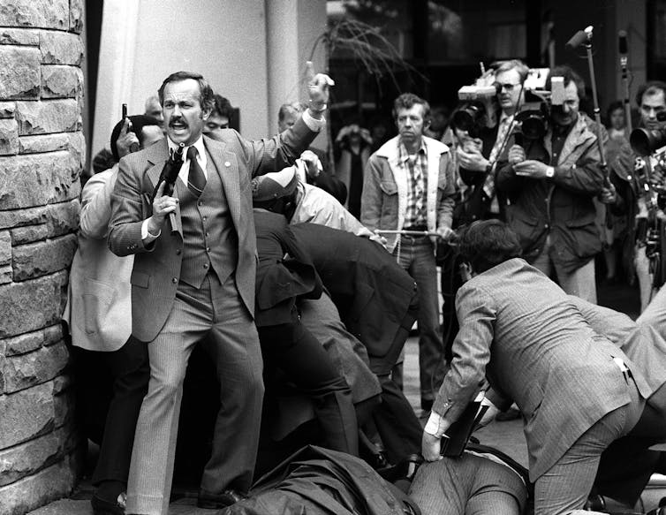

John Hinckley is wrestled to the ground in 1981 after shooting President Ronald Reagan. Ron Edmonds/AP

As the US has become increasingly polarised in recent years, the political environment today has become volatile again.

In 2011, Representative Gabby Giffords was [shot and nearly killed](https://www.npr.org/series/132783213/arizona-shooting-rampage-congresswoman-others-shot) at an event in Arizona by a man suffering from paranoid schizophrenia. In 2017, a Bernie Sanders supporter [shot at several Republican congressmen and staffers](https://edition.cnn.com/2017/06/14/homepage2/james-hodgkinson-profile/index.html), nearly killing Representative Steve Scalise of Louisiana, now the House majority leader.

And of course, the Trump-instigated insurrection of the Capitol during the counting of electoral votes in the 2020 presidential election gives millions of Americans good reason to believe that Trump and his supporters remain a threat to democratic processes.

**Democrats’ opportunity**

Another immediate consequence of the assassination attempt will be to turn the national conversation temporarily away from Biden’s debate performance in late June. This political dilemma for Democrats, however, will not go away.

Given Biden’s age and obvious decline, White House efforts to prop up perceptions about his fitness for office will likely not be enough to persuade his fellow Democrats he can beat Trump in November.

Even before the shooting, [polls indicated](https://www.nytimes.com/interactive/2024/us/elections/polls-president.html) Biden was likely to lose the election. It will be even harder now, given the shooting will galvanise Trump’s supporters and likely widen his appeal to others.

Many Democrats believe a different candidate – Vice President Kamala Harris or another leading Democrat – would have a better chance.

The Trump shooting now presents a new opportunity for Democrats to reset their campaign and make a broader appeal to American voters for calm and national unity.

They will need to tone down their own rhetoric about Trump’s threat to democracy and instead make the case that their policy agenda is the preferred one for the American people.

The question is: can they quickly identify a new candidate to drive this new message? Even in the wake of Trump’s near-death experience, that remains the biggest question in American politics.

**Republicans’ challenge**

Trump’s near-death experience will give his campaign – already based on portraying him as a victim of Democrats and the establishment – renewed energy. The pictures of Trump, with blood on his face, raising his fist in defiance after he was shot, are more valuable than hundreds of millions of dollars in campaign ads.

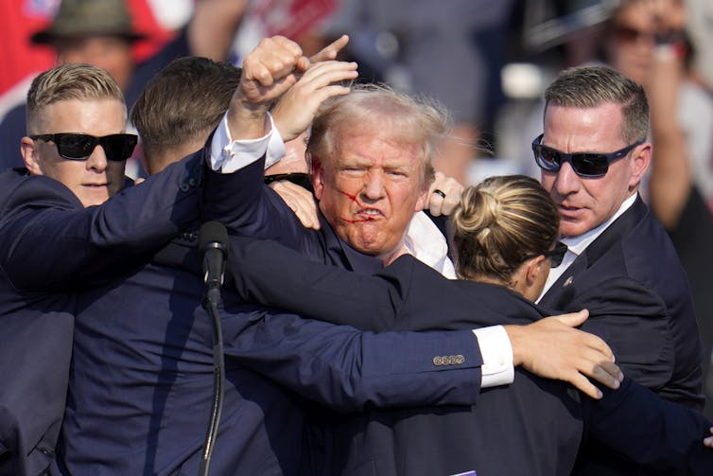

Trump raises his fist after being shot at in Pennsylvania. Gene J. Puskar/AP

However, Republicans and fervent Trump supporters will now face a different challenge. The urge to exploit the shooting – whether the shooter was politically motivated or not – will be very difficult to resist.

Some Trump supporters are already blaming Democrats for the event, such as Republican [Senator JD Vance](https://www.politico.com/live-updates/2024/07/14/trump-rally-shooting-updates/eric-swalwell-jd-vance-00168103), considered a frontrunner to be Trump’s vice presidential running mate.

House Speaker Mike Johnson and others have also [criticised Biden](https://edition.cnn.com/2024/07/14/politics/biden-say-trump-shooting-bullseye/index.html#:%7E:text=%E2%80%9CPresident%20Biden%20himself%20said%20in,%E2%80%9CToday%E2%80%9D%20show%20on%20Sunday.) for saying before the assassination that he would “put a bullseye” on Trump.

Politicising the shooting in this way might have success in boosting turnout of Trump supporters in November, but it could also drive further acrimony and unhinged rhetoric from those on the right.

For instance, any attempt to turn this tragedy into an attack on Democrats or Biden and his character could prove counterproductive and only remind voters of Trump’s tendency to incite nasty divisiveness.

Instead, Trump has an opportunity to show real leadership and make a broader appeal to undecided and independent voters. With his base locked in more than ever, will he reach out to persuadable Republican moderates and disaffected Democrats? Can he show that he can tone down his antagonistic rhetoric and even reach across the aisle?

[Reagan did so](https://edition.cnn.com/2011/OPINION/03/30/avlon.reagan.shooting/index.html) – at least in tone if not his policy agenda – after he nearly died from an assassin’s bullet in 1981.

So, can Republicans and Democrats use the tragic Trump shooting to pivot to a more positive message? American voters – as well as the US’s friends and allies around the world – are no doubt hoping so.

The day after the shooting, Biden called Trump to express his concerns about his health and discuss the tragic event. Perhaps this small gesture of bipartisanship and civility can be an example for all in the days ahead.