**PolfWack Technologies Main Website Design Document**

This design document will outline the project description for the PolfWack Technologies Main Website. The first section will describe the problem this project is trying to solve. The second section will list the requirements of the project. The third section will provide a high-level system design of the project. The fourth section will show a low-level service design for the project, complete with class diagrams and use-case diagrams. The fifth section will be a description of the team for this project.

**Project Problem Description**

The problem this project is trying to solve is very simple. PolfWack Technologies needs a website to start marketing out its services. The website needs to appeal to potential clients by being visually appealing and functionally sound. This website will act as a springboard for PolfWack Technologies, allowing the company access to the software development industry.

**Requirements**

The requirements for this project will be more outlined like a list of pages for the website. Since the server is already up and running, defining these website pages will provide clear direction on how to solve the problem. The website will include:

1. A home page
2. An about us page that describes the company’s mission and personnel
3. A services page that shows the services the company offers
4. A portfolio page where the company can show previous projects
5. A contact page where potential clients can send emails to the company
   1. An email forum
      1. First and Last Name
      2. Email
      3. Message body

These pages need to be displayed in a visually appealing manner, while being functionally sound. This website is the first impression potential clients will have of the company.

**High-Level System Design**

This section describes the high-level system design for the project. The first part will describe the system design. The second part will show a diagram of the high-level system design. The third part will describe how the system design will best fulfill the requirements of the project.

**High-Level System Design Description**

The project will follow a classic server-model website. A server-model website consists of a host machine that serves request from users, providing them with the pages they need. The server for this project is already configured, as polfwack.tech is already up and running. The focus of this project will be the actual pages the server provides to users.

**High-Level System Design Diagram**

Here is a diagram of the high-level design described previously:

This system will be the easiest to complete. The fact that the website will use individual pages to convey information makes a server architecture organizationally the best option. In theory, each web page will represent a different file on the server. It will also be able to make the website visually appealing and functionally sound using this approach.

**Low-Level Service Design**

In the spirit of keeping with the governing principles of PolfWack Technologies, each web page is a micro-service, and the website itself is the micro-serviced application. Each page will essentially be the same, because at this point the pages just contain information, with the exception of the email forum. For conciseness’ sake, there will be a diagram detail a general outline for the pages, and information will be added to pages later.

Here is the diagram of a general page outline:

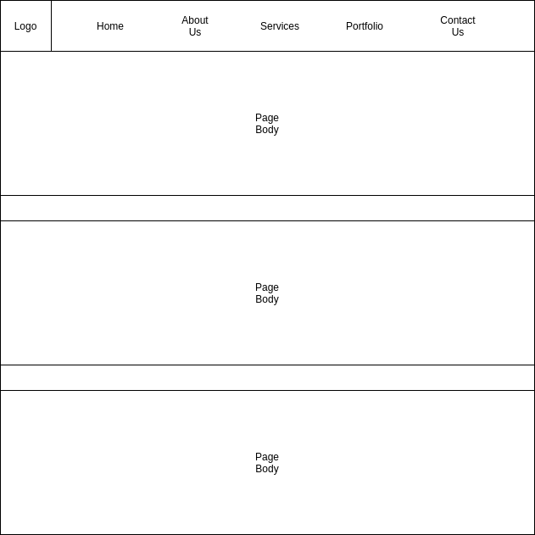

There will be a header so the user can navigate to other pages in the website. There will also be information in the page body, along with pictures to make the website visually appealing. The pages will be written in React because it is a very popular web framework, and it is can easily run on a shared hosting platform.

In React, components can also inherit from and compose other components. This is useful because all of the pages are basically the same, and each of them will have a header. Using React, we can generate the following class diagram for the web pages:

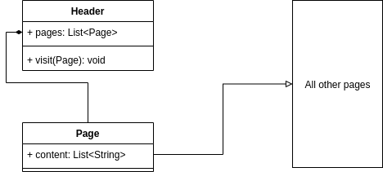

The only use for these pages are navigating to different site, which is done using the Header. When the user clicks on the page link in the Header, the Header then loads the next page. Because the use case is so simple, there is no need for a use case diagram

The service will fulfill all of the requirement of the project. From each web page, the user will be able to navigate to any other web page. The inheritance feature of React will allow for an elegant solution to the pages. The website will also be visually appealing and functionally sound by using the React framework.

**Team Description**

The team will consist of the following members:

* Dax Thompson as Web Developer and Project Manager
* Hayden Allred as Web Developer
* Will Cornell as Graphic Designer and Assistant Web Developer

**Project Summary**

The document outlined the design for the PolfWack Technologies Main Website project. The first section discussed the problem the project aimed to solve. The second section outlined the requirements of the project. The third section talked about the high-level system design for the project. The fourth section described the low-level service design. The fifth section listed the team members and their responsibilities for the project.