安装nginx

Yum install nginx –y 即可

配置nginx

/etc/nginx/nginx.conf 中

新增一组配置

server {

listen 8080;

server_name 47.100.130.174;

#charset koi8-r;

#access_log logs/host.access.log main;

location / {

root /var/www/html;

index index.html index.htm;

expires 1d;

}

}

即可

Nginx 支持php

需要安装 php-fpm

yum install php-fpm

service php-fpm restart

nginx.conf 中

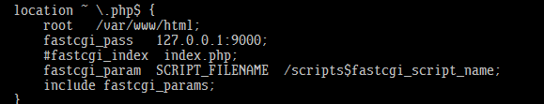

放开注释

fastcgi_params 末尾需要加上

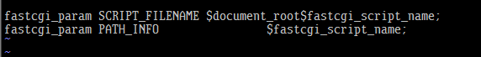

Php-安装

https://blog.csdn.net/long12310225/article/details/77357255

wget http://www.[**PHP**](http://lib.csdn.net/base/php).net/distributions/[**php**](http://lib.csdn.net/base/php)-5.3.3.tar.gz

tar –xzvf php-5.3.3.tar.gz

cd php-5.3.3.tar.gz

./configure --prefix=/usr/local/php /  
             --enable-fpm /  
             --with-fpm-user=fpm /  
             --with-fpm-group=fpm /  
             --with-[**MySQL**](http://lib.csdn.net/base/mysql)=mysqlnd /  
             --with-mysqli=mysqlnd /  
             --with-pdo-[**mysql**](http://lib.csdn.net/base/mysql)=mysqlnd /  
             --without-pdo-sqlite /  
             --without-sqlite3 /  
             --without-sqlite /  
             --with-mysql-sock=/tmp/mysql.sock /  
             --with-curl /  
             --enable-mbstring /  
             --with-mhash /  
             --with-mcrypt /  
             --with-openssl /  
             --with-gd /  
             --enable-sockets /  
             --with-gettext /  
             --with-zlib /  
             --enable-zip /  
             --enable-soap /  
             --with-xmlrpc

php-mysqli 等扩展库找不到

bison-devel bison-devel zlib-devel libmcrypt-devel mcrypt-devel mhash-devel openssl-devel libxml2-devel libcurl-devel bzip2-devel readline-devel libedit-devel

以上库缺啥就yum install xxx即可

安装指定版本php时

[yum install php-mysqli](http://stackoverflow.com/a/23713997/111307) 安装php-mysqli

重启php-fpm即可

Service php-fpm restart