# FESC Florida Energy Systems Consortium Redesign

Proposal for the redesign of <http://floridaenergy.ufl.edu/>

Notes on FESC:

* (FESC) was created by the Florida State government to promote collaboration among the energy experts at its 12 supported universities to share energy-related expertise.

* Research funding was designated for FAU, FIU, FSU, UCF, UF, and USF

## Objectives/purpose of the redesign

*“Goal of the consortium is to become a world leader in energy research, education, technology, and energy systems analysis.” -FESC*

To become a world leader, I think first impressions are important. Especially if the first place the world would like to know about you and what you do is on the world wide web. The web site needs a major re-design just based on this goal that their aiming for and their users involved. The site needs to be tailored based on their user needs, which would be university staff, students and government employees. Provide the data they need with less clicks as possible.

## State of the current site

The site itself looks pretty basic, simple HTML and with images. Almost 90’s looking website. But pretty much has the essentials of a modern day website, header, navigation, search, breadcrumbs, footer, etc. Just not a very attractive design. Some out of date content and really old images.

Upon further investigation of the site code, there was quite a lot of linking to CSS and JavaScript for a site that looked pretty simple, and also noticed the use of “***wp-…***” on directories, which indicate possible use **WordPress** on the development of the site or maybe certain sections of the site.

There seems to be a lot of links and content, was a little time consuming to review every page and to prioritize. So to help with the review, I used <https://www.xml-sitemaps.com> to generate a site map so that I can easily view the pages and sub-pages all at once.

Pages indexed: **500 (crawled: 528)**

Pages size: **10.99Mb**

Broken links: **3**

Upon further review of the indexed data, there was a lot of links to go through and again noticed some use of “**wp-content**”. Out of date content that go back as far as 2009 which can probably be delete or archived. Based on the sitemap generator there are about 500 pages and documents. Some duplicated links and/or titles on pages and also on search results.

A lot of PDF documents, which loads just fine, but could have use mobile first design for better viewing on devices.

Main top navigation and sub left menu has inconsistent look and feel as you drill down to sub menus and pages. Site definitely not responsive. Though the site looks as is on tablet mode and functional, menu is a little squished and unresponsive.

HTML Validation - a lot of deprecated attributes. Again this could be due to the use of Wordpress template.

The FESC site (<http://floridaenergy.ufl.edu/>) looks like it’s maintained and hosted by University of Florida based on their host domain. Which is a good thing since, most of their user base and traffic will be coming from that region.

## Performance

For performance testing, I used webpagetest.com and pingdom.com.

Webagetest.com results came up with:

FireFox – Load time: 6.166s

Chrome – Load time: 4.423s

Safari (iOS 11) – 7.683s

For pingdom.com these were the results, which seemed more realistic.

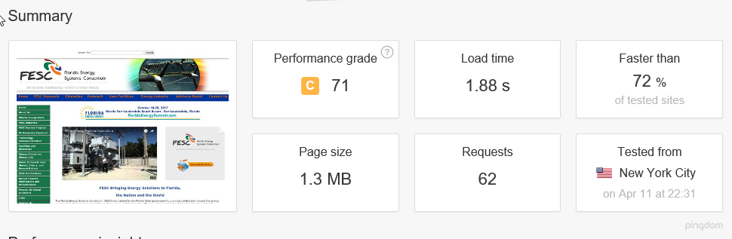

During my personal test on both desktop and mobile, on initial page load, overall it came up fairly quick and full page. Similar with pingdom results. But with a slight delay on the loading of media content like the images and video links. Some improvements can be done by optimizing of images on the site.

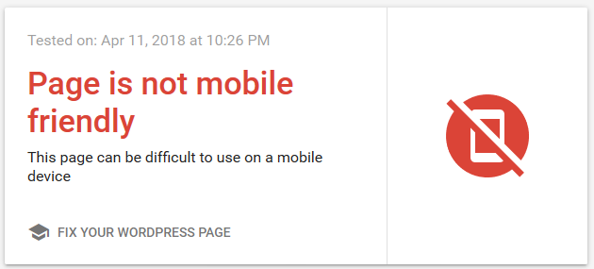Functionality, it works, page comes up full on both desktop and mobile but definitely not responsive. Not touch friendly requires a lot of clicking and scrolling. Ease of use can be improved upon.

## User Research

Expected users would be University Students, University Staff, and Government Employees. I think the main top navigation is appropriately prioritized. This would be a good start for their user base.

**Home - FESC Research - Education - Outreach - User Facilities - Energy Industry - Advisory Board -Contact Us**

With university students focused on the education and research. Government employees focused on the energy industry and advisory board, etc.

## Device support necessary

Device support is definitely necessary, especially for students, staff and employees that are out in the field or located at these energy facilities. These devices would be possibly be Windows based tablets (government employees) and iOS/Android devices (university staff and students).

This would improve collaboration, research and data sharing between the users.

## Recommendations

As most users would probably be university students with majors in the energy industry, with collaboration with other universities. It is critical that the site should be re-designed for mobile first. With the amount of pages and content, search and navigation is key.

Though their content does seem relevant and important. The Main and sub navigation should be appropriately prioritized based on the user needs. Should not take no more than 3 clicks. Make them part of the Main navigation menu as possible drop down menus.

Move the image slideshow probably just below the navigation, and possibly add a description for each image as they change. More carousel like, that can also include news or events.

Avoid use of WordPress.

Definitely should start clean, with how simple the current site looks and their content, redesign and development with HTML5/CSS/JavaScript will suffice. This will also make it lightweight to improve performance.

Possible use of a grid system on the entire site, especially on pages that contain data tables.

Nice that they have the search at the top but could use some filtering and be part of the main navigation and visible at all times for both desktop and mobile view.

Optimize images for better load times and resolution. Collaborate with the university to get more current and modern images for use on the website.

Add some social forum for all users to collaborate and share.

Research more on the user side, if you browse all the partnering university websites, so much more modern and responsive. Check on how university students link or navigate to this site. Maybe take ideas from those sites and apply them here. As you want a seamless browsing as you jump back and forth to the FESC site and the university websites