##### Design1 – Header

In Desgn1, the most important aspect is the curved division between header image and content below.

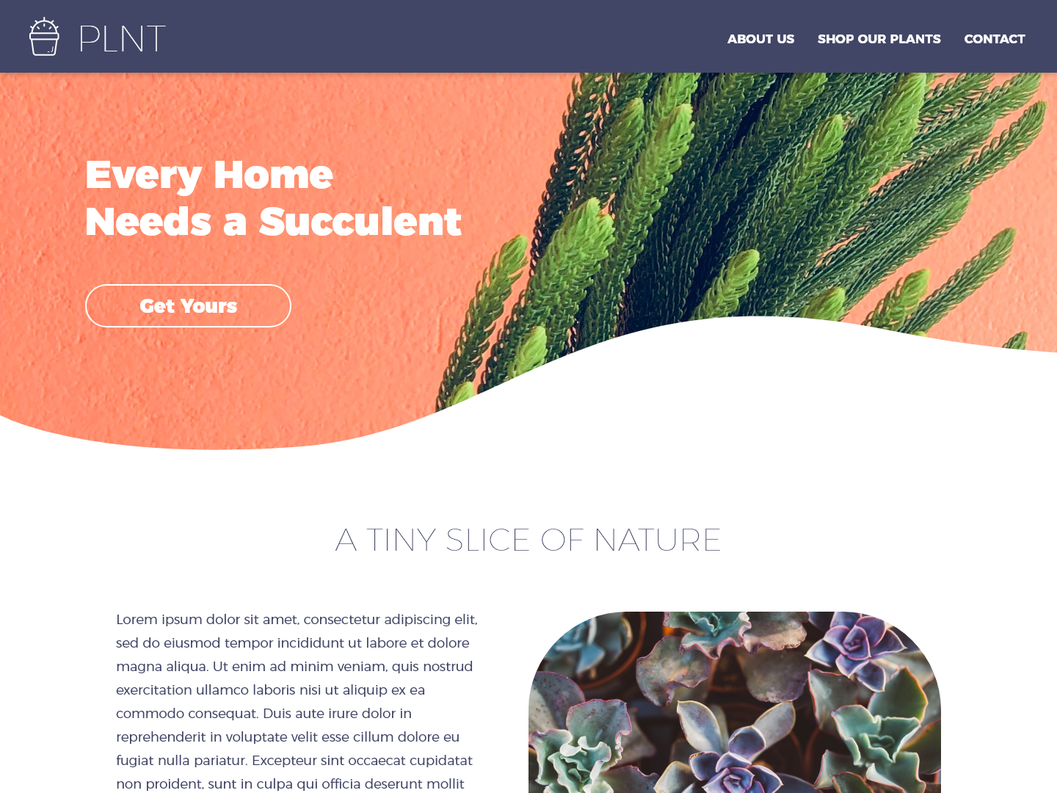

1. If you are familiar with the tag use (svg, path, clipPath), I think it will take just a little work to accomplish. Based on what I have researched so far on SVG and examples, it only takes a few lines of code.

Example: <https://codepen.io/Alexandr_T/pen/rYKOea>

2. Probably the only other easy option is to insert an image as background that has been edited with the curve.   
  
3. Sure, I think it adds a nice touch to a site. But would avoid too much white space. Maybe as it responds maybe lessen the curve. Also, add a fallback for older browsers like IE, which according to CANIUSE, is supported but not very well.  
  
4. Assuming I’m unaware of the use HTML SVG or Canvas, I would probably try to use divs, maybe 3 divs that are in-line and maybe use CSS border radius and transform for the bottom border to do my best to get as close to the result. If I can’t get the result I want, will probably just end up using an edited image as a background.

But definitely HTML SVG Path is the way to go.

##### Design2 - Signup01

In Design2, the "Indoors" and "Outdoors" buttons will submit the form.

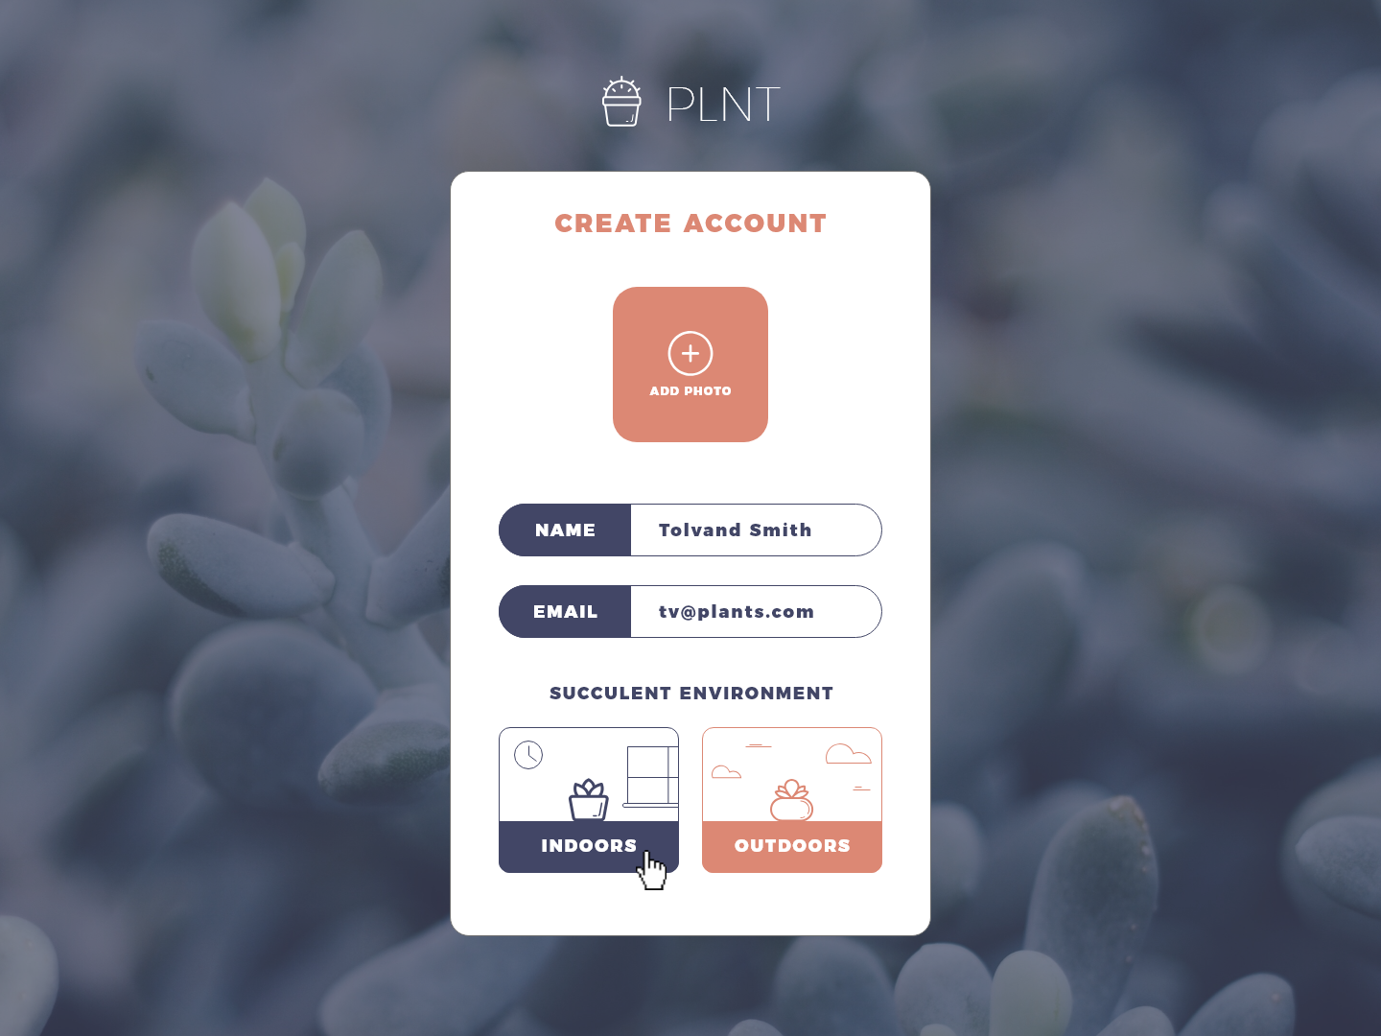

1. It should just take a little amount of work to accomplish this design.  
   
2. Other options would be an image exactly like it and add a link or onclick event. Or simply just use a button tag with a name of just INDOORS or OUTDOORS.

3. It seems overly designed for a button, we all know what indoors and outdoors mean. I don’t think there is a need for a visual description. Those that are visually impaired might also have difficulty viewing it. But if I were to use an image I would use a realistic image of an actual plant with an indoor and outdoor setting.

4. I would have used 2 divs, one contained within the other. The container div would have the environment image background and rounded borders. The inner div would align to the bottom, centered text and background color and add a bottom border radius to match the radius of the container div.

##### Design3 - Signup02

Don't miss the note from designer in Design3.

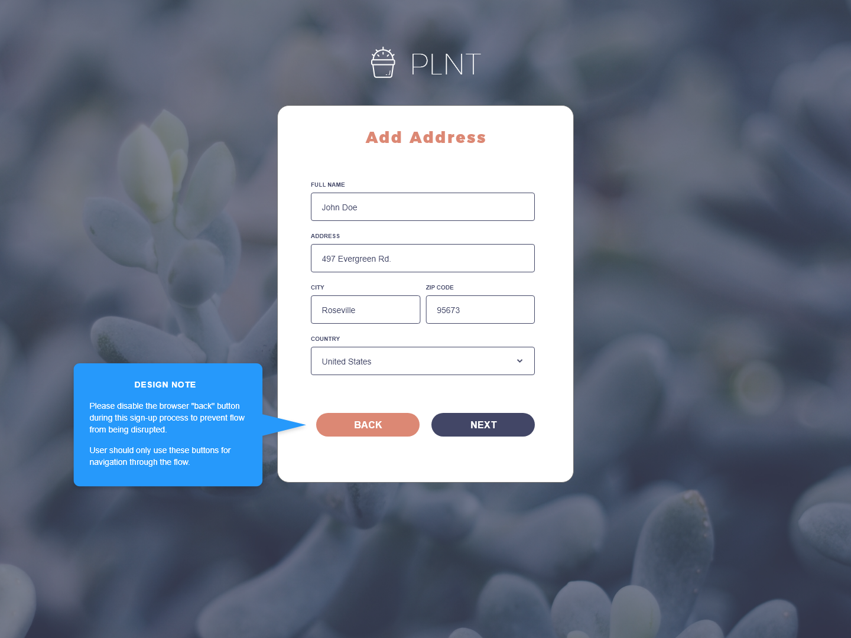

1. If it’s simply just disabling the button in the sign-up, that can easily be done and will take little work. I would probably ask for more context about this note. As to why and/or exactly at what point do you want to disable. Do we want to disable as the user enters this page, focus on the form fields, or when the form is complete and then enabled? Because as a user, I might want to go back to change my options or something.  
2. There are other ways it can be done, maybe some CSS or use of JavaScript libraries. But to the simplest way is to use the disabled attribute on the button tag.

3. Again, I would ask for more clarity for this feature. If it’s for navigation I think it’s okay to keep it enabled. Instead maybe create a script that would prevent the form fields to clear out as the user navigates through the signup process. Disable makes more sense on the Next button, you would want to complete the address fields before you move next.

4. Once it has been determined when disable will trigger, create a script, either when the user hits the page, focus on the fields or complete the form fields, the script will trigger the disable button attribute or apply other methods like CSS to grey it out or make un clickable.