辅助标示牌枚举类型汇总
SuppSignType
0 | NO_ENTRY | 禁止驶入 | 
1 | PROHIBIT_MOTOR_ENTERING | 禁止机动车驶入 | 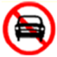
2 | PROHIBIT_TEMPORARY_AND_PROLONGED_PARKING | 禁止临时及长时间停车 | 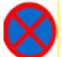
3 | PROHIBIT_PROLONGED_PARKING | 禁止长时间停车 | 
4 | NO_PARKING | 禁止停车 | 
5 | NO_OVERTAKING | 禁止超车 | 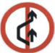
6 | CANCEL_NO_OVERTAKING | 解除禁止超车 | 
7 | PROHIBIT_TURN_LEFT | 禁止左转弯 | 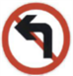
8 | PROHIBIT_TURN_RIGHT | 禁止右转弯 | 
9 | PROHIBIT_TURN_U | 禁止掉头 | 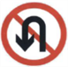
10 | STOP_SIGN | 停车标识 | 
11 | YIELD_SIGN | 让行标识 | 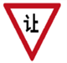
12 | ATTENTION_CHILDREN | 注意儿童 | 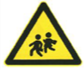
13 | ATTENTION_PEDESTRIANS | 注意行人 | 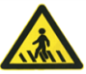
14 | ROAD_CONSTRUCTION_SIGN | 道路施工标识 | 
15 | SHARP_TURN_LEFT | 左转急弯 | 
16 | SHARP_TURN_RIGHT | 右转急弯 | 
17 | VEHICLE_MERGE_LEFT | 左侧车辆汇入 | 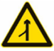
18 | VEHICLE_MERGE_RIGHT | 右侧车辆汇入 | 