BACSE324 · Embedded Systems Architecture · Fall 2026 · Final Report

Gesture-Controlled Smart Glove for Human–Computer Interaction
Final report · concept to realisation · due end of October · 15–20 pages excluding front matter and appendices
Scope tier | Tier 2 — full embedded system
Submission date | 27 October 2026
Repository link | https://github.com/dayaj1222/data-glove
Demo video link | To be added before submission (90-second demo video)

Team
Member | Reg. no. | Module owned | Sections written
Dayakrishn Joshi | 25BCE2951 | ESP-32 firmware, MPU-6500 I²C and flex ADC acquisition, host serial link, air-mouse engine and games | §1–§7, §9, §11
Syed Mohammad Ayaan | 25BCE2311 | System modelling (FSM, schedule), PC recognition pipeline | §4, §8, §10

Declaration
We declare that this report and the work it describes are our own, and that every external source, library and tool is acknowledged in the references.
Member | Signature | Date
Dayakrishn Joshi
Syed Mohammad Ayaan

Abstract
Mouse and keyboard input ties a user's hands to a desk. This project builds a wearable glove that turns hand pose and motion into desktop input. An ESP-32 reads two flex sensors and an MPU-6500 accelerometer/gyroscope at 50 Hz and streams a 48-byte frame over USB serial to a Linux host. The host reads three palm orientations (from gravity) combined with three finger states into nine distinct gestures, and injects cursor movement, clicks, scroll, window drag and browser navigation through a uinput virtual device; when the glove goes silent every input is released. Frame-to-cursor latency measured 6.3 ms mean (n = 60) against a 20 ms target, and a lost glove released all inputs in 490 ms against 500 ms. The main limitation is that the MPU-6500 has no magnetometer, so heading drifts and the cursor is driven by turn rate, not absolute direction.

Contents
Abstract 2
1 Problem and requirements 3
1.1 Problem statement 3
1.2 Requirements 3
1.3 Constraints 3
2 Alternatives considered 4
2.1 Microcontroller 4
2.2 Link between glove and PC 4
2.3 Gesture recognition approach 5
3 Architecture and hardware 6
3.1 System architecture 6
3.2 Schematic and pin map 7
3.3 Power budget 7
3.4 Build 8
4 Design models 9
4.1 CDFG and critical path 9
4.2 System FSM 10
4.3 Task schedule 11
4.4 Changes since Review 2 11
5 Firmware structure 12
5.1 Layers and modules 12
5.2 Implementation of the models 12
5.3 Model-to-code traceability 13
6 Optimisation 13
7 Test plan and measured results 14
7.1 Timing measurements 15
7.2 Discussion 16
8 Design-decision log 17
9 Bill of materials and cost 18
10 Individual contribution 18
11 Limitations and future work 19
References 19
Appendices 19
A Source code 19
B Raw data 20
Submission checklist 20

1 Problem and requirements

1.1 Problem statement
Controlling a computer normally needs a keyboard and a mouse, which occupy both hands and a flat surface. People presenting, demonstrating or working away from the desk need an input device they can wear. The glove should let one operator move a cursor, click, scroll, move and resize windows and navigate back/forward using only the pose and motion of the hand, with no camera and no external infrastructure, and it must fail safe: a lost or unplugged glove must never leave a button or modifier key held down.

1.2 Requirements
ID | Requirement | Measurable target | Priority (must / should) | Verified in
R-F1 | Stream two flex channels and six IMU axes from the glove to the PC without loss | ≥ 50 frames/s, 48 B each, no framing errors | must | §7 T1, T2
R-F2 | Distinguish nine gestures: three palm orientations × three finger states (A, B, A+B) | 9 of 9 gestures produce their own action | must | §7 T3
R-F3 | Turn gestures into real desktop input on Linux (cursor, click, scroll, window drag, back/forward) | Virtual input device created; every gesture emits its events | must | §7 T4
R-F4 | Fail safe: release every button and key when the glove stops sending | Released within 500 ms of the last frame | must | §7 T5 (fault)
R-F5 | Classify recorded gestures with a trained model | ≥ 90 % accuracy on real glove recordings | should | §7 T10
R-N1 | Latency from frame arrival to cursor event | ≤ 20 ms | must | §7 T6
R-N2 | Per-sample processing cost on the host | ≤ 1 ms (5 % of the 20 ms frame period) | must | §7 T7
R-N3 | Gyro offset after calibration, so the cursor does not creep when the hand is still | ≤ 1 deg/s residual | should | §7 T8
R-N4 | Firmware fits the ESP-32 with headroom | ≤ 50 % flash, ≤ 25 % RAM | should | §7 T9

1.3 Constraints
Hardware: one ESP-32 DevKit, one MPU-6500 breakout, two flex sensors, one status LED; no magnetometer, no wireless link and no additional sensors or buttons were allowed or used. Power: 5 V from the USB port; no battery. Time: about six weeks from proposal to final review. Team: two students. Host: Linux with the Hyprland compositor, because injection uses the kernel uinput interface. Wiring: dupont wires without a breadboard (soldering is listed as future work).

2 Alternatives considered

2.1 Microcontroller
Criterion (requirement ID) | Weight | ESP-32 DevKit | Arduino Nano | Raspberry Pi Pico
Sampling headroom for 2 ADC + I²C at 50 Hz (R-F1, R-N1) | 25 | 5 — 240 MHz dual core | 1 — 16 MHz AVR, 2 KB RAM | 3 — 133 MHz dual core
ADC resolution and enough ADC1 channels (R-F1) | 20 | 4 — 12-bit, 8 ADC1 channels | 2 — 10-bit | 3 — 12-bit, 3 channels
USB serial to the PC with one cable (R-F1, constraints) | 25 | 5 — CP2102 on board | 4 — CH340/FTDI on board | 4 — native USB
Firmware room for filtering and calibration (R-N4) | 15 | 5 — 4 MB flash, 520 KB RAM | 2 — 32 KB flash | 4 — 2 MB flash
Availability to the team (constraints) | 15 | 5 — owned | 3 — buy | 3 — buy
Weighted total (score × weight ÷ 100) | 100 | 4.8 | 2.4 | 3.4

Chosen: ESP-32 DevKit · Because: it has the headroom for the 50 Hz loop and on-board filtering, a 12-bit ADC, and USB serial on one cable, and the team already owned it. Spec sources: Espressif ESP32 datasheet, Microchip ATmega328P datasheet, Raspberry Pi RP2040 datasheet.

2.2 Link between glove and PC
Criterion (requirement ID) | Weight | USB serial (CP2102) | Wi-Fi UDP | Bluetooth
Reliability: no pairing, no packet loss on a cable (R-F1, R-F4) | 30 | 5 — wired, ordered bytes | 3 — UDP datagrams can drop | 2 — pairing and dropouts
Setup effort for the user (constraints) | 25 | 5 — plug in | 2 — Wi-Fi credentials and IP | 2 — pairing
Bandwidth for 48 B × 50 Hz = 2.4 kB/s (R-F1) | 20 | 5 — 11.5 kB/s available at 115200 baud | 5 | 4
Power from the host (constraints) | 15 | 5 — USB powers the board | 2 — needs a battery | 2 — needs a battery
Loss detection for the safe state (R-F4) | 10 | 5 — read error on unplug | 2 — timeout only | 2 — timeout only
Weighted total (score × weight ÷ 100) | 100 | 5.0 | 2.9 | 2.4

Chosen: USB serial · Because: it is the most reliable link, needs no configuration and powers the board. This replaced the Wi-Fi/UDP path planned in Review 2, which needed a phone bridge and network setup (see §4.4, §8 D2).

2.3 Gesture recognition approach
Criterion (requirement ID) | Weight | Rule grid (palm zone × fingers) | Windowed classifier (RandomForest) | Neural network on raw windows
Deterministic: every gesture always gives its action (R-F2) | 30 | 5 — by construction | 3 — probabilistic | 3 — probabilistic
Low latency per decision (R-N1, R-N2) | 25 | 5 — 16 µs per sample | 2 — about 15–20 ms per call | 1 — heavier
Needs no training data (constraints) | 20 | 5 — one calibration pose each | 2 — needs labelled recordings | 1 — needs many recordings
Works on the real mounting (R-F2) | 15 | 5 — calibrated nearest pose | 3 | 3
Extensible to new gestures (R-F5) | 10 | 2 — add a grid cell | 5 — record and retrain | 5
Weighted total (score × weight ÷ 100) | 100 | 4.7 | 2.8 | 2.3

Chosen: Rule grid for desktop control · Because: it is deterministic, costs 16 µs per sample and needs no data. The RandomForest classifier stays in the system for recorded-gesture experiments, but it was only trained on synthetic frames and is not used for control (see §7 T10, §11).

3 Architecture and hardware

3.1 System architecture
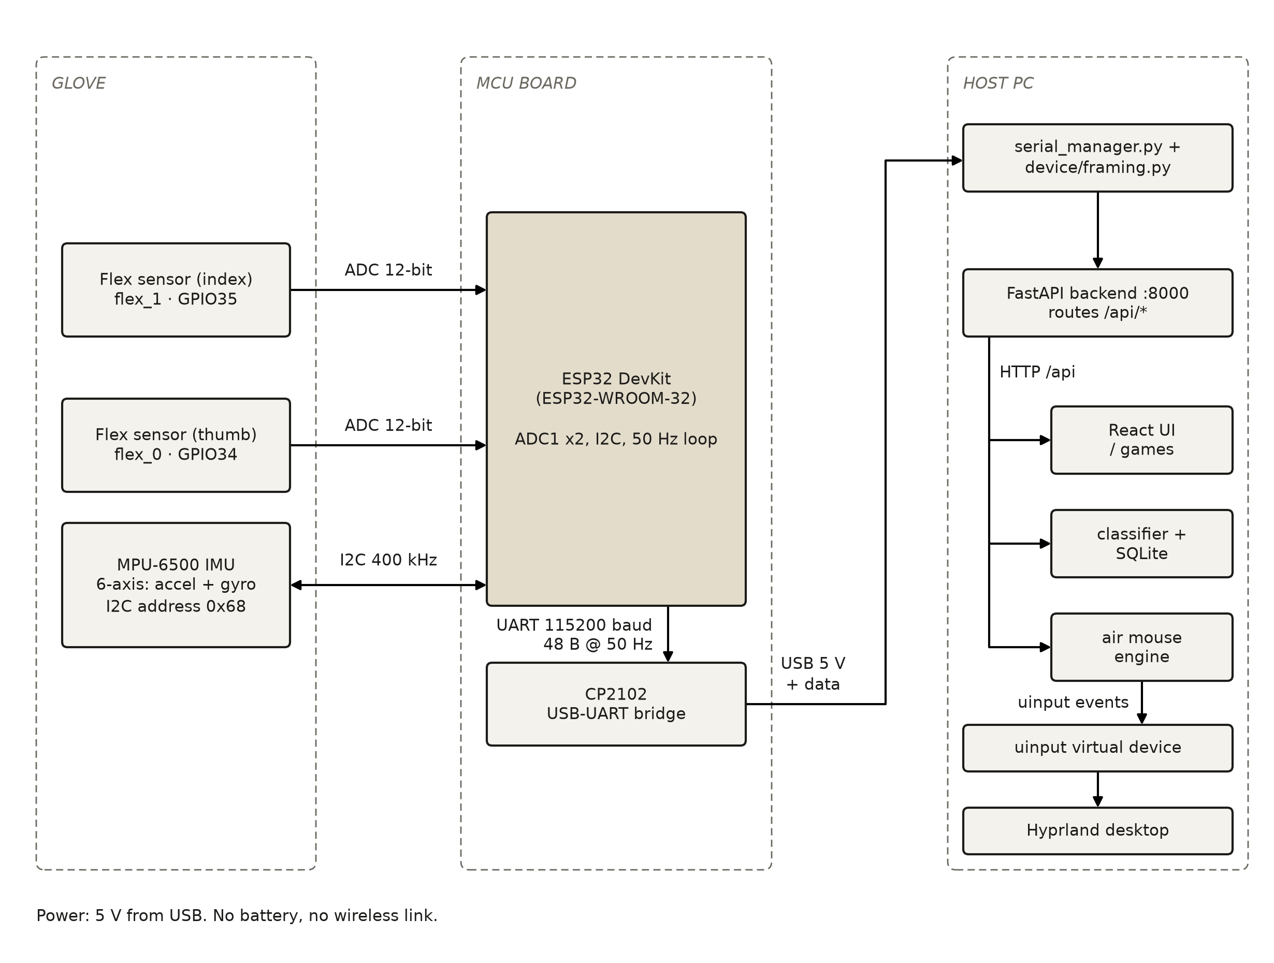
Figure 1 — System block diagram, final version: glove sensors → ESP-32 → USB serial → host software → uinput.

3.2 Schematic and pin map
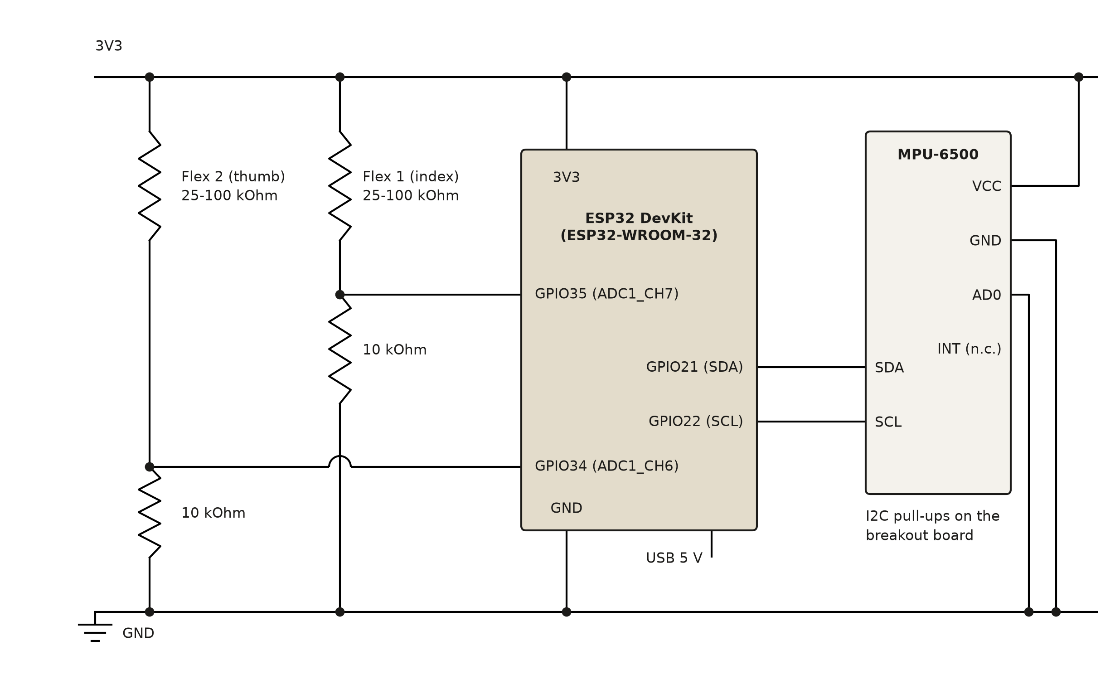
Figure 2 — Circuit schematic: two flex dividers on ADC1, MPU-6500 on I²C, power from USB.
MCU pin | Function | Connected to | Notes (pull-up, level shift, interrupt)
GPIO34 (ADC1_CH6) | Flex sensor 2 (flex_0) | 3V3 – flex – node – 10 kΩ – GND; node to GPIO34 | Input-only pin with no internal pull; the 10 kΩ resistor is mandatory or the pin floats
GPIO35 (ADC1_CH7) | Flex sensor 1 (flex_1) | Same divider; node to GPIO35 | Input-only, ADC1 so it keeps working if Wi-Fi is ever enabled
GPIO21 | I²C SDA | MPU-6500 SDA | 400 kHz; pull-ups on the breakout board
GPIO22 | I²C SCL | MPU-6500 SCL | 400 kHz; address 0x68 (AD0 low), WHO_AM_I 0x70
3V3 | Sensor supply | MPU-6500 VCC and both flex dividers | Single 3V3 pin: the three connections are joined at one junction
UART0 TX/RX (GPIO1/3) | Frame stream to PC | CP2102 USB-UART bridge | 115200 baud, 8N1; 48-byte frame at 50 Hz
GPIO2 | Status LED | On-board LED | Lit while flex_0 reads below 500 counts

3.3 Power budget
Component | Supply voltage | Active current | Sleep current | Duty cycle | Average current
ESP-32 DevKit (WROOM-32 + CP2102), radios off | 5 V USB (3.3 V on board) | ≈ 70 mA (datasheet, 240 MHz, estimated) | none: no sleep mode is used | 100 % | ≈ 70 mA
MPU-6500 (accelerometer + gyroscope) | 3.3 V | 3.2 mA (datasheet) | 8 µA (unused) | 100 % | 3.2 mA
Flex sensor divider × 2 (flat, ≈ 25 kΩ + 10 kΩ) | 3.3 V | ≈ 0.09 mA each (computed 3.3 V ÷ 35 kΩ) | n/a | 100 % | ≈ 0.19 mA
Status LED (on board) | 3.3 V | ≈ 5 mA when lit (estimated) | n/a | low | < 1 mA
Total from the USB port | 5 V | — | — | — | ≈ 75 mA ≈ 0.38 W (estimated, not measured)

3.4 Build
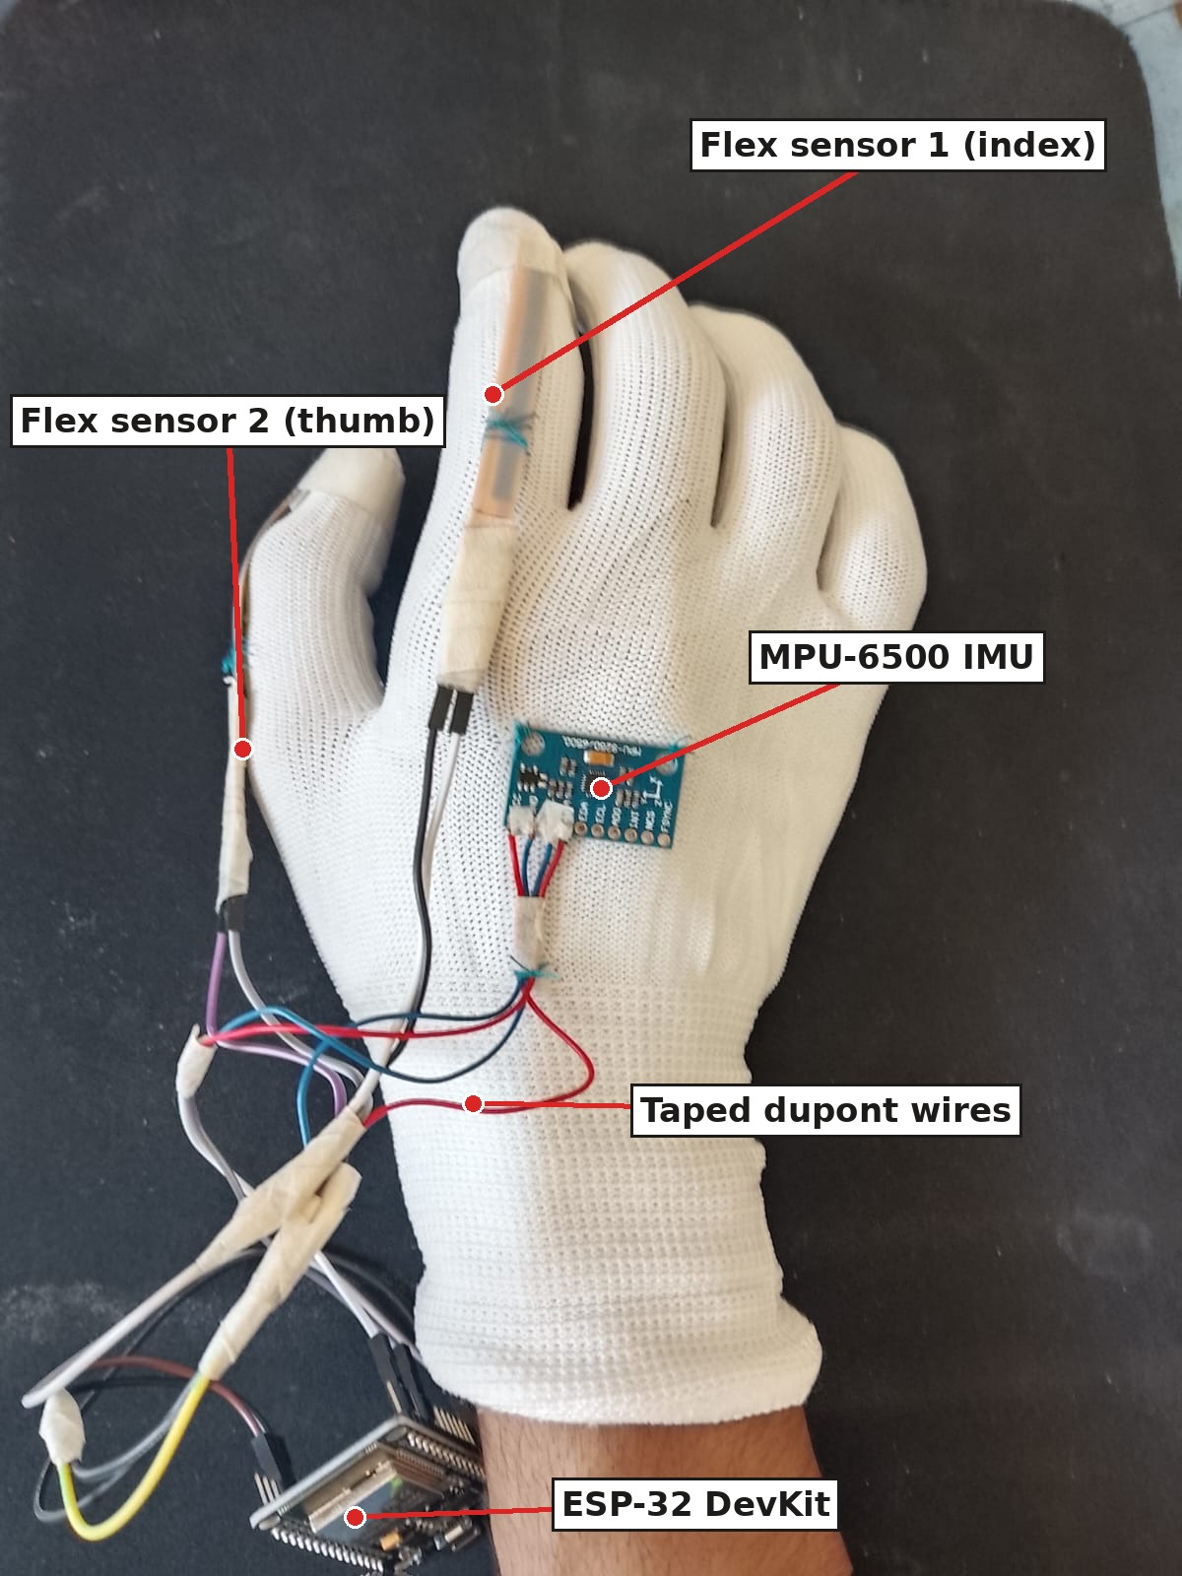
Figure 3 — Assembled glove hardware.

4 Design models

4.1 CDFG and critical path
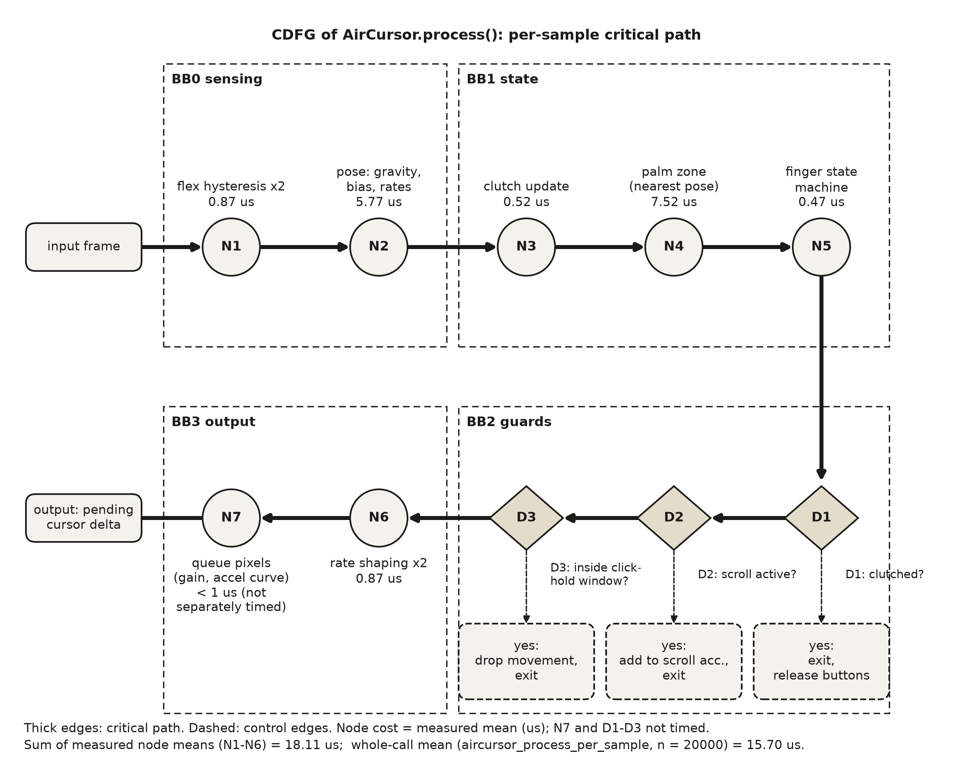
Figure 4 — CDFG of AirCursor.process(), the per-sample critical path of the air mouse. Node costs are measured means in µs; each includes timer overhead, so they sum to more than the whole-call mean.

4.2 System FSM
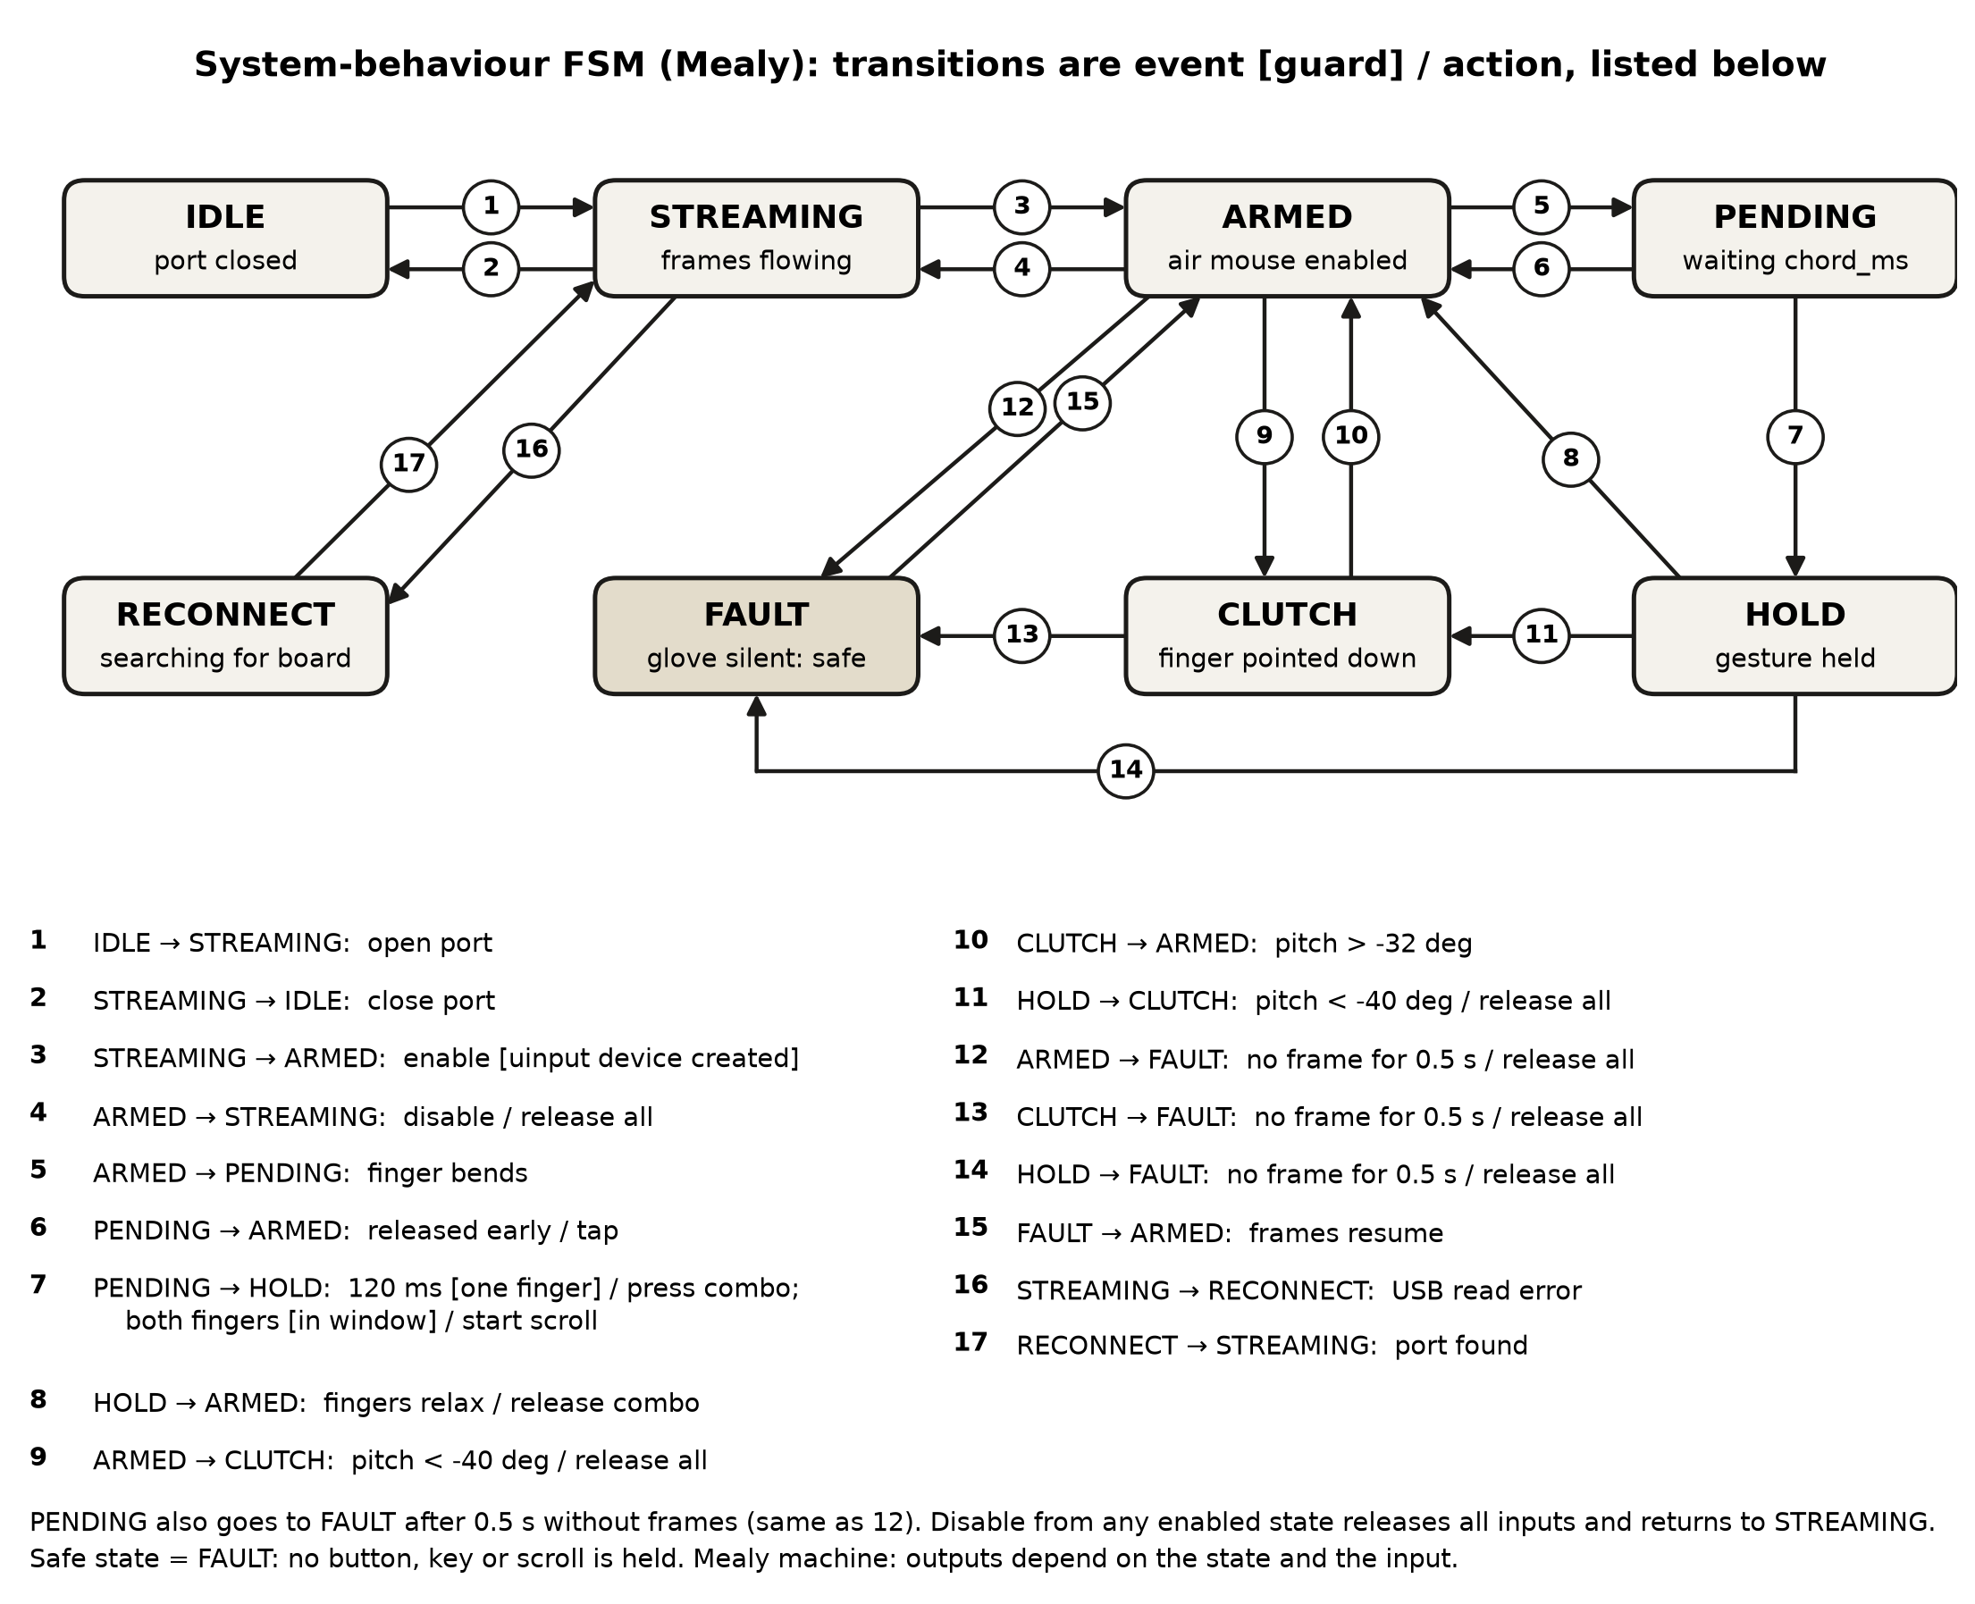
Figure 5 — System FSM, final (Mealy). Safe state = FAULT.

4.3 Task schedule
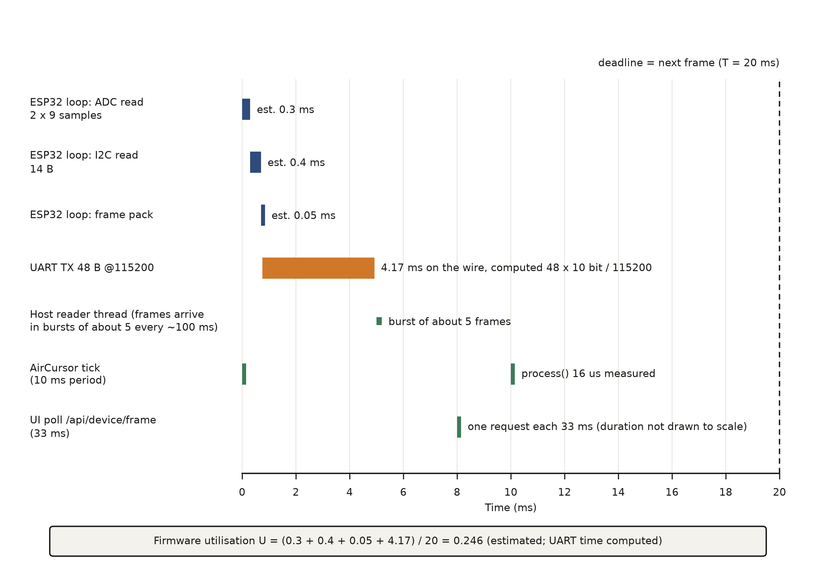
Figure 6 — Schedule timeline over one 20 ms frame, final.

4.4 Changes since Review 2
Model element | Review 2 version | As built | Why it changed
Glove-to-PC link | Wi-Fi/UDP datagrams on port 5005 through a phone bridge | USB serial at 115200 baud through the CP2102 | The phone bridge needed network setup and added latency and a failure point; one cable gives power and data (D2)
IMU | MPU-9250, 9-axis with magnetometer | MPU-6500, 6-axis, no magnetometer | The fitted part answered WHO_AM_I 0x70 and never responded at the AK8963 address 0x0C (117 of 117 reads); yaw is rate-only (D1, D4)
Frame format | 46-byte datagram, no sync | 48 bytes: 0xAA 0x55 header + 5 × uint16 + 9 × float32 | A header lets the parser resync byte-by-byte after corruption; framing tests caught three real bugs (D3)
Firmware tasks and period | FreeRTOS imuTask / flexTask / packetTask / txTask / wdtTask, 100 Hz | One cooperative loop on a fixed 20 ms (50 Hz) deadline, no RTOS | U ≈ 0.25 on one core needs no preemption; 50 Hz uses 21 % of the UART instead of 42 % (D6)
Critical function | predict(): window inference, ≈ 15 ms estimated | AirCursor.process(): per-sample control path, 16 µs measured | Desktop control is the real-time path; predict() is off the control path and its model is now cached (D9)
System FSM | IDLE / STREAMING / TRACKING / ACTING / FAULT / RECOVER | IDLE / STREAMING / ARMED / PENDING / HOLD / CLUTCH / FAULT / RECONNECT | The control engine is a gesture state machine; FAULT now also releases all held inputs (D7)
Scheduling approach | Rate-monotonic with a watchdog task | Cyclic executive in firmware; 10 ms host tick; 0.5 s stale-frame watchdog | Single-loop firmware has nothing to preempt; the watchdog moved to the host, which owns the safe state (D6, D8)

5 Firmware structure

5.1 Layers and modules
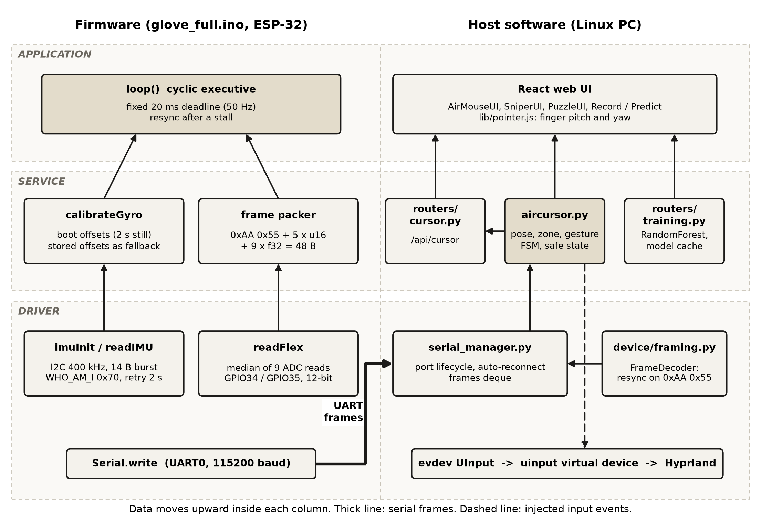
Figure 7 — Firmware and host module diagram: drivers, services and application layers.

5.2 Implementation of the models
Firmware: setup() initialises the ADC (12-bit, 11 dB attenuation), I²C at 400 kHz and, once the IMU answers WHO_AM_I = 0x70, measures the gyro offset over 2 s and uses it only if the board was still. loop() is a cyclic executive: it advances a deadline by FRAME_PERIOD_US = 20 000 µs, reads both flex channels (median of 9 ADC reads), reads the IMU in one 14-byte I²C burst, packs the frame and writes it; if a frame overruns by more than one period the deadline is reset so the loop never runs a burst of catch-up frames. Host: the gesture FSM is a state machine in AirCursor._fingers() with explicit state fields (_gesture, _pend_t, _clutched, _zone); the zone is decided once per gesture and held until the fingers relax. The schedule is realised by two threads: the serial reader (blocking reads, frames arrive in bursts of about five) and a 10 ms tick thread that processes every new frame and drains queued movement. Faults are caught at four places: an I²C error drops the firmware to a retry path every 2 s; framing resynchronises on the 0xAA 0x55 header; a read error on the USB port triggers _reconnect(), which finds the board again even if it renumbers from ttyUSB0 to ttyUSB1; and a 0.5 s gap in frames calls _release_all(), the safe state.

5.3 Model-to-code traceability
Model element | File | Function | Commit / line
CDFG N1 flex hysteresis | backend/app/aircursor.py | Hysteresis.update | 593306a · l.106
CDFG N2 pose (gravity, bias, rates) | backend/app/aircursor.py | AirCursor.pose | 593306a · l.300
CDFG N3–N4 clutch and palm zone | backend/app/aircursor.py | _update_clutch, _update_zone | 593306a · l.332, 348
CDFG N5 / FSM PENDING → HOLD | backend/app/aircursor.py | _fingers, _start, _end | 593306a · l.490–506
FSM FAULT / safe state | backend/app/aircursor.py | _release_all, _loop (stale branch) | 593306a · l.286, 617
FSM RECONNECT | backend/app/serial_manager.py | SerialManager._reconnect | 593306a · l.186
FSM IDLE / STREAMING | backend/app/serial_manager.py | open, close, _reader_loop | 593306a · l.79, 138, 158
Frame resync and parse | backend/app/device/framing.py | FrameDecoder.feed, parse_binary_frame | 593306a · l.118, 45
Firmware 50 Hz cyclic executive | firmware/glove_full/glove_full.ino | loop, FRAME_PERIOD_US | 369d7f0 · l.157, 22
Firmware IMU task | firmware/glove_full/glove_full.ino | imuInit, readIMU, calibrateGyro | 369d7f0 · l.52, 114, 85
Firmware flex task | firmware/glove_full/glove_full.ino | readFlex (median of 9) | 369d7f0 · l.129
Classifier inference (off control path) | backend/app/routers/training.py | predict, load_model | f9c818e · l.205, 28

6 Optimisation
Metric | Baseline | Optimised | Change | Mechanism | Requirement
Flash (bytes) | 305 324 (23 % of 1 310 720) | not optimised | — | From the build output; headroom was ample, so none was attempted | R-N4
RAM (bytes) | 23 644 (7 % of 327 680) | not optimised | — | From the build output | R-N4
Critical-path latency: predict() per call (ms, n = 200) | 19.7 ± 5.4 | 15.0 ± 2.9 | −4.7 ms (×1.31 faster) | Model pickle cached in memory and re-read only when its file changes (mtime key) | R-N1
Samples the cursor loop uses per second | ≈ 10 (newest frame of each USB burst) | ≈ 50 (every frame) | ≈ ×5 | Process every new frame from the frames deque; USB delivers frames in bursts of about 5. Usable accelerometer samples captured in 0.7 s rose from 7 to 37 | R-F1, R-N1
Gyro offset used by the cursor (deg/s, X / Y / Z) | 5.10 / 7.41 / 0.50 raw offset | ≤ 0.5 after calibration | about 15× less on the worst axis | Stored offsets measured over 299 still samples, re-measured for 2 s at boot when the board is still, plus online bias learning on the host | R-N3
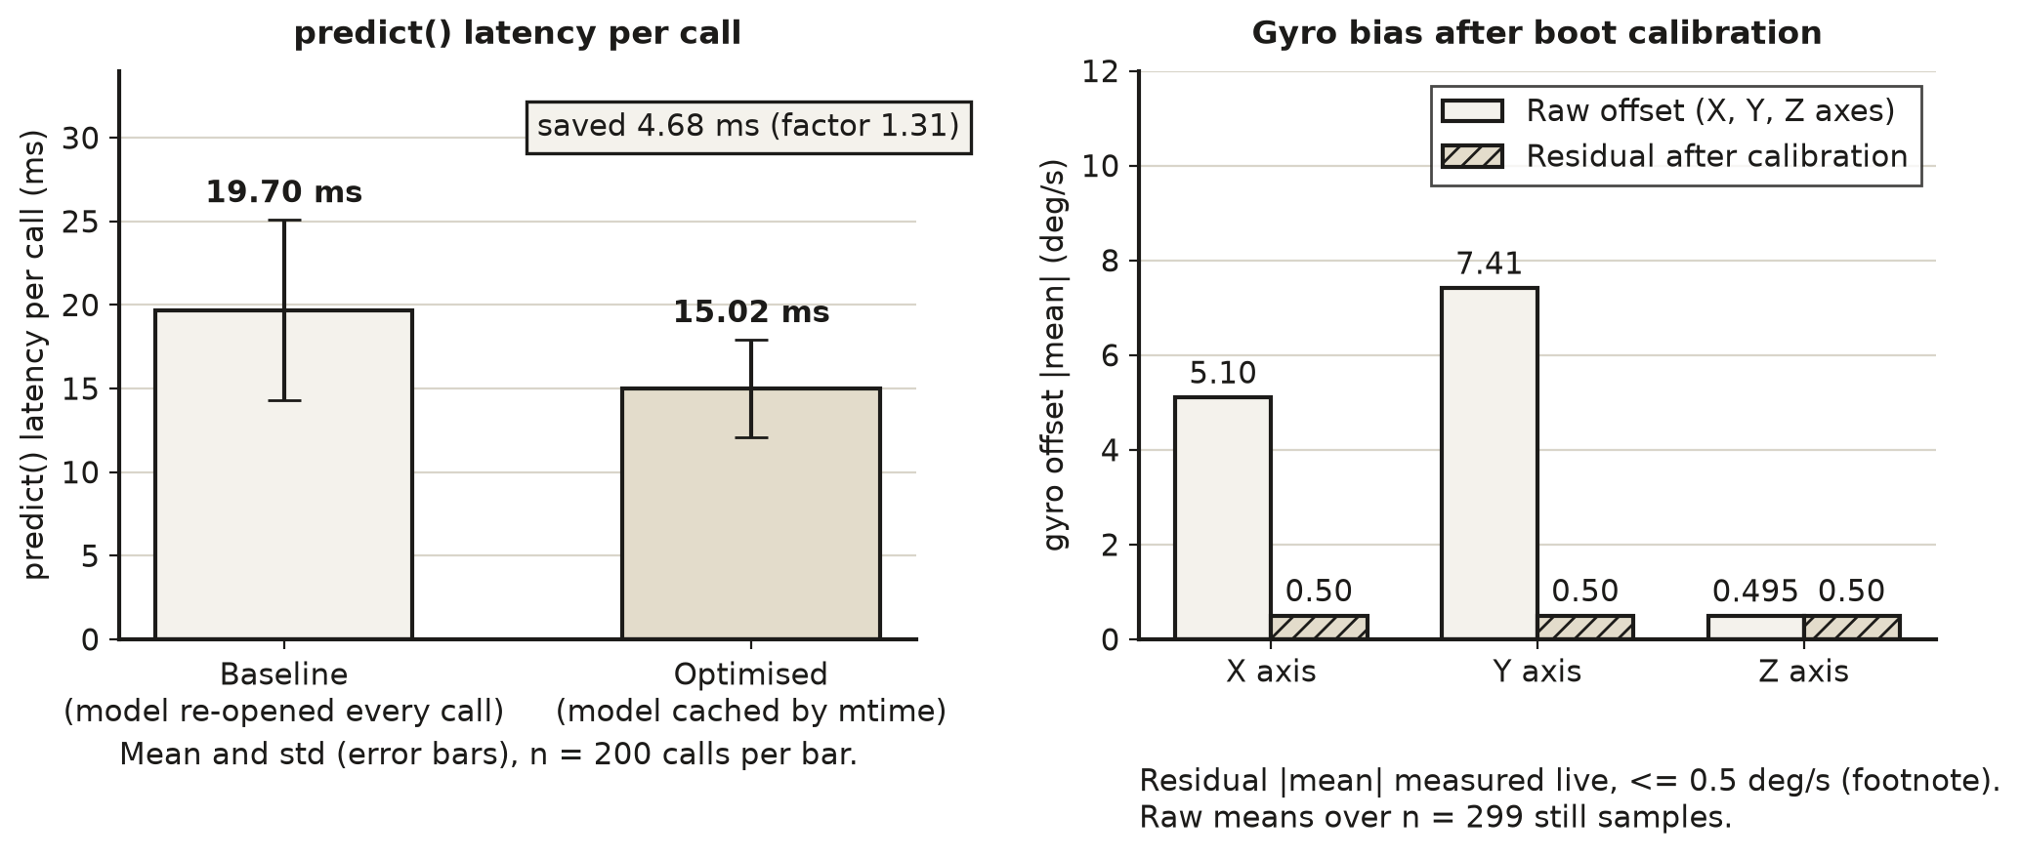
Figure 8 — Optimisation results: predict() latency before and after caching, and gyro offset before and after calibration.

Trade-off accepted: the cached model stays resident in memory (about 0.15–0.47 MB per model), and a model file replaced within the same timestamp tick would not be re-read. Processing every frame costs a few extra microseconds per frame and removes the 10 Hz sampling limit.

7 Test plan and measured results
Test ID | Requirement | Method and equipment | Expected | Measured (n, mean, spread) | Pass / fail
T1 | R-F1 | Count frames served by the backend over a fixed interval, board streaming over USB (host clock) | ≥ 50 frames/s | ≈ 50.5 frames/s (101 frames in 2 s, n = 1; the 60 s run still has to be repeated) | Pass (provisional)
T2 | R-F1 | pytest on the frame decoder: garbage between frames, split frames, trailing text, long lines (18 tests) | All pass; no bytes lost | 18 of 18 pass; the tests found and fixed 3 real bugs | Pass
T3 | R-F2 | pytest drives AirCursor with synthetic frames through all 9 palm × finger cells, plus zone, lock and chord cases (23 tests) | 9 of 9 cells give their own events | 23 of 23 pass, 9 of 9 cells; synthetic frames, not a real hand | Pass
T4 | R-F3 | Create the uinput device, drive it, and check it appears under /sys/class/input; events captured with a fake device in tests | Device created; each gesture emits its events | Device "Data Glove Air Mouse" created and removed cleanly; events as expected in T3. Live desktop run still to be demonstrated | Pass (device); demo pending
T5 (fault) | R-F4 | Hold the primary finger bent (left button down), then stop sending frames; time until the button-up event (n = 10) | ≤ 500 ms | 489.9 ms mean, std 4.0, max 495.9 (n = 10) | Pass (margin 4 ms on the worst run)
T6 | R-N1 | Push a 5-frame burst into the engine and time until the first cursor event is written (n = 60, development PC) | ≤ 20 ms | 6.3 ms mean, std 1.5, p99 10.3, max 10.3 (n = 60) | Pass
T7 | R-N2 | perf_counter around AirCursor.process() on a moving, bent-finger frame (n = 20 000) | ≤ 1 ms | 15.7 µs mean, std 13.9, p99 40.9, max 863 µs | Pass
T8 | R-N3 | Raw gyro over 299 still samples (5 min), offsets stored in firmware; residual observed on the live stream after calibration | ≤ 1 deg/s | Raw offsets −5.10 / 7.41 / −0.50 deg/s (std 0.18 / 0.22 / 0.15); residual about ±0.5 deg/s observed (single session) | Pass (informal residual)
T9 | R-N4 | arduino-cli compile of glove_full for esp32:esp32:esp32 | ≤ 50 % flash, ≤ 25 % RAM | Flash 305 324 B (23 %), RAM 23 644 B (7 %) | Pass
T10 | R-F5 | Train/test accuracy of the stored RandomForest models | ≥ 90 % on real recordings | Not met: the 248 stored recordings are synthetic (flex mean 501 counts); no real glove dataset was recorded | Fail (not tested on real data)

7.1 Timing measurements
Task | WCET (Review 2) | WCET measured | Jitter | Deadline met?
Firmware imuTask (I²C 14 B burst) | 0.42 ms (estimated) | not measured: no logic analyser | not measured | Not verified (estimate 0.4 ms of 20 ms)
Firmware flexTask (2 × 9 ADC reads) | 0.18 ms (estimated) | not measured | not measured | Not verified
Firmware frame pack + UART TX | 0.21 + 0.90 ms (estimated) | 4.17 ms on the wire (computed: 48 B × 10 bit ÷ 115 200) | not measured | Yes by computation (4.9 ms of 20 ms)
Host AirCursor.process() per sample | not in Review 2 | 15.7 µs mean, p99 40.9 µs | std 13.9 µs | Yes (0.08 % of 20 ms)
Host frame decode (FrameDecoder.feed) | < 0.5 ms (estimated) | 8.4 µs mean | std 12.5 µs | Yes
Host inference tick (extract_features + predict) | 15.3 ms (estimated) | 0.91 + 15.0 ms | std 2.9 ms | Yes (250 ms deadline)

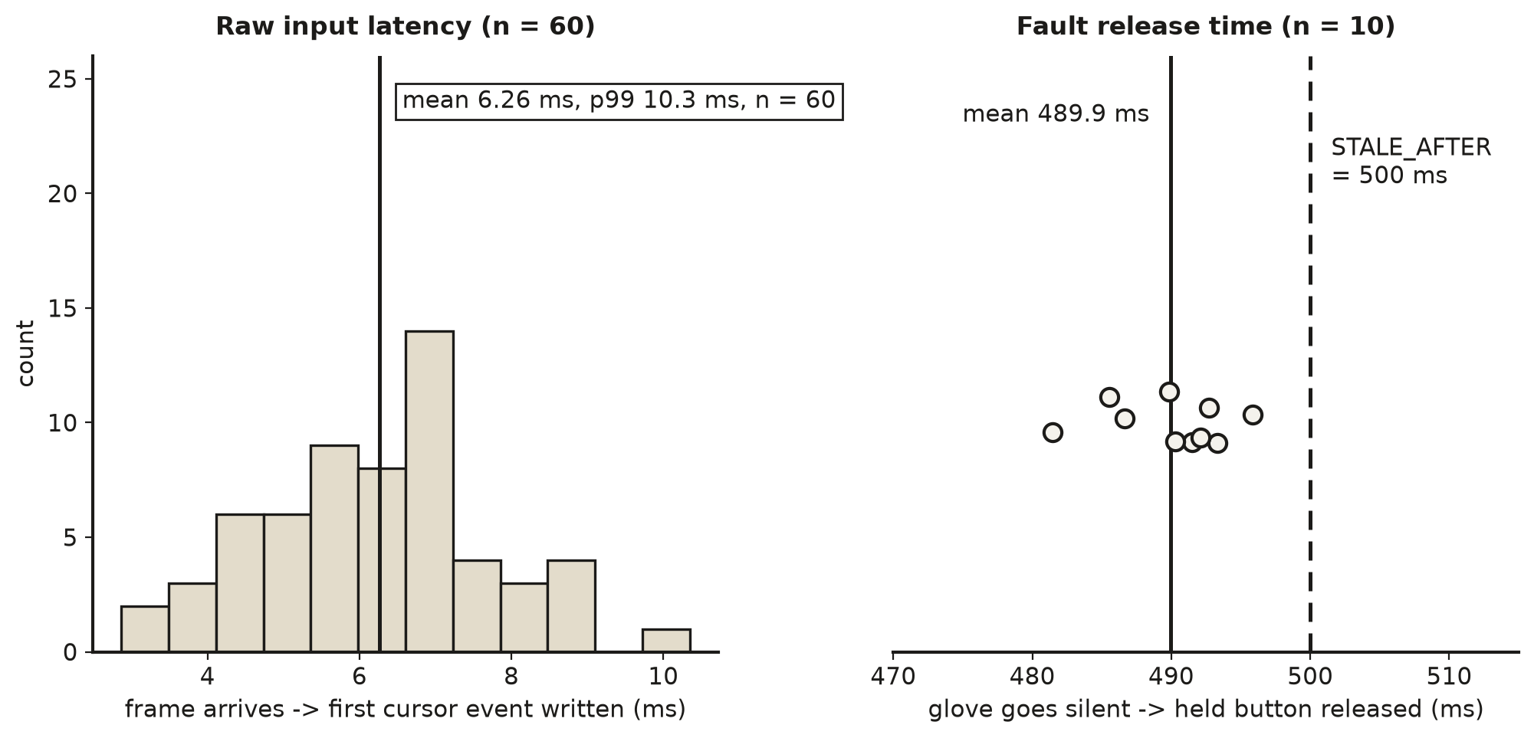
Figure 9 — Host-side timing: frame-to-cursor latency (left) and time to release a held button after the glove goes silent (right). No scope or logic-analyser capture was available for the firmware.

7.2 Discussion
Nine of the ten tests pass against their targets (T1 provisionally, T4 for the virtual device only) and one fails (T10). The software path is far inside its budget: processing a sample costs 16 µs and a frame reaches the cursor in 6 ms on average, against 1 ms and 20 ms targets. The safe-state test is the tightest: the glove-silent watchdog releases inputs after 0.5 s by design, so measured releases of 481–496 ms leave only 4 ms of margin to the 500 ms target; the timeout is a constant, so the margin is set by the sleep granularity of the 10 ms tick and would need a tighter bound if the target were lowered. Three things were not measured and are stated as such: firmware task WCET and jitter (no logic analyser), supply current (no meter in the loop; §3.3 is a datasheet estimate) and the frame rate over a long run. T10 fails: the recognition requirement R-F5 could not be verified because only synthetic recordings exist. The control path therefore uses the deterministic gesture grid, whose nine cells are verified by T3 on synthetic frames, and a live demonstration on the real glove is still required to close T4. The host numbers were taken on the development PC and move noticeably with load (repeated runs of the same script gave a process() mean between 13 and 16 µs and a frame-to-cursor mean between 4 and 6 ms), so means should be read together with the spreads shown. In Figure 4 the six node means add up to slightly more than the whole-call mean because each node was timed on its own, and every separate timing includes the cost of the timer call itself; the whole-call figure is the one used in the requirements.

8 Design-decision log
ID | Date | Decision | Alternatives rejected | Reason and evidence | Consequence
D1 | 2026-10-16 | Treat the IMU as an MPU-6500 (6-axis) and drop the magnetometer | Keep assuming an MPU-9250; try to enable the AK8963 | WHO_AM_I = 0x70 in 117 of 117 reads and no response at 0x0C; no register setting can add a sensor that is not on the die | No absolute heading; docs corrected (commit a3fec5c)
D2 | 2026-10-25 | Make the ESP-32 the only data source and remove the phone bridge | Keep Wi-Fi/UDP via a phone; Bluetooth | A bridge needed network setup and added a failure point; USB gives power and data on one cable (commit 874408a) | Simpler setup; one cable; port renumbering must be handled
D3 | 2026-10-25 | Add a 0xAA 0x55 sync header and extract framing into a pure, tested module | Fixed-size reads without sync | 18 unit tests caught 3 bugs: text before a marker lost, long lines dropped byte-by-byte, trailing text lost on flush | 2 extra bytes per frame (48 B)
D4 | 2026-10-16 | Keep gyro Z as a rate, drop yaw angle | Integrate gyro Z as a heading; use a compass | Integrated yaw drifts about 10° per minute and no magnetometer is available; dead-reckoned position drifts quadratically | Cursor driven by turn rate
D5 | 2026-10-26 | Drive the desktop cursor with relative rates, like a mouse | Absolute pointing from integrated yaw | Rates do not drift; absolute yaw would creep off target within seconds | User re-clutches by lowering the hand
D6 | 2026-10-25 | Single 50 Hz cooperative firmware loop, no RTOS | FreeRTOS task per sensor at 100 Hz | U ≈ 0.25 on one core; 100 Hz needs 42 % of the UART, 50 Hz needs 21 % | No preemption; one overrun resets the deadline
D7 | 2026-10-27 | Gesture grid: 3 palm zones × 3 finger states, zone locked per gesture | Roll-angle thresholds; per-gesture ML | Fixed roll thresholds assumed a mounting the glove does not have and misread the zones; nearest captured pose works on any mounting | Needs a 3-pose calibration
D8 | 2026-10-27 | Release all inputs when frames stop for 0.5 s | Rely on the OS or the user | A lost cable must not leave Super or a button held (T5) | A 0.5 s pause freezes input
D9 | 2026-10-27 | Cache the classifier model by file mtime | Reload every call; reload on a timer | Saves 4.7 ms per call (×1.31) and stays correct after retraining | A resident copy of the model

9 Bill of materials and cost
Item | Part number | Qty | Unit cost (₹) | Source | Total (₹)
ESP-32 DevKit (WiFi + Bluetooth, CP2102 USB-UART) | ESP32 board, CP2102 | 1 | 420 | Local shop, receipt 09-10-2026 | 420
MPU-6500 IMU breakout (I²C) | MPU-6500 | 1 | ≈ 500 | Purchased (approximate) | ≈ 500
Flex sensor | Resistive flex sensor | 2 | ≈ 300 | Purchased (approximate) | ≈ 600
Resistor, 10 kΩ (used ×2, one per divider) | 10 kΩ | 1 | 5 | Local shop, receipt 09-10-2026 | 5
Glove (carrier) | — | 1 | ≈ 300 | Purchased (approximate) | ≈ 300
Jumper wires, solder, USB micro-B cable | — | 1 set | — | Already owned | —
4-pin push button, pack of 3 (not used) | 5 mm | 1 | 10 | Local shop, receipt 09-10-2026; not used | 10
Breadboard, 400 tie points (not used) | — | 1 | 45 | Local shop, receipt 09-10-2026; not used | 45
TP4056 Li-ion charging module (not used) | TP4056 | 1 | 23 | Local shop, receipt 09-10-2026; not used | 23
3.7 V 800 mAh Li-Po battery (not used) | — | 1 | 250 | Local shop, receipt 09-10-2026; not used | 250
Total purchased |  |  |  | Receipt ₹753 + stated items | ≈ 2 153
Of which used in the final build |  |  |  | Items not marked “not used” | ≈ 1 825
The Li-Po battery, charger module, breadboard and push button were bought early in the project; the final design is powered from USB, wired without a breadboard and uses no extra button, so they are listed but not counted in the final build. The IMU, flex-sensor and glove prices are approximate, from memory of the purchase.

10 Individual contribution
Member | Module owned | Evidence (files, commits) | Report sections | Share %
Dayakrishn Joshi | ESP-32 firmware, IMU and flex acquisition, serial link, air-mouse engine, games | firmware/glove_full/, backend/app/aircursor.py, serial_manager.py, device/framing.py, frontend/src/ (git history of the repository) | §1–§7, §9, §11 | 50
Syed Mohammad Ayaan | System modelling (FSM, schedule), PC recognition pipeline | Review 2 §3, §5, §6, §7; evidence for the Final build to be added by the member | §4, §8, §10 | 50

11 Limitations and future work
Fell short or not done: (1) The MPU-6500 has no magnetometer, so there is no absolute heading; the cursor follows turn rate and the user re-clutches. (2) The classifier (R-F5) was never validated: only synthetic recordings exist, so no accuracy on real hand data can be claimed. (3) Firmware task timing, supply current and a long frame-rate run were not measured; §3.3 and the firmware rows of §7.1 are datasheet or computed estimates. (4) The build is dupont-wired without a breadboard or solder; loose joints caused a floating ADC input, an IMU that dropped off the bus and repeated USB over-current disconnects, and a reversed supply once overheated the IMU. (5) The air-mouse thresholds and angles were validated on synthetic frames and a virtual device; the live-hand demonstration is still to be completed. (6) Only Linux with Hyprland is supported. What I would change: solder every joint and add a strain relief; record a real gesture dataset; add a third flex channel; and fit a magnetometer for a drift-free heading. Next engineering step: measure firmware WCET with a GPIO toggle on a logic analyser, measure supply current, and rerun T1 over 60 s.

References
[1] Espressif Systems, “ESP32 Series Datasheet.”
[2] InvenSense, “MPU-6500 Product Specification,” rev. 1.3.
[3] InvenSense, “MPU-6500 Register Map and Descriptions,” rev. 2.1.
[4] Silicon Labs, “CP2102/9 Single-Chip USB to UART Bridge Data Sheet.”
[5] C. L. Liu and J. W. Layland, “Scheduling Algorithms for Multiprogramming in a Hard-Real-Time Environment,” J. ACM, vol. 20, no. 1, pp. 46–61, 1973.
[6] Linux kernel documentation, “Userspace I/O input: uinput,” kernel.org.
[7] G. Tarasov, “python-evdev,” https://python-evdev.readthedocs.io.
[8] F. Pedregosa et al., “Scikit-learn: Machine Learning in Python,” J. Mach. Learn. Res., vol. 12, pp. 2825–2830, 2011.
[9] S. Ramírez, “FastAPI,” https://fastapi.tiangolo.com.
[10] Hyprland, “Binds (mouse binds and dispatchers),” Hyprland Wiki.

Appendices

A Source code
Repository: https://github.com/dayaj1222/data-glove (branch main). Key files: firmware/glove_full/glove_full.ino; backend/app/aircursor.py, serial_manager.py, device/framing.py, routers/cursor.py, routers/training.py; frontend/src/components/AirMouseUI.js, SniperUI.js, PuzzleUI.js; frontend/src/lib/pointer.js; tests in backend/tests/ (41 tests).

B Raw data
docs/calibration/gyro_still.jsonl (299 still samples, raw gyro and accelerometer); docs/measurements/results.json (all host timing results, raw latency and release samples); docs/measurements/measure_host.py (script that produced them, run from backend/). Review 2 models and figures are in the separate Review 2 document.

Submission checklist
Item | ✓
15–20 pages excluding front matter and appendices; guidance blocks deleted | ✓
Every requirement has an ID, a measurable target and a test | ✓
At least two alternatives compared for each major decision | ✓
Models revised to match the build; changes since Review 2 listed | ✓
Traceability table from model elements to code | ✓
Optimisation with measured before and after | ✓
Repeated measurements with spread; one fault-injection test | ✓
Decision log, BOM and contribution table complete

