BACSE324 · Embedded Systems Architecture · Fall 2026 · Review 2

Design Models: CDFG, FSM and Task Schedule
Review 2 submission · due end of September · 6–10 pages excluding cover and appendices
Project title | Gesture-Controlled Smart Glove for Human–Computer Interaction
Scope tier (from review sheet) | Tier 2 — full embedded system
Submission date | September 2026
Repository link (optional) | github.com/dayaj1222/data-glove

Team
Member | Reg. no. | Module owned | Sections written
Dayakrishn Joshi | 25BCE2951 | ESP-32 firmware, MPU-6500 I²C + flex ADC acquisition | §1, §2, §4
Syed Mohammad Ayaan | 25BCE2311 | ESP-32 wireless link, PC recognition pipeline | §3, §5, §6, §7

1 System recap
The Smart Glove is a wearable input device that converts hand pose (two flex sensors) and hand motion (an MPU-6500 6-axis IMU) into standard keyboard and mouse events on a PC, for a single operator who wants hands-free control. The ESP-32 firmware samples both flex ADC channels and the IMU over I²C at a fixed rate and frames them into a fixed-width binary record: five 16-bit flex counts followed by nine 32-bit floats (accelerometer x, y, z, gyroscope x, y, z, magnetometer x, y, z; the magnetometer slots always read zero because the MPU-6500 has none) — a 46-byte datagram, parsed on the host by glove/protocol/simple.py::SimpleBinaryProtocol.parse using the <5H9f struct format.
Frames arrive over UDP (default port 5005) through glove/transport/udp.py::UDPTransport.recv, are pushed through glove/pipeline/main.py::Pipeline.run, classified, and dispatched to an action binding. On the PC a portable recognition layer classifies the gesture and an OS-specific layer injects it as input (uinput on Linux, SendInput on Windows). The host pipeline is transport- and recogniser-agnostic — Transport, Protocol, Recognizer and Action are all interfaces — so the same code runs against the mock transport used in unit tests and the live UDP link.
Deviations from the approved proposal. Two changes were made at the design stage: (i) the proposed MPU6050 was replaced by the MPU-6500 (6-axis accelerometer + gyroscope, I²C, WHO_AM_I = 0x70) for availability. The part has no magnetometer, so there is no absolute heading: pitch and roll come from the accelerometer, and yaw is available only as an integrated gyro rate; (ii) only two flex sensors are fitted rather than five, since flex sensors are the most expensive part and two (index + thumb) are sufficient to demonstrate distinct poses in a proof-of-concept. The wire format already carries five flex slots, so the two fitted sensors populate flex[0] and flex[1] and the remaining slots read zero; no host change is needed when the other three are added.
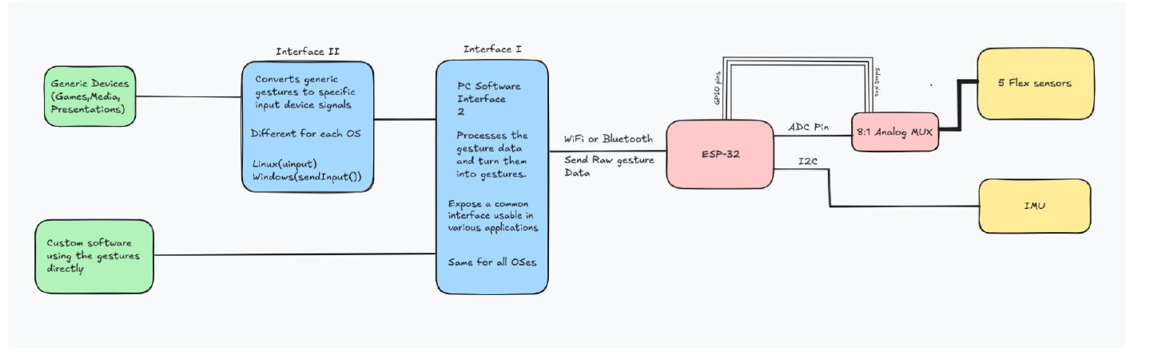
Figure 1 — System block diagram: glove sensors → ESP-32 → PC software stack → applications.

1.1 Conditions carried from proposal review
Condition / mandatory addition (from your review sheet) | Status | Where it is addressed
Justify the critical function against ≥3 candidates | Done | §2.1
Provide a CDFG with node costs and the critical path | Done | §2.2–2.4
Provide a system FSM with a fault and safe state | Done | §3
State the WCET source and a schedulability proof | Done | §4.1, §4.3

2 Control Data Flow Graph

2.1 Choosing the critical function
Function / ISR | Trigger | Rate | Est. execution time | Deadline | Chosen? Why / why not
Window inference (features + model.predict) | prediction timer | 4 Hz | ~15 ms | 250 ms | Chosen. Longest execution, most data dependencies, blocks action dispatch.
Frame poll (wireless RX) | poll | 30 Hz | ~2–5 ms | 33 ms | No — small, stateless.
Frame parse (SimpleBinaryProtocol) | per datagram | 30 Hz | <0.5 ms | 33 ms | No — trivial fixed cost.

Justification: Window inference in backend/app/routers/training.py::predict has the longest execution time, consumes the whole buffered window (most data dependencies), and blocks the action dispatch that follows it.

2.2 The CDFG
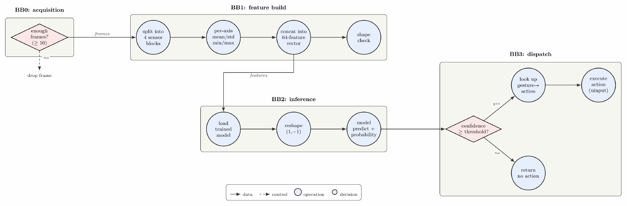
Figure 2 — CDFG of predict(). Circles = operations, diamonds = decisions, solid = data edges, dashed = control edges, grouped into basic blocks BB0–BB3.

2.3 Node table
Node | Operation | Inputs | Output | Est. cost (cycles / µs) | Source line or function
N1 | Check window ≥10 frames | frame buffer | drop | 200 | predict
N2 | Split into 4 sensor blocks | frames | blocks | 400 | extract_features
N3 | Per-axis mean/std/min/max | block | 4 stats/axis | 2500 | extract_features
N4 | Concat into 64 features | stats | vector | 300 | extract_features
N5 | Shape check vs model | features, model | ok / HTTP 400 | 100 | predict
N6 | Load pickled model | path | model | 1500 | predict
N7 | Reshape (1, −1) | features | 2-D array | 50 | predict
N8 | predict + predict_proba | features, model | id, conf | 8000 | predict
N9 | Confidence ≥ threshold? | conf, thr | bool | 50 | predict_and_act
N10 | Look up action binding | gesture id | record | 300 | predict_and_act
N11 | Execute action (uinput) | config | input event | 2000 | actions/*

All costs are estimated (Python-level, dev PC); none measured yet.

2.4 Critical path
Critical path (node sequence) | Total latency | Deadline | Slack
window → split → stats → concat → load → predict → conf → lookup → execute | ~15.3 ms | 250 ms | ~234.7 ms

What the CDFG tells us about the implementation: The model load (1.5 ms) is on the path every call because predict re-opens the .pkl. This dependency will be broken: the model is cached at startup in the Final build. Recomputing full-window statistics (2.5 ms) could be made incremental, but slack is ample, so it is deferred.

3 System-behaviour FSM

3.1 Model type
Model type: Mealy. Outputs depend on state and input — a recognised gesture emits an action only when confidence ≥ threshold. A Moore machine cannot express “act only if confident”.

3.2 State diagram
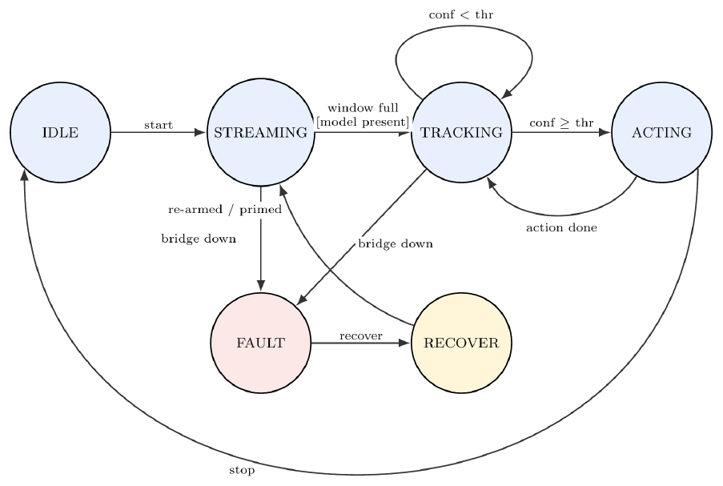
Figure 3 — System FSM. Every transition is labelled event [guard] / action.

3.3 State transition table
Current state | Event | Guard | Next state | Output / action
IDLE | start | sensors available | STREAMING | open transport, buffer
IDLE | start | sensors unavailable | FAULT | sensor-unavailable error
STREAMING | frame | buffer < window | STREAMING | append frame
STREAMING | window full | bridge up, model present | TRACKING | run inference
STREAMING | link lost | — | FAULT | glove-disconnected error
TRACKING | tick | confidence < threshold | TRACKING | none (display “—”)
TRACKING | tick | confidence ≥ threshold | ACTING | dispatch action
ACTING | action done | binding found | TRACKING | inject key/mouse event
ACTING | action done | no binding | TRACKING | none (logged)
FAULT | recover | link/sensor restored | RECOVER | re-arm, clear buffer
FAULT | stop | — | IDLE | close transport
RECOVER | re-armed | buffer primed | STREAMING | resume streaming

3.4 Fault, recovery and safe state
Safe state and outputs: FAULT outputs no keyboard or mouse events — no key held, no button pressed, no relative motion; every injected event ends with a release and syn(), so a stuck modifier (e.g. held super) can never lock the desktop. FAULT is reachable from every other state by the fatal-error / link-loss event. Recovery: recover → RECOVER, which clears the frame buffer (stale frames must never be inferred against) and returns to STREAMING only once primed. A watchdog transition (STREAMING/TRACKING → FAULT on link lost) prevents a dropped wireless link leaving the system silently half-running.

3.5 Completeness check
State ↓ / Event → | start | frame | window full / re-armed | bridge down / recover
IDLE | STREAMING | — | — | —
STREAMING | — | STREAMING | TRACKING | FAULT
TRACKING | — | — | — | FAULT
ACTING | — | — | — | FAULT
FAULT | — | — | — | RECOVER
RECOVER | — | — | STREAMING | FAULT

4 Task schedule

4.1 Task set
Task | Trigger | Period T | WCET C | Deadline D | Priority | U = C / T | WCET source
IMU sample (imuTask) | timer, core 0 | 10 ms | 0.42 ms | 10 ms | High | 0.042 | estimated (I²C @ 400 kHz)
Flex sample (flexTask) | timer, core 0 | 10 ms | 0.18 ms | 10 ms | High | 0.018 | estimated (ADC 12-bit)
Frame build (packetTask) | queue recv | 10 ms | 0.21 ms | 10 ms | Medium | 0.021 | estimated
Wireless TX (txTask) | frame ready | 10 ms | 0.90 ms | 10 ms | Medium | 0.090 | estimated (UDP sendto)
Host frame poll | timer | 33 ms | ~5 ms | 33 ms | High | 0.152 | estimated
Host inference tick | timer | 250 ms | 15.3 ms | 250 ms | Med | 0.061 | estimated
Watchdog (wdtTask) | timer | 3000 ms | 0.05 ms | 3000 ms | Low | 0.00002 | estimated

Total utilisation U = ≈ 0.17 on the ESP-32 (four firmware tasks) and ≈ 0.21 on the host (poll + inference + watchdog). All WCETs are estimated from the fixed peripheral costs (I²C transfer, ADC conversion, UDP sendto) until measured with a GPIO toggle and logic analyser.

4.2 Scheduling approach
Approach chosen: Task level: Rate-Monotonic (RMS). Operation level: ASAP list scheduling.
Why this approach and not the obvious alternative: The task set is small, fixed-rate and preemption-cheap, so RMS static priorities are simple and provable. EDF would allow higher utilisation but needs dynamic sorting and response-time checks; at U ≈ 0.21 it buys nothing. A cyclic executive adds jitter without benefit. ASAP gives the shortest schedule for a mostly-serial CDFG chain.

4.3 Schedulability analysis
RMS utilisation bound U ≤ n(2^{1/n} − 1), n = 3 (poll, inference, watchdog):
bound = 3(2^{1/3} − 1) = 0.7798, U = 5/33 + 15.3/250 + 1/3000 = 0.2130 ≤ 0.7798
On the ESP-32 the four firmware tasks run under FreeRTOS with rate-monotonic priorities (periods 10/10/10/3000 ms, U_fw = 0.171, well under the n = 4 bound of 0.757); each completes well inside its 10 ms frame because the samplers are pure blocking I²C/ADC reads with no dynamic allocation. Both task sets are schedulable by the utilisation bound. Worst-case response for the host inference task: R ≈ 15.3 + 5 (one poll interference) = 20.3 ms ≪ 250 ms (slack ≈ 229.7 ms), so no response-time analysis is required.
Operation level — ASAP control-step chain: window → split → stats → concat → load → predict → conf → lookup → execute; all nodes have zero mobility except the model load, removable by caching.

4.4 Timeline
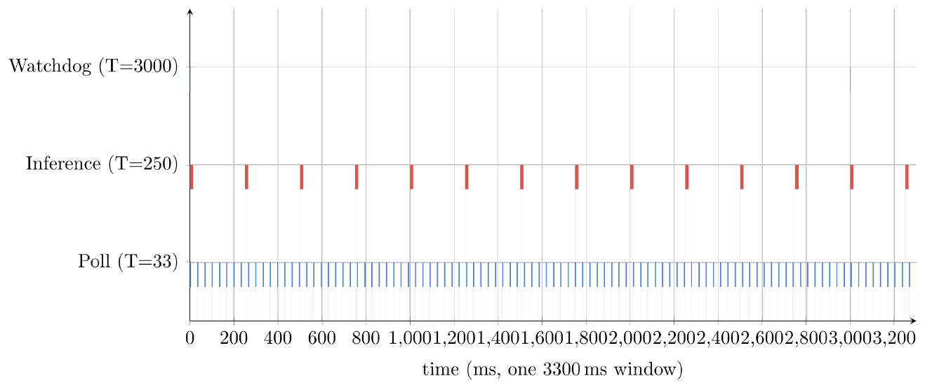
Figure 4 — Schedule over one hyperperiod (task level): poll @ 33 ms, inference @ 250 ms, watchdog @ 3000 ms; each inference bar sits well inside its frame.

4.5 Shared resources and interrupts
Shared resource | Used by | Protection | Worst-case blocking
SQLite glove.db | record / train / predict | session per request | one transaction; no ISR shares it
Frame buffer | poll (write), inference (read) | single-threaded | none observed
Model .pkl | inference, retrain | load-per-request | ~1.5 ms (removed by caching)
uinput device | action dispatch | one UInput/action; syn() | serialised by OS input layer
I²C bus | imuTask / flexTask | one bus mutex | one transaction
Wireless RX ring buffer | firmware txTask / host poll | single-producer ring | one buffer copy

5 Planned traceability
Model element (CDFG node, FSM state, task) | Planned file | Planned function | Owner
Window guard | PredictUI.js | runPrediction | DJ
Feature build | training.py | extract_features | DJ
Inference | training.py | predict | DJ
Dispatch | training.py | predict_and_act | DJ
Input injection | input/keyboard.py, mouse.py | tap / click | DJ
FSM states | stateMachine.js (new) | — | SA
Frame poll task | backend/app/bridge.py | get_latest_grouped | SA
Inference tick task | PredictUI.js | setInterval(…, 250) | DJ
Watchdog task (host) | frontend/src/components/RecordingUI.js | checkBridge | SA
IMU sampling task | firmware/src/imu.c | imuTask() | DJ
Flex ADC task | firmware/src/flex.c | flexTask() | DJ
Frame build task | firmware/src/packet.c | packetTask() | DJ
Wireless TX task | firmware/src/net.c | txTask() | SA
Watchdog task (firmware) | firmware/src/wdt.c | wdtTask() | SA

6 Plan to Final
Remaining work | Owner | Target date | Risk and fallback
Cache model in memory | DJ | early Oct | Low; fallback = load per request
Extract FSM module | SA | early Oct | Medium; fallback = FSM stays implicit
Integrate ESP-32 + MPU-6500 + flex on the glove | DJ | mid Oct | High (hardware); fallback = IMU-only
FreeRTOS task skeleton (imuTask/flexTask/txTask) | DJ | mid Oct | Medium; fallback = single super-loop
Measure firmware WCETs (GPIO toggle + logic analyser) | DJ | mid Oct | Medium; fallback = keep estimates
Fault-state unit tests | SA | late Oct | Low

7 Individual contribution
Member | Model / section produced | Module for Final | Share %
Dayakrishn Joshi | System recap, CDFG, task set | ESP-32 firmware + ADC acquisition | 50
Syed Mohammad Ayaan | System FSM, schedulability, traceability, plan | ESP-32 WiFi/UDP link + PC recognition pipeline | 50

References
[1] Espressif Systems, ESP32 Series Datasheet, 2024.
[2] InvenSense, MPU-6500 Six-Axis (Gyro + Accelerometer) MEMS MotionTracking Device Product Specification, rev. 1.3.
[3] InvenSense, MPU-6500 Register Map and Descriptions, rev. 2.1.
[4] C. L. Liu and J. W. Layland, “Scheduling Algorithms for Multiprogramming in a Hard-Real-Time Environment,” J. ACM, 20(1):46–61, 1973.

Submission checklist
Item | ✓
Guidance blocks deleted; 6–10 pages excluding cover and appendices | ✓
Critical function justified against at least three candidates | ✓
CDFG with node costs and the critical path stated | ✓
FSM with model type, transition table, fault and safe state | ✓
Task set with WCET source, chosen approach and schedule-ability proof | ✓
Every carried condition listed with its status | ✓
Every member named against a model they can explain | ✓

