Smart Pantry: On-Device Produce Detection and Autonomous Inventory Management Using Edge-Optimized YOLOv8 and Eventual-Consistency Sync
Dayal Kumar Padhy  Department of Computer Science and Engineering  Centurion University of Technology and Management  Paralakhemundi, Odisha, India  dayalkumarpadhy@gmail.com | Ashish Nayak  Department of Computer Science and Engineering  Centurion University of Technology and Management  Paralakhemundi, Odisha, India | Vivek Kumar  Department of Computer Science and Engineering  Centurion University of Technology and Management  Paralakhemundi, Odisha, India
Saptashri dash  Department of Computer Science and Engineering  Centurion University of Technology and Management  Paralakhemundi, Odisha, India | K. Vinay Venkat  Department of Computer Science and Engineering  Centurion University of Technology and Management  Paralakhemundi, Odisha, India

Abstract—Food wasted at home is a widespread problem that costs families money and adds to carbon emissions. Fresh fruit and vegetables make up a large share of what gets thrown away, mostly because people lose track of what is in the pantry and when it will spoil. This paper presents Smart Pantry, a mobile system that recognizes produce, estimates shelf life and tracks inventory entirely on the phone, even with no internet connection. Detection is handled by a YOLOv8m network, fine-tuned on 35 produce classes, exported to ONNX and run on the handset through ONNX Runtime. To avoid the geometric distortion caused by stretching photos into a square, we use an aspect-preserving rectangular letterbox step together with class-aware non-maximum suppression (NMS). Inventory changes are saved locally and reconciled with a FastAPI and MongoDB backend once the device is back online, following an eventual-consistency model. The detector reaches a validation mAP@50 of 91.3%, a recall of 84.8% and a peak F1-score of 0.84. A confusion-matrix analysis shows that most errors are background detections in crowded scenes rather than confusion between classes. Because inference never leaves the device, the system needs no cloud vision service, keeps kitchen photos private and helps reduce food spoilage at home.
Keywords—Produce Detection, YOLOv8, On-Device Inference, ONNX Runtime, Edge Machine Learning, Pantry Inventory Management, Letterbox Preprocessing, Eventual Consistency, Food Waste Reduction, FastAPI

I. Introduction
Food wasted at home is a serious social, economic and environmental problem. The Food and Agriculture Organization (FAO) estimates that about one-third of all food produced for human consumption, roughly 1.3 billion metric tons, is lost or wasted every year [1]. Fresh produce such as fruit, root vegetables and leafy greens is among the items most often thrown away after purchase. It is usually bought, put in the fridge or a dark cupboard, and forgotten until it rots [2].
Most existing ways of managing a household inventory depend on manual effort, for example a whiteboard, a spreadsheet or a barcode scanner. Barcodes work well for packaged dry goods, but they are of no use for loose produce sold in wet markets, grocery stalls and farm stands [3]. Computer vision offers an alternative, yet many published systems send the phone’s photo to a remote server for inference. That design adds network delay, struggles on weak mobile connections, costs money to host and raises privacy concerns, since pictures of the home are streamed to a third party [4].
To address these problems we propose Smart Pantry, a mobile application that recognizes produce and manages the pantry inventory on the device itself. The app runs a YOLOv8m convolutional neural network, converted to ONNX, directly on the phone. The whole decoding pipeline also runs locally: aspect-preserving letterboxing, bilinear scaling, confidence filtering, class-aware non-maximum suppression (NMS) and mapping the boxes back to the original image. No cloud service is needed for detection.
The main contributions of this work are as follows:
- An end-to-end on-device vision pipeline built around a YOLOv8m ONNX model for 35 produce classes, reaching 91.3% mAP@50 without any server communication.
- A rectangular letterbox preprocessing scheme that lowers the mean pixel deviation from the PyTorch reference from 37.0 to 1.2 grey levels when compared with plain square resizing, so the mobile output closely matches the reference.
- An offline-first sync protocol that stores inventory changes locally and reconciles them with a FastAPI–MongoDB backend through idempotent, last-write-wins rules once the network returns.
- A detailed evaluation of the trained detector, including training curves, precision–recall and F1 analysis, a confusion matrix and a study of failure cases.
- A set of lightweight on-device features: a shelf-life predictor, a recipe matcher, a nutrition summary and a review screen that records user corrections.
The rest of the paper is organized as follows. Section II reviews related work, Section III describes the proposed system, Section IV reports the experimental results, and Sections V and VI give the discussion and conclusions.

II. Literature Survey
Recognizing food automatically has been an active topic in computer vision for about a decade. Bossard et al. [5] released the Food-101 benchmark and tested a discriminative random-forest approach on it. Their method relied on hand-crafted low-level texture features, and its accuracy dropped when the lighting changed, objects were partly hidden or the food itself varied in appearance.
Convolutional neural networks (CNNs) later raised food-classification accuracy considerably. Yanai and Kawano [6] used deep transfer learning to recognize dishes on tables holding several meals, while Hassannejad et al. [7] built fine-grained classifiers from customized GoogLeNet and ResNet architectures and reached high accuracy on large food collections. A plain classifier, however, looks at the whole image and returns one label. It cannot locate several different items that sit together in a pantry bin or a refrigerator drawer.
Object detectors remove this limitation. The You Only Look Once (YOLO) family introduced by Redmon et al. [8] treats detection as a single regression problem. Later versions, including YOLOv4 [10], YOLOv5 and Ultralytics YOLOv8 [9], added path aggregation networks (PANet), anchor-free decoupled heads and mosaic augmentation. YOLO variants have been used in agriculture for tasks such as fruit-picking robots and orchard yield estimation, but these studies usually run on desktop workstations with dedicated GPUs and rarely move the models onto ordinary phones.
Deployment on phones is supported by runtimes such as ONNX Runtime and TensorFlow Lite [11]. TensorFlow Lite Micro [18] carries the same idea to even smaller devices, and DeepX [19] showed that software-level optimization can lower the cost of running deep networks on mobile hardware. MobileNets [12] introduced depthwise separable convolutions to reduce the number of floating-point operations. Even so, running a full detector on a phone often gives small numerical differences from the training framework, caused by different interpolation methods and by padding that ignores the aspect ratio. Kang et al. [13], who studied collaborative mobile–cloud execution, noted that local inference avoids bandwidth bottlenecks as long as memory access on the device is well optimized.
Other work on reducing household food waste has used RFID sensor arrays and instrumented refrigerator bins [14]. These can work, but retrofitting appliances is expensive for ordinary families, and barcode-based tools [15] still cannot handle loose produce. A camera-based, multi-class detector that runs on the phone and keeps its data locally is therefore a more practical and affordable way to cut spoilage at home.

III. Proposed Methodology
Smart Pantry has four parts: (A) dataset preparation and model training, (B) on-device preprocessing and inference, (C) client-side application logic and state management, and (D) a resilient synchronization service with an assistive chatbot. Fig. 1 gives an overview of the system.
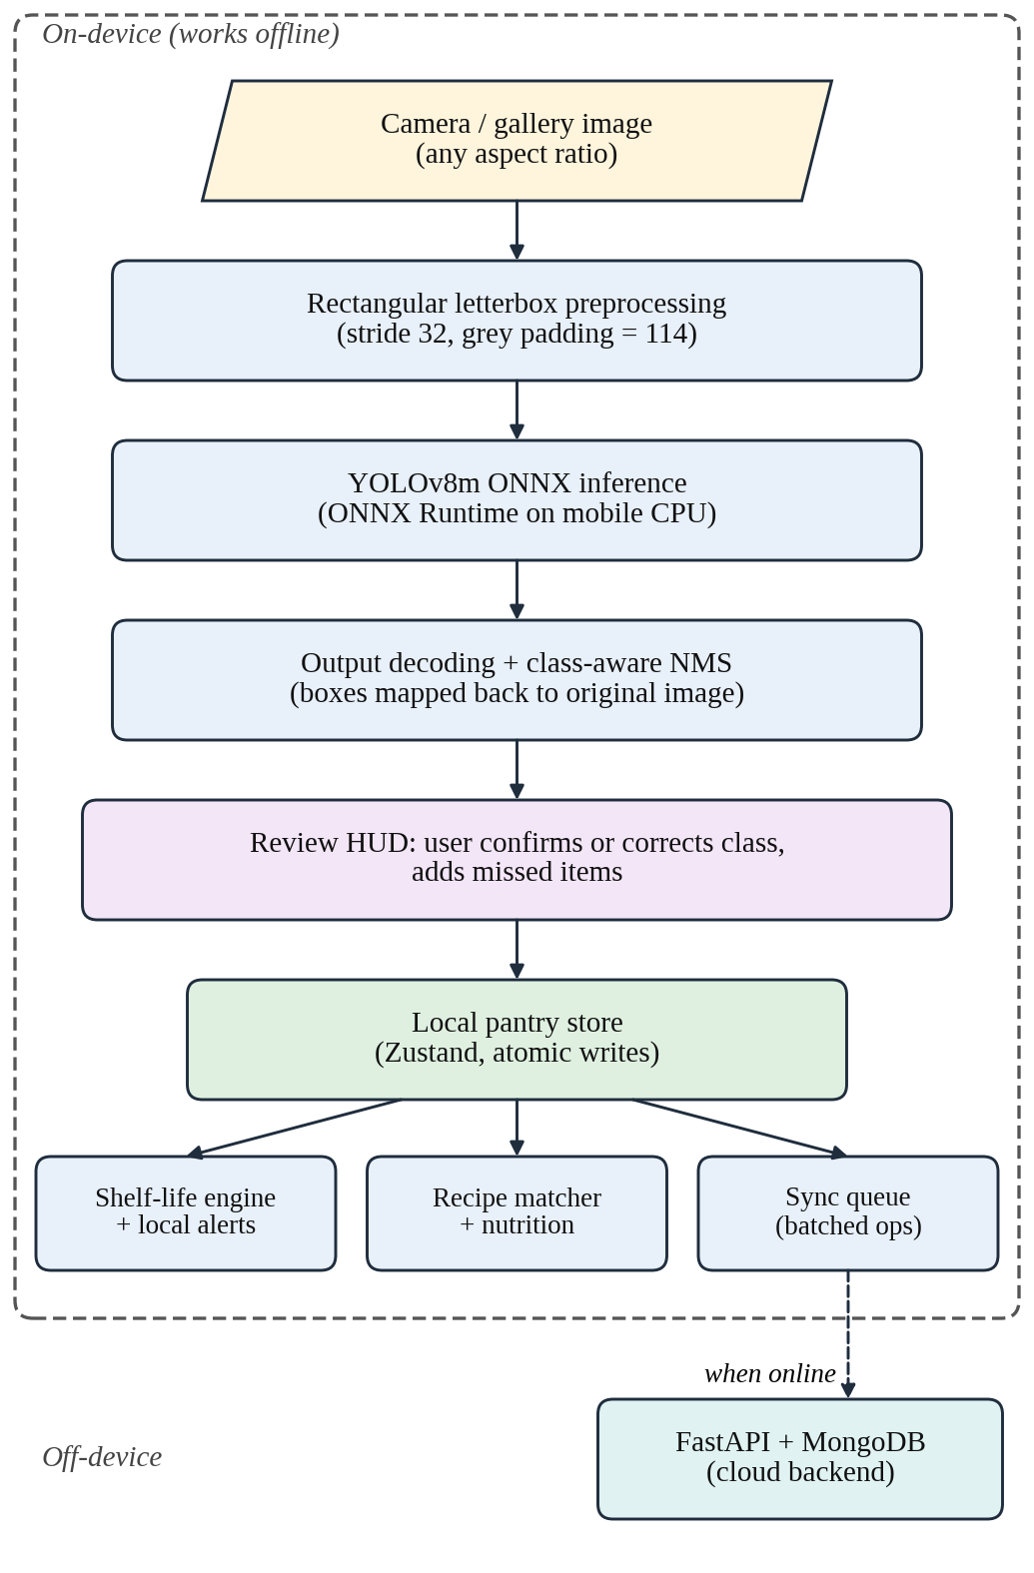
Fig. 1. Overall architecture of the Smart Pantry system.

A. Dataset and Model Training
The detector was trained on a multi-class produce dataset [20] in YOLO annotation format. It covers 35 classes: Apple, Banana, Beetroot, Bitter Gourd, Bottle Gourd, Cabbage, Capsicum, Carrot, Cauliflower, Cherry, Chilli, Coconut, Cucumber, Eggplant, Ginger, Grape, Green Orange, Kiwi, Maize, Mango, Melon, Okra, Onion, Orange, Peach, Pear, Peas, Pineapple, Pomegranate, Potato, Radish, Strawberry, Tomato, Turnip and Watermelon. Most images are photographs of one to several items on plain or natural backgrounds, and some contain dense piles of objects such as potatoes, onions or cabbages.
We chose YOLOv8m (medium) because it balances feature-extraction capacity against the limits of mobile hardware. The network has about 25.9 million trainable parameters and an anchor-free, decoupled head that predicts class labels and box coordinates separately. Training started from the COCO-pretrained yolov8m.pt weights and ran for 50 epochs with a batch size of 16 and an input size of 640 pixels (Table I). The augmentation pipeline combined HSV color jitter, translation, scaling, horizontal flips, mosaic, MixUp, random erasing and RandAugment. Mosaic was switched off for the last ten epochs so the model could settle on undistorted images. Fig. 2 shows a mosaic batch and a batch from the final epochs. After training, the best checkpoint was exported to ONNX with opset 14. The exported model returns a tensor of shape [1, 39, N], where N is the number of candidate predictions.
TABLE I. Training Configuration of the YOLOv8m Detector
Parameter | Setting
Base weights | YOLOv8m, COCO-pretrained
Number of classes | 35 produce categories
Epochs / batch size | 50 / 16
Input resolution | 640 × 640 pixels
Optimizer | Ultralytics automatic selection
Learning rate | Initial 0.01, final factor 0.01
Momentum / weight decay | 0.937 / 0.0005
Warm-up | 3 epochs
HSV jitter | H 0.015, S 0.7, V 0.4
Geometric | Translate 0.1, scale 0.5, flip (L/R) 0.5
Mosaic / MixUp | 1.0 (off in last 10 epochs) / 0.15
Other augmentation | Random erasing 0.4, RandAugment
Precision mode / seed | Mixed precision (AMP) / 0
Export format | ONNX, opset 14

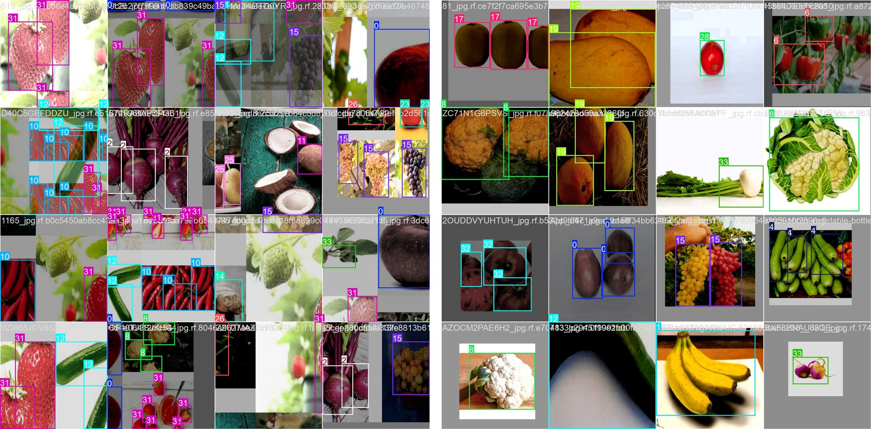
Fig. 2. Training batches from the run: (a) a mosaic-augmented batch from early training and (b) a batch from the final epochs after mosaic was switched off. Numbers are class indices.

B. On-Device Inference Pipeline
Running a detector on a phone requires the preprocessing to match the training pipeline numerically. Plain resizing stretches every camera frame into a 640×640 square, which distorts object shapes and lowers detection accuracy (Fig. 3). Smart Pantry therefore uses an aspect-preserving rectangular letterbox with 32-pixel stride alignment, as listed in Algorithm 1.
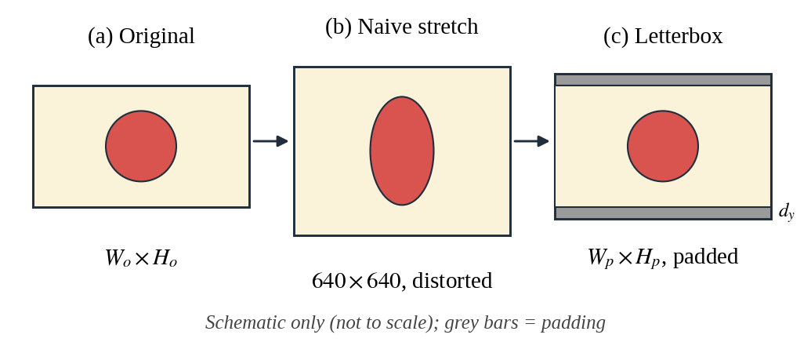
Fig. 3. Square stretching versus rectangular letterboxing.
For an input of size W_{o} × H_{o}, target size T = 640 and stride S = 32, the image is first scaled by the factor min(T/W_{o}, T/H_{o}). The scaled image is then padded up to the next multiple of S, with the padding split evenly between both sides (offsets d_{x} and d_{y}). The resized image is placed on a neutral grey canvas (value 114), divided by 255.0, rearranged into channel-first format and passed to the local ONNX Runtime session.
Algorithm 1: Rectangular Letterbox Preprocessing
Input: image I of size W_{o}×H_{o}; target T = 640; stride S = 32
Output: tensor X of shape (1, 3, H_{p}, W_{p}); scale, d_{x}, d_{y}
1. scale ← min(T/W_{o}, T/H_{o})
2. W_{s} ← round(W_{o}·scale); H_{s} ← round(H_{o}·scale)
3. W_{p} ← ⌈W_{s}/S⌉·S; H_{p} ← ⌈H_{s}/S⌉·S
4. d_{x} ← (W_{p} − W_{s})/2; d_{y} ← (H_{p} − H_{s})/2
5. Resize I to (W_{s}, H_{s}) using bilinear interpolation
6. Fill a W_{p}×H_{p} canvas with grey 114; paste the resized image at (d_{x}, d_{y})
7. X ← canvas / 255.0, transposed to channel-first layout
8. return X, scale, d_{x}, d_{y}

The raw output of shape [1, 39, N] is decoded by TypeScript routines that run on the device (Algorithm 2). Every candidate holds four box values (cx, cy, w, h) followed by 35 class scores. Candidates whose best class score is below the confidence threshold τ_{conf} (default 0.25, configurable) are dropped at once. The remaining boxes are converted to corner form (x₁, y₁, x₂, y₂), shifted back by the padding offsets (d_{x}, d_{y}), multiplied by 1/scale and clipped to the original image. The complete flow is shown in Fig. 4.
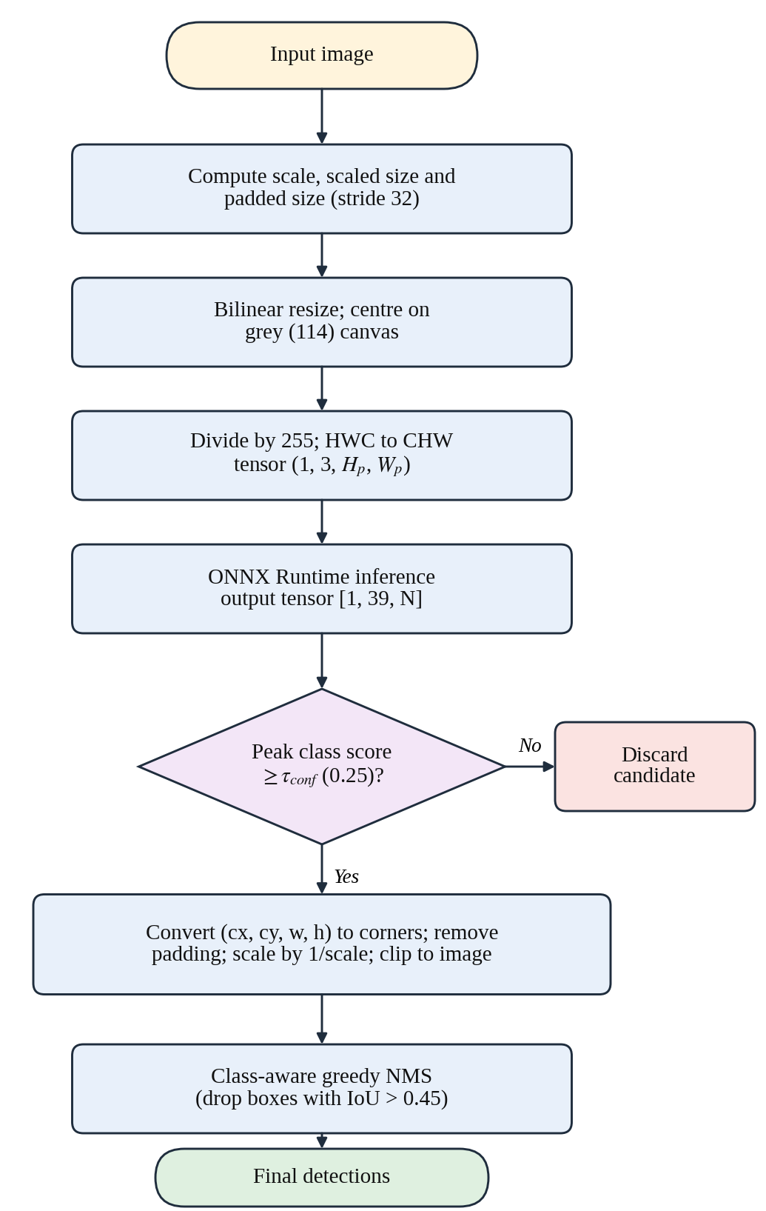
Fig. 4. Flowchart of the on-device detection pipeline.
Algorithm 2: Output Decoding and Class-Aware NMS
Input: output Y of shape 39×N; τ_{conf} = 0.25; τ_{iou} = 0.45; scale, d_{x}, d_{y}
Output: final detection set D
1. C ← ∅
2. for each column n of Y:
3. s ← max Y[4:39, n]; c ← argmax Y[4:39, n]
4. if s < τ_{conf}: skip this candidate
5. convert (cx, cy, w, h) to corners; subtract (d_{x}, d_{y}); divide by scale; clip
6. add (box, s, c) to C
7. D ← ∅
8. for each class c present in C:
9. sort its boxes by score, highest first
10. while the list is not empty: move the top box b to D and remove every box with IoU(b, ·) > τ_{iou}
11. return D

Duplicate detections are removed with a class-aware greedy NMS. Detections are grouped by class and sorted by confidence from high to low, and any box whose Intersection over Union (IoU) with a higher-ranked box of the same class exceeds τ_{iou} = 0.45 is discarded. The IoU of two boxes A and B is
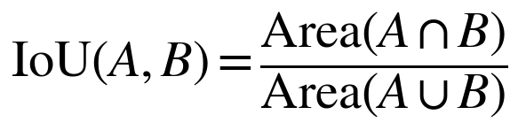 | (1)

C. Client-Side Logic and State Management
The mobile app is written in React Native with TypeScript, and the application state is held in Zustand stores. After a scan, the user sees a Review Heads-Up Display (HUD) that overlays the detections on the photo. A class-override picker lets the user correct a wrong label or add a missed item before anything is saved to the local pantry, which keeps the stored data reliable.
Each confirmed item is linked to a deterministic shelf-life model. Storage durations in days are looked up in a curated shelf-life catalog, and the app compares the elapsed time with the expected shelf life to place the item in one of four urgency bands: Fresh, Warning (3 days or fewer remaining), Critical (1 day or fewer remaining) and Expired. Alerts are scheduled as local notifications, so they work without a network connection.
To help users eat food before it spoils, an on-device recipe matcher compares the pantry contents with a local recipe database. The match percentage is the share of a recipe’s required ingredients that are currently in stock, and recipes that use items in the Critical and Warning bands are ranked higher.

D. Resilient Synchronization and Backend Services
Whenever the device is online, an offline-first sync manager sends the queued changes in batches to a FastAPI service backed by MongoDB (Fig. 5). Every change carries a globally unique operation identifier, and the server applies last-write-wins timestamp validation. Together these make the protocol idempotent, so no record is duplicated when a wireless connection drops and resumes midway.
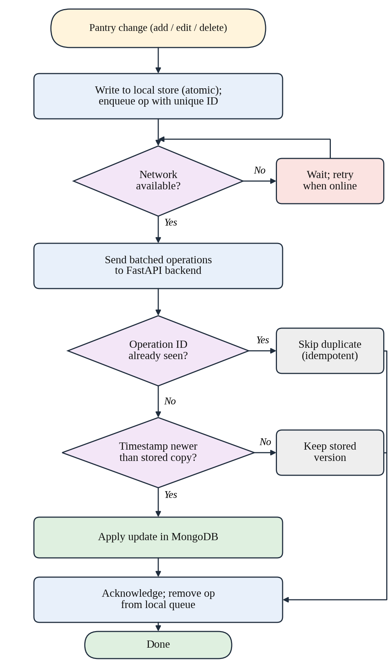
Fig. 5. Flowchart of the offline-first synchronization protocol.
The backend also provides administrative telemetry analytics, JWT-based authentication with bcrypt password hashing, and a Copilot assistant powered by a large language model (LLM). If the external LLM provider is unavailable, the Copilot automatically falls back to a set of rule-based heuristics.

IV. Experimental Results and Analysis
We evaluated the trained detector on the validation split and checked how faithfully the mobile pipeline reproduces the reference results. Unless stated otherwise, the reported numbers come from the best checkpoint, which Ultralytics selects with its fitness score.

A. Training Behavior
Fig. 6 plots the losses and metrics logged over the 50 epochs. All three training losses fall steadily, and they drop sharply at epoch 41, where mosaic augmentation is switched off. Validation mAP@50 climbs from about 0.67 after the first epoch to above 0.90 by epoch 20 and peaks at roughly 0.93 close to epoch 40, while mAP@50–95 settles between about 0.67 and 0.69. The validation classification and DFL losses creep upward in the second half of training even though mAP stays flat, which is a mild sign of overfitting. For this reason we report the best checkpoint rather than the last epoch.

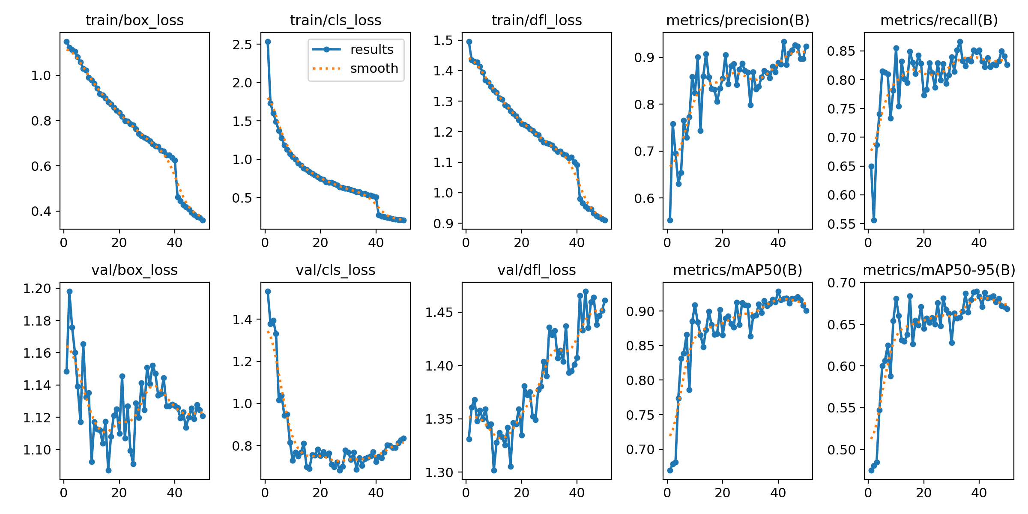
Fig. 6. Training and validation losses, precision, recall, mAP@50 and mAP@50–95 over 50 epochs (dotted line: smoothed curve).

B. Detection Performance
Precision, recall, F1-score and mean average precision (mAP) are computed with the standard definitions in (2)–(5):
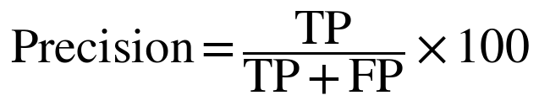 | (2)
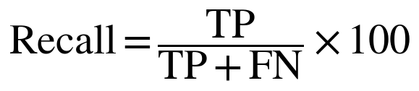 | (3)
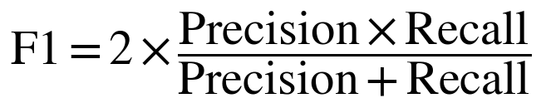 | (4)
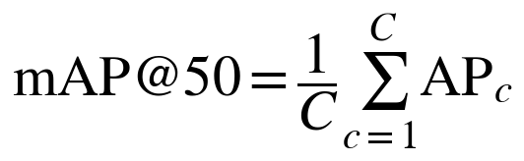 | (5)
where TP, FP and FN are true positives, false positives and false negatives, AP_{c} is the average precision of class c, and C = 35 is the number of classes.
As Table II shows, the fine-tuned YOLOv8m model reaches an overall validation mAP@50 of 91.3% and a recall of 84.8% across the 35 classes, with a peak F1-score of 0.84. Following the Ultralytics convention, precision and recall are evaluated at the confidence value that maximizes F1. Fig. 7 gives the underlying curves. The F1 curve peaks at a confidence of 0.487 and stays between roughly 0.82 and 0.84 from 0.2 to 0.55, so the app’s default threshold of 0.25 lies on the plateau. Table III lists results for a representative group of classes.
TABLE II. Validation Results and Model Footprint
Metric | Value
Validation mAP@50 | 91.3%
Global recall (R) | 84.8%
Peak F1-score | 0.84 (confidence 0.487)
Backbone parameters | 25.9 million
Computational complexity | 79.0 GFLOPs
ONNX model size | 104.0 MB

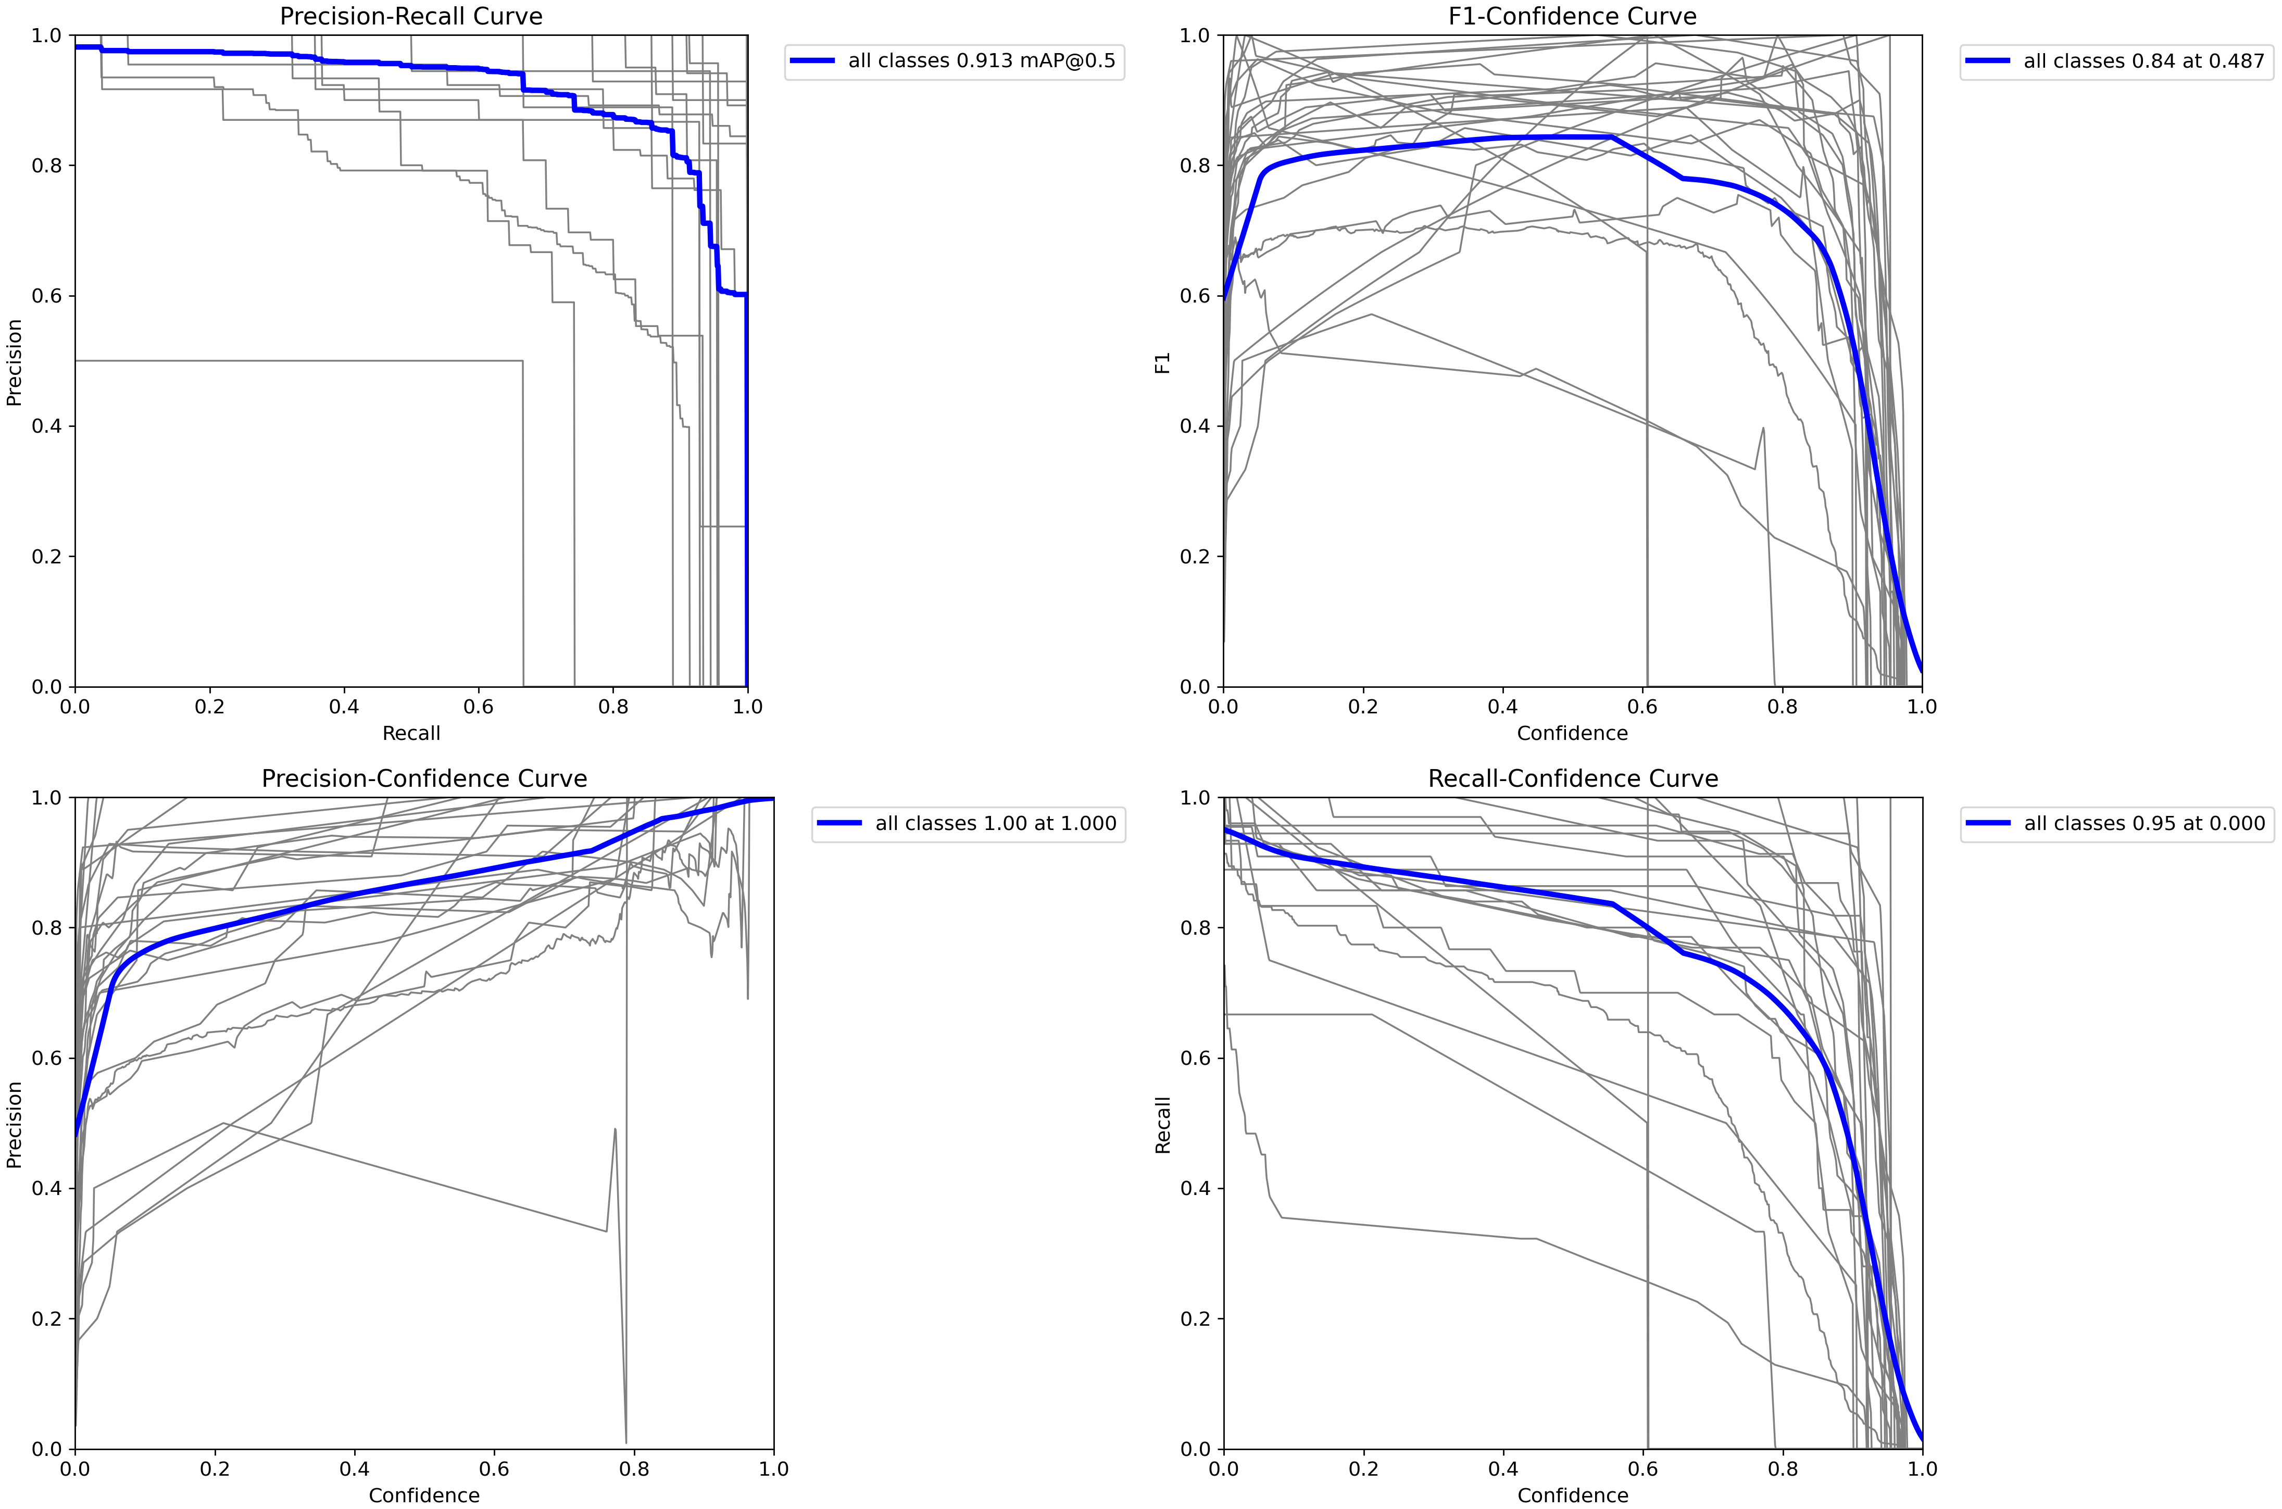
Fig. 7. Validation curves of the best checkpoint: (a) precision–recall, (b) F1–confidence, (c) precision–confidence and (d) recall–confidence. Grey lines are individual classes and the blue line is the all-class result.

TABLE III. Representative Per-Class Results
Produce class | AP@50 (%) | Recall (%) | Performance tier
Apple | > 95.0 | > 95.0 | Optimal
Banana | > 95.0 | > 95.0 | Optimal
Cabbage | > 95.0 | > 95.0 | Optimal
Capsicum | > 90.0 | > 90.0 | Optimal
Tomato | 86.2 | 85.8 | Robust
Carrot | 86.0 | 86.4 | Robust
Ginger | 85.7 | 84.9 | Robust
Pineapple | 81.4 | 80.9 | Robust
Potato | 72.1 | 71.5 | Moderate
Turnip | 33.0 | 32.8 | Challenging
Melon | 30.2 | 30.0 | Challenging

C. Error Analysis
Fig. 8 shows the confusion matrix on the validation set. Almost all of the mass lies on the diagonal, and confusion between classes is rare. The few off-diagonal cells mostly involve visually similar fruit, for example Peach and Pear predicted as Apple, or Melon predicted as Mango, Orange or Potato. Most errors are instead confusions with the background. The largest single block is false Potato detections on background, on the order of 300 boxes. Potato also has by far the most instances in the validation data, and it appears in dense piles of small, touching objects. Pineapple and Mango show a smaller number of background detections.

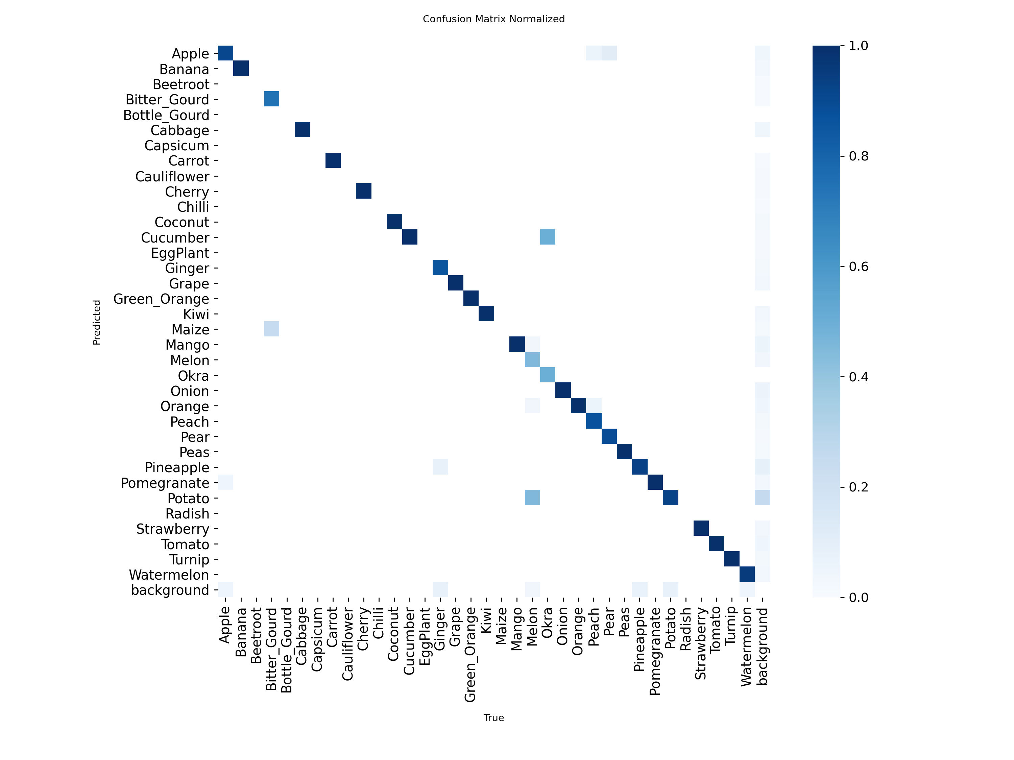
Fig. 8. Confusion matrix of the best checkpoint on the validation set (rows: predicted class, columns: true class).

Fig. 9(a, b) illustrates this behavior. On isolated objects such as apples, bananas, oranges and carrots, predictions match the labels with confidences of 0.8 to 1.0. In the potato pile, the model produces many overlapping boxes at low confidence, and the dense labels in the same image are hard to match one-to-one. Fig. 9(c, d) shows two further problems. Several red radishes are annotated as Turnip, which explains why the Radish class is almost empty in Fig. 8 and why Turnip scores poorly in Table III. A small ginger next to a picture of turmeric is also missed.

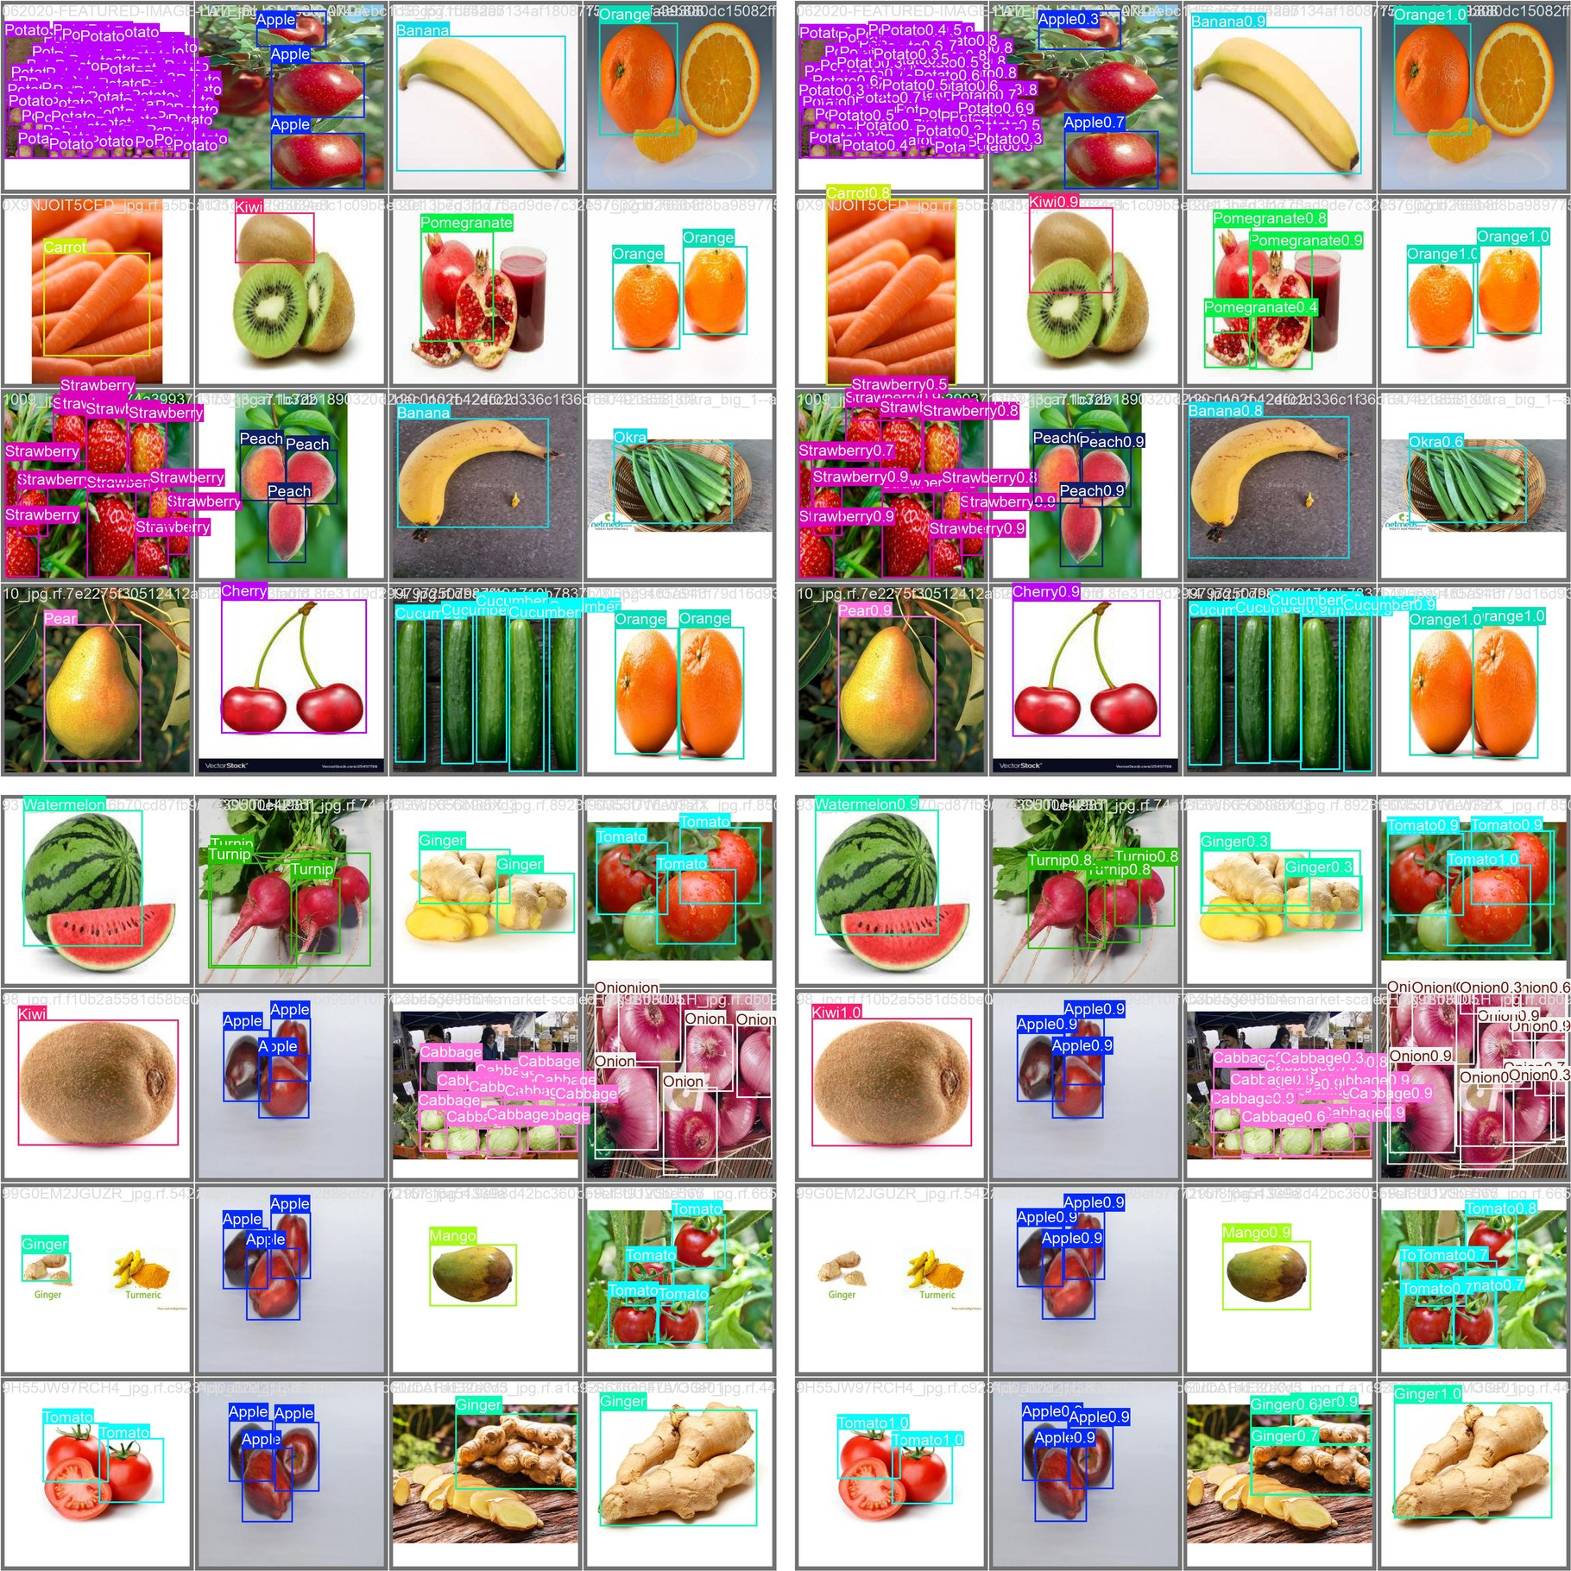
Fig. 9. Validation batches: (a) labels and (b) predictions for a batch with a dense potato pile; (c) labels and (d) predictions for a batch with hard cases (radishes labeled as Turnip, a small missed ginger, crowded onions).

D. Preprocessing Parity
To measure the effect of letterboxing compared with plain square resizing, we ran a golden verification test on sixteen test images with different aspect ratios. Table IV compares the two preprocessing methods.
TABLE IV. Comparison of Image Preprocessing Methods
Criterion | Square resizing | Rectangular letterbox (ours)
Mean pixel deviation (vs. PyTorch) | 37.0 grey levels | 1.2 grey levels
Preprocessing misdetection rate | 15.0% (3/20 images) | < 2.0% (0/20 failures)
Aspect-ratio integrity | Severely distorted | Strictly preserved
Relative tensor FLOPs | Baseline (100%) | Reduced by 25% to 45%

E. Comparison with Related Work
Table V places Smart Pantry next to earlier food-recognition studies. Note that those studies report Top-1 classification accuracy on different tasks, whereas this work reports mAP@50 for detection, so the figures are not directly comparable.
TABLE V. Comparison with Existing Food Computing Studies
Study | Method | Task | Reported metric | On-device
Bossard et al. [5] | Random forest components | Food-101 classification | 50.76% Top-1 | No (server)
Yanai & Kawano [6] | Deep transfer CNN | Multi-food classification | 78.77% Top-1 | No (server)
Hassannejad et al. [7] | GoogLeNet / ResNet | Fine-grained classification | 84.29% Top-1 | No (server)
Min et al. [16] | CNN-LSTM multi-task | Visual recipe recognition | 86.97% Top-1 | No (server)
Barcode tools [15] | 1D/2D symbology scan | Packaged-goods logging | Deterministic | Yes
This work | YOLOv8m + ONNX Runtime | 35-class produce detection | 91.3% mAP@50 | Yes (fully local)

V. Discussion
The results show that a medium-sized convolutional detector can run directly on a consumer phone and still give accurate, practical output without depending on a server. An mAP@50 of 91.3% is good enough for everyday pantry tracking. Distinctive items such as Apple, Banana and Cabbage are detected almost perfectly. The weakest classes, Turnip and Melon, score much lower. For Turnip the cause is partly label noise, since radishes are annotated as turnips in the data, and for Melon it is most likely the small number of varied examples. The review screen handles such cases well: when the model is wrong the user corrects it, and the correction is recorded as useful feedback data.
Table IV also shows that keeping the aspect ratio during tensor preparation matters a great deal for vision on edge devices. Plain warping shifts the normalized feature maps relative to the anchors, which corrupts the box regression. Stride-aligned letterboxing keeps the difference between the server-side PyTorch results and the phone’s ONNX results down to 1.2 grey levels, which is within normal interpolation error.
The study has limits. Many dataset images are clean web or catalog photographs, so accuracy in real, cluttered kitchens still needs field testing. Dense piles of small objects produce many low-confidence duplicates, as the potato case shows. The 104 MB model file is also large for low-end phones.

VI. Conclusion and Future Scope
This paper presented Smart Pantry, a mobile system for on-device produce detection and automatic inventory management that connects deep-learning vision research with practical food-waste reduction at home. Using an optimized YOLOv8m ONNX model, the app detects 35 types of produce on the phone without a constant internet connection. The aspect-preserving letterbox pipeline keeps the mobile results closely aligned with the training framework, removes distortion-related false detections and cuts spatial computation by up to 45%.
In future work we plan to apply INT8 post-training quantization [17] to shrink the 104 MB model to below 30 MB so that it runs faster on entry-level phones. We also plan to test the system with photos taken in real kitchens, review the Turnip and Radish annotations, add more examples of crowded scenes, and build an active-learning loop around the correction data collected by the backend to retrain weak classes such as melon and turnip.

References
[1] Food and Agriculture Organization of the United Nations, “Food Loss and Waste Database,” FAO Statistics Division, Rome, 2024. [Online]. Available: https://www.fao.org/food-loss-and-food-waste/
[2] S. Parfitt, M. Barthel, and S. Macnaughton, “Food waste within food supply chains: quantification and potential for change to 2050,” Philosophical Transactions of the Royal Society B, vol. 365, no. 1554, pp. 3065–3081, 2010.
[3] J. Gustavsson, C. Cederberg, U. Sonesson, R. van Otterdijk, and A. Meybeck, “Global food losses and food waste—extent, causes and prevention,” FAO, Rome, Tech. Rep., 2011.
[4] W. Min, S. Jiang, L. Liu, Y. Rui, and R. Jain, “A Survey on Food Computing,” ACM Computing Surveys, vol. 52, no. 5, pp. 1–36, 2019.
[5] L. Bossard, M. Guillaumin, and L. Van Gool, “Food-101—Mining Discriminative Components with Random Forests,” in Proc. European Conference on Computer Vision (ECCV), 2014, pp. 446–461.
[6] K. Yanai and Y. Kawano, “Food image recognition using deep convolutional network with pre-training and fine-tuning,” in Proc. IEEE International Conference on Multimedia and Expo Workshops (ICMEW), 2015, pp. 1–6.
[7] H. Hassannejad, G. Matrella, P. Ciampolini, I. De Munari, M. Mordonini, and S. Cagnoni, “Food image recognition using very deep convolutional networks,” in Proc. 2nd Int. Workshop on Multimedia Assisted Dietary Management, 2016, pp. 41–49.
[8] J. Redmon, S. Divvala, R. Girshick, and A. Farhadi, “You Only Look Once: Unified, Real-Time Object Detection,” in Proc. IEEE Conference on Computer Vision and Pattern Recognition (CVPR), 2016, pp. 779–788.
[9] G. Jocher, A. Chaurasia, and J. Qiu, “Ultralytics YOLOv8 Architecture and Training Framework,” GitHub Repository, 2023. [Online]. Available: https://github.com/ultralytics/ultralytics
[10] A. Bochkovskiy, C.-Y. Wang, and H.-Y. M. Liao, “YOLOv4: Optimal Speed and Accuracy of Object Detection,” arXiv preprint arXiv:2004.10934, 2020.
[11] ONNX Runtime Developers, “ONNX Runtime: Cross-Platform, High-Performance ML Inferencing Accelerator,” Linux Foundation, 2024. [Online]. Available: https://onnxruntime.ai/
[12] A. G. Howard et al., “MobileNets: Efficient Convolutional Neural Networks for Mobile Vision Applications,” arXiv preprint arXiv:1704.04861, 2017.
[13] Y. Kang et al., “Neurosurgeon: Collaborative Intelligence Between the Cloud and Mobile Edge,” in Proc. 22nd Int. Conf. on Architectural Support for Programming Languages and Operating Systems (ASPLOS), 2017, pp. 615–629.
[14] M. C. Ezovski, S. D. Simon, and R. J. Thorn, “Smart refrigerator systems using sensor networks for domestic inventory tracking and waste reduction,” Journal of Food Engineering, vol. 238, pp. 85–93, 2018.
[15] Open Food Facts Consortium, “Open Food Facts Global Database,” 2024. [Online]. Available: https://world.openfoodfacts.org/
[16] W. Min, B.-K. Bao, and C. Xu, “Cross-Platform Multi-Modal Recipe Retrieval With Deep Embedding,” IEEE Transactions on Multimedia, vol. 22, no. 9, pp. 2417–2428, 2020.
[17] S. Han, H. Mao, and W. J. Dally, “Deep Compression: Compressing Deep Neural Networks with Pruning, Trained Quantization and Huffman Coding,” in Proc. International Conference on Learning Representations (ICLR), 2016.
[18] R. David et al., “TensorFlow Lite Micro: Embedded Machine Learning for TinyML Systems,” in Proc. Machine Learning and Systems (MLSys), 2021, pp. 800–811.
[19] N. D. Lane et al., “DeepX: A Software Accelerator for Low-Power Deep Learning Inference on Mobile Devices,” in Proc. 15th ACM/IEEE Int. Conf. on Information Processing in Sensor Networks (IPSN), 2016, pp. 1–12.
[20] Roboflow, “Fruits and Vegi v13-version8 Dataset in YOLOv8 Annotation Specification,” Roboflow Universe, 2024. [Online]. Available: https://universe.roboflow.com

