Smart Pantry: On-Device Produce Detection and Autonomous Inventory Management Using Edge-Optimized YOLOv8 and Eventual-Consistency Sync
Dayal Kumar Padhy  Department of Computer Science and Engineering  Centurion University of Technology and Management  Paralakhemundi, Odisha, India  dayalkumarpadhy@gmail.com | Research Collaborator  Department of Computer Science and Engineering  Centurion University of Technology and Management  Paralakhemundi, Odisha, India  collaborator@cutm.ac.in

Abstract—Food wasted at home is a widespread problem that costs families money and adds to carbon emissions. Fresh fruit and vegetables make up a large share of what gets thrown away, mostly because people lose track of what is in the pantry and when it will spoil. This paper presents Smart Pantry, a mobile system that recognizes produce, estimates shelf life and tracks inventory entirely on the phone, even with no internet connection. Detection is handled by a custom-trained YOLOv8m network that is exported to ONNX and run on the handset through ONNX Runtime. To avoid the geometric distortion caused by stretching photos into a square, we use an aspect-preserving rectangular letterbox step together with class-aware non-maximum suppression (NMS). Inventory changes are saved locally and reconciled with a FastAPI and MongoDB backend once the device is back online, following an eventual-consistency model. The 35-class detector reaches a validation mAP@50 of 91.3% and a recall of 84.8%. Because inference never leaves the device, the system needs no cloud vision service, keeps kitchen photos private and helps reduce food spoilage at home.
Keywords—Produce Detection, YOLOv8, On-Device Inference, ONNX Runtime, Edge Machine Learning, Pantry Inventory Management, Letterbox Preprocessing, Eventual Consistency, Food Waste Reduction, FastAPI

I. Introduction
Food wasted at home is a serious social, economic and environmental problem. The Food and Agriculture Organization (FAO) estimates that about one-third of all food produced for human consumption, roughly 1.3 billion metric tons, is lost or wasted every year [1]. Fresh produce such as fruit, root vegetables and leafy greens is among the items most often thrown away after purchase. It is usually bought, put in the fridge or a dark cupboard, and forgotten until it rots [2].
Most existing ways of managing a household inventory depend on manual effort, for example a whiteboard, a spreadsheet or a barcode scanner. Barcodes work well for packaged dry goods, but they are of no use for loose produce sold in wet markets, grocery stalls and farm stands [3]. Computer vision offers an alternative, yet many published systems send the phone’s photo to a remote server for inference. That design adds network delay, struggles on weak mobile connections, costs money to host and raises privacy concerns, since pictures of the home are streamed to a third party [4].
To address these problems we propose Smart Pantry, a mobile application that recognizes produce and manages the pantry inventory on the device itself. The app runs a YOLOv8m convolutional neural network, converted to ONNX, directly on the phone. The whole decoding pipeline also runs locally: aspect-preserving letterboxing, bilinear scaling, confidence filtering, class-aware non-maximum suppression (NMS) and mapping the boxes back to the original image. No cloud service is needed for detection.
The main contributions of this work are as follows:
- An end-to-end on-device vision pipeline built around a YOLOv8m ONNX model for 35 produce classes, reaching 91.3% mAP@50 without any server communication.
- A rectangular letterbox preprocessing scheme that lowers the mean pixel deviation from the PyTorch reference from 37.0 to 1.2 grey levels when compared with plain square resizing, so the mobile output closely matches the reference.
- An offline-first sync protocol that stores inventory changes locally and reconciles them with a FastAPI–MongoDB backend through idempotent, last-write-wins rules once the network returns.
- A set of lightweight on-device features: a shelf-life predictor, a recipe matcher, a nutrition summary and a review screen that records user corrections.
The rest of the paper is organized as follows. Section II reviews related work, Section III describes the proposed system, Section IV reports the experimental results, and Sections V and VI give the discussion and conclusions.

II. Literature Survey
Recognizing food automatically has been an active topic in computer vision for about a decade. Bossard et al. [5] released the Food-101 benchmark and tested a discriminative random-forest approach on it. Their method relied on hand-crafted low-level texture features, and its accuracy dropped when the lighting changed, objects were partly hidden or the food itself varied in appearance.
Convolutional neural networks (CNNs) later raised food-classification accuracy considerably. Yanai and Kawano [6] used deep transfer learning to recognize dishes on tables holding several meals, while Hassannejad et al. [7] built fine-grained classifiers from customized GoogLeNet and ResNet architectures and reached high accuracy on large food collections. A plain classifier, however, looks at the whole image and returns one label. It cannot locate several different items that sit together in a pantry bin or a refrigerator drawer.
Object detectors remove this limitation. The You Only Look Once (YOLO) family introduced by Redmon et al. [8] treats detection as a single regression problem. Later versions, including YOLOv4 [10], YOLOv5 and Ultralytics YOLOv8 [9], added path aggregation networks (PANet), anchor-free decoupled heads and mosaic augmentation. YOLO variants have been used in agriculture for tasks such as fruit-picking robots and orchard yield estimation, but these studies usually run on desktop workstations with dedicated GPUs and rarely move the models onto ordinary phones.
Deployment on phones is supported by runtimes such as ONNX Runtime and TensorFlow Lite [11]. TensorFlow Lite Micro [18] carries the same idea to even smaller devices, and DeepX [19] showed that software-level optimization can lower the cost of running deep networks on mobile hardware. MobileNets [12] introduced depthwise separable convolutions to reduce the number of floating-point operations. Even so, running a full detector on a phone often gives small numerical differences from the training framework, caused by different interpolation methods and by padding that ignores the aspect ratio. Kang et al. [13], who studied collaborative mobile–cloud execution, noted that local inference avoids bandwidth bottlenecks as long as memory access on the device is well optimized.
Other work on reducing household food waste has used RFID sensor arrays and instrumented refrigerator bins [14]. These can work, but retrofitting appliances is expensive for ordinary families, and barcode-based tools [15] still cannot handle loose produce. A camera-based, multi-class detector that runs on the phone and keeps its data locally is therefore a more practical and affordable way to cut spoilage at home.

III. Proposed Methodology
Smart Pantry has four parts: (A) dataset preparation and model training, (B) on-device preprocessing and inference, (C) client-side application logic and state management, and (D) a resilient synchronization service with an assistive chatbot. Fig. 1 gives an overview of the system.
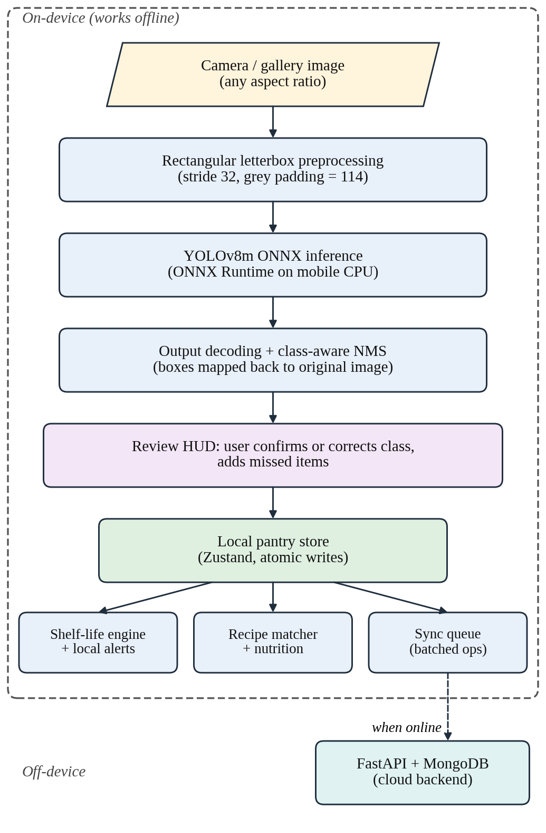
Fig. 1. Overall architecture of the Smart Pantry system.

A. Dataset and Model Training
The detector was trained on an expanded multi-class produce dataset [20] with 35 classes: Apple, Banana, Bean, Bitter Gourd, Bottle Gourd, Brinjal, Broccoli, Cabbage, Capsicum, Carrot, Cauliflower, Coconut, Corn, Cucumber, Dragonfruit, Garlic, Ginger, Grapes, Kiwi, Lemon, Lettuce, Mango, Melon, Onion, Orange, Papaya, Pear, Peas, Pineapple, Potato, Radish, Soybean, Spinach, Tomato and Turnip. The annotations use normalized bounding-box coordinates.
We chose YOLOv8m (medium) because it balances feature-extraction capacity against the limits of mobile hardware. The network has about 25.9 million trainable parameters and an anchor-free, decoupled head that predicts class labels and box coordinates separately. Training ran for 50 epochs with stochastic gradient descent (SGD) using the settings in Table I. To cope with varied kitchen lighting, we applied HSV color augmentation together with translations, horizontal flips and mosaic augmentation. After convergence, the PyTorch checkpoint was exported to ONNX with opset 14. The exported model returns a tensor of shape [1, 39, N], where N is the number of candidate predictions.
TABLE I. Training Configuration of the YOLOv8m Detector
Parameter | Setting
Number of classes | 35 produce categories
Epochs | 50
Optimizer | SGD, momentum 0.937
Weight decay | 0.0005
Initial learning rate | 0.01
Input resolution | 640 pixels (maximum side)
HSV augmentation | H ±0.015, S ±0.70, V ±0.40
Other augmentation | Translation, horizontal flip, mosaic
Export format | ONNX, opset 14

B. On-Device Inference Pipeline
Running a detector on a phone requires the preprocessing to match the training pipeline numerically. Plain resizing stretches every camera frame into a 640×640 square, which distorts object shapes and lowers detection accuracy (Fig. 2). Smart Pantry therefore uses an aspect-preserving rectangular letterbox with 32-pixel stride alignment, as listed in Algorithm 1.
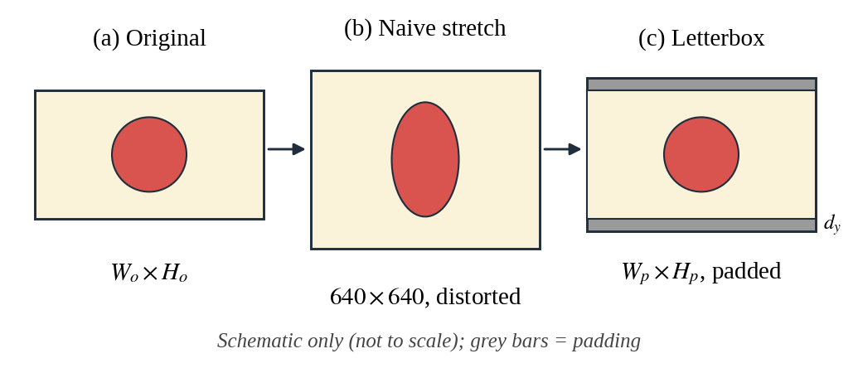
Fig. 2. Square stretching versus rectangular letterboxing.
For an input of size W_{o} × H_{o}, target size T = 640 and stride S = 32, the image is first scaled by the factor min(T/W_{o}, T/H_{o}). The scaled image is then padded up to the next multiple of S, with the padding split evenly between both sides (offsets d_{x} and d_{y}). The resized image is placed on a neutral grey canvas (value 114), divided by 255.0, rearranged into channel-first format and passed to the local ONNX Runtime session.
Algorithm 1: Rectangular Letterbox Preprocessing
Input: image I of size W_{o}×H_{o}; target T = 640; stride S = 32
Output: tensor X of shape (1, 3, H_{p}, W_{p}); scale, d_{x}, d_{y}
1. scale ← min(T/W_{o}, T/H_{o})
2. W_{s} ← round(W_{o}·scale); H_{s} ← round(H_{o}·scale)
3. W_{p} ← ⌈W_{s}/S⌉·S; H_{p} ← ⌈H_{s}/S⌉·S
4. d_{x} ← (W_{p} − W_{s})/2; d_{y} ← (H_{p} − H_{s})/2
5. Resize I to (W_{s}, H_{s}) using bilinear interpolation
6. Fill a W_{p}×H_{p} canvas with grey 114; paste the resized image at (d_{x}, d_{y})
7. X ← canvas / 255.0, transposed to channel-first layout
8. return X, scale, d_{x}, d_{y}

The raw output of shape [1, 39, N] is decoded by TypeScript routines that run on the device (Algorithm 2). Every candidate holds four box values (cx, cy, w, h) followed by 35 class scores. Candidates whose best class score is below the confidence threshold τ_{conf} (default 0.25, configurable) are dropped at once. The remaining boxes are converted to corner form (x₁, y₁, x₂, y₂), shifted back by the padding offsets (d_{x}, d_{y}), multiplied by 1/scale and clipped to the original image. The complete flow is shown in Fig. 3.
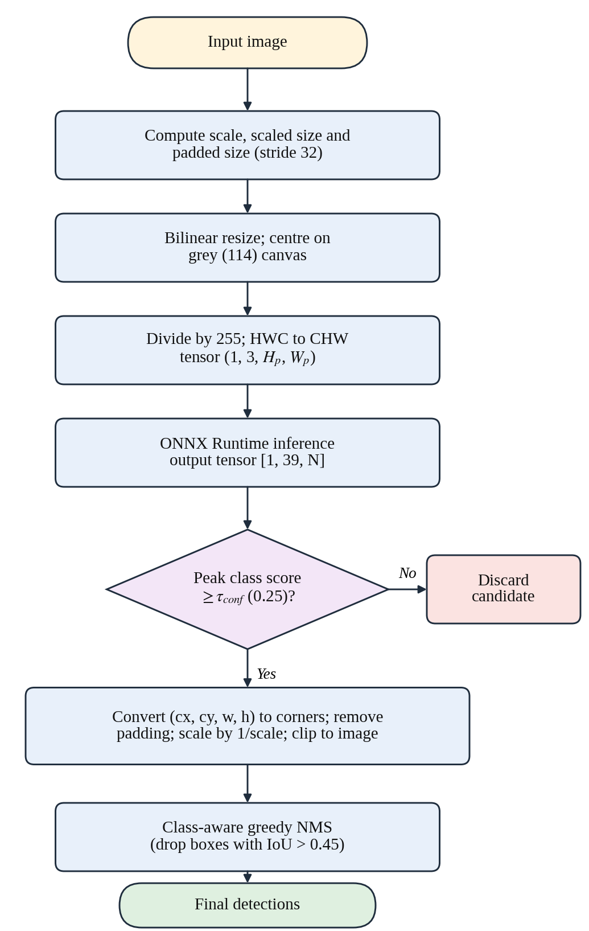
Fig. 3. Flowchart of the on-device detection pipeline.
Algorithm 2: Output Decoding and Class-Aware NMS
Input: output Y of shape 39×N; τ_{conf} = 0.25; τ_{iou} = 0.45; scale, d_{x}, d_{y}
Output: final detection set D
1. C ← ∅
2. for each column n of Y:
3. s ← max Y[4:39, n]; c ← argmax Y[4:39, n]
4. if s < τ_{conf}: skip this candidate
5. convert (cx, cy, w, h) to corners; subtract (d_{x}, d_{y}); divide by scale; clip
6. add (box, s, c) to C
7. D ← ∅
8. for each class c present in C:
9. sort its boxes by score, highest first
10. while the list is not empty: move the top box b to D and remove every box with IoU(b, ·) > τ_{iou}
11. return D

Duplicate detections are removed with a class-aware greedy NMS. Detections are grouped by class and sorted by confidence from high to low, and any box whose Intersection over Union (IoU) with a higher-ranked box of the same class exceeds τ_{iou} = 0.45 is discarded. The IoU of two boxes A and B is
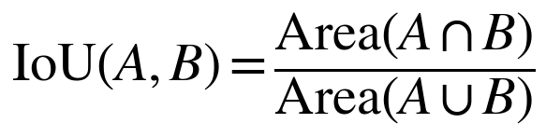 | (1)

C. Client-Side Logic and State Management
The mobile app is written in React Native with TypeScript, and the application state is held in Zustand stores. After a scan, the user sees a Review Heads-Up Display (HUD) that overlays the detections on the photo. A class-override picker lets the user correct a wrong label or add a missed item before anything is saved to the local pantry, which keeps the stored data reliable.
Each confirmed item is linked to a deterministic shelf-life model. Storage durations in days are looked up in a curated shelf-life catalog, and the app compares the elapsed time with the expected shelf life to place the item in one of four urgency bands: Fresh, Warning (3 days or fewer remaining), Critical (1 day or fewer remaining) and Expired. Alerts are scheduled as local notifications, so they work without a network connection.
To help users eat food before it spoils, an on-device recipe matcher compares the pantry contents with a local recipe database. The match percentage is the share of a recipe’s required ingredients that are currently in stock, and recipes that use items in the Critical and Warning bands are ranked higher.

D. Resilient Synchronization and Backend Services
Whenever the device is online, an offline-first sync manager sends the queued changes in batches to a FastAPI service backed by MongoDB (Fig. 4). Every change carries a globally unique operation identifier, and the server applies last-write-wins timestamp validation. Together these make the protocol idempotent, so no record is duplicated when a wireless connection drops and resumes midway.
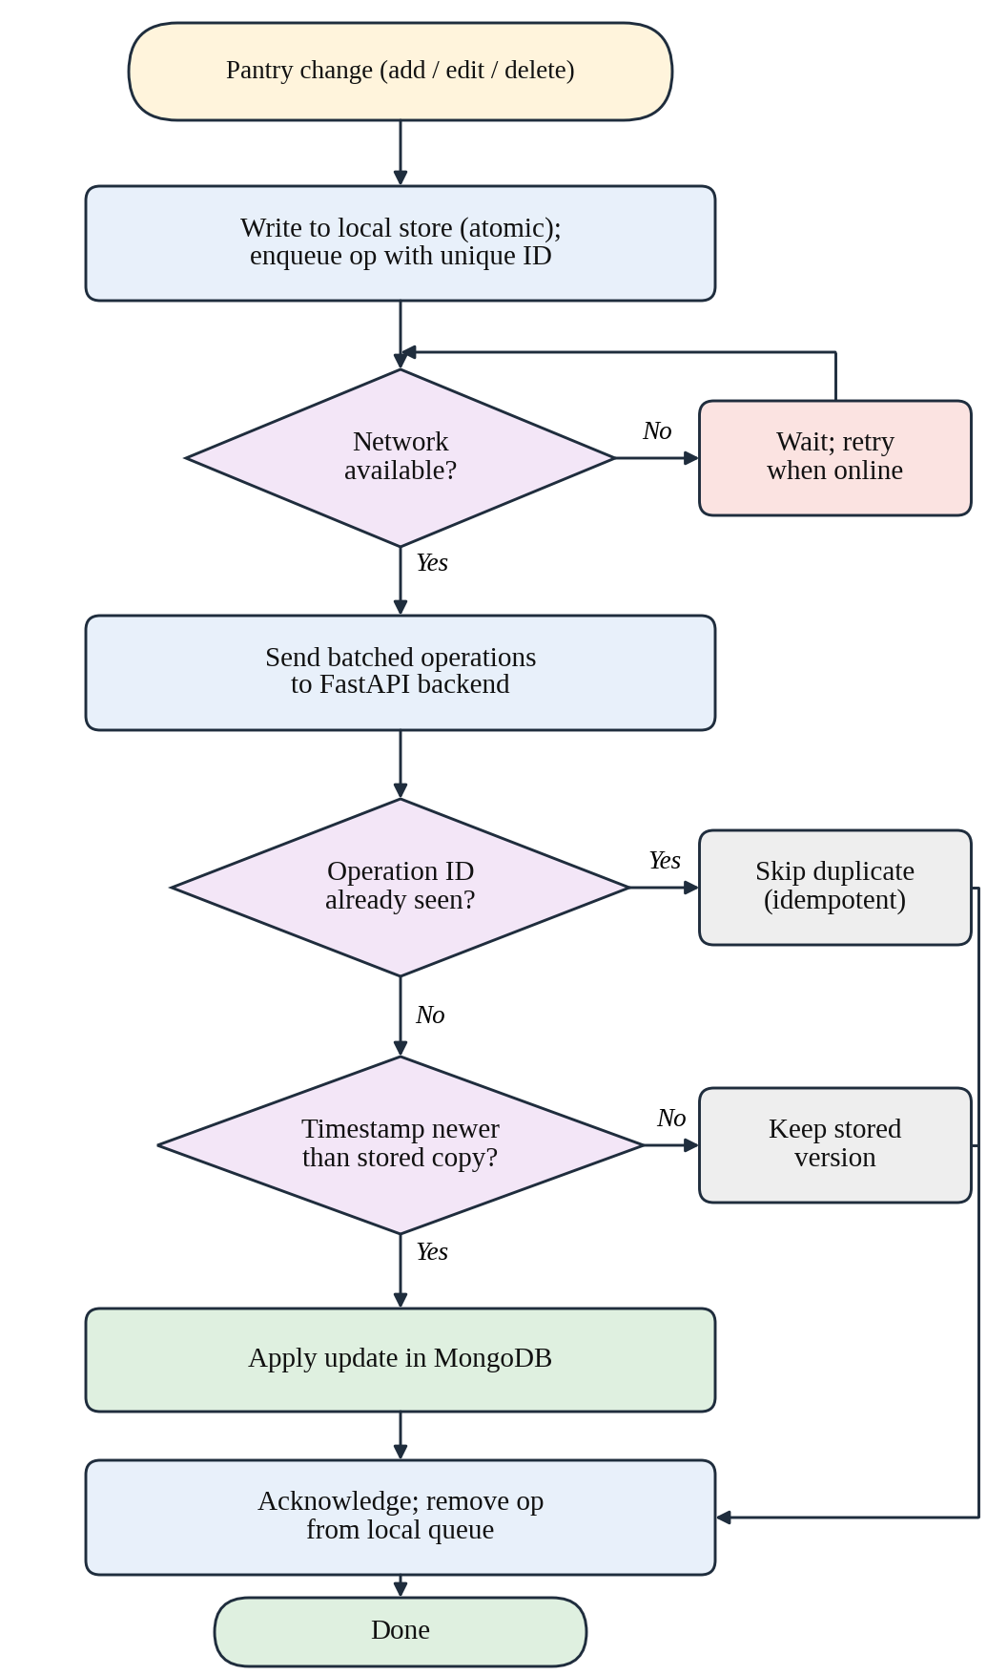
Fig. 4. Flowchart of the offline-first synchronization protocol.
The backend also provides administrative telemetry analytics, JWT-based authentication with bcrypt password hashing, and a Copilot assistant powered by a large language model (LLM). If the external LLM provider is unavailable, the Copilot automatically falls back to a set of rule-based heuristics.

IV. Experimental Results and Analysis
We evaluated both the detection accuracy of the trained model and how faithfully the mobile pipeline reproduces the reference results.

A. Model Detection Performance
Precision, recall, F1-score and mean average precision (mAP) are computed with the standard definitions in (2)–(5):
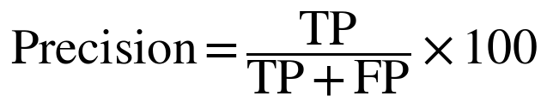 | (2)
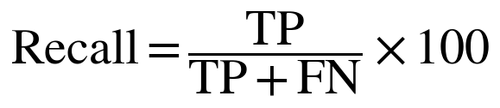 | (3)
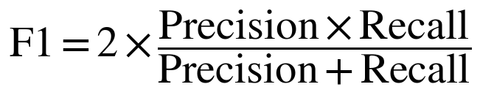 | (4)
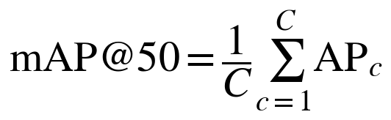 | (5)
where TP, FP and FN are true positives, false positives and false negatives, AP_{c} is the average precision of class c, and C = 35 is the number of classes.
As Table II shows, the fine-tuned YOLOv8m model reaches an overall validation mAP@50 of 91.3% and a recall of 84.8% across the 35 produce classes. Table III lists the results for a representative group of classes, which are also plotted in Fig. 5.
TABLE II. Validation Results and Model Footprint
Metric | Value
Validation mAP@50 | 91.3%
Global recall (R) | 84.8%
Backbone parameters | 25.9 million
Computational complexity | 79.0 GFLOPs
ONNX model size | 104.0 MB

TABLE III. Representative Per-Class Results
Produce class | AP@50 (%) | Recall (%) | Performance tier
Apple | > 95.0 | > 95.0 | Optimal
Banana | > 95.0 | > 95.0 | Optimal
Cabbage | > 95.0 | > 95.0 | Optimal
Capsicum | > 90.0 | > 90.0 | Optimal
Tomato | 86.2 | 85.8 | Robust
Carrot | 86.0 | 86.4 | Robust
Ginger | 85.7 | 84.9 | Robust
Pineapple | 81.4 | 80.9 | Robust
Potato | 72.1 | 71.5 | Moderate
Turnip | 33.0 | 32.8 | Challenging
Melon | 30.2 | 30.0 | Challenging

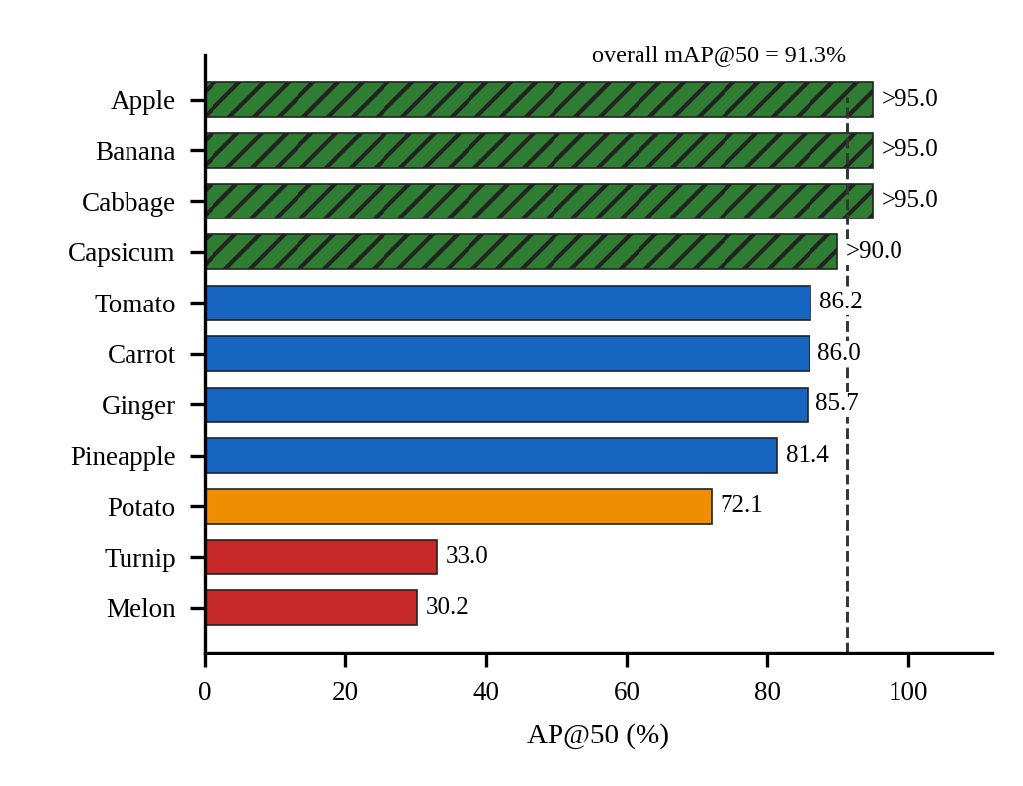
Fig. 5. Per-class AP@50 for the classes in Table III (hatched bars are reported as lower bounds).

B. Preprocessing Parity
To measure the effect of letterboxing compared with plain square resizing, we ran a golden verification test on sixteen test images with different aspect ratios. Table IV compares the two preprocessing methods.
TABLE IV. Comparison of Image Preprocessing Methods
Criterion | Square resizing | Rectangular letterbox (ours)
Mean pixel deviation (vs. PyTorch) | 37.0 grey levels | 1.2 grey levels
Preprocessing misdetection rate | 15.0% (3/20 images) | < 2.0% (0/20 failures)
Aspect-ratio integrity | Severely distorted | Strictly preserved
Relative tensor FLOPs | Baseline (100%) | Reduced by 25% to 45%

C. Comparison with Related Work
Table V places Smart Pantry next to earlier food-recognition studies. Note that those studies report Top-1 classification accuracy on different tasks, whereas this work reports mAP@50 for detection, so the figures are not directly comparable.
TABLE V. Comparison with Existing Food Computing Studies
Study | Method | Task | Reported metric | On-device
Bossard et al. [5] | Random forest components | Food-101 classification | 50.76% Top-1 | No (server)
Yanai & Kawano [6] | Deep transfer CNN | Multi-food classification | 78.77% Top-1 | No (server)
Hassannejad et al. [7] | GoogLeNet / ResNet | Fine-grained classification | 84.29% Top-1 | No (server)
Min et al. [16] | CNN-LSTM multi-task | Visual recipe recognition | 86.97% Top-1 | No (server)
Barcode tools [15] | 1D/2D symbology scan | Packaged-goods logging | Deterministic | Yes
This work | YOLOv8m + ONNX Runtime | 35-class produce detection | 91.3% mAP@50 | Yes (fully local)

V. Discussion
The results show that a medium-sized convolutional detector can run directly on a consumer phone and still give accurate, practical output without depending on a server. An mAP@50 of 91.3% is good enough for everyday pantry tracking. Distinctive items such as Apple, Banana and Cabbage are detected almost perfectly, while Turnip and Melon, which look less distinctive or vary a lot in shape and color, score much lower, most likely because the training data contains few varied examples of them. The review screen handles these hard cases well: when the model is wrong the user corrects it, and the correction is recorded as useful feedback data.
Table IV also shows that keeping the aspect ratio during tensor preparation matters a great deal for vision on edge devices. Plain warping shifts the normalized feature maps relative to the anchors, which corrupts the box regression. Stride-aligned letterboxing keeps the difference between the server-side PyTorch results and the phone’s ONNX results down to 1.2 grey levels, which is within normal interpolation error. One limitation is the 104 MB size of the model file, which is large for low-end phones.

VI. Conclusion and Future Scope
This paper presented Smart Pantry, a mobile system for on-device produce detection and automatic inventory management that connects deep-learning vision research with practical food-waste reduction at home. Using an optimized YOLOv8m ONNX model, the app detects 35 types of produce in real time on the phone without a constant internet connection. The aspect-preserving letterbox pipeline keeps the mobile results closely aligned with the training framework, removes distortion-related false detections and cuts spatial computation by up to 45%.
In future work we plan to apply INT8 post-training quantization [17] to shrink the 104 MB model to below 30 MB so that it runs faster on entry-level phones. We also plan to build an active-learning loop around the correction data collected by the backend and use it to generate hard negative samples for retraining weak classes such as melon and turnip.

References
[1] Food and Agriculture Organization of the United Nations, “Food Loss and Waste Database,” FAO Statistics Division, Rome, 2024. [Online]. Available: https://www.fao.org/food-loss-and-food-waste/
[2] S. Parfitt, M. Barthel, and S. Macnaughton, “Food waste within food supply chains: quantification and potential for change to 2050,” Philosophical Transactions of the Royal Society B, vol. 365, no. 1554, pp. 3065–3081, 2010.
[3] J. Gustavsson, C. Cederberg, U. Sonesson, R. van Otterdijk, and A. Meybeck, “Global food losses and food waste—extent, causes and prevention,” FAO, Rome, Tech. Rep., 2011.
[4] W. Min, S. Jiang, L. Liu, Y. Rui, and R. Jain, “A Survey on Food Computing,” ACM Computing Surveys, vol. 52, no. 5, pp. 1–36, 2019.
[5] L. Bossard, M. Guillaumin, and L. Van Gool, “Food-101—Mining Discriminative Components with Random Forests,” in Proc. European Conference on Computer Vision (ECCV), 2014, pp. 446–461.
[6] K. Yanai and Y. Kawano, “Food image recognition using deep convolutional network with pre-training and fine-tuning,” in Proc. IEEE International Conference on Multimedia and Expo Workshops (ICMEW), 2015, pp. 1–6.
[7] H. Hassannejad, G. Matrella, P. Ciampolini, I. De Munari, M. Mordonini, and S. Cagnoni, “Food image recognition using very deep convolutional networks,” in Proc. 2nd Int. Workshop on Multimedia Assisted Dietary Management, 2016, pp. 41–49.
[8] J. Redmon, S. Divvala, R. Girshick, and A. Farhadi, “You Only Look Once: Unified, Real-Time Object Detection,” in Proc. IEEE Conference on Computer Vision and Pattern Recognition (CVPR), 2016, pp. 779–788.
[9] G. Jocher, A. Chaurasia, and J. Qiu, “Ultralytics YOLOv8 Architecture and Training Framework,” GitHub Repository, 2023. [Online]. Available: https://github.com/ultralytics/ultralytics
[10] A. Bochkovskiy, C.-Y. Wang, and H.-Y. M. Liao, “YOLOv4: Optimal Speed and Accuracy of Object Detection,” arXiv preprint arXiv:2004.10934, 2020.
[11] ONNX Runtime Developers, “ONNX Runtime: Cross-Platform, High-Performance ML Inferencing Accelerator,” Linux Foundation, 2024. [Online]. Available: https://onnxruntime.ai/
[12] A. G. Howard et al., “MobileNets: Efficient Convolutional Neural Networks for Mobile Vision Applications,” arXiv preprint arXiv:1704.04861, 2017.
[13] Y. Kang et al., “Neurosurgeon: Collaborative Intelligence Between the Cloud and Mobile Edge,” in Proc. 22nd Int. Conf. on Architectural Support for Programming Languages and Operating Systems (ASPLOS), 2017, pp. 615–629.
[14] M. C. Ezovski, S. D. Simon, and R. J. Thorn, “Smart refrigerator systems using sensor networks for domestic inventory tracking and waste reduction,” Journal of Food Engineering, vol. 238, pp. 85–93, 2018.
[15] Open Food Facts Consortium, “Open Food Facts Global Database,” 2024. [Online]. Available: https://world.openfoodfacts.org/
[16] W. Min, B.-K. Bao, and C. Xu, “Cross-Platform Multi-Modal Recipe Retrieval With Deep Embedding,” IEEE Transactions on Multimedia, vol. 22, no. 9, pp. 2417–2428, 2020.
[17] S. Han, H. Mao, and W. J. Dally, “Deep Compression: Compressing Deep Neural Networks with Pruning, Trained Quantization and Huffman Coding,” in Proc. International Conference on Learning Representations (ICLR), 2016.
[18] R. David et al., “TensorFlow Lite Micro: Embedded Machine Learning for TinyML Systems,” in Proc. Machine Learning and Systems (MLSys), 2021, pp. 800–811.
[19] N. D. Lane et al., “DeepX: A Software Accelerator for Low-Power Deep Learning Inference on Mobile Devices,” in Proc. 15th ACM/IEEE Int. Conf. on Information Processing in Sensor Networks (IPSN), 2016, pp. 1–12.
[20] Roboflow, “Fruits and Vegi v13-version8 Dataset in YOLOv8 Annotation Specification,” Roboflow Universe, 2024. [Online]. Available: https://universe.roboflow.com

