**Exp. 1 :: Design an LED flasher.**

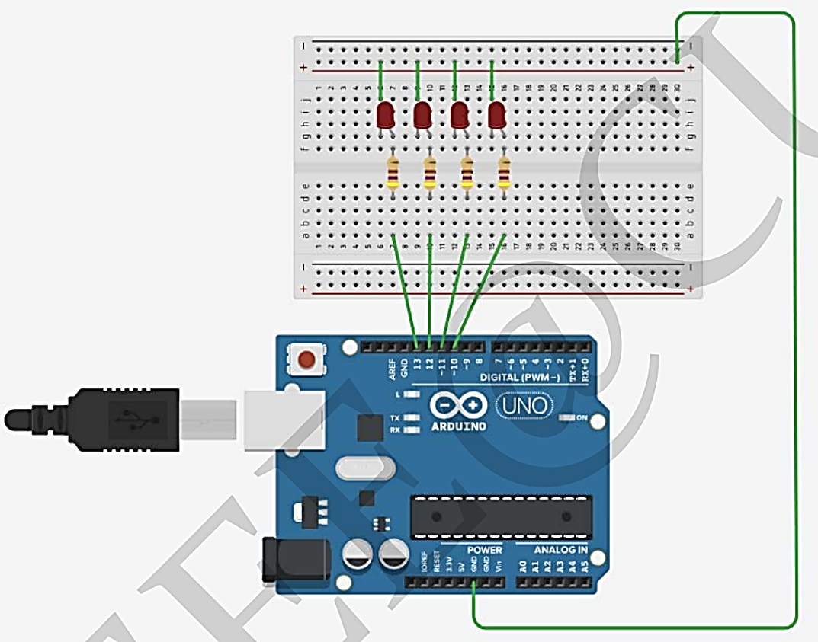

**Theory::** The input voltage (Pin 4) range for single-supply operation is specified as 0 V to +VS – 4 V, which in this case is 0 V to 1 V. While this specification is for normal linear operation, the absolute maximum input limit is +VS on a single supply, so we are not in danger of damaging the chip with our input voltage that can run up to +5 V. The output frequency in the linear portion of the VIN range is defined as

f_OUT = V_IN(1/{10V{R_T}{C_T}}) = V_IN(1/{10V{(5 MΩ)}{(0.1 μF)}}) = V_IN(1/{10V{(0.5s)}}) = V_IN(1/{5Vs})

For VIN = 1 V, we have f = 0.2 Hz.

The oscillation frequency is determined by RT and CT. In voltage-to-frequency conversion applications the oscillation frequency is typically set to be in the tens or hundreds of kilohertz, but for this lab it was set to flash the LED at a rate that was observable. The low rate requires a large RC time constant, which was obtained with the 0.1 μF capacitor and 5 MΩ resistor.

The op-amp requires a small input bias current on each input, and these currents are closely, but not perfectly matched. The current flowing through RT produces a voltage drop across RT, introducing an error into the frequency setting. Compensation resistor, RC, a resistor equal in value to RT, is added to the non-inverting input (Pin 4) to produce a nearly identical voltage drop is as is across RT. This technique minimizes the offset error between the two op-amp inputs, and produces the most accurate output frequency. This is an important consideration in circuits that are used as voltage-to-frequency converters, but not so important in simple LED flashing circuits. When observing the voltage on Pin 4, a jumper wire must be placed across RC (shown as dotted line in the schematic) in order to eliminate DC losses that occur due to the M1K input loading the 5 MΩ source resistance.

* In a voltage-feedback op-amp circuit, negative feedback causes the feedback voltage on the inverting input to track the voltage on the non-inverting input. The voltage on Pin 3 is the feedback voltage, and this should track the voltage applied to Pin 4 very closely as long as the output of the emitter follower can follow it and the input common-mode range is not violated.

**Concept Used :** Collect all the required components and get ready! Place the 555 timer IC on breadboard as per shown in the breadboard setup image given above .Connect pin 1 of 555 timer IC to the ground. You can see the pin structure of 555 timer IC in the pin diagram shown below .Connect pin 2 to the positive end of capacitor. The longer lead of a polarized capacitor is the positive and the shorter one is negative. Connect the negative lead of the capacitor with the ground of battery .Also connect the pin 2 with pin 6 of the 555 timer IC .Connect the pin 3 which is the output pin with the positive lead of LED using 1kΩ resistor. Negative lead of LED needs to be connected with the ground .Connect pin 4 with the positive end of battery .Pin 5 doesn’t connect with anything .Connect pin 6 with pin 7 using a 470kΩ resistor .Connect pin 7 with the positive end of battery using 1kΩ resistor .Connect pin 8 with the positive end of battery .Finally connect the battery leads with the breadboard to start the power supply in the circuit .Once you connect battery in the circuit, it should flash the LED.

* Learning & Observations : The AD654 is a voltage-to frequency converter that can be used for many functions, ranging from precise signal transmission to simple LED flashing
* Op-amp circuits require input bias currents, and offset errors can be minimized by matching the resistances that each input bias current flows through
* The two voltage-feedback op-amp input voltage levels track each other closely when negative feedback is applied around the op-amp

Problems &Troubleshooting : There are multiple types of LED Lighting products on the market and most of them require a low voltage Power Supply, also known as an LED Transformer or LED Driver. With that being said it is very important to understand the differences between LED products and what types of power supplies they require and also there mounting restrictions so you know that you are using compatible lights and transformers. If you are having issues with your LED Power Supply read through this tutorial to see some common troubleshooting techniques. **Keep in mind that using a 24VDC power supply with a 12VDC LED Light will not make it twice as bright, and vice versa, doing so will cause damage to the LED products and is a serious fire hazard. Never use 2 power supplies on one LED Light or LED Light Controller.**

Preacautions : • Do not drop the LED, expose it to impact with hard objects, handle it with force, or scratch the surface. The broken LED may cause injuries.

• When replacing the LED, check the rating (voltage and wattage) and socket base design of the new LED. Ensure the new LED in positioned correctly and snap it firmly into the socket. A loosely fitted LED may come out of the socket, or overheat.

• Before replacing the LED, disconnect the battery, and let the LED cool down. The hot LED may cause burns.

• After replacing the LED, check to ensure no portion of the light fixtures or electric cord is touching the LED. If this occurs, the heated fixtures or cord may cause a fire.

• Dispose of the used LED on an as•is basis. If the LED is shattered, the broken pieces of glass may cause injuries.

• Keep the LED out of reach of infants and small children. They may swallow it.