**Aim**:-Design a system with two buttons such that a. red light when any button is pressed during day. b. green light when both buttons are pressed during day.

**Apparatus**:-2 switches,4 resistors,7 wires,2 leds,aurdino,breadboard.

**Circuit Diagram**:-

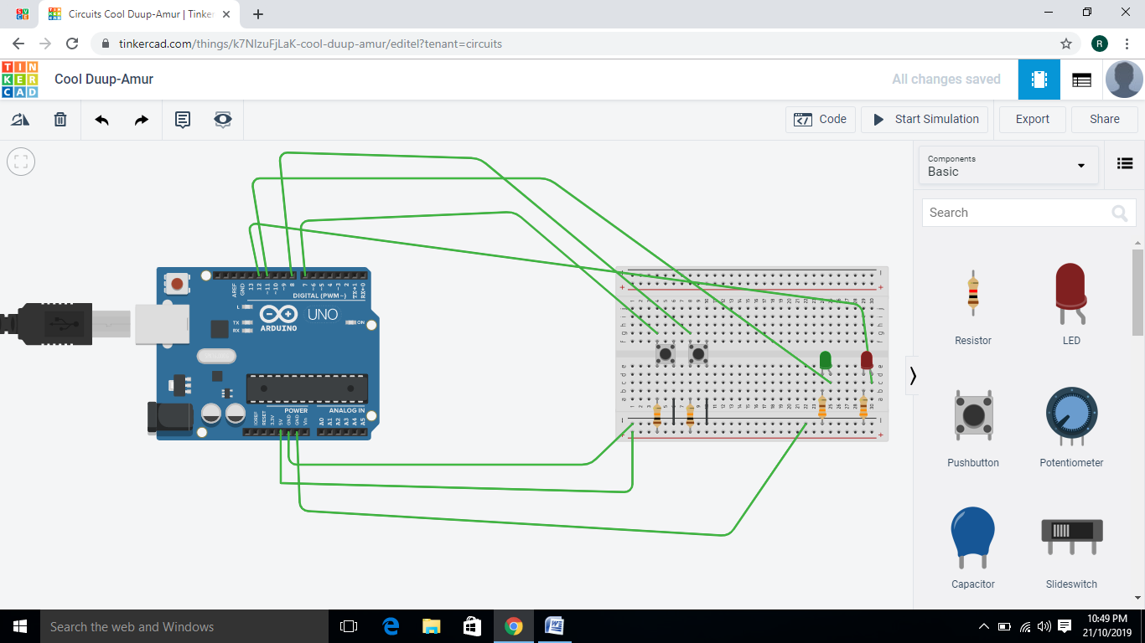

**Program**:- void setup()

{

pinMode(7, INPUT);

pinMode(8, INPUT);

pinMode(12, OUTPUT);

Serial.begin(9600);

pinMode(11, OUTPUT);

}

void loop()

{

if (digitalRead(7) == 1 && digitalRead(8) != 1) {

digitalWrite(12, HIGH);

Serial.println("go");

digitalWrite(11, LOW);

} else {

if (digitalRead(8) == 1 &&digitalRead(7) == 1) {

digitalWrite(12, HIGH);

Serial.println("get ready");

digitalWrite(11, HIGH);

} else {

Serial.println("stop");

}

}

delay(10); // Delay a little bit to improve simulation performance

}

**Result**:-Leds blink when button is pressed verified by uploading the program.