| **Department of Computer Science (DCCO)**  **Information Technology Engineering Career**  **Systemas Fundamentals**  **NRC 8399** |
| --- |
|  |
| Web Page  UndarratedEc |

**Project**

**Presented by:** Anchapaxi Dayana, Andrade Robinson, Ayo Dennis, Cadena Diego.

**Teacher:** Edison Lascano

City: Sangolquí

Fecha: 11/01/2023



**PERFIL DE PROYECTO**

1. Introduction 2

2. Work approach 3

2.1 Problem formulation 3

2.2 Justification 3

3. System of objectives 3

3.1. Overall objective 3

3.2. Specific Objectives 3

4. Scope 3

5. Theoretical Framework 4

6. Methodology (Marco de trabajo 5W+2H)/Análisis y Diseño de MV3 4

7. Ideas to Defend 4

8. Expected Results 4

9. Feasibility(Ex.) 4

9.1 Humana 5

9.1.1 Business Tutor 5

9.1.2 Academic Tutor 5

9.1.3 Students 5

9.2 Technological 5

9.2.1 Hardware 5

9.2.2 Software 5

10. Conclusions and recommendations 5

10.1 Conclusions 5

10.2 Recommendations 5

1. **Introduction**

Nowadays, websites for the sale of sporting goods have become an essential part of daily life and especially for virtual sales and purchases, however some of the stores do not have such websites or their performance is not effective.

This document addresses a solution to one of the problems that affect many of the physical stores, and is to carry out a purchase or consultation of any item online, through a page.

In the area of the sale and purchase talking about sporting goods stores, it is essential to have access to information on both the articles and their prices, as well as it is also necessary to control their personal data as there are situations in which these data are required for the verification of the purchase and the verification of the purchase of the sporting goods, where the seller must verify payments, avoiding errors during the process of selling an item.

For these reasons, it is considered important to implement a sales control web page, which allows to optimize this process to benefit both the buyer and the seller, allowing better control and avoiding situations in which errors are found when selling sporting goods. As an example, it has been taken into consideration to create the web page of the sports equipment sales entity "UnderratedEc", specifically the functionality for the sale of their articles, in which it is possible to observe how to carry out this process and what considerations should be taken into account to carry it out.

1. **Work approach**

**2.1 Problem formulation**

This website is mainly based on the display and sale of sporting goods from the sporting goods store called "UnderratedEc". Since this was done in person in each physical store and in many cases to acquire a physical article, it was often impossible, because the time and distance of some people, who were in another place, was an impediment. That is why it is necessary for any store to have an optimal website to offer products to customers, and customers in turn, can make inquiries and searches for the sporting goods they require, being that within this website is the customer who has an effective navigation, just as the store salespeople can verify the orders correctly. Therefore, the implementation of the web page will be developed with the support of the authorities of the sporting goods store "UnderratedEc" who will be in charge of establishing the system requirements.

**2.2 Justification**

The sporting goods stores are one of the main axes if we are talking about sports, the purpose of this project is to establish a website that will help us to improve the sale of sporting goods, considering the design of user navigation to make it easier, so our website will manage to implement a web page sales and search to provide greater attention to the user, improvement and optimization of processes, being that customers through this application verify it through the website.

1. **Objective System**

**3.1. General Objective**

Develop a web page that allows to manage the administration of students' grades through an agile methodology, for the search and purchase of sporting goods by customers.

**3.2. Specific Objectives**

* Identify the functional and non-functional requirements of the web page issued by the administrator.

* Perform test cases and error reporting for the different functional requirements.

1. **Scope**

1. Management of modification and administration of customers by the administrator.

2. Management of the search of articles on the part of the clients.

3. Management of the purchase on the part of the clients.

1. **Theoretical Framework**

**GITHUB**

It is a website that provides a service for hosting software repositories managed by the Git version control system, where it is possible to share code or projects in an easier way with people around the world.

**GitHub Desktop**

It is a GitHub desktop application, which allows you to use version control in a simpler way. GitHub desktop is a graphical user interface designed to facilitate the use of Git.

**WEB PAGE**

A web page is a digital document that is accessed through a browser, while a website is a set of related web pages under the same theme, which are well organized and hosted on the Internet through a domain name.

**HTML**

Hypertext Markup Language (HTML) is the code used to structure and display a web page and its contents. For example, its contents could be paragraphs, a bulleted list, or images and data tables.

**CSS**

CSS is a computer language that specifies how documents are presented to users: how they are designed, laid out, etc. A document is usually a text file structured with a markup language: HTML is the most common, but there are also others such as SVG or XML.

1. **Methodology (5W+2H Framework)/**

As a methodology, the use of online documents is proposed, where the problem, the solutions required for it and the activities to be carried out by each team member can be presented.

The following questions are posed in the framework:

5W questions

1) What-What: Develop a web page to manage the sale of sporting goods from the Underrated store.

2) When-When: The development of the project will be carried out during the academic period from October 2022 to March 2022.

3) Why-Why: To optimize access to the purchase of sporting goods by customers.

4) Where-Where: The development of the system will be done together with the group members through the

group members through class hours and online meetings.

5) Who-Who: The project will be carried out by the members of the group, the academic tutor and the administrator of the "Who-Who" store.

and the administrator of the "Underrated" store.

P2H Questions

1) How-How: By means of a survey of requirements that allows to demonstrate the needs that the administrator has to implement them in the web page.

2) How much- How much: The tools to be used to create the web page are free, so it will not have any cost.

**Ideas to Defend**

With the implementation of a web page for the sale of sporting goods for the "Underrated" store, the management and operation of the store will be improved and optimized, since at the moment the "Underrated" store does not have a system that allows this type of requirement.

The development of the project is based on the guidelines of the 5W+2H Framework that allows identifying the functional requirements so that the product meets all the user's needs.

**Expected Results**

At the end of the project, the sporting goods store "Underrated" will have a web system that will speed up the process of search and purchase of customers, in addition to being a very helpful tool for both to receive sales and show new products, by the store managers, since through this website will be able to have a control of sales and check the progress of sales and search for them.

1. **Feasibility**

| **QUANTITY** | **DESCRIPTION** | **UNIT VALUE**  **(USD)** | **TOTAL VALUE**  **(USD)** |
| --- | --- | --- | --- |
| 1 | **OFFICE EQUIPMENT**  DELL CORE I7 Laptop Computer  HP CORE I5 laptop computer  DELL CORE I7 Laptop Computer  DELL CORE I5 Laptop Computer  **SOFTWARE**  Windows 10 operating system  G Suite ((Google Docs, Google Sheets and Google Drive)  Visual Studio Code | 800  650  800  700  40  0  0  0 | 800  650  800  700  160  0  0  0 |
|  | | **TOTAL** | 3110 |

Tabla 1: Presupuesto del proyecto

Recuperado de: (Mercado Libre 2021)

Nota: Las PC/portátiles son propiedad de los desarrolladores.

**9.1 Humana**

**9.1.1 AdministraTor**

* (Business mentor)

**9.1.2 Academic Tutor**

* Edison Lascano

**9.1.3 Students**

Equipo: Anchapaxi Daya

Equipo: Andrade Robinson

Equipo: Ayo Dennis

Equipo: Cadena Diego

**9.2 Technological**

* + 1. **Hardware**

We will use DELL and HP laptops, with Intel Core i5 and i7 processors that will allow us to create and store all the information, documentation and coding of the project and thus have a better administration for our project.

The equipment we have for the realization of the project are: DELL Core I7/8th generation, DELL Core I7/4th generation, DELL Core I5/7th generation and HP Core I5/8th generation laptops, 8 GB RAM.

* + 1. **Software**

With the use of software you will have multiple tools that will be of great help for the documentation, modeling and coding of the project, these tools are the following:

* Operating System: Microsoft Windows 10
* G Suite that will allow us to perform both documentation and requirements matrix in shared documents.
* Visual Studio Code is a great editor for HTML development, it has features such as syntax highlighting, brace matching in expressions and snippets that can add functionality to your day to day.
* Hypertext Markup Language (HTML) is the code used to structure and display a web page and its contents. For example, its contents could be paragraphs, a bulleted list, or images and data tables.
* CSS is a computer language that specifies how documents are presented to users: how they are designed, laid out, etc. A document is usually a text file structured with a markup language: HTML is the most common, but there are also others such as SVG or XML.

**10. Conclusions and recommendations**

**10.1 Conclusions**

* It was possible to develop a website that allows the organization for a better sale of items that allowed to manage the search and sales preference within the website of the sporting goods store "UnderratedEc" to customers, which also greatly facilitates the work of the staff that makes up the store, meeting all the functional requirements requested by the business tutor.
* Thanks to the implementation of the 5W and 2H framework, it was possible to have a better organization of the functional requirements to be fulfilled and to adequately distribute those responsible for each of them in order to present them according to the established delivery times.
* With the test cases performed, it was possible to identify in time the errors that the web page had and correct them in time to finally have a fully functional product according to the requirements.

**10.2 Recommendations**

* The use of the user stories framework matrix is recommended in order to identify the functional requirements in a simpler way and be able to implement them effectively in any system or web page.
* It is recommended to use the user stories matrix, to correctly manage the requirements and the order required for the progress and advancement of the project to be optimal, obtaining a functional project.

**11. Bibliografía**

* DEP. DE CIENCIAS DE LA COMPUTACIÓN . (s.f.). Obtenido de <http://www.jtech.ua.es/dadm/restringido/java/sesion01-apuntes.pdf>
* García, A. A. (2007). Obtenido de <https://repositorio.upct.es/bitstream/handle/10317/179/pfc2475.pdf>
* GCF GLOBAL. (s.f.). Obtenido de <https://edu.gcfglobal.org/es/informatica-basica/que-son-las-aplicaciones-web/1/>
* Velazquez, J. L. (AGOSTO de 2010). *Universidad de Guanajuato*. Obtenido de <https://www.cimat.mx/~pepe/cursos/lenguaje_2010/slides/slide_17.pdf>
* Gustavo, B., Por, BV y Por, DA (2019, 12 de abril). GitHub: ¿Qué Es GitHub Y Cómo Utilizarlo? Recuperado el 3 de julio de 2021 del sitio web Hostinger.es: <https://www.hostinger.es/tutoriales/que-es-github>
* Mercado Libre 2021 https://articulo.mercadolibre.com.ec/MEC-431095223-licencia-windows-10-pro5-pc-retail-original-permanent-_JM#position=15&search_layout=stack&type=item&tracking_id=e0907923-ef75-4930-b77e-1bbfdf6158d6

**Anexos.**

**Anexo I. Requeriments**

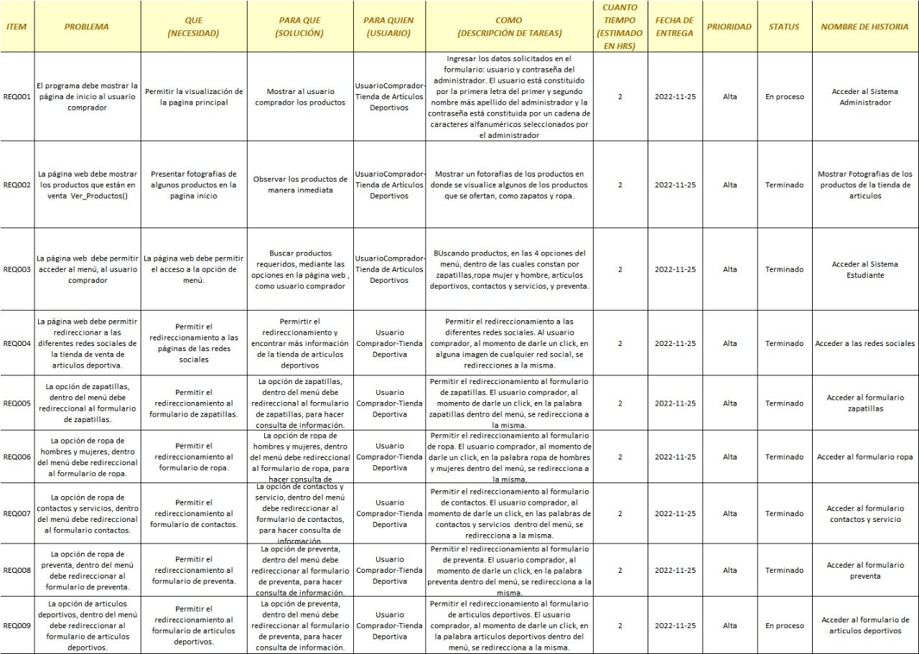



**Anexo II. Use Case Diagram**

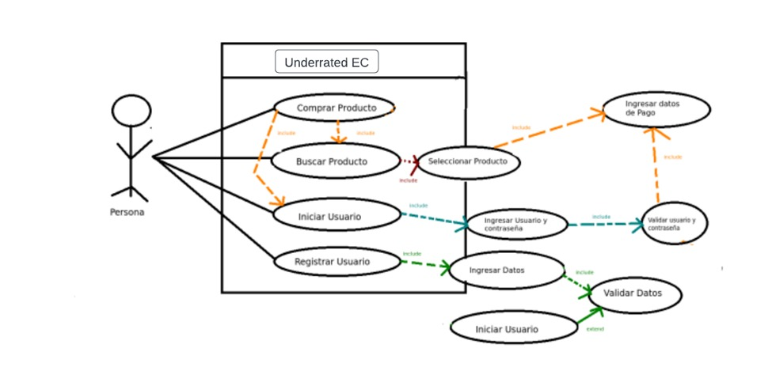

**Anexo III. Class Diagram**

