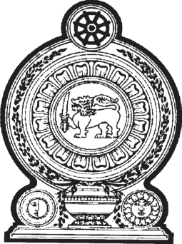

**PARLIAMENT OF THE DEMOCRATIC SOCIALIST REPUBLIC OF**   
**SRI LANKA**

**NATIONAL MINIMUM WAGE OF WORKERS**  **(AMENDMENT) ACT, No. 16 OF 2021**

**[Certified on 16th of August, 2021]**

*Printed on the Order of Government*

Published as a Supplement to Part II of the **Gazette of the Democratic Socialist Republic of Sri Lanka** of August 20, 2021

PRINTEDATTHEDEPARTMENTOFGOVERNMENTPRINTING, SRILANKA   
TOBEPURCHASEDATTHEGOVERNMENTPUBLICATIONSBUREAU, COLOMBO5

**Price : Rs. 5.00**  **Postage : Rs. 15.00**

*This Act can be downloaded from* www.documents.gov.lk 

|  |  |
| --- | --- |
| *National Minimum Wage of Workers* | 1 |

*(Amendment) Act, No. 16 of 2021*

[Certified on 16th of August, 2021]

L.D.—O. 25/2019

AN ACTTOAMENDTHE NATIONAL MINIMUM WAGEOF WORKERS

ACT, NO. 3 OF 2016

BE it enacted by the Parliament of the Democratic Socialist

Republic of Sri Lanka as follows:—

|  |  |  |
| --- | --- | --- |
| **1.** | This Act may be cited as the National Minimum | Short title |

Wage of Workers (Amendment) Act, No. 16 of 2021.

|  |  |  |
| --- | --- | --- |
| **2.** | Section 3 of the National Minimum Wage of Workers | Amendment of section 3 of Act, No. 3 of 2016 |
| Act, No. 3 of 2016 is hereby amended in subsection (1) thereof by the substitution for the words, “shall be ten thousand | |

rupees and the national minimum daily wage of a worker shall be four hundred rupees” of the words, “shall be twelve thousand five hundred rupees and the national minimum daily wage of a worker shall be five hundred rupees.”.

|  |  |  |
| --- | --- | --- |
| **3.** | In the event of any inconsistency between the Sinhala | Sinhala text to  prevail in case  of inconsistency |
| and Tamil texts of this Act, the Sinhala text shall prevail. | |

|  |  |
| --- | --- |
| 2 | *National Minimum Wage of Workers* |

*(Amendment) Act, No. 16 of 2021*

English Acts of the Parliament can be purchased at the “PRAKASHANA PIYASA”, DEPARTMENTOF GOVERNMENT PRINTING, NO. 118, DR. DANISTER DE SILVA MAWATHA, COLOMBO 8.