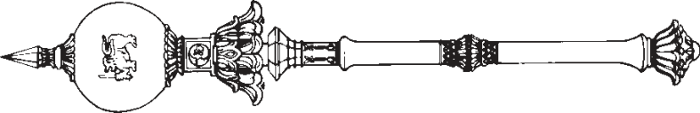

**PARLIAMENT OF THE DEMOCRATIC SOCIALIST REPUBLIC OF**   
**SRI LANKA**

*————————*

**MUSLIM MARRIAGE AND DIVORCE (REPEAL)**

**A**

**BILL**

**to repeal the Muslim Marriage and Divorce Act, No. 13 of 1951**

*————————*

*Presented by the Hon. (Ven.) Athuraliye Rathana Thero, M.P. on 09th of February, 2021*

(Published in the Gazette on February 1, 2021)

*Ordered by Parliament to be printed*

*————————*

**[Bill No. 26]**

PRINTEDATTHEDEPARTMENTOFGOVERNMENTPRINTING, SRILANKA   
TOBEPURCHASEDATTHEGOVERNMENTPUBLICATIONSBUREAU, COLOMBO5

**Price : Rs. 6.00**  **Postage : Rs. 15.00**

*This Bill can be downloaded from* www.documents.gov.lk 

|  |  |
| --- | --- |
| *Muslim Marriage and Divorce (Repeal)* | 1 |

AN ACTTOREPEALTHE MUSLIM MARRIAGEAND DIVORCE   
ACT, NO. 13 OF 1951

BE it enacted by the Parliament of the Democratic Socialist Republic of Sri Lanka as follows:-

**1.** This Act may be cited as the Muslim Marriage and Short title Divorce (Repeal) Act, No. of 2021.

|  |  |  |  |
| --- | --- | --- | --- |
| 5 | **2.** | The Muslim Marriage and Divorce Act, No. 13 of | Repeal of |
| 1951 is hereby repealed. | | Act, No. 13 |
| of 1951 |
| **3.** | In the event of any inconsistency between the Sinhala | Sinhala text |
| and Tamil texts of this Act, the Sinhala text shall prevail. | | to prevail in |
| case of |

inconsistency

|  |  |
| --- | --- |
| 2 | *Muslim Marriage and Divorce (Repeal)* |

Department of Government Printing