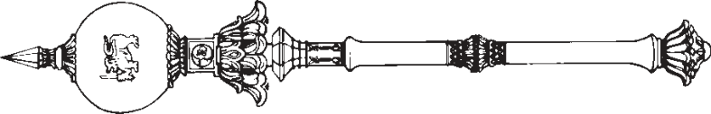

**PARLIAMENT OF THE DEMOCRATIC SOCIALIST REPUBLIC OF**   
**SRI LANKA**

*————————*

**NATIONAL MINIMUM WAGE OF WORKERS (AMENDMENT)**

**A**

**BILL**

**to amend the National Minimum Wage of Workers Act, No. 3 of 2016**

*————————*

*Presented by the Minister of Labour on 24th of March, 2021*

(Published in the Gazette on March 09, 2021)

*Ordered by Parliament to be printed*

*————————*  
**[Bill No. 37]**

PRINTEDATTHEDEPARTMENTOFGOVERNMENTPRINTING, SRILANKA   
TOBEPURCHASEDATTHEGOVERNMENTPUBLICATIONSBUREAU, COLOMBO5

**Price : Rs. 6.00**  **Postage : Rs. 15.00**

*This Bill can be downloaded from* www.documents.gov.lk 

2-2dp

|  |  |
| --- | --- |
| *National Minimum Wage of Workers* | 1 |

*(Amendment)*

L.D.—O. 25/2019

AN ACTTOAMENDTHE NATIONAL MINIMUM WAGEOF WORKERS

ACT, NO. 3 OF 2016

BE it enacted by the Parliament of the Democratic Socialist

Republic of Sri Lanka as follows:—

|  |  |  |
| --- | --- | --- |
| **1.** | This Act may be cited as the National Minimum | Short title |

Wage of Workers (Amendment) Act, No. of 2021.

|  |  |  |  |
| --- | --- | --- | --- |
| 5 | **2.** | Section 3 of the National Minimum Wage of Workers | Amendment |
| Act, No. 3 of 2016 is hereby amended in subsection (1) thereof | | of section 3 of |
| Act, No. 3 of |
| by the substitution for the words, “shall be ten thousand | |
| 2016 |
| rupees and the national minimum daily wage of a worker | |

shall be four hundred rupees” of the words, “shall be twelve 10 thousand five hundred rupees and the national minimum daily wage of a worker shall be five hundred rupees.”.

|  |  |  |
| --- | --- | --- |
| **3.** | In the event of any inconsistency between the Sinhala | Sinhala text to prevail in case of |
| and Tamil texts of this Act, the Sinhala text shall prevail. | |

inconsistency

|  |  |
| --- | --- |
| 2 | *National Minimum Wage of Workers* |

*(Amendment)*

DEPARTMENTOFGOVERNMENTPRINTING