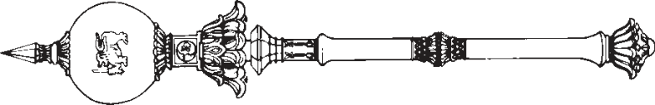

**PARLIAMENT OF THE DEMOCRATIC SOCIALIST REPUBLIC OF**   
**SRI LANKA**

*————————*

**CONVENTION AGAINST TORTURE AND OTHER CRUEL, INHUMAN OR DEGRADING TREATMENT OR PUNISHMENT (AMENDMENT)**

**A**

**BILL**

**to amend the Convention Against Torture and other Cruel, Inhuman or Degrading Treatment or Punishment Act, No. 22 of 1994**

*————————*

*Presented by the Minister of Justice on 08th of June, 2021*

(Published in the Gazette on May 20, 2021)

*Ordered by Parliament to be printed*

*————————*  
**[Bill No. 52]**

PRINTEDATTHEDEPARTMENTOFGOVERNMENTPRINTING, SRILANKA   
TOBEPURCHASEDATTHEGOVERNMENTPUBLICATIONSBUREAU, COLOMBO5

**Price : Rs. 6.00**  **Postage : Rs. 15.00**

*This Bill can be downloaded from* www.documents.gov.lk 

*STATEMENT OF LEGAL EFFECT*

*Clause 2* : This clause amends section 2 of the Convention against Torture and other Cruel, Inhuman or Degrading Treatment or Punishment Act, No. 22 of 1994 by increasing the fine in respect of the offence of torture specified in subsection (4).

|  |  |
| --- | --- |
| *Convention Against Torture and other Cruel,* | 1 |

*Inhuman or Degrading Treatment or Punishment*   
 *(Amendment)*   
L.D.—O. 3/2021

AN ACTTOTOAMENDTHE CONVENTION AGAINST TORTUREANDOTHER CRUEL, INHUMANOR DEGRADING TREATMENTOR PUNISHMENT ACT, NO. 22 OF1994

BE it enacted by the Parliament of the Democratic Socialist Republic of Sri Lanka as follows:—

|  |  |  |
| --- | --- | --- |
| **1.** | This Act may be cited as the Convention Against | Short title |

Torture and other Cruel, Inhuman or Degrading Treatment

|  |  |  |  |
| --- | --- | --- | --- |
| 5 | or Punishment (Amendment) Act, No. of 2021. | | Amendment |
| **2.** | Section 2 of the Convention Against Torture and |
| other Cruel, Inhuman or Degrading Treatment or Punishment | | of section 2 |
| of Act, No. |
| Act, No. 22 of 1994 is hereby amended in subsection (4) of | | 22 of 1994 |

that section by the substitution for the words “a fine not less 10 than ten thousand rupees and not exceeding fifty thousand rupees.”, of the words “a fine not less than fifty thousand rupees and not exceeding two hundred thousand rupees.”.

|  |  |  |
| --- | --- | --- |
| **3.** | In the event of any inconsistency between the Sinhala | Sinhala text to prevail in case of |
| and Tamil texts of this Act, the Sinhala text shall prevail. | |

inconsistency

|  |  |
| --- | --- |
| 2 | *Convention Against Torture and other Cruel,* |

*Inhuman or Degrading Treatment or Punishment*   
*(Amendment)*

Department of Government Printing