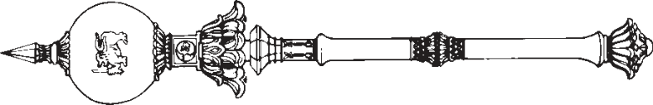

**PARLIAMENT OF THE DEMOCRATIC SOCIALIST REPUBLIC OF**   
**SRI LANKA**

*————————*

**INDUSTRIAL DISPUTES (AMENDMENT)**

**A**

**BILL**

**to amend the Industrial Disputes Act (Chapter 131)**

*————————*

*Presented by the Minister of Labour and Foreign Employment on 10th of August, 2022*

(Published in the Gazette on July 04, 2022)

*Ordered by Parliament to be printed*

*————————*

**[Bill No. 132]**

PRINTEDATTHEDEPARTMENTOFGOVERNMENTPRINTING, SRILANKA   
TOBEPURCHASEDATTHEGOVERNMENTPUBLICATIONSBUREAU, COLOMBO5

**Price : Rs. 12.00**  **Postage : Rs. 15.00**

*This Bill can be downloaded from* www.documents.gov.lk 

*STATEMENT OF LEGAL EFFECT*

*Clause 2*: This clause amends section 46 of the Industrial Disputes Act (Chapter 131) and the legal effect of the section as amended is to provide for representation of any party to any proceeding under the said Act by an Attorney-at-law or a representative as specified in that section.

*Industrial Disputes (Amendment)* L.D.-O. 19/2017

1

AN ACTTOAMENDTHE INDUSTRIAL DISPUTES ACT   
(CHAPTER 131)

BE it enacted by the Parliament of the Democratic Socialist Republic of Sri Lanka as follows:-

**1.** This Act may be cited as the Industrial Disputes Short title (Amendment) Act, No. of 2022.

|  |  |  |
| --- | --- | --- |
| 5 | **2.** Section 46 of the Industrial Disputes Act | Amendment of |
| section 46 of |
| (Chapter 131) (hereinafter referred to as the “principal |
| Chapter 131 |
| enactment”) is hereby amended by the repeal of subsections |

(1), (2) and (3) thereof, and the substitution therefor of the following subsections:–

10 “(1) Any party to any proceeding under this Act taken by or before any authorized officer, arbitrator, industrial court or labour tribunal or the Commissioner may, act through an Attorney-at-law or a representative of the party.

15 (2) For the purposes of this Act, a representative of a party shall–

(*a*) where the party is a trade union, or consists   
of two or more trade unions, be a person to   
represent such union or each such union;

20 (*b*) where the party consists partly of any trade union or unions and partly of employers or workmen who are not members of any such union, be a person to represent such union or of each such union and a prescribed number 25 of persons nominated in accordance with regulations by such employers or workmen; and

|  |  |  |
| --- | --- | --- |
| 2 | (*c*) | *Industrial Disputes (Amendment)* |
| where the party consists of employers or |

workmen, be a prescribed number of persons   
nominated by such employers or workmen.”.

|  |  |  |
| --- | --- | --- |
| 5 | **3.** In the event of any inconsistency between the Sinhala | Sinhala text to |
| and Tamil texts of this Act, the Sinhala text shall prevail. | prevail in case |
| of |

inconsistency

|  |  |
| --- | --- |
| *Industrial Disputes (Amendment)* | 3 |

Department of Government Printing