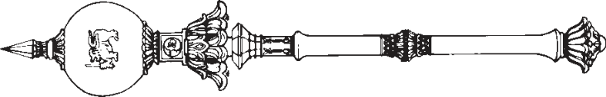

**PARLIAMENT OF THE DEMOCRATIC SOCIALIST REPUBLIC OF**   
**SRI LANKA**

*————————*

**CARRIAGE BY AIR (AMENDMENT)**

**A**   
**BILL**

**to amend the Carriage by Air Act, No. 29 of 2018**

*————————*  
 *Presented by the Minister of Ports, Shipping and Aviation*  *on 23rd of May, 2023*   
 (Published in the Gazette on April 03, 2023)   
 *Ordered by Parliament to be printed*  
 *————————*  
**[Bill No. 180]**   
 PRINTEDATTHEDEPARTMENTOFGOVERNMENTPRINTING, SRILANKA

TOBEPURCHASEDATTHEGOVERNMENTPUBLICATIONSBUREAU, COLOMBO5

**Price : Rs. 10.00**  **Postage : Rs. 150.00**

*This Bill can be downloaded from* www.documents.gov.lk 

*STATEMENT OF LEGAL EFFECT*   
 *Clause 2* : This clause amends section 5 of the Carriage by Air Act and the legal effect of the section as amended is to provide for the Minister to specify the limits of liability for domestic carriage by air, whereby the higher threshold applicable to the limits of liability for international carriage by air will not be applicable to domestic carriage by air.

*Carriage by Air (Amendment)* L.D.-O. 33/2022

1

AN ACTTOAMENDTHE CARRIAGEBY AIR   
 ACT, NO. 29 OF 2018   
BE it enacted by the Parliament of the Democratic Socialist   
Republic of Sri Lanka as follows:-  
 **1.** This Act may be cited as the Carriage by Air Short title (Amendment) Act, No. of 2023.

|  |  |  |
| --- | --- | --- |
| 5 | **2.** Section 5 of the Carriage by Air Act, No. 29 of 2018 | Amendment of |
| s e c t i o n 5 o f |
| is hereby amended by the insertion immediately after |
| Act, No. 29 of |
| subsection (2) of that section, of the following new | 2018 |

subsections:–  
 “(3) The Minister may, from time to time by Order 10 published in the *Gazette*, specify the limits of liability as may be applicable to carriage by air not being international carriage by air.”.

|  |  |  |
| --- | --- | --- |
| **3.** | In the event of any inconsistency between the Sinhala | Sinhala text to prevail in case of inconsistency |
| and Tamil texts of this Act, the Sinhala text shall prevail. | |

|  |  |
| --- | --- |
| 2 | *Carriage by Air (Amendment)* |

Department of Government Printing