1.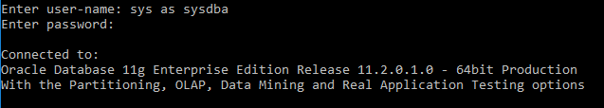

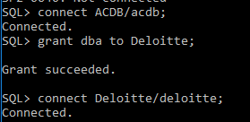

2.

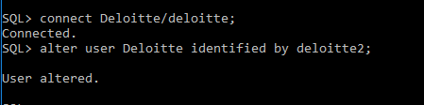

4.select first_name as WORKER_NAME from Worker

5.select upper(first_name) as UPPER_FIRST from Worker

6.select distinct department from Worker

7.select instr(first_name,’A’) from Worker where first_name=’Amitabh’

8.select substr(first_name,1,3) from Worker

9.select rtrim(first_name) from Worker

10.select ltrim(department) from Worker

11.select distinct department,length(department) from Worker

12.select replace(first_name,'A','a') from Worker

13.select (first_name||' '||last_name)as complete_name from Worker

14.select * from Worker order by first_name

15.select * from Worker order by first_name,department desc

16.select * from Worker where first_name like 'Vipul' or first_name like 'Satish'

17.select * from Worker where first_name not like 'Vipul' or first_name not like 'Satish'

18.select * from Worker where department='Admin'

19.select * from Worker where first_name like '%A%'

20.select * from Worker where first_name like '%A' or first_name like '%a'

21.select * from Worker where first_name like '______a' or first_name like '______A'

22.SET SERVEROUTPUT ON;

DECLARE

V_max number;

BEGIN

select max(department_id) into V_max from departments;

DBMS_OUTPUT.PUT_LINE('Maximum dept id:'||V_max);

END;

/

23.SET SERVEROUTPUT ON;

DECLARE

"BEGIN" varchar(25):='Uppercase';

BEGIN

DBMS_OUTPUT.PUT_LINE("BEGIN");

END;

24.SET SERVEROUTPUT ON;

DECLARE

V_global number:=8;

BEGIN

DECLARE

V_local number:=12;

BEGIN

V_local:=V_local+12;

DBMS_OUTPUT.PUT_LINE(V_local);

DBMS_OUTPUT.PUT_LINE(V_global);

END;

V_global:=V_global+35;

DBMS_OUTPUT.PUT_LINE(V_global);

END;

25.SET SERVEROUTPUT ON;

DECLARE

c_sal number(5);

n_sal number(5);

BEGIN

select salary into c_sal from employees where employee_id=122;

DBMS_OUTPUT.PUT_LINE(c_sal);

update employees

set salary=salary+5000

where employee_id=122;

select salary into n_sal from employees where employee_id=122;

DBMS_OUTPUT.PUT_LINE(n_sal);

end;